**CSV to SHP Project**

A csv file is provided. This file needs to be stripped of special characters (%, $, etc) headers, and spaces facilitating the creation of a shapefile. The csv contains attributes on fire ignitions, i.e. date, acreage, location. There should be a separate shapefile created for each individual park unit (ReportingUnitId) as well as a one shapefile for the entire csv file.

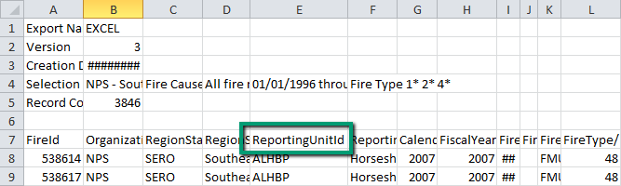

The resulting shapefiles need to be saved in a new folder, designated by the end user.

Within ArcMap a button needs to be created, with a GUI interface prompting the end user to select the csv for conversion and the output location of the new folder where the shapefiles will be saved too. The resulting shapefiles need to be named in the following convention; { ReportingUnitId}_YYYYMMDD. The date reflects the date in which the shapefile was made. Newly created shapefiles *should be added* to an ArcMap Document.

**Additional details**:

Use this path to the projection file. "Coordinate Systems/Geographic Coordinate Systems/North America/NAD 1983.prj"

The best way to approach this is to open the csv file, read the contents, modify the contents and create an edited csv that can be imported into ArcGIS using "LongitudeNAD83" for the x values and "LatitudeNAD83" for the y values. The edited csv version needs to have:

* The first 6 rows removed.
* Columns BU through FU removed. (Column numbers 73-177)
* Any blanks, slashes, or other special characters in fieldnames replaced with underscores.
* Points with no coordinate specified (“LongitudeNAD83" and “LatitudeNAD83” are empty strings), should be placed at (0,0).

This edited csv should be importable to ArcGIS. Then a single shapefile with all the data can be created. Then the individual unit shapefiles can be created by doing selections based on the park unit as specified above.

--Project request from Justin Shedd.