**Are you having PythonWin IDE problems?**

It seems a few students are having problems with opening PythonWin and importing ‘arcpy’. If you encountered this problem, please try the solutions below:

1. Make sure you are connected to the ArcGIS License server. Open the ArcCatalog or ArcMap and see if any popup shows up. If a popup message says something like “Cannot connect to license server”, then try to make sure you are connected to the Internet. If this does not solve the problem, go to step 2.
2. Reboot your computer. If the problem still persists, uninstall and reinstall PythonWin. If this does not solve the problem, choose step 3, step 4 or step 5 below.
3. Try the solution “1. I just installed PythonWin and I get an error when I import arcpy. What’s wrong?” in the following FAQ:

<http://courses.ncsu.edu/gis540/common/FAQ.html>

1. If you often have problems with PythonWin, you may want to try out the PyScripter.
2. If none of above solutions fix the problem, write [cnr_help@ncsu.edu](mailto:cnr_help@ncsu.edu) with a detailed description of your problem.
3. If you prefer using PythonWin, but you have a problem with PythonWin on your computer, use NCSU VCL. Make a reservation for “**ArcGIS 10.1 SP1 With Office 2007**”. For more information, see “3. What is the VCL?” in the following FAQ:

<http://courses.ncsu.edu/gis540/common/FAQ.html>

**PyScripter**

Download link: <https://code.google.com/p/pyscripter/downloads/list>

Download “PyScripter-v2.5.3-Setup.exe”

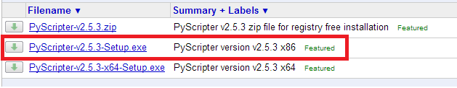

Input arguments:

1. Run > Command Line Parameters…

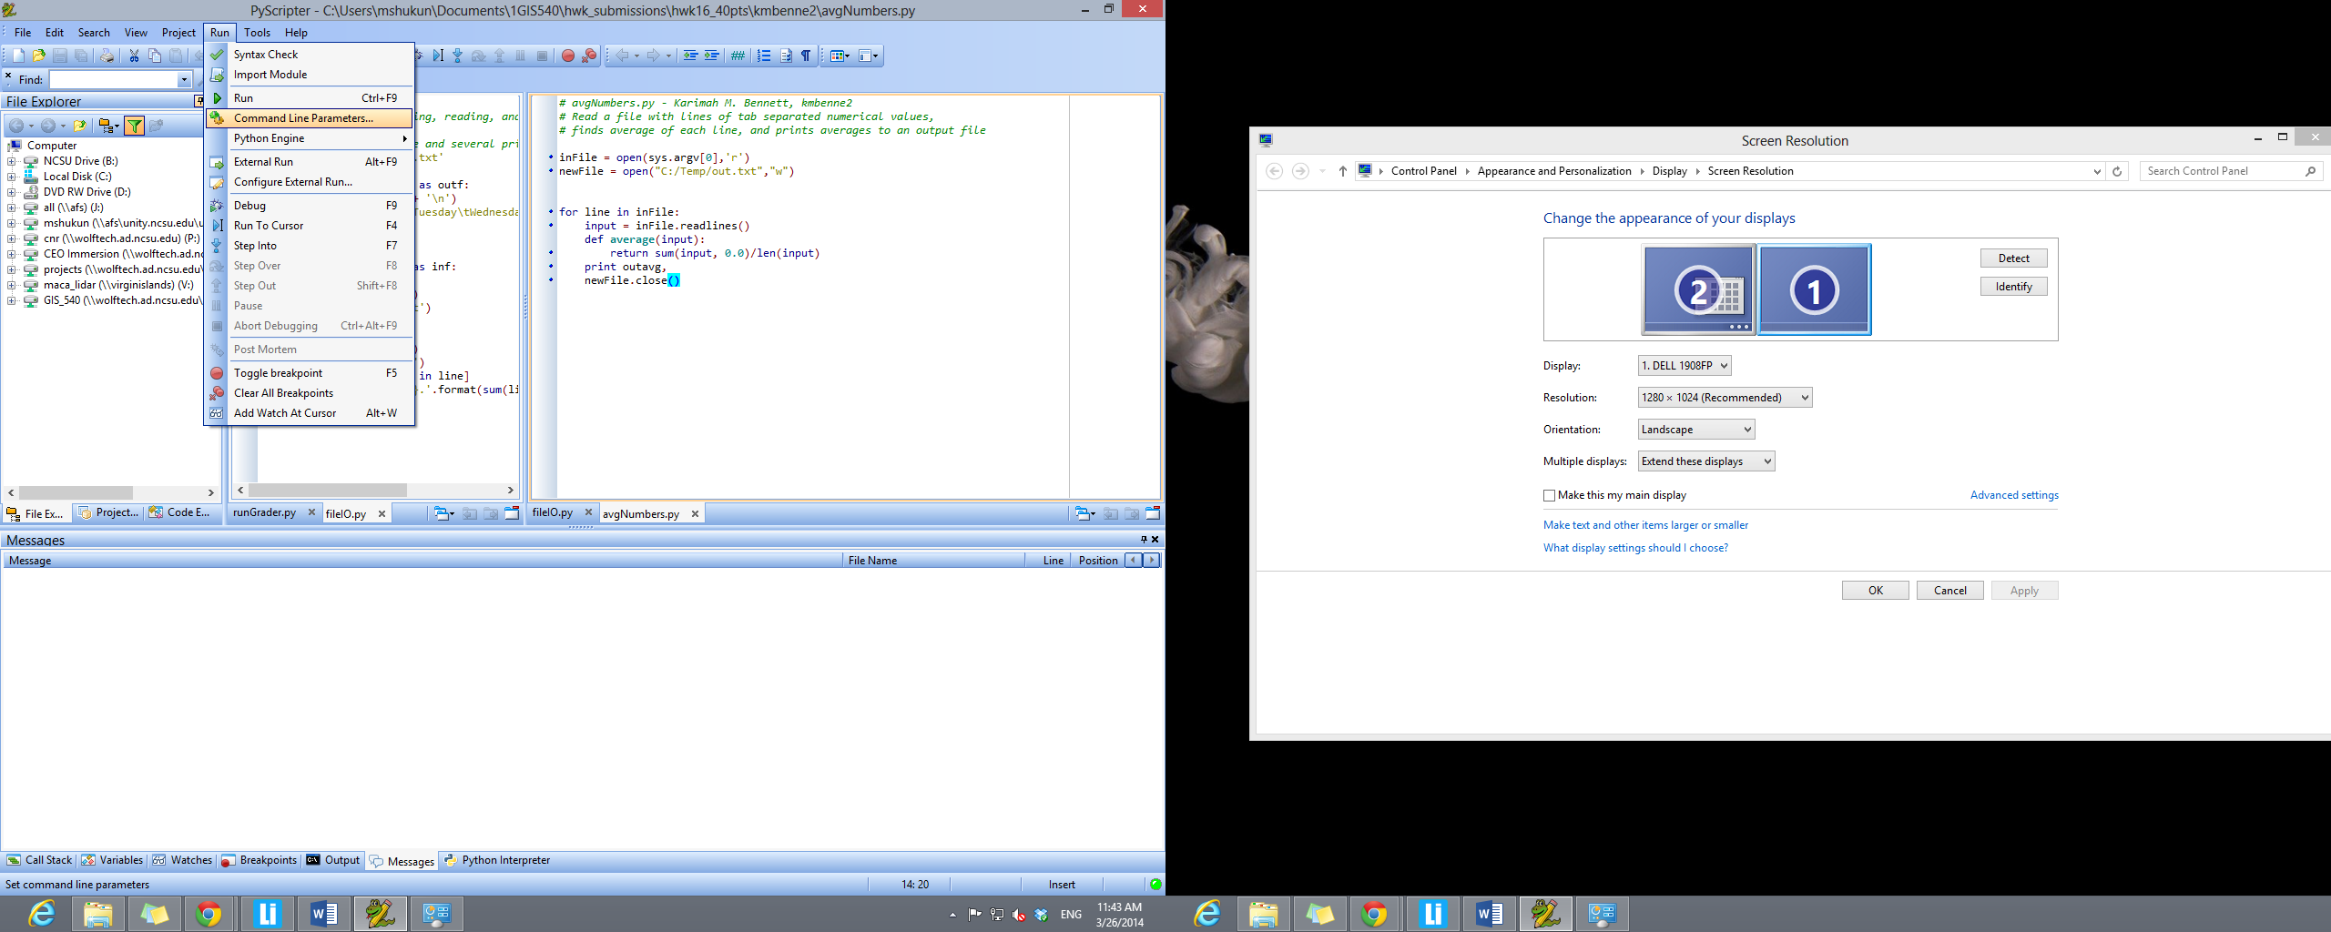

1. Check “Use Command Line Parameters?” > Type in the parameters in the text field > Click OK

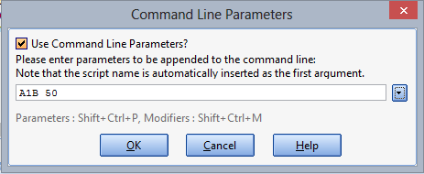

1. Click Run



Note: If you need to test a script using no input arguments, uncheck “Use Command Line Parameters?” If your script does not take arguments and you leave this checked, it will not cause any problems. For this reason, in general it’s best that you leave this checked so that you won’t forget to check it when needed.

4. Instructions for debugging with Pyscripter are available here:

http://courses.ncsu.edu/gis540/common/scripting_topics/debugging.htm#pyscripter