<https://velocity.ncsu.edu/dl/5lp6jq9/52985>

Extract rpy2.zip and copy it to

C:\python26\arcgis10.0\lib\site-packages

Then open up python win ….Navigate to C:\python26\lib\site-packages\rpy2 and drag the setup.py into your python win screen…Then click on the running man ..to run and add build install..and then click ok.

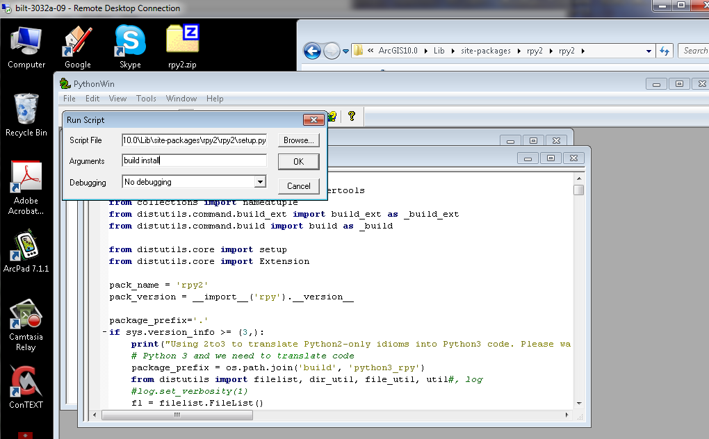

Last step is to go back to python win and type : import rpy2 and hit enter. If no errors occurred your done. If you get an error make sure you have copied just Rpy2 to the site packages. Sometime when you extract your get a nested folder rpy2\rpy2 …you just want one rpy2.

Here is a link to a video showing how to install rpy2

<http://cnr.online.ncsu.edu/online/Viewer/?peid=7cb05e70994a442888abc247bec17cb41d>