**Assignment 2.**

**Install BlenderGIS addon**

1. https://github.com/domlysz/BlenderGIS/wiki/Install-and-usage

**Install Blender sketchfab addon**

1. https://sketchfab.com/exporters/blender

**Setup coordinate system**

1. Go to User Preferences > addons . In the search section type “GIS”, then activate “3D view: Blender GIS”.
2. Expand BlenderGIS tap and in Spatial Reference Systems’ section, press +Add to create a new coordinate system. Use 3358 for definition and NAD83(HARN) for description. Check “Save to addon Preferences” and press OK.
3. Click Save User Setting (on left bottom side of the user preferences window) and close the preference window

**Setup Scene coordinate system**

1. Find and click on GIS addon’s interface in 3D viewport’s left toolbar
2. In the “Geoscene” section , click on the gear shape icon and switch to NAD83(HARN), click ok.

**Import Digital surface model**

1. Go to file > import > Georeferenced Raster
2. Browse assignment directory and click on DSM.tif
3. In the “Import Georaster” section (bottom left side of the vindow” ) Set mode to “AS DEM”
4. Set Subdivision to Subsurf
5. Make sure the CRS is NAD83(HARN), click on import Georaster. The final model should look like figure1.

**Surface subdivision and refinement**

1. Make sure that the surface model is selected
2. In the bottom ribbon, Object interaction mode switch to “Edit Mode”
3. In the bottom ribbon, Switch to Face select
4. In bottom ribbon, Select click on (De)select All or use keyword “A” to select all faces
5. From Tools menu in left toolbar select “Subdivide” . The subdivide dialogue should appear on the bottom left on the toolbar. For “ Number of Cuts” select 5
6. In the bottom ribbon, Object interaction mode switch to “Edit Mode”
7. In the bottom ribbon, Object menu > convert to select “Convert to Mesh”

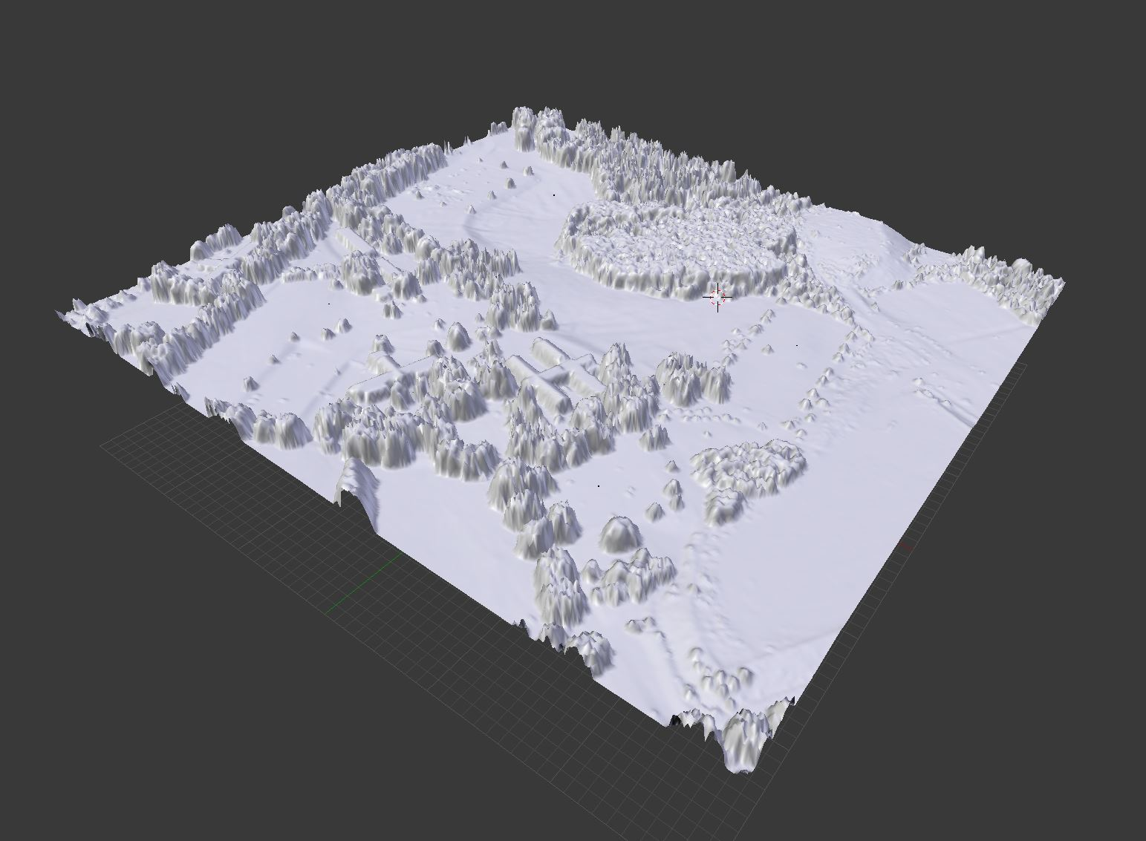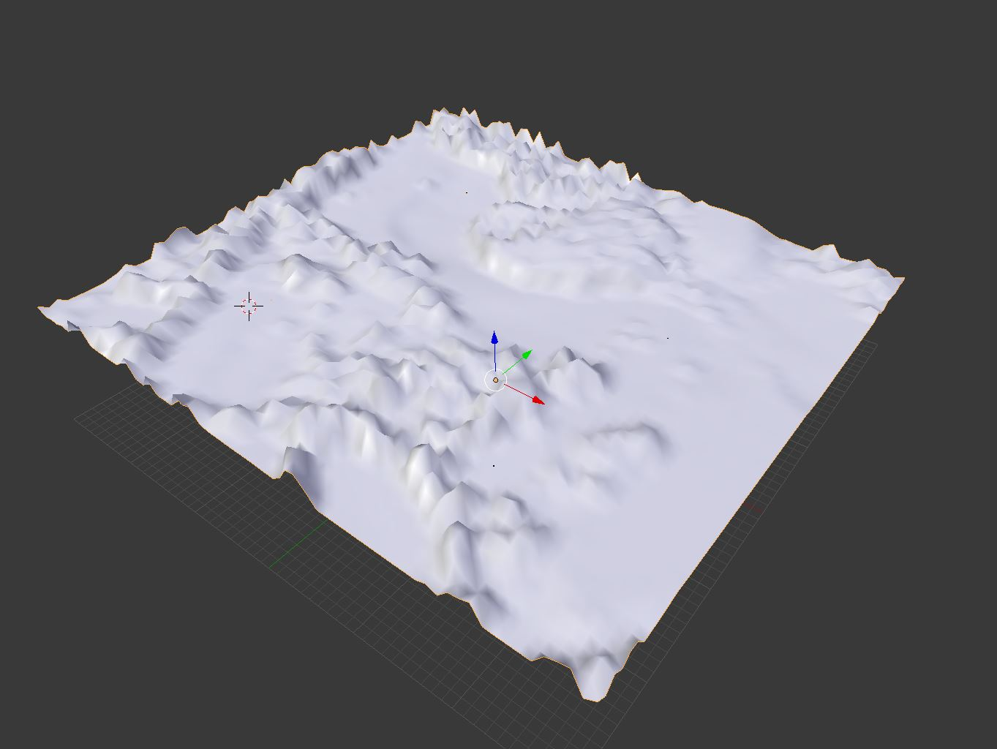

Figure 1 Figure 2

**Import Viewpoint’s Shape file**

1. Go to file > import > Shapefile
2. Browse assignment directory and click on vpoint.shp and click on “Import Shp” . The shape import dialogue should appear in front of the GIS adoon interface.
3. Activate “Elevation from field” and in field section select “height”
4. Activate “Elevation from field” and in field section select “height”
5. Activate “Separate objects”
6. Activate “Object from field” and in field section select “Name”, you should be able to see 4 the points on the surface and 4 objects added to the Outliner with the names “Viewshed_1, Viewshed_2,Viewshed_3, Viewshed_4”

**Create spheres for viewshed points and align them with imported points**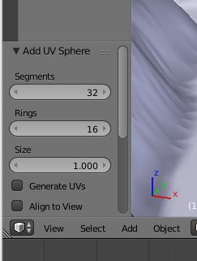

1. Go to 3D Viewport’s bottom ribbon > Add > Mesh > UV sphere. The Add UV phere dialogue will open on the left side of the Toolbar.
2. Set the Size parameter to 1.000
3. Select Sphere object and press Shift + D or ctrl+c , ctrl+v to make a copy of the object , you should see the Sphere.001 in the outliner
4. Make 4 copies of the sphere.
5. In Outliner select the object “Viewshed_1” and go to Properties Editor > Object > Location to retrieve the viewshed point’s coordinates (X,Y,Z). 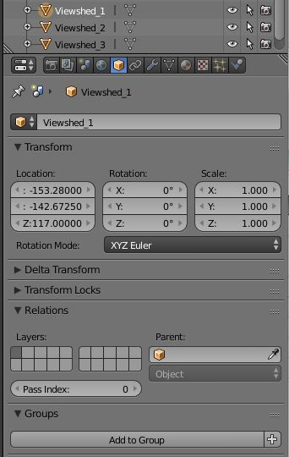
6. Move each of the 4 spheres to the corresponding viewshed location by typing in the coordinates in their location parameter (Properties Editor > Object > Location).
7. You should now have 4 spheres aligned on the imported viewshed points.
8. There are much shorter workflows for aligning two objects in Blender (see for example <http://blender.stackexchange.com/questions/2289/is-there-an-easy-way-to-align-two-objects-on-a-specific-axis>)

**Generate 4 copies of the surface**

1. Select DSM object and press Shift + D or ctrl+c , ctrl+v to make a copy of the object , you should see the DSM.001 in the outliner
2. Select the DSM.001 , go to Properties Editor > Object (cube icon)
3. In the “Transform” section > Location > X: type 750 to move the duplicate surface 750 meters to the east
4. Create another copy of the DSM , put -750 for Y parameter to move the duplicate surface 750 meters to the south
5. Create another copy of the DSM, put 750 for X parameter and -750 in Y parameter. The final model should look like figure 3.

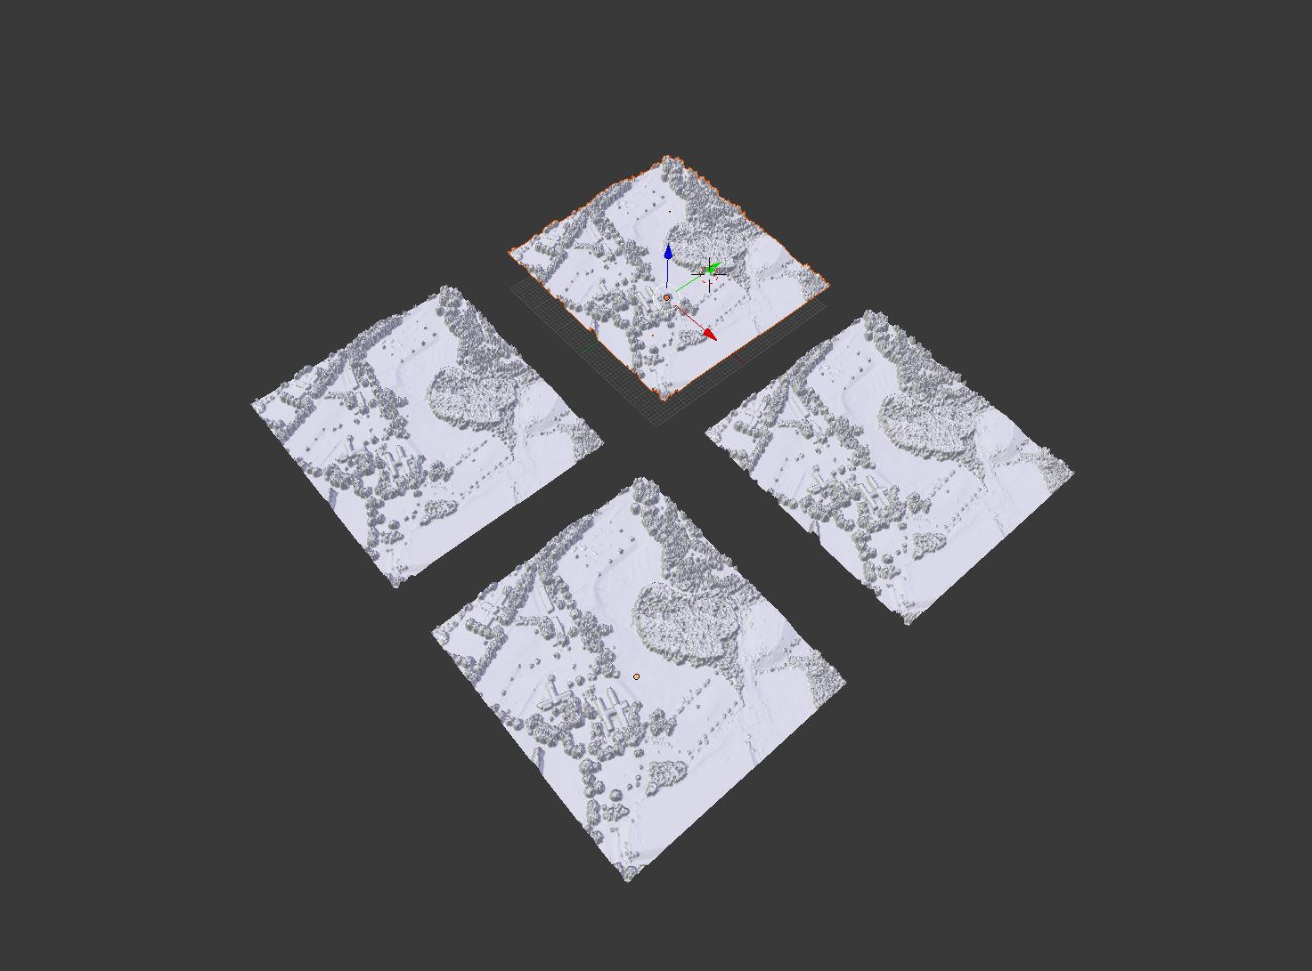

**Figure 3**

**Move viewshed spheres to their corresponding viewshed points**

At this point you should have 4 surface objects and 4 spheres on the first surface. Now lets distribute spheres across 4 surfaces so each surface has a sphere related to one of the viewshed points.

1. Select Sphere.001 go to Properties Editor > Object > Delta location
2. In X parameters type 750
3. Repeat step 1 for Sphere.002 , put -750 for Y parameter
4. Repeat step 1 for Sphere.003 , put 750 for X parameter and - 750 for X parameter.

**Upload the model in sketchfab**

1. Select surfaces individually and create a material with a unique name for each (fig 4)

Note : Sketchfab discriminates objects with their assigned materials (two object with same material will be grouped).

1. Select all four spheres and assign one material for all of them (we need the spheres grouped in Sketchfab)
2. In outliner select 4 DSM models and 8 spheres one after another while holding shift key
3. You should see all 8 objects highlighted in orange
4. Go to sketchfab addon menu located in Toolbar
5. Choose “Selection” for “Model” and “ None” for lamp
6. Make a title and description for the model and click upload (fig 5).

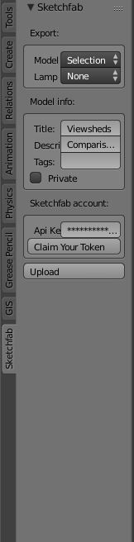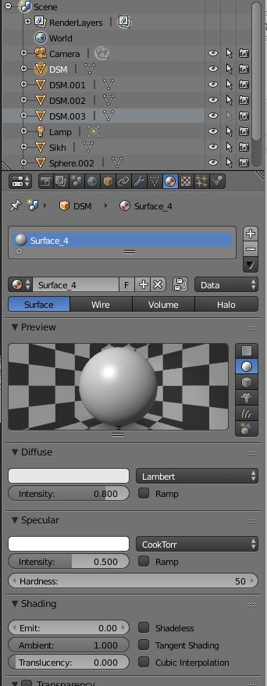

Fig 4 Fig 5

**Drape four viewshed maps in Sketchfab and publish the model**

Apply the following procedures using the 3D setting tools in Sketchfab .

1. Select a background for the model (preferably solid color)
2. Adjust the lighting so that all four models are lit and proper shadows are casted. It is recommended to use multiple light sources to ensure all 4 models are lit.
3. Set each of the provided viewshed maps (assignment folder, e.g., viewshed_1.png) to individual surfaces
4. You can select surfaces by browsing the drop-down menu in material setting.
5. Given the variety of textures provided in the folder, you have plenty of options to visualize the 4 viewshed points in different and creative ways ! for starters try to use grayscale viewsheds as emission maps (in material setting) and turn on Blooming in the post-effects setting.
6. Annotate the models on the location of spheres (e.g, Viewshed 1).
7. Your sketchfab model may look like <https://sketchfab.com/models/6660c1572f9c46c192f019229d323259>

**Deliverables**

Insert a link to the annotated sketchfab model on Piazza on the same 3Dvis post as the first Blender and Sketchfab post.