1. Test connetion失败

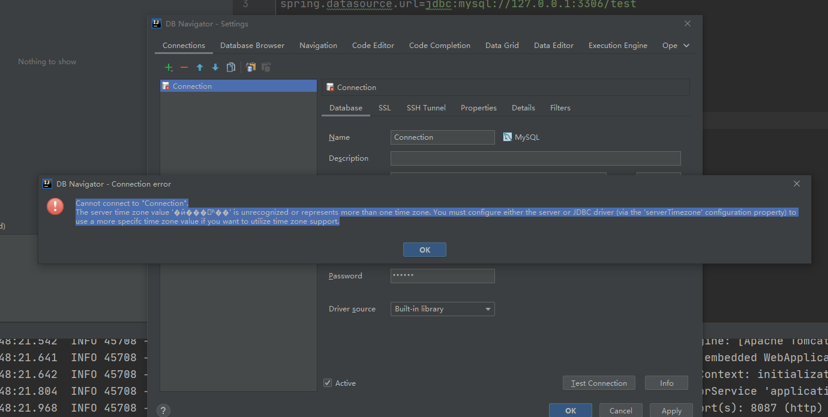

解决 set global time_zone='+8:00';



# MySQL可视化工具之Navicat for MySQL破解：

# <https://blog.csdn.net/pc915968220/article/details/100763987>

1. 解决Navicat for MySQL 连接 Mysql 8.0.11 出现1251- Client does not support authentication protocol 错误：

https://blog.csdn.net/seventopalsy/article/details/80195246