This is very simple if you used your pem file ( I am using MacOS / windows user can follow the same steps.)

1. Just download your [FileZilla](https://filezilla-project.org/download.php?type=client) (I'm using MacOS - and downloaded free version, that's good enough)

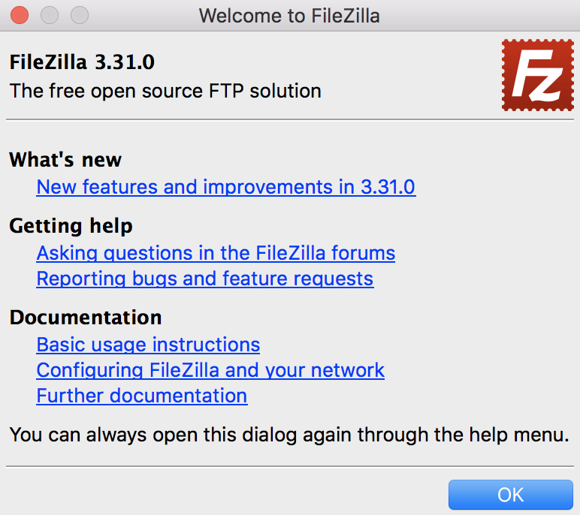

1. Open **Site Manager** in FileZilla (⌘S) -> **New Site**

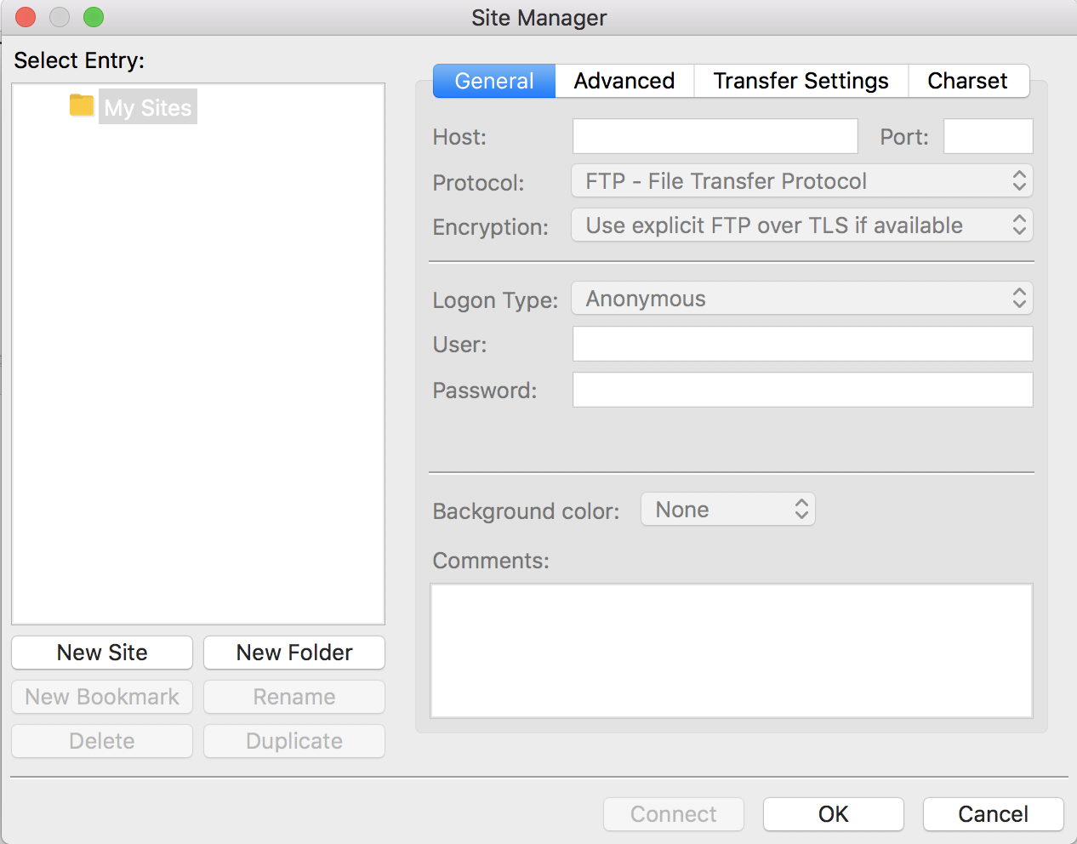

1. Put your host name in the **Host** field.

Example: eca-**-**-**-111.ap-southwest-9.compute.amazonaws.com

* Select Protocol as **SFTP - SSH File Transfer Protocol**
* Select Logon type as **Key File**
* Put your user name in the **User** field : for me it's **ubuntu** ([find your ssh user](https://docs.aws.amazon.com/AWSEC2/latest/UserGuide/managing-users.html))

Note:

**OS vs Username**

Amazon - ec2-user

Centos - centos

Debian - admin or root

Fedora - ec2-user

RHEL - ec2-user or root

SUSE - ec2-user or root

Ubuntu - ubuntu or root

1. For Key file field, browse your pem file: and **click Connect**

[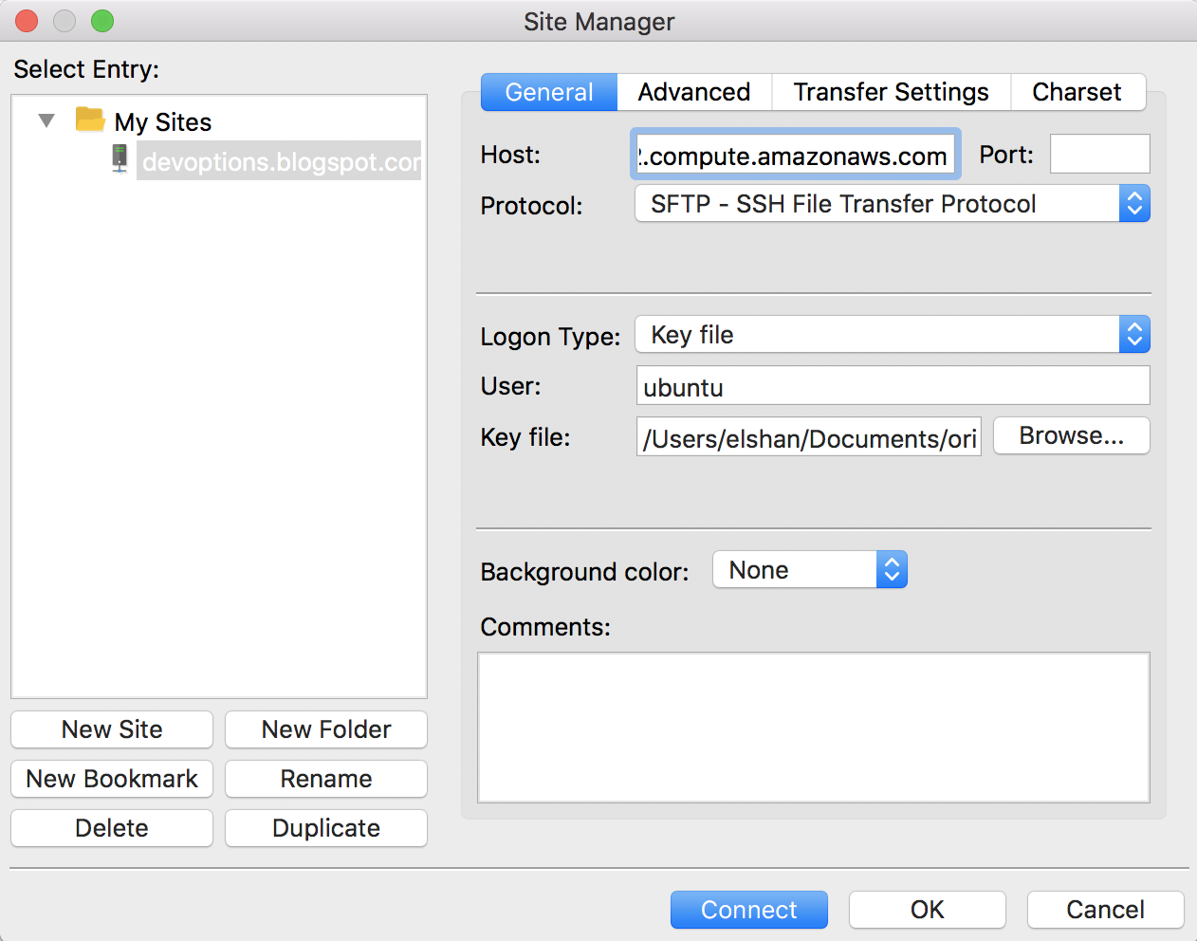](https://i.stack.imgur.com/PbfPO.png)

**Note:**

**(Remember to allow SSH connection to your IP address from EC2)** If not you will get connecting error message!

Note: Allowing your IP to connect your aws instance via SFTP

EC2 -> SecurityGroups -> SSH -> Inbound rules -> Edit -> Add Rule ( SSH|TCP|22|My IP(it's get ip automatically | name for rule) -> Save