함수 실행순서

fetch_reviews()

f = open(input_save_path(), 'w', *encoding*='utf-8')

result_list = fectch_score_result(URL)

code = split_url()

함수 설명

def split_url():

url = input('url을 입력하세요')

code_str = re.search('code=[0-9]*', url).group()

code = re.search('[0-9]+', code_str).group()

return code

ㅇㄴㄹ

ㄴㅇㄹ

ㅇ

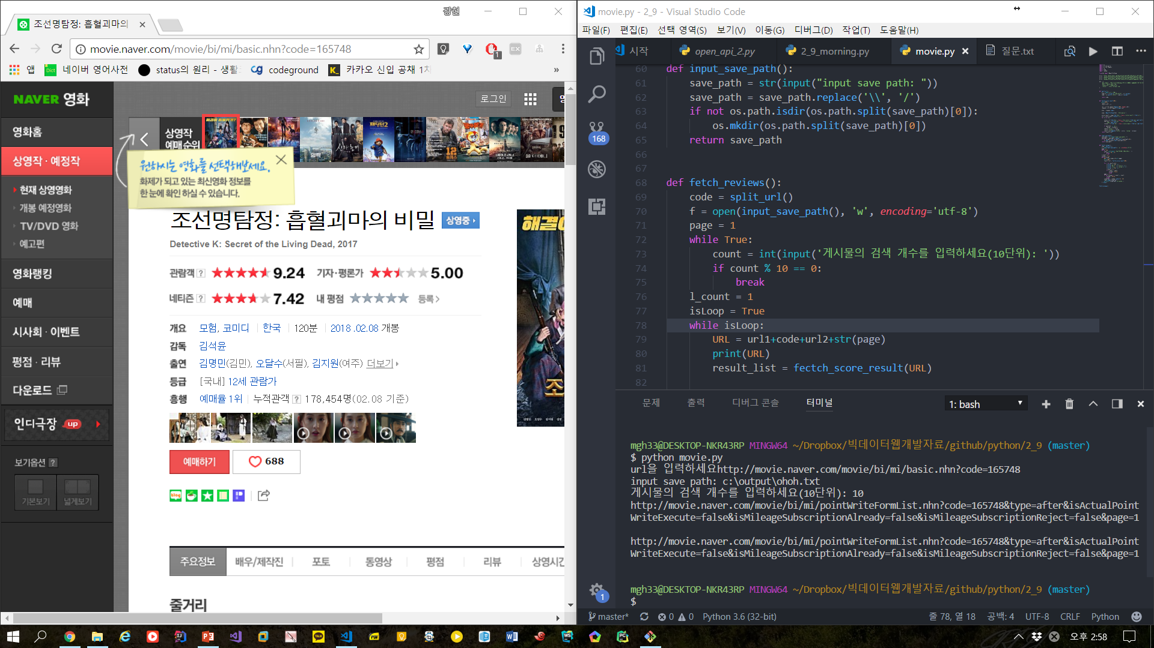

ㄹ