Name: Junyang Xin

NID: N11176767

1. 1) Tow trees

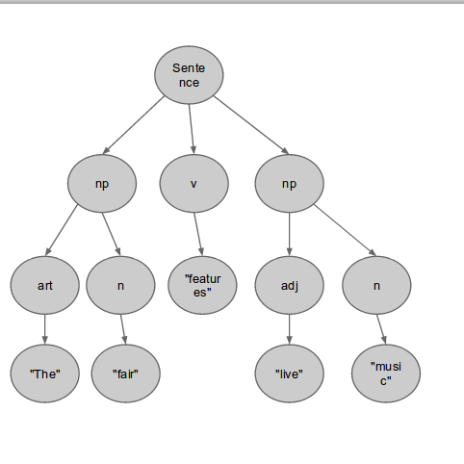

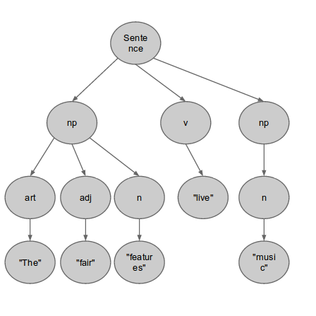

2) Suggested constraint: Distinguish between transitive and intransitive verbs. This can be achived by adding rules to the grammar to enforce that transitive verbs can subcategorize for an NP or a non-finite VP, while intransitive verbs can only subcategorize for a non-finite VP or a PP. In the example provided, 'features' is a transitive verb, and 'live' when considered a verb is an intransitive verb, and what follows 'live' is a noun 'music', thus the ambiguity can be resolved by this constraint.

2. 1) Top-Down Backtracking - sentence:1, np:4

Chart Parser - sentence:1, np:3

2) Top-Down Backtracking - sentence:3, np:5

Bottom-Up - sentence:7, np:6

Chart Parser - sentence:3, np:3

3. Modified grammar:

sentence := threeSgNp v | nonThreeSgNp vs | X1 | X2;

X1 := threeSgNp v threeSgNp | threeSgNp v nonThreeSgNp ;

X2 := nonThreeSgNp vs threeSgNp | nonThreeSgNp vs nonThreeSgNp ;

threeSgNp := n | art n | adj n | art adj n;

nonThreeSgNp := ns | art ns | adj ns | art adj ns;

And the dictionary file has the content below:

/\*\*\*\*\*\*\*\*\*\*\*\*Separating Line\*\*\*\*\*\*\*\*\*\*\*\*\*\*/

my,, cat = art;

the,, cat = art;

old,, cat = adj;

young,, cat = adj;

cat,, cat = n;

cats,, cat = ns;

mouse,, cat = n;

mice,, cat = ns;

chase,, cat = vs;

chases,, cat = v;

with,, cat = p;

relish,, cat = n;

play,, cat = vs;

plays,, cat = v;

football,, cat = n;

footballs,, cat = ns;

fair,, cat = n;

fair,, cat = adj;

answers,, cat = v;

answer,, cat = vs;

answers,, cat = ns;

answer,, cat = n;

questions,, cat = ns;

question,, cat = n;

questions,, cat = v;

question,, cat = vs;

lives,, cat = v;

live,, cat = vs;

live,, cat = adj;

music,, cat = n;

features,, cat = v;

feature,, cat = vs;

features,, cat = ns;

feature,, cat = n;

/\*\*\*\*\*\*\*\*\*\*\*\*Separating Line\*\*\*\*\*\*\*\*\*\*\*\*\*\*/

Using this new grammer and dictionary, the parse of "The fair answers questions" only returns one parse which is consistent with the subject-verb number agreement.

4. J&M excercise 5.1

1. Atlanta should be tagged as NNP

2. dinner should be tagged as NN

3. have should be tagged as VBP

4. Can should be tagged as MD