FINS5545 FINANCIAL MARKET DATA LITERACY | PROJECT B

MarketReady Funds
Systematic multi-asset funds with coverage-aware news sentiment
z5603162 | Source sample: 1 January 2020 to 31 December 2023
Out-of-sample fund evidence: 1 January 2021 to 31 December 2023

Executive summary
MarketReady Funds turns the course equity, crypto, and headline datasets into 12 separately investable systematic products and a decision-focused Streamlit interface. The product covers three asset families and four portfolio rules, so investors can separate a choice about market exposure from a choice about portfolio construction. All reported fund returns are walk-forward, allow holdings to drift between monthly rebalances, and deduct 5 basis points per unit of realised turnover. They are net of that estimated trading cost but before management fees, taxes, spreads, and market impact.
Audited headline results: Crypto Minimum Variance records the highest Sharpe ratio (1.03) but also a 71.9% maximum drawdown. Combined Risk Parity delivers a 0.89 Sharpe ratio with a 19.5% drawdown. The finance-extended VADER model changes 3.2% of headline scores, but the lagged signal's one- and five-day mean rank ICs are only 0.006 and -0.002. Its equity tilt reduces Sharpe from 0.722 to 0.695, while improving maximum drawdown by 0.46%.
The main economic result is not that optimisation always wins. Equity Equal Weight produces a 0.82 Sharpe ratio, ahead of the three optimised equity funds. Mean-sensitive Maximum Sharpe is the weakest equity rule. By contrast, the Combined Risk Parity fund balances the high upside of crypto against its large losses more effectively than the other combined products. These comparisons support a product range rather than a single claimed winner.
The sentiment extension is deliberately reported as a negative result. Its near-zero rank correlations and non-positive high-minus-low spreads do not support a profitable cross-sectional ranking in this sample; higher turnover then adds cost. The app therefore presents sentiment as an analytic with explicit coverage, not as a promise of alpha or a forecast.

1. Product, investor, and data scope

The product
MarketReady Funds is aimed at a financially literate self-directed investor who wants rules-based diversification but needs to understand the evidence before allocating. The investable object is each fund, defined by one asset family and one portfolio method. Management could charge a fee on assets in those funds; the prototype does not process orders or money. Its value is transparent comparison: the same metrics, information clock, transaction-cost rule, and visual language apply to every product.

Investor journey
- Compare. Filter the 12-fund marketplace and compare risk-adjusted growth.
- Inspect. Open a fact sheet with return, risk, drawdown, and current targets.
- Allocate. Combine up to five funds and simulate a normalized historical mix.
- Contextualise. Read sector news tone beside coverage and the fusion diagnostic.

Data foundation and provenance
Table 1. Inputs retained for Station 3. Dates are capped at 31 December 2023. Source: FINS5545 provided bundle and author calculations.
Input | Retained rows | Frequency | Use in Part B
Equity prices | 50,300 | Equity trading days | 50 adjusted-close return series
Crypto prices | 14,610 | Seven days per week | 10 native-calendar return series
Unique headlines | 146,836 | Event dates | 146,830 alignable headlines scored

The ETL preserves genuine extreme returns and removes only key duplicates and rows outside the stated sample. Equity and crypto returns are computed inside ticker on their native calendars. Crypto returns are then left-joined to equity dates for the combined funds, intentionally excluding weekend-only moves rather than differencing price levels after a calendar merge. Six year-end headlines cannot map to a later 2023 trading day, leaving 146,830 scored observations.

2. Fund construction and the information clock
The first live weight is formed only after a full trailing estimation window. Equity and combined funds start on 4 January 2021 after 252 equity observations; crypto funds start on 1 January 2021 after 365 native-calendar observations. The first observed date of each month is a rebalance. If t is a rebalance date, every return used to estimate its target ends strictly before t.
target weights at t = model(returns from t - window through t - 1)
Table 2. Walk-forward fund specifications. Annualisation matches the asset calendar; caps are per asset. Source: author design.
Family | Assets | Window | Annualisation | Max weight | Live start
Equity | 50 | 252 | 252 | 15% | 2021-01-04
Crypto | 10 | 365 | 365 | 35% | 2021-01-01
Combined | 60 | 252 | 252 | 12% | 2021-01-04

Four portfolio rules
Equal Weight is a transparent baseline. Minimum Variance minimises forecast portfolio variance. Maximum Sharpe maximises expected excess return per unit of volatility with a zero risk-free rate. Risk Parity minimises differences between assets' variance contributions. All targets are long-only and fully invested. To reduce estimation noise, annualised means are shrunk 50% toward the cross-sectional mean and the sample covariance is shrunk 10% toward its diagonal. Assets need at least 80% of the trailing window; any remaining gaps would be filled by that asset's window mean. Combined moments use already-computed crypto daily returns observed on equity dates and are annualised at 252 periods; crypto-only moments use the full seven-day series and 365.

Execution and validation
After each monthly trade, asset weights drift with relative returns until the next rebalance. Turnover is one half of the absolute difference between the new target and the actual pre-trade weights. A cost of 5 basis points per unit of that turnover is deducted on the rebalance date. This model is more realistic than holding target weights constant every day, but it still omits spreads, market impact, taxes, fees, and capacity limits. Reported 'net' results refer only to this estimated trading-cost deduction; no management fee is included.
Reproducibility gate: The final pipeline passes 23 of 23 checks covering unique keys, first-return boundaries, forward-only headline alignment, 12 fund identities, long-only weights summing to one, strict estimation timing, method differentiation, solver reliability, sentiment bounds, signal-calendar coverage, risk-contribution reconciliation, annual outputs, and fusion weights. Across 1,129,320 repeated estimation-window cells, 0 are mean-filled and no asset-window fails the 80% coverage rule. There are 1 solver fallback event(s). On failure or a non-finite SLSQP solution, the same cap is applied to inverse variance for Minimum Variance, positive mean divided by variance for Maximum Sharpe, or inverse volatility for Risk Parity.

3. Out-of-sample fund comparison
Table 3. Out-of-sample fund performance after 5 basis points per unit of realised turnover but before management fees. Return is the annualised arithmetic mean; volatility uses the matching 252- or 365-period calendar; Sharpe assumes a 0% risk-free rate; turnover is average realised monthly turnover. Source sample: 2020-2023; live period: 2021-2023. Source: author calculations.
Fund | Return | Vol. | Sharpe | Max DD | Turnover
Equity Equal Weight | 13.2% | 16.1% | 0.82 | -20.3% | 2.7%
Equity Maximum Sharpe | 6.6% | 15.8% | 0.42 | -20.9% | 27.3%
Equity Minimum Variance | 6.4% | 12.6% | 0.51 | -15.4% | 12.8%
Equity Risk Parity | 10.5% | 14.5% | 0.72 | -18.5% | 3.2%
Crypto Equal Weight | 67.8% | 81.9% | 0.83 | -81.6% | 5.9%
Crypto Maximum Sharpe | 44.5% | 76.2% | 0.58 | -83.2% | 20.1%
Crypto Minimum Variance | 75.6% | 73.1% | 1.03 | -71.9% | 11.3%
Crypto Risk Parity | 68.9% | 79.9% | 0.86 | -79.9% | 6.4%
Combined Equal Weight | 16.4% | 21.6% | 0.76 | -27.9% | 3.9%
Combined Maximum Sharpe | 12.1% | 18.5% | 0.65 | -20.1% | 28.0%
Combined Minimum Variance | 6.5% | 12.5% | 0.52 | -15.7% | 12.2%
Combined Risk Parity | 14.4% | 16.2% | 0.89 | -19.5% | 3.8%

Table 3 separates high return from usable risk. Crypto Minimum Variance leads the Sharpe ranking at 1.03 and compounds $1 to $4.31, but its 71.9% maximum drawdown is outside a conventional balanced-investor tolerance. Crypto therefore supplies the largest upside and the largest path risk. Annualised arithmetic returns should not be mistaken for CAGRs; volatility drag makes that distinction material for crypto.
Combined Risk Parity is the strongest combined product, with a 0.89 Sharpe ratio, 14.4% annualised return, and -19.5% maximum drawdown. It outperforms Combined Equal Weight on Sharpe because its volatility-based targets keep crypto near a single-digit to low-teens family weight. Combined Minimum Variance suppresses volatility further but gives up too much return over this live sample. A 1.0% annual management fee would reduce Combined Risk Parity's reported return to 13.4% and Sharpe to 0.82; it remains the highest-Sharpe combined fund under that simple fee sensitivity.
Within equities, the simple Equal Weight fund has the highest Sharpe ratio (0.82). Maximum Sharpe ranks last at 0.42 and carries the highest average equity turnover. The result is consistent with noisy mean estimates: optimising a ratio built on expected returns can amplify sampling error even after shrinkage. The comparison argues for showing several rules and their costs rather than presenting the in-sample objective as an investor guarantee.

4. Growth paths: asset family dominates method
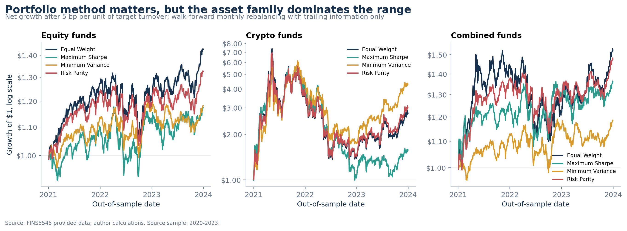
Figure 1. Growth of $1 for four monthly walk-forward methods in equity, crypto, and combined families, after 5 basis points per unit of realised turnover and before management fees. Log scales allow proportional comparison. Live period: 2021-2023. Source: FINS5545 data and author calculations.
Figure 1 shows that the choice of asset family creates a wider range of outcomes than the choice of optimiser. Equity and combined products finish in a relatively narrow band, while crypto paths rise rapidly in 2021, lose most of those gains through 2022, and only partly recover in 2023. A terminal value alone would hide that sequence.
Minimum Variance is the clear crypto leader at the sample end, but it still spends a long period more than 60% below its prior peak. Within equities, Equal Weight and Risk Parity recover more strongly than the two moment-optimised alternatives. Within the combined family, Risk Parity offers the best return-risk compromise, while Equal Weight accepts the larger crypto allocation mechanically created by one weight per asset.
Annual results in Table 10 make the regime dependence explicit. Combined Risk Parity returns 37.3% in 2021, -6.8% in 2022, and 15.5% in 2023; Crypto Minimum Variance moves from 328.1% to -59.3% and then 147.2%. Method rankings vary by year, but the core conclusions remain: crypto drives the widest outcomes, Risk Parity limits its combined-fund influence, and no three-year Sharpe ranking is a forecast of the next regime.

5. Downside experience is part of the product
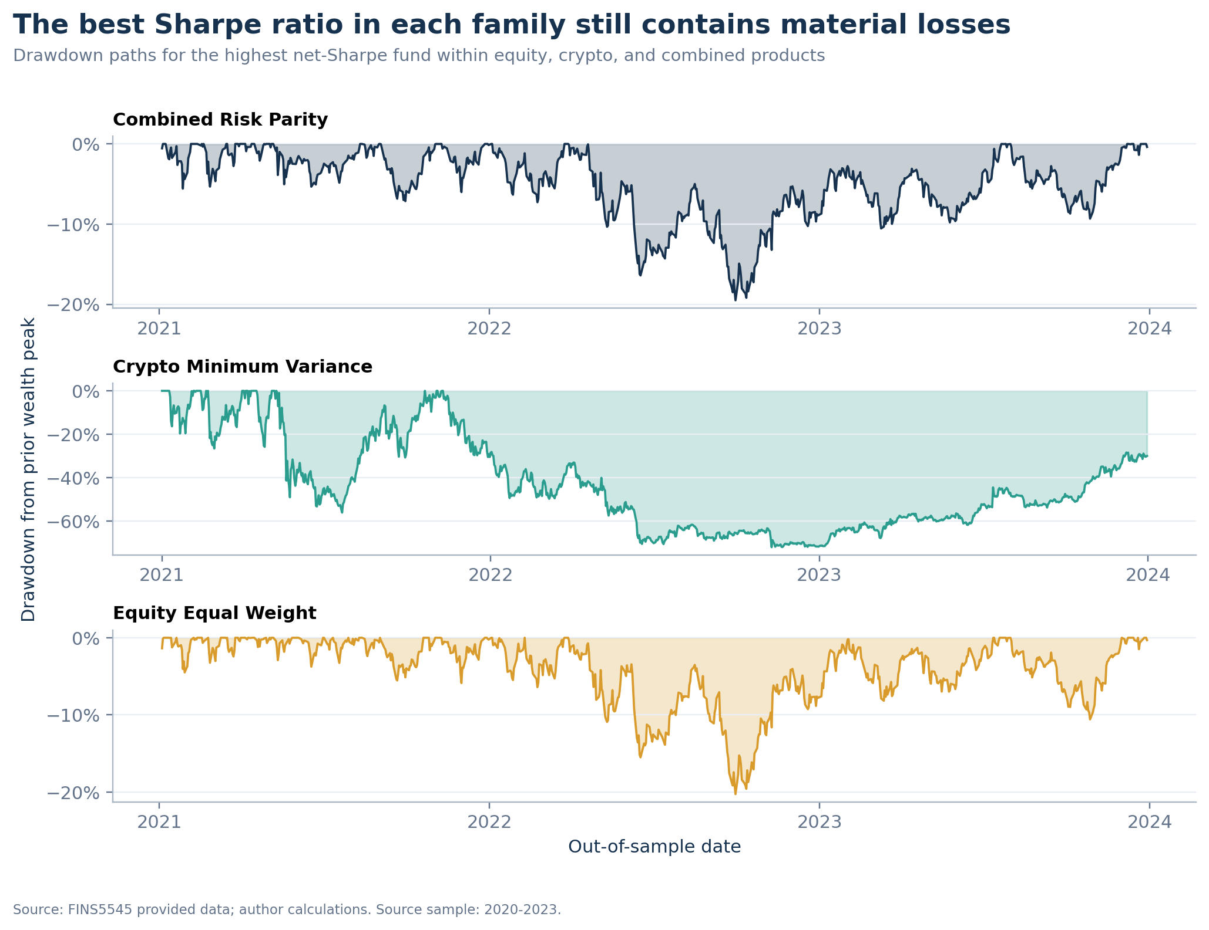
Figure 2. Drawdown from the prior wealth peak for the highest-Sharpe fund in each family. Live period: 2021-2023. Source: FINS5545 data and author calculations.
Figure 2 changes the product conclusion. Combined Risk Parity and Equity Equal Weight both lose roughly one fifth from peak to trough, while Crypto Minimum Variance falls more than 70%. Crypto's Sharpe ratio above one does not make its loss experience moderate. The high annualised mean and extreme drawdown coexist because the series is highly volatile and path dependent.
For the target user, maximum drawdown is easier to translate into a funding decision than volatility alone. A 72% loss requires a subsequent gain of about 257% to recover. That arithmetic is why MarketReady Funds exposes drawdown in every fact sheet and why the allocation lab does not default to the single highest-Sharpe fund. A fund range should let investors express different loss tolerances rather than collapse the choice to a leaderboard.

6. Targets, drift, and fact sheets
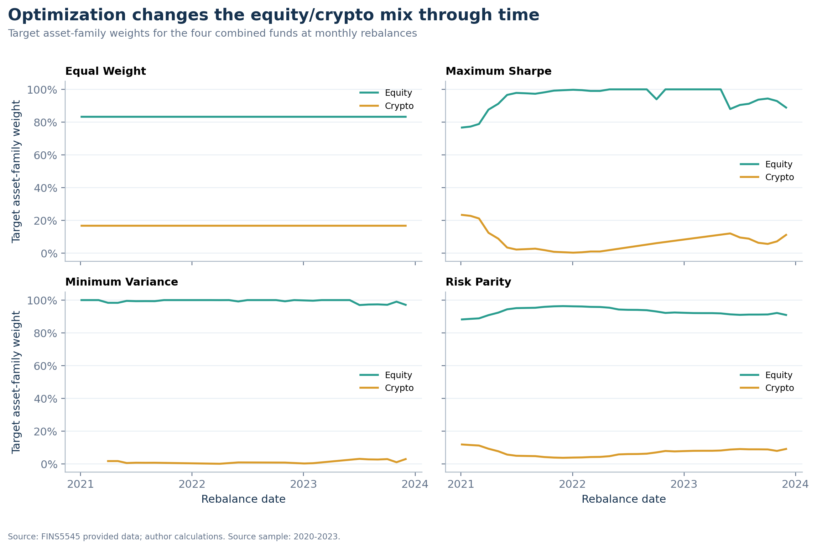
Figure 3. Target equity and crypto family weights for the four combined funds at monthly rebalances. Values between rebalances drift with returns and are not shown. Live period: 2021-2023. Source: author calculations.
Figure 3 shows capital allocation, but capital weight is not risk weight. The diagnostic below uses each rebalance's same 252-period, diagonally shrunk combined covariance matrix to decompose target variance into equity and crypto components.
Table 4. Combined-fund target diagnostics across 36 monthly rebalances. Capital and covariance-risk figures are medians; the capital range is in parentheses. Effective holdings are 1/HHI. Source: author calculations.
Method | Crypto capital | Crypto risk | Effective N | Top 5 | Turnover
Equal Weight | 16.7% (16.7%-16.7%) | 38.4% | 60.0 | 8.3% | 3.9%
Minimum Variance | 0.0% (0.0%-3.0%) | 0.0% | 12.0 | 54.7% | 12.2%
Maximum Sharpe | 1.4% (0.0%-23.3%) | 4.1% | 10.5 | 60.0% | 28.0%
Risk Parity | 7.6% (3.7%-11.8%) | 16.7% | 49.6 | 16.2% | 3.8%

Table 4 explains why the methods behave differently. Equal Weight puts 16.7% of capital in crypto but a median 38.4% of estimated variance comes from crypto. Risk Parity uses median crypto capital of only 7.6% and holds its family risk share at 16.7%: 10 of 60 equal asset-level risk budgets. Maximum Sharpe is visibly less stable: crypto capital ranges from 0.0% to 23.3%, its median effective holdings fall to 10.5, its top five positions hold 60.0%, and average turnover is 28.0%. These are sample diagnostics of mean-sensitive concentration, not forecasts of future instability.

Twelve consistent fact sheets
Each app fact sheet joins the fund's live growth and drawdown path to annualised return, annualised volatility, Sharpe ratio, maximum drawdown, ending value, and the complete latest target portfolio. Combined fact sheets also show capital versus covariance-risk share and concentration. The latest three largest holdings for every fund are audited in Table 7. Full targets remain downloadable from the app and in results/data/fund_weights.csv. This design keeps the report comparative while letting the product serve position-level detail on demand.

7. Sector sentiment: tone must be read beside coverage
VADER 3.3.2 scores each original headline without lowercasing or removing punctuation, negation, boosters, or capitalisation. Those features are inputs to the model, not formatting noise. Its compound score bounds the adjusted valence sum x as follows (Hutto and Gilbert, 2014):
compound = x / sqrt(x^2 + 15)
The finance extension adds 20 reviewed words, 9 reviewed phrases, and 5 intensity modifiers from the Week 8 ten-rater exercise. The code snapshots and restores VADER's module dictionaries so repeated runs do not contaminate the baseline. Headline scores are averaged within ticker-day first; observed ticker-day means are then equally weighted within sector. No-news observations remain missing in the headline index, while a separate neutral-fill series multiplies observed tone by ticker coverage.
The finance extension changes 3.2% of scores and reduces the share classified as neutral from 49.5% to 48.7%. Table 13 reports the full distribution. This is dictionary-coverage evidence, not an accuracy claim, because no labelled finance-headline test set is available.
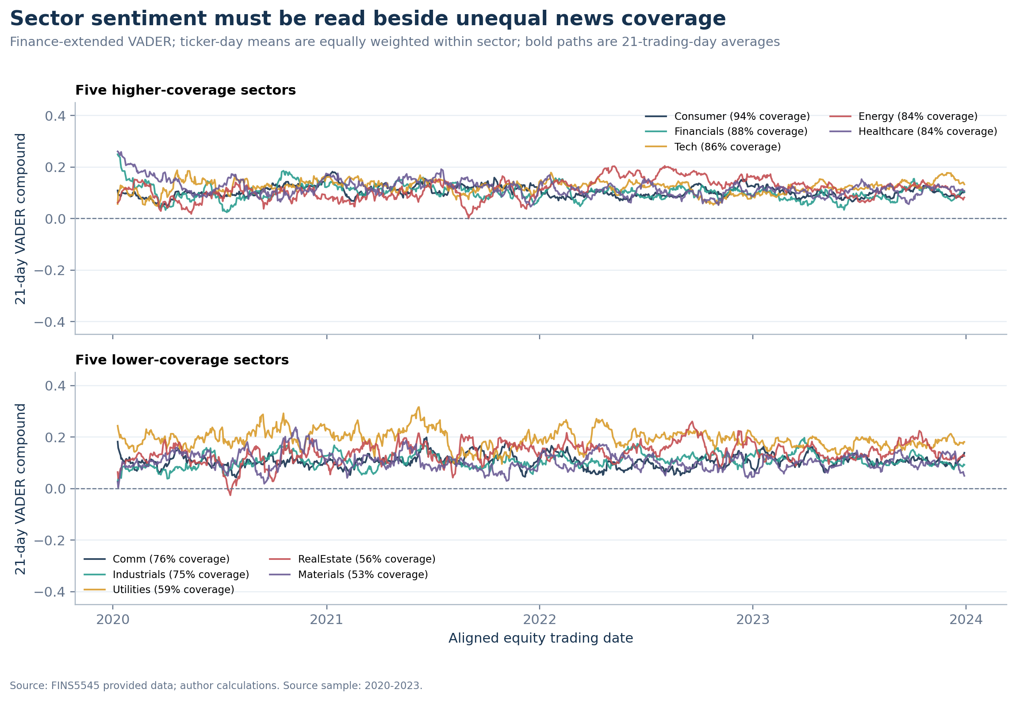
Figure 4. Twenty-one-trading-day mean finance-extended VADER compound score by equity sector, split by average ticker-news coverage. Index dates: 2020-2023. Source: FINS5545 headlines and author calculations.
Table 5. Cross-sectional validation of the effective lagged ticker signal against future equity returns. IC is the daily Spearman rank correlation; H-L is the equal-weight top-minus-bottom sentiment quintile return in basis points. HAC t-statistics use horizon minus one lag. Signal dates match the live equity fund period, 2021-2023. Source: author calculations.
Horizon | Mean IC | IC t | H-L (bp) | H-L t | IC > 0
1 day | +0.006 | +0.92 | -0.04 | -0.01 | 51.3%
5 days | -0.002 | -0.20 | -4.72 | -0.37 | 47.5%

Figure 4 is therefore a descriptive tone index, not evidence of return predictability. Table 5 finds a one-day mean IC of 0.006 (HAC t=0.92) and a five-day IC of -0.002 (t=-0.20). The high-minus-low spread is -0.04 bp at one day and -4.72 bp at five days. These tests do not show an economically or statistically persuasive positive ranking relation in this sample; the five-day observations overlap, so its HAC result remains descriptive.

8. Fusion extension: an informative negative result
The fusion starts from Equity Risk Parity. For each ticker, the model forms a 21-trading-day mean headline score, lags both tone and coverage by one trading day, standardises available tone across tickers, and scales the z-score by the square root of lagged coverage. At each monthly rebalance, the base target is multiplied by exp(0.30 times the effective signal) and projected back to the long-only 15% cap. Saturday and Monday headlines aligned to Monday can therefore first influence Tuesday; a Monday rebalance never uses Monday coverage.
Table 6. Before-and-after equity sentiment fusion after 5 basis points per unit of realised turnover and before management fees. Live period: 2021-2023. Source: author calculations.
Strategy | Return | Vol. | Sharpe | Max DD | Turnover
Base risk parity | 10.5% | 14.5% | 0.722 | -18.5% | 3.2%
Coverage-aware tilt | 10.1% | 14.5% | 0.695 | -18.0% | 11.5%

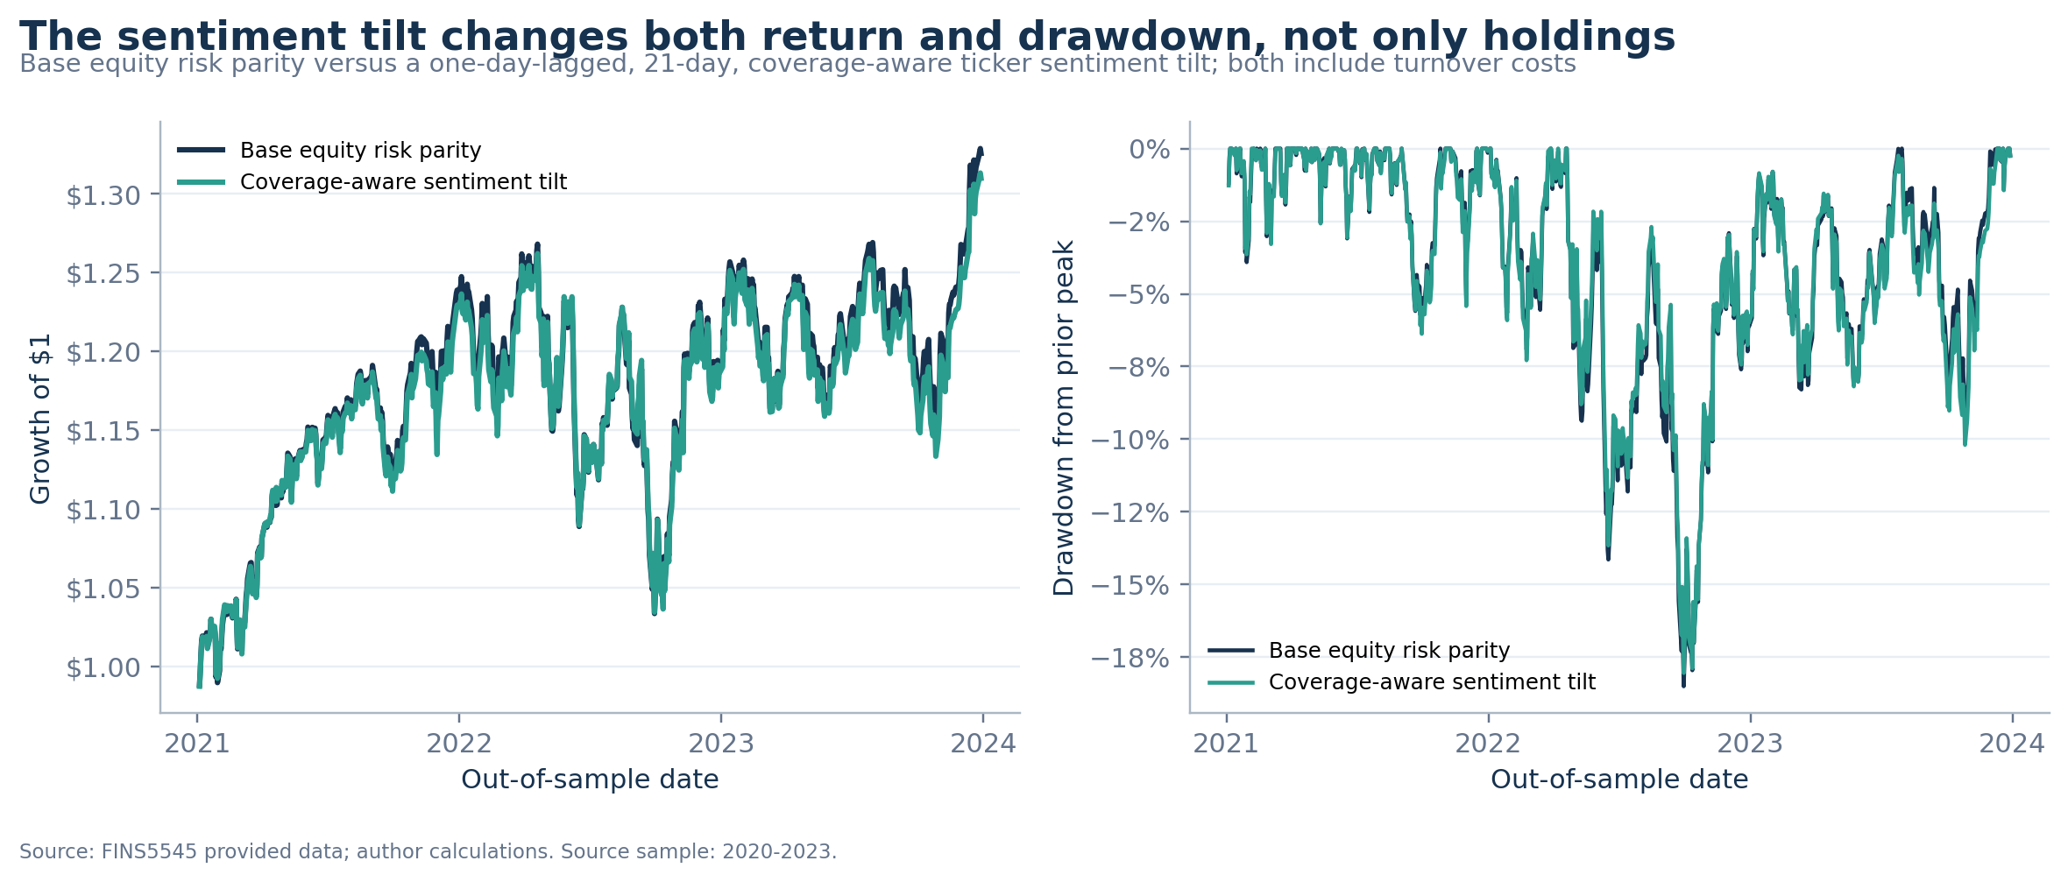
Figure 5. Growth and drawdown for Equity Risk Parity before and after the one-day-lagged, coverage-aware sentiment tilt. Both strategies include turnover costs. Live period: 2021-2023. Source: author calculations.
Table 6 and Figure 5 reject a simple alpha story in this sample. The tilt lowers annualised return by 0.40%, lowers Sharpe by 0.026, and raises average monthly turnover from 3.2% to 11.5%. Maximum drawdown improves by 0.46%. Before trading costs, the return gap is 0.36%; the tilt's incremental annual trading-cost drag is only 0.05%. The near-zero ICs and non-positive spreads therefore explain more of the underperformance than cost alone; turnover modestly worsens it.
The extension still adds product value: it demonstrates a complete, auditable use of unstructured data with an explicit information clock, a reviewed domain lexicon, and a coverage control. Table 12 shows the conclusion is qualitatively stable: a half-strength 21-day tilt and a slower 42-day tilt also remain below the base Sharpe of 0.722. This is not a parameter search for a winner; the two alternatives are prespecified implementation checks. The app keeps sentiment as an analytic until labelled text validation and longer return evidence support promotion.

9. App implementation, reflection, and recommendations

A lightweight deployment architecture
The root Streamlit entrypoint reads committed CSV and JSON artifacts only. It does not download raw data, run VADER, solve an optimisation, or backtest on a viewer's machine. A cached loader validates required columns and dates before any page renders. Pure data helpers calculate current holdings and custom fund-level allocations; chart helpers apply one Plotly design system. URL query parameters preserve the active view, and every investor-facing table or simulated path can be downloaded. Combined fact sheets expose capital versus covariance-risk shares; the allocation lab aggregates latest targets to show equity-versus-crypto capital exposure, major equity sectors, top underlying holdings, effective holdings, and top-five concentration. All five views pass headless AppTest. The app is live on Streamlit Community Cloud and deployed from the main branch of the public GitHub repository.

What worked and what did not
The strongest fund result is diversification by risk rather than estimation of means. Combined Risk Parity converts a median 7.6% crypto capital allocation into a 16.7% crypto covariance-risk budget and a higher Sharpe ratio than the equity risk-parity base without inheriting crypto's full drawdown. Equal Weight is also difficult to beat within equities. These outcomes favour transparent rules and show why optimised objectives must be judged out of sample.
The finance lexicon reduces the share classified as neutral, but the project cannot claim better classification without labelled finance headlines. Coverage remains unequal: average ticker coverage is about 94% in Consumer and 53% in Materials. The return tests then find near-zero rank ICs and no positive high-minus-low spread. Three live fund years are also too short to distinguish a persistent relationship from one market regime.

Three real-world recommendations
- Keep Combined Risk Parity as the balanced flagship. Position it for diversified-growth investors able to tolerate a roughly 20% historical drawdown. Explain that 7.6% median crypto capital supplies 16.7% of estimated risk; do not default to Crypto Minimum Variance despite its Sharpe.
- Hold the sentiment tilt in research. Require a labelled headline validation sample, publisher and duplicate-event controls, and rolling parameter tests before any client capital follows it.
- Add implementation realism before accepting client capital. Quote trading-cost-adjusted and management-fee-adjusted returns separately, publish look-through overlap and concentration, and stress spreads, slippage, capacity, and rebalance timing before accepting client capital.

Conclusion
MarketReady Funds completes all four Data Factory Floor stages: a verified foundation, return and text features, walk-forward funds plus sentiment analytics, and a tested investor interface. The project produces a credible product range because it makes its negative results as visible as its strong ones. Twelve fact sheets, explicit timing, audited coverage, reproducible artifacts, and a lightweight deployed app are available through the live service and its public source repository.

References
FINS5545 Course Team. (2026). FinTech Project 2026 - FINS5545: Financial Market Data Literacy [Project brief and provided market/news data bundle]. UNSW Business School.
Hutto, C. J., and Gilbert, E. (2014). VADER: A parsimonious rule-based model for sentiment analysis of social media text. Proceedings of the International AAAI Conference on Web and Social Media, 8(1), 216-225. https://doi.org/10.1609/icwsm.v8i1.14550

Report basis
All numerical statements and exhibits in this report are generated from the committed results/data and results/tables artifacts. The reproducible build command is python scripts/run_part_b.py, followed by python scripts/build_report.py. The Word file is the editable source; the PDF is generated from the same content model.

Project links
Live app: https://marketready-funds-ustakylve9nywmyokqp4q4.streamlit.app/
Public GitHub repository: https://github.com/lgua9087/marketready-funds
The live app is deployed from the repository's main branch with streamlit_app.py at the repository root.

Appendix A. Risk-adjusted ranking
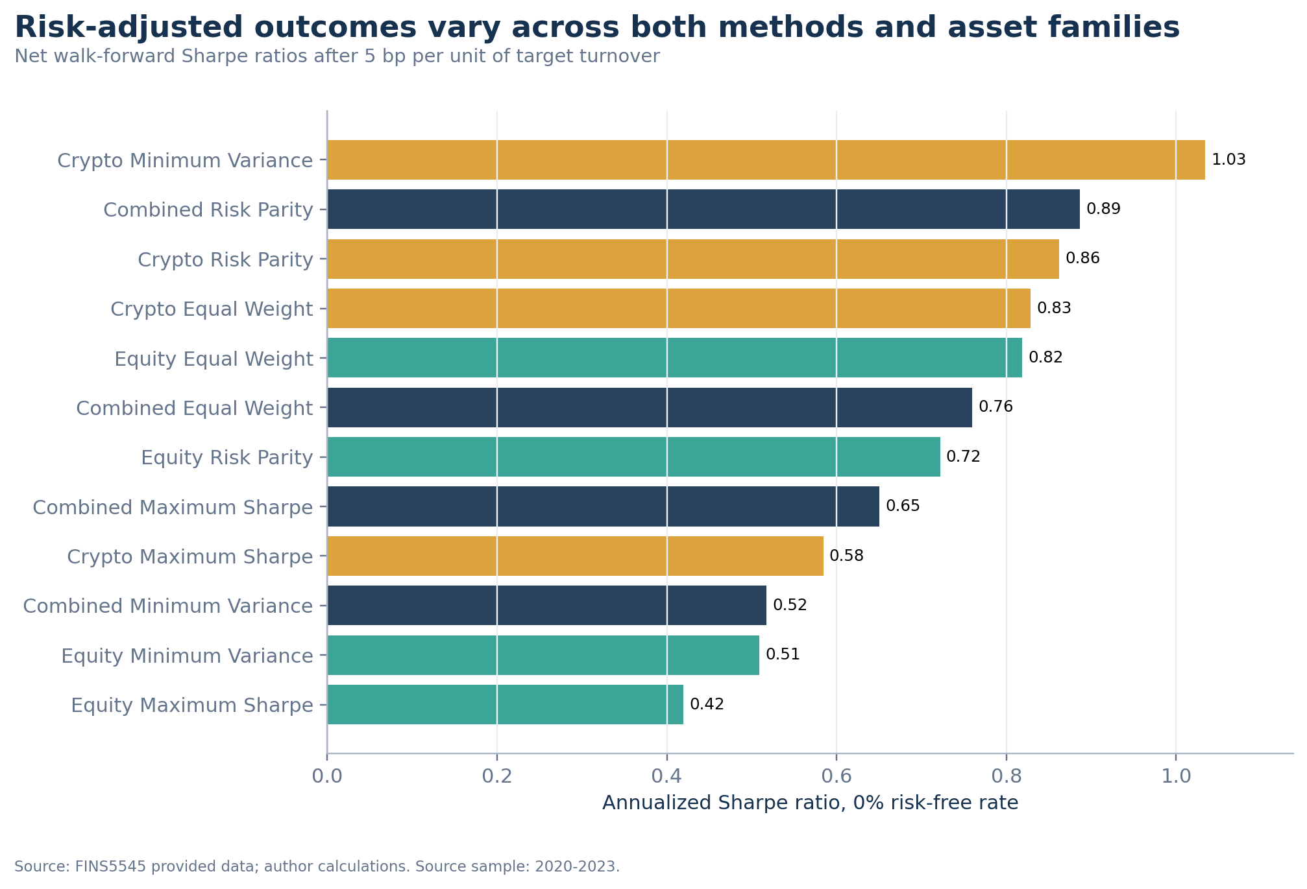
Figure 6. Annualised Sharpe ratio for all 12 funds after 5 basis points per unit of realised turnover and before management fees, using a 0% risk-free rate. Live period: 2021-2023. Source: FINS5545 data and author calculations.
Figure 6 confirms that no single optimisation method dominates across families. Minimum Variance leads crypto, Risk Parity leads combined funds, and Equal Weight leads equities. The ranking is consistent with the report's recommendation to sell a range of clearly differentiated products rather than one universal rule.

Appendix B. Latest holdings summary
Table 7. Three largest target positions for every fund at its latest 2023 rebalance. Full holdings and exact weights are in results/data/fund_weights.csv and the app fact sheets. Source: author calculations.
Fund | Target date | Three largest targets
Combined Equal Weight | 2023-12-01 | ABBV 1.7%; ABT 1.7%; ADBE 1.7%
Combined Maximum Sharpe | 2023-12-01 | SO 12.0%; NVDA 12.0%; GE 12.0%
Combined Minimum Variance | 2023-12-01 | KO 12.0%; WMT 12.0%; MRK 10.6%
Combined Risk Parity | 2023-12-01 | MRK 3.8%; ABBV 3.7%; WMT 3.4%
Crypto Equal Weight | 2023-12-01 | ADA-USD 10.0%; BCH-USD 10.0%; BTC-USD 10.0%
Crypto Maximum Sharpe | 2023-12-01 | BTC-USD 35.0%; TRX-USD 35.0%; ETH-USD 16.0%
Crypto Minimum Variance | 2023-12-01 | BTC-USD 35.0%; TRX-USD 35.0%; ETH-USD 26.9%
Crypto Risk Parity | 2023-12-01 | TRX-USD 15.5%; BTC-USD 13.3%; ETH-USD 11.7%
Equity Equal Weight | 2023-12-01 | ABBV 2.0%; ABT 2.0%; ADBE 2.0%
Equity Maximum Sharpe | 2023-12-01 | GE 15.0%; SO 15.0%; NVDA 14.7%
Equity Minimum Variance | 2023-12-01 | KO 15.0%; WMT 15.0%; MRK 10.3%
Equity Risk Parity | 2023-12-01 | MRK 4.1%; ABBV 3.9%; WMT 3.8%

Appendix C. Validation and source integrity
Table 8. Critical pipeline validation results. Every check must pass before artifacts are written. Source: automated author tests.
Validation check | Passed
Equity ticker-date keys are unique | Yes
Crypto ticker-date keys are unique | Yes
News ticker-date-title keys are unique | Yes
First equity return is missing within ticker | Yes
First crypto return is missing within ticker | Yes
Headline mapping never moves backward | Yes
Twelve fund products are present | Yes
Three fund families are present | Yes
Four methods per family are present | Yes
Fund weights sum to one | Yes
Fund weights are long-only | Yes
Every estimation sample ends before its rebalance | Yes
Portfolio methods produce distinct latest weights | Yes
Solver success rate is at least 95% | Yes
Ten sector sentiment indices are present | Yes
Sentiment scores remain inside minus one to one | Yes
Ticker signal dates cover the usable equity-return calendar | Yes
Fusion weights sum to one | Yes
Combined capital weights sum to one | Yes
Combined covariance risk contributions sum to one | Yes
Sentiment prediction tests cover one and five trading days | Yes
Annual fund results cover every fund in 2021 through 2023 | Yes
Fusion robustness includes base case and two prespecified alternatives | Yes

Table 9. Retained source-integrity checks after the mandatory sample cap and exact-key deduplication. Source: FINS5545 data and author calculations.
Check | Count | Treatment
Equity rows | 50,300 | retained after 2023 cutoff
Crypto rows | 14,610 | 10 rows after 2023 removed
Unique news headlines | 146,836 | ticker-date-title duplicates removed
Equity duplicate keys | 0 | must equal zero
Crypto duplicate keys | 0 | must equal zero
News duplicate keys | 0 | must equal zero
Nonpositive equity prices | 0 | must equal zero
Nonpositive crypto prices | 0 | must equal zero
Equity OHLC flags | 0 | must equal zero
Crypto OHLC flags | 0 | must equal zero
Rows removed after cutoff | 10 | mandatory sample cap
News duplicates removed | 2,847 | exact copied headlines only

Appendix D. Annual results
Table 10. Calendar-year total returns after the 5-basis-point trading-cost model and before management fees. Partial-year observations are not present; every fund has a full 2021, 2022, and 2023 live year. Source: author calculations.
Fund | 2021 | 2022 | 2023
Equity Equal Weight | 27.1% | -4.4% | 17.3%
Equity Maximum Sharpe | 10.0% | 2.6% | 4.0%
Equity Minimum Variance | 13.6% | 3.0% | 1.1%
Equity Risk Parity | 23.7% | -3.8% | 11.4%
Crypto Equal Weight | 257.2% | -61.0% | 99.0%
Crypto Maximum Sharpe | 300.3% | -73.9% | 51.0%
Crypto Minimum Variance | 328.1% | -59.3% | 147.2%
Crypto Risk Parity | 261.3% | -60.3% | 109.2%
Combined Equal Weight | 42.9% | -14.7% | 24.9%
Combined Maximum Sharpe | 26.1% | 3.5% | 4.4%
Combined Minimum Variance | 12.7% | 2.6% | 2.5%
Combined Risk Parity | 37.3% | -6.8% | 15.5%

Table 10 shows that no method wins every calendar year. The three-year product conclusions nevertheless survive the year split: crypto remains the widest-upside and deepest-downside family, while Combined Risk Parity participates in 2021 and 2023 gains with a materially smaller 2022 loss than Combined Equal Weight.

Appendix E. Assumption robustness
Table 11. Combined Risk Parity sensitivity. Trading-cost scenarios reprice realised turnover; management fees are charged continuously to the baseline 5-basis-point path. Returns are annualised arithmetic means. Live period: 2021-2023. Source: author calculations.
Scenario | Return | Sharpe | Max DD | Ending $1
Trading cost: 0 bp | 14.4% | 0.888 | -19.5% | $1.48
Trading cost: 5 bp; fee: 0% | 14.4% | 0.887 | -19.5% | $1.48
Trading cost: 10 bp | 14.3% | 0.885 | -19.5% | $1.48
5 bp cost + 0.5% annual fee | 13.9% | 0.856 | -19.7% | $1.45
5 bp cost + 1.0% annual fee | 13.4% | 0.825 | -19.9% | $1.43

Table 12. Prespecified sentiment-fusion implementation checks, all after 5 basis points per unit of realised turnover and before management fees. These are robustness checks, not a parameter search. Live period: 2021-2023. Source: author calculations.
Scenario | Return | Sharpe | Max DD | Turnover
Base equity risk parity | 10.5% | 0.722 | -18.5% | 3.2%
21-day signal, 0.15 tilt | 10.3% | 0.709 | -18.3% | 6.4%
21-day signal, 0.30 tilt (primary) | 10.1% | 0.695 | -18.0% | 11.5%
42-day signal, 0.30 tilt | 9.5% | 0.654 | -18.4% | 7.6%

Table 11 shows that doubling the trading-cost rate does not alter the combined-fund recommendation, while a 1% annual management fee reduces but does not reverse the flagship's Sharpe advantage. Table 12 shows every prespecified tilt variant below the equity Risk Parity base, so the research-only sentiment conclusion is qualitatively stable.

Appendix F. Text model and estimation audit
Table 13. Plain and finance-extended VADER distributions across 146,830 aligned headlines. Thresholds are positive >= 0.05, negative <= -0.05, and neutral otherwise. Source: vaderSentiment 3.3.2 and author extension.
Model | Mean | Positive | Neutral | Negative | Changed
Plain VADER | +0.106 | 37.5% | 49.5% | 13.0% | 0.0%
Finance-extended | +0.110 | 38.3% | 48.7% | 13.1% | 3.2%

Table 14. Return-data availability across repeated monthly estimation windows. Optimizer cells count overlapping window observations; exclusions count an asset-window failing the 80% rule. Source: automated author audit.
Family | Windows | Cells | Mean-filled | Share | Exclusions
Equity | 36 | 453,600 | 0 | 0.00% | 0
Crypto | 36 | 131,400 | 0 | 0.00% | 0
Combined | 36 | 544,320 | 0 | 0.00% | 0

Table 14 records zero return imputations and zero asset-window exclusions across 1,129,320 optimizer cells. The single fallback in Combined Maximum Sharpe on 3 October 2022 is therefore a solver event, not missing-data repair. Its positive-mean/variance fallback is normalized under the same long-only 12% cap.

