GAD Corner
Administrative User Manual
Municipality of Montalban (Rodriguez), Rizal

1. Introduction
Welcome to the GAD Corner Admin Panel. This user manual will guide you through managing the Gender and Development platform, from content updates to administrative oversight.

2. Authentication
Access the admin panel at /admin/login. Only authorized officers should possess credentials.
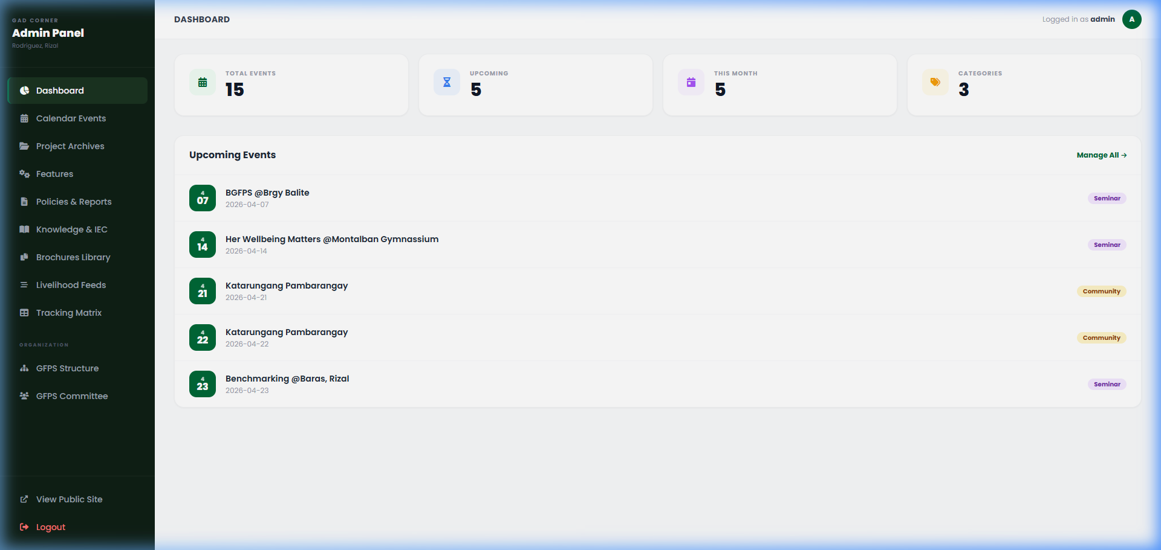
Figure 1: Admin Portal Login Dashboard Overview

3. Dashboard Overview
The dashboard provides real-time counts for events and keeps you informed about upcoming activities.

4. Site Features & Scraper Settings
Manage the homepage carousel and scraper configuration.
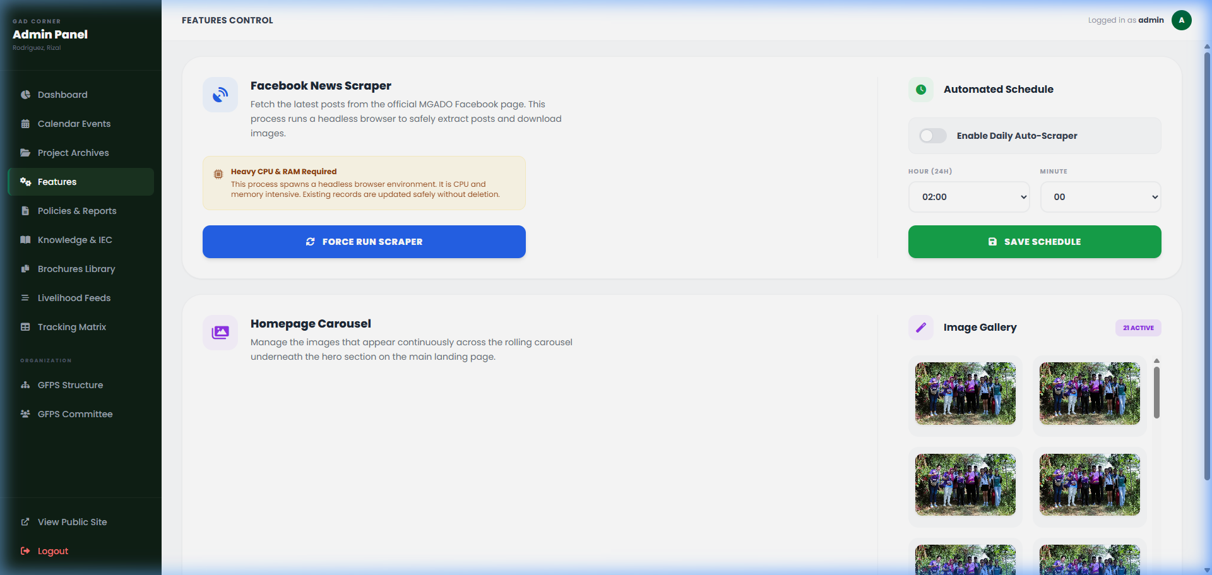
Figure 2: Site Features and Robot Scraper settings.

5. Policies Management
The policies module allows archiving Circulars, Memos, and Local Government Policies with dedicated years and categories.
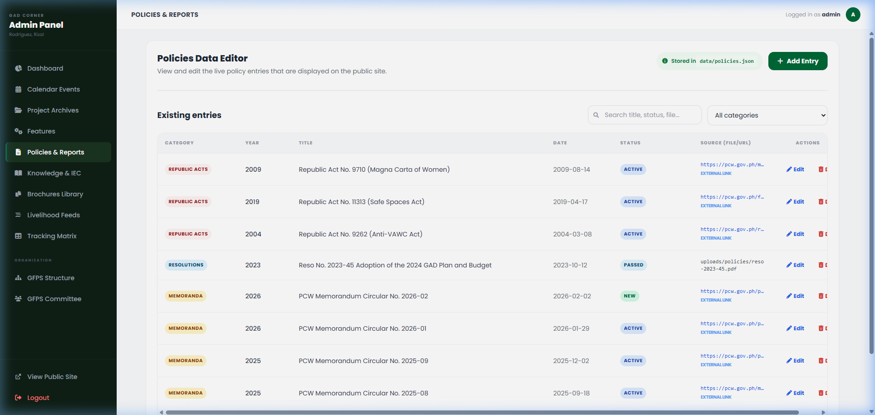
Figure 3: GAD Policy Management portal.

6. Calendar Management
Maintain a current list of activities for the public calendar.
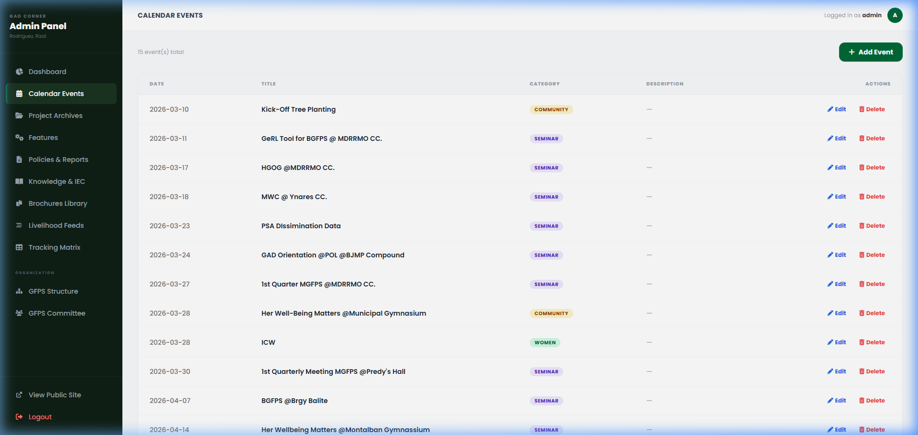
Figure 4: Calendar Event Creation Tool.

7. Project Archives
Track project progress across Proposed, Ongoing, and Completed stages.
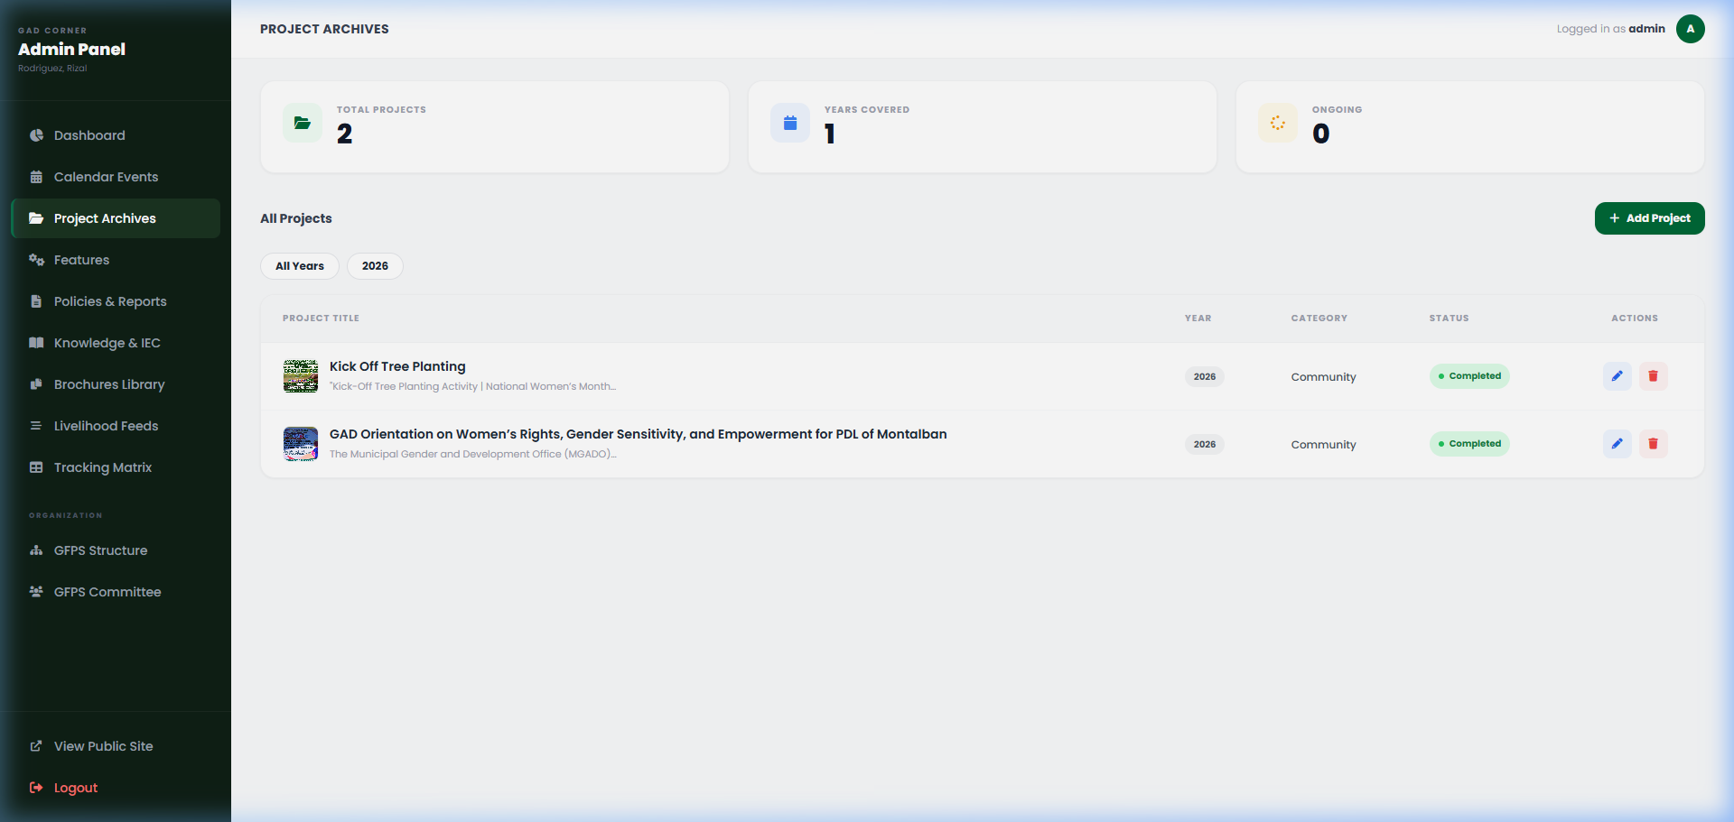
Figure 5: GAD Project Listing dashboard.

8. Knowledge Products
Distribute official reports and learning materials.
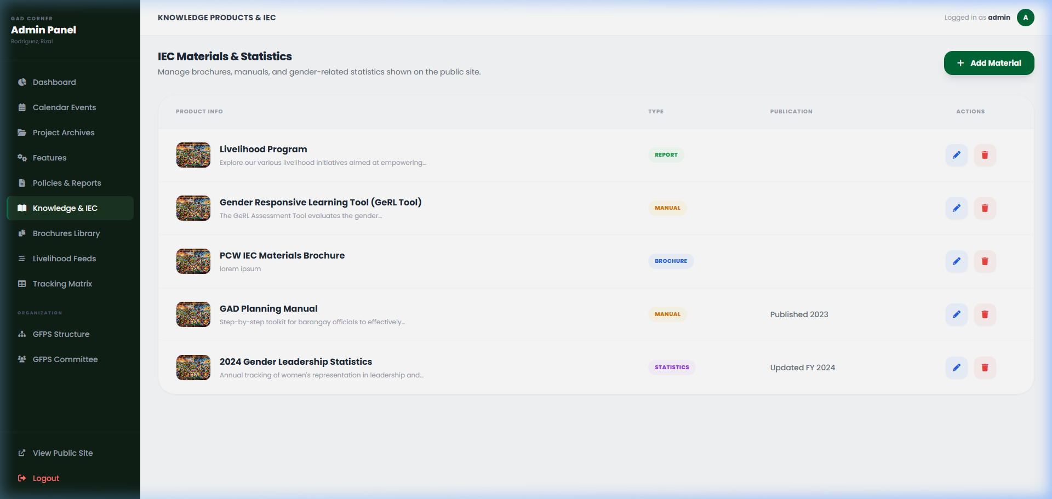
Figure 6: Learning materials management.

9. Brochures
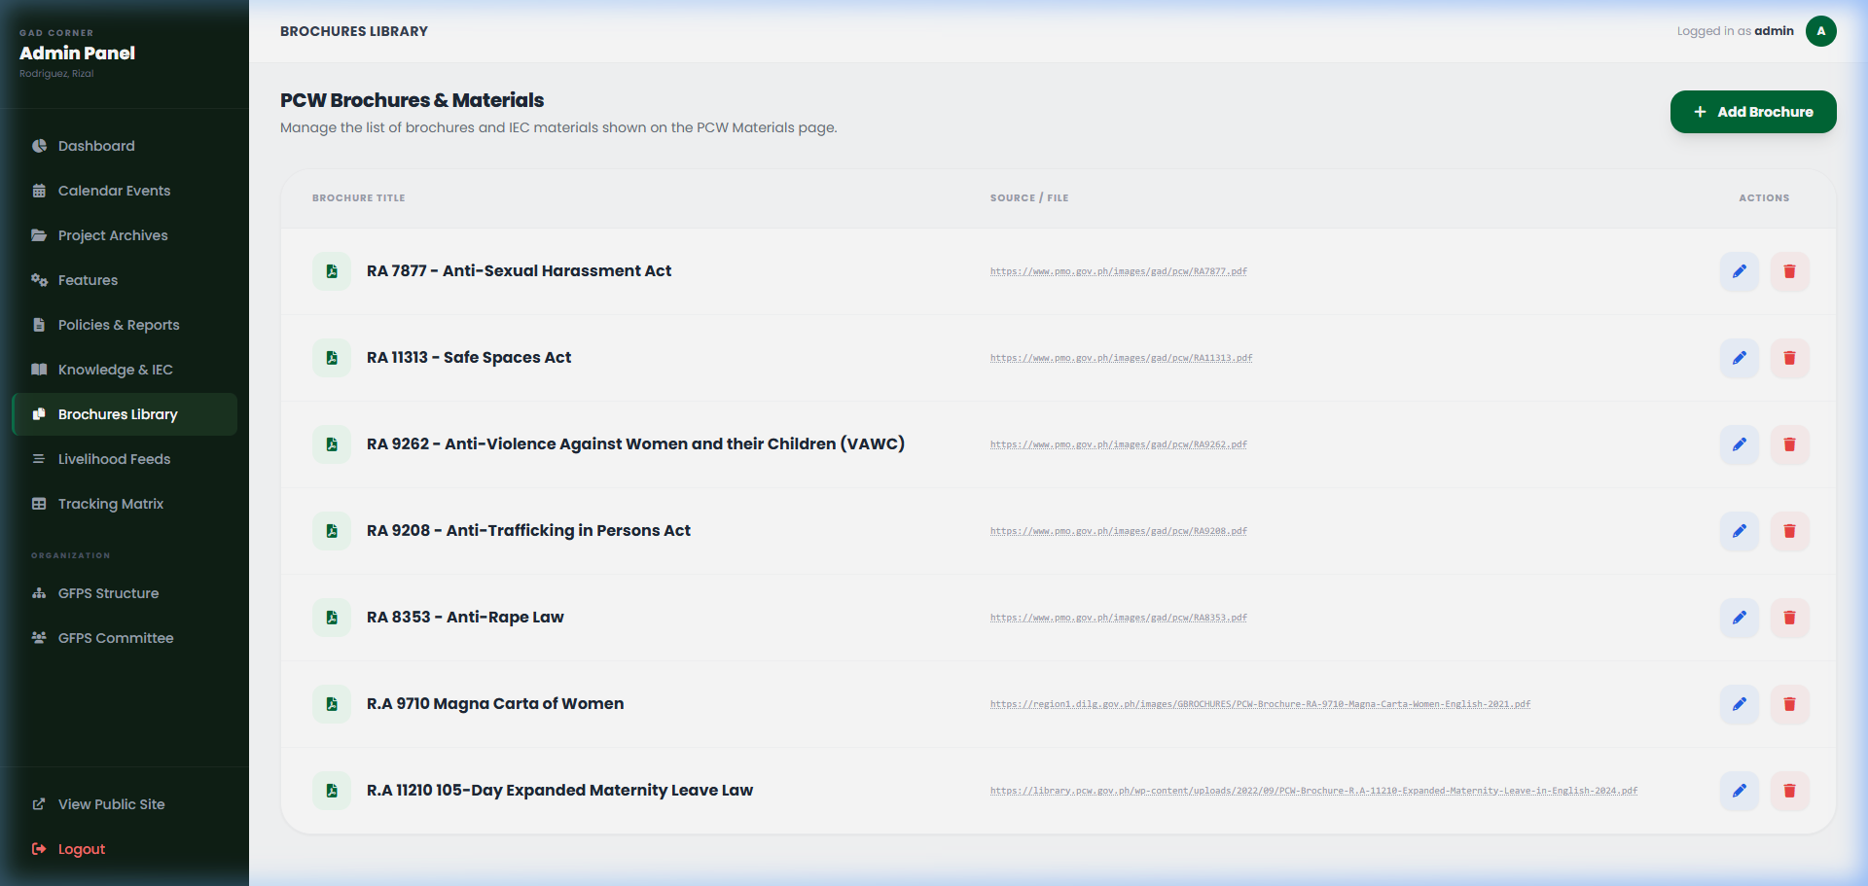
Figure 7: Manage Digital Brochures.

10. Livelihood Program feeds
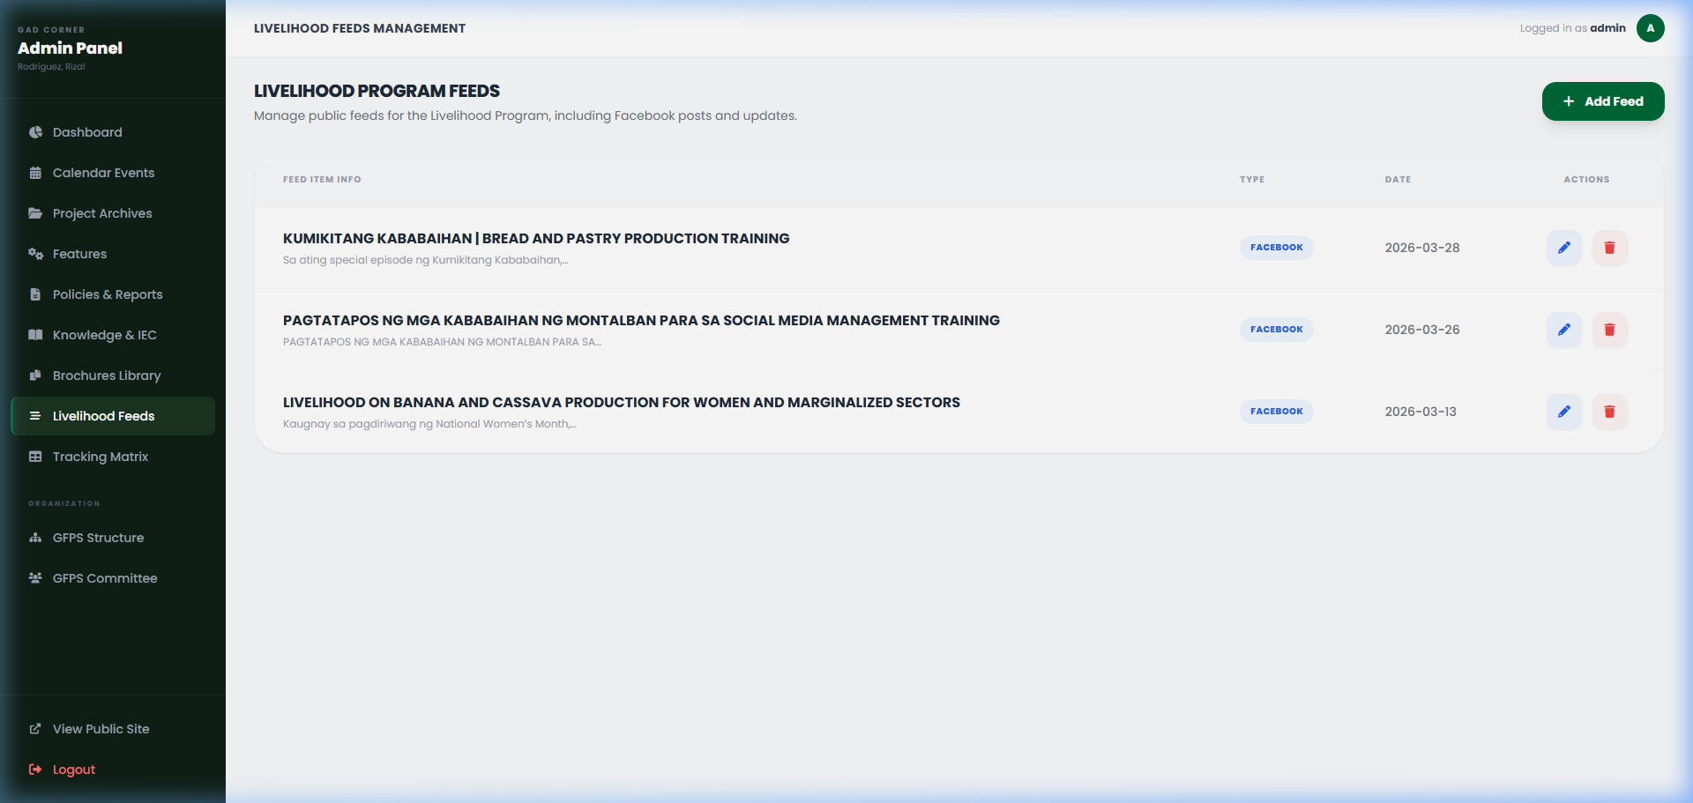
Figure 8: Integrating social media feeds.

11. Org Structure & GFPS Committee
Update the institutional hierarchy and committee member profiles.
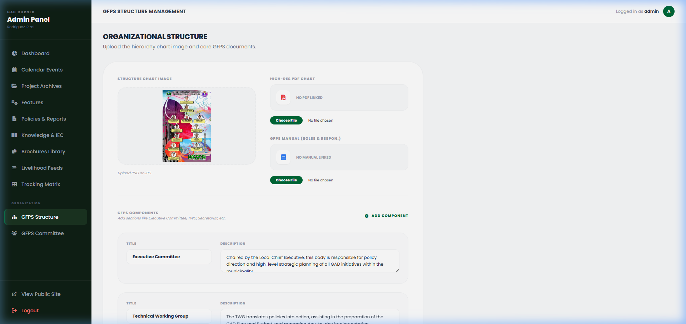
Figure 9: Hierarchy management.
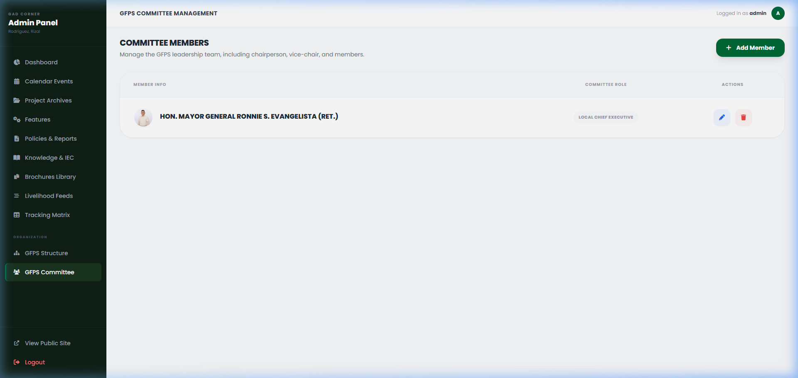
Figure 10: Committee member updates.

12. Tracking Matrix
Real-time logging of all administrative actions for audit compliance.
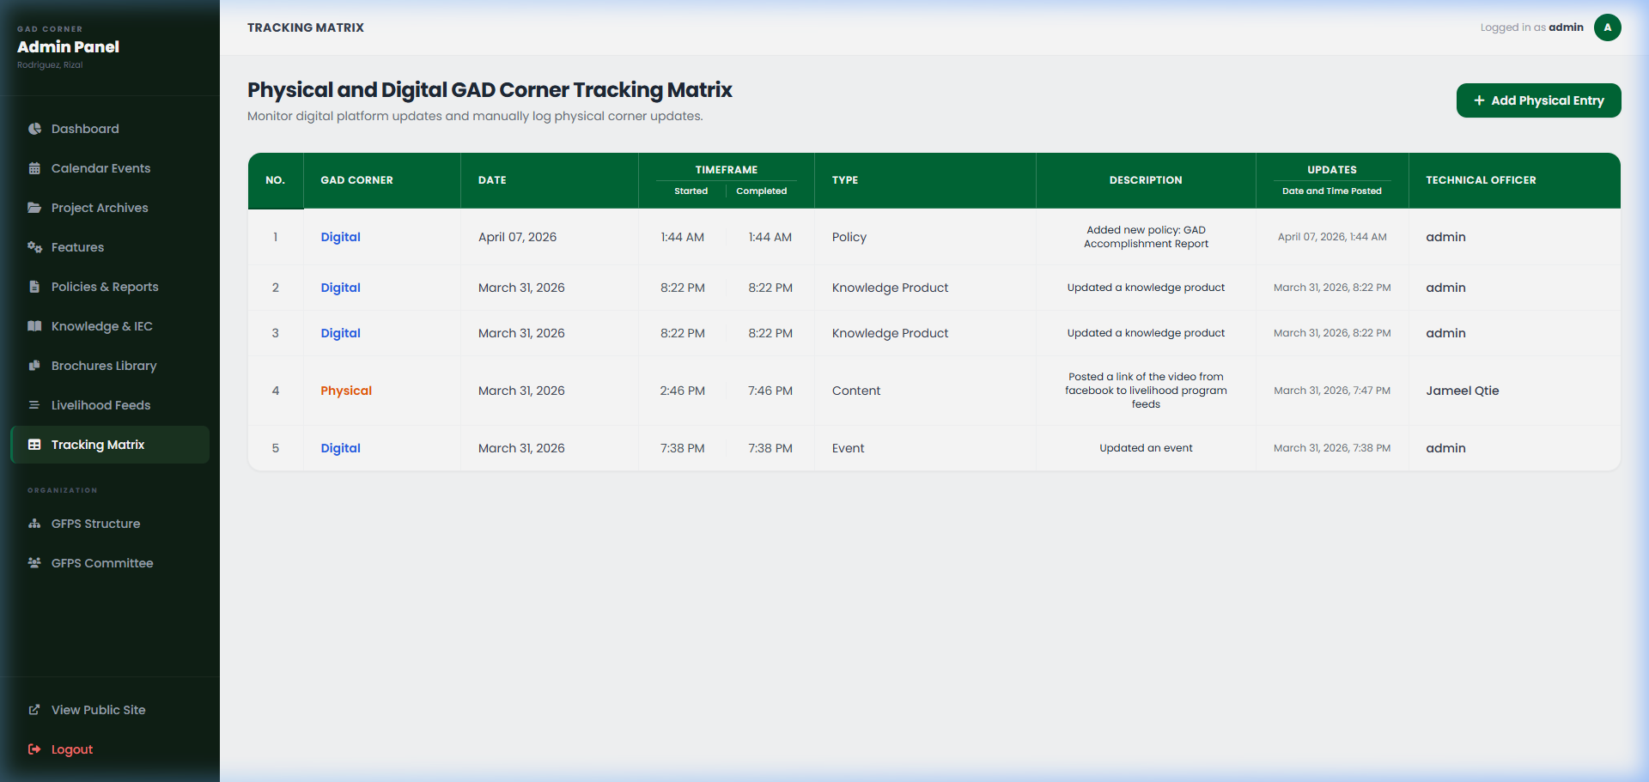
Figure 11: System Audit Log and Tracking Matrix.
End of Document

