GAD Corner - Citizen Guide

1. Overview
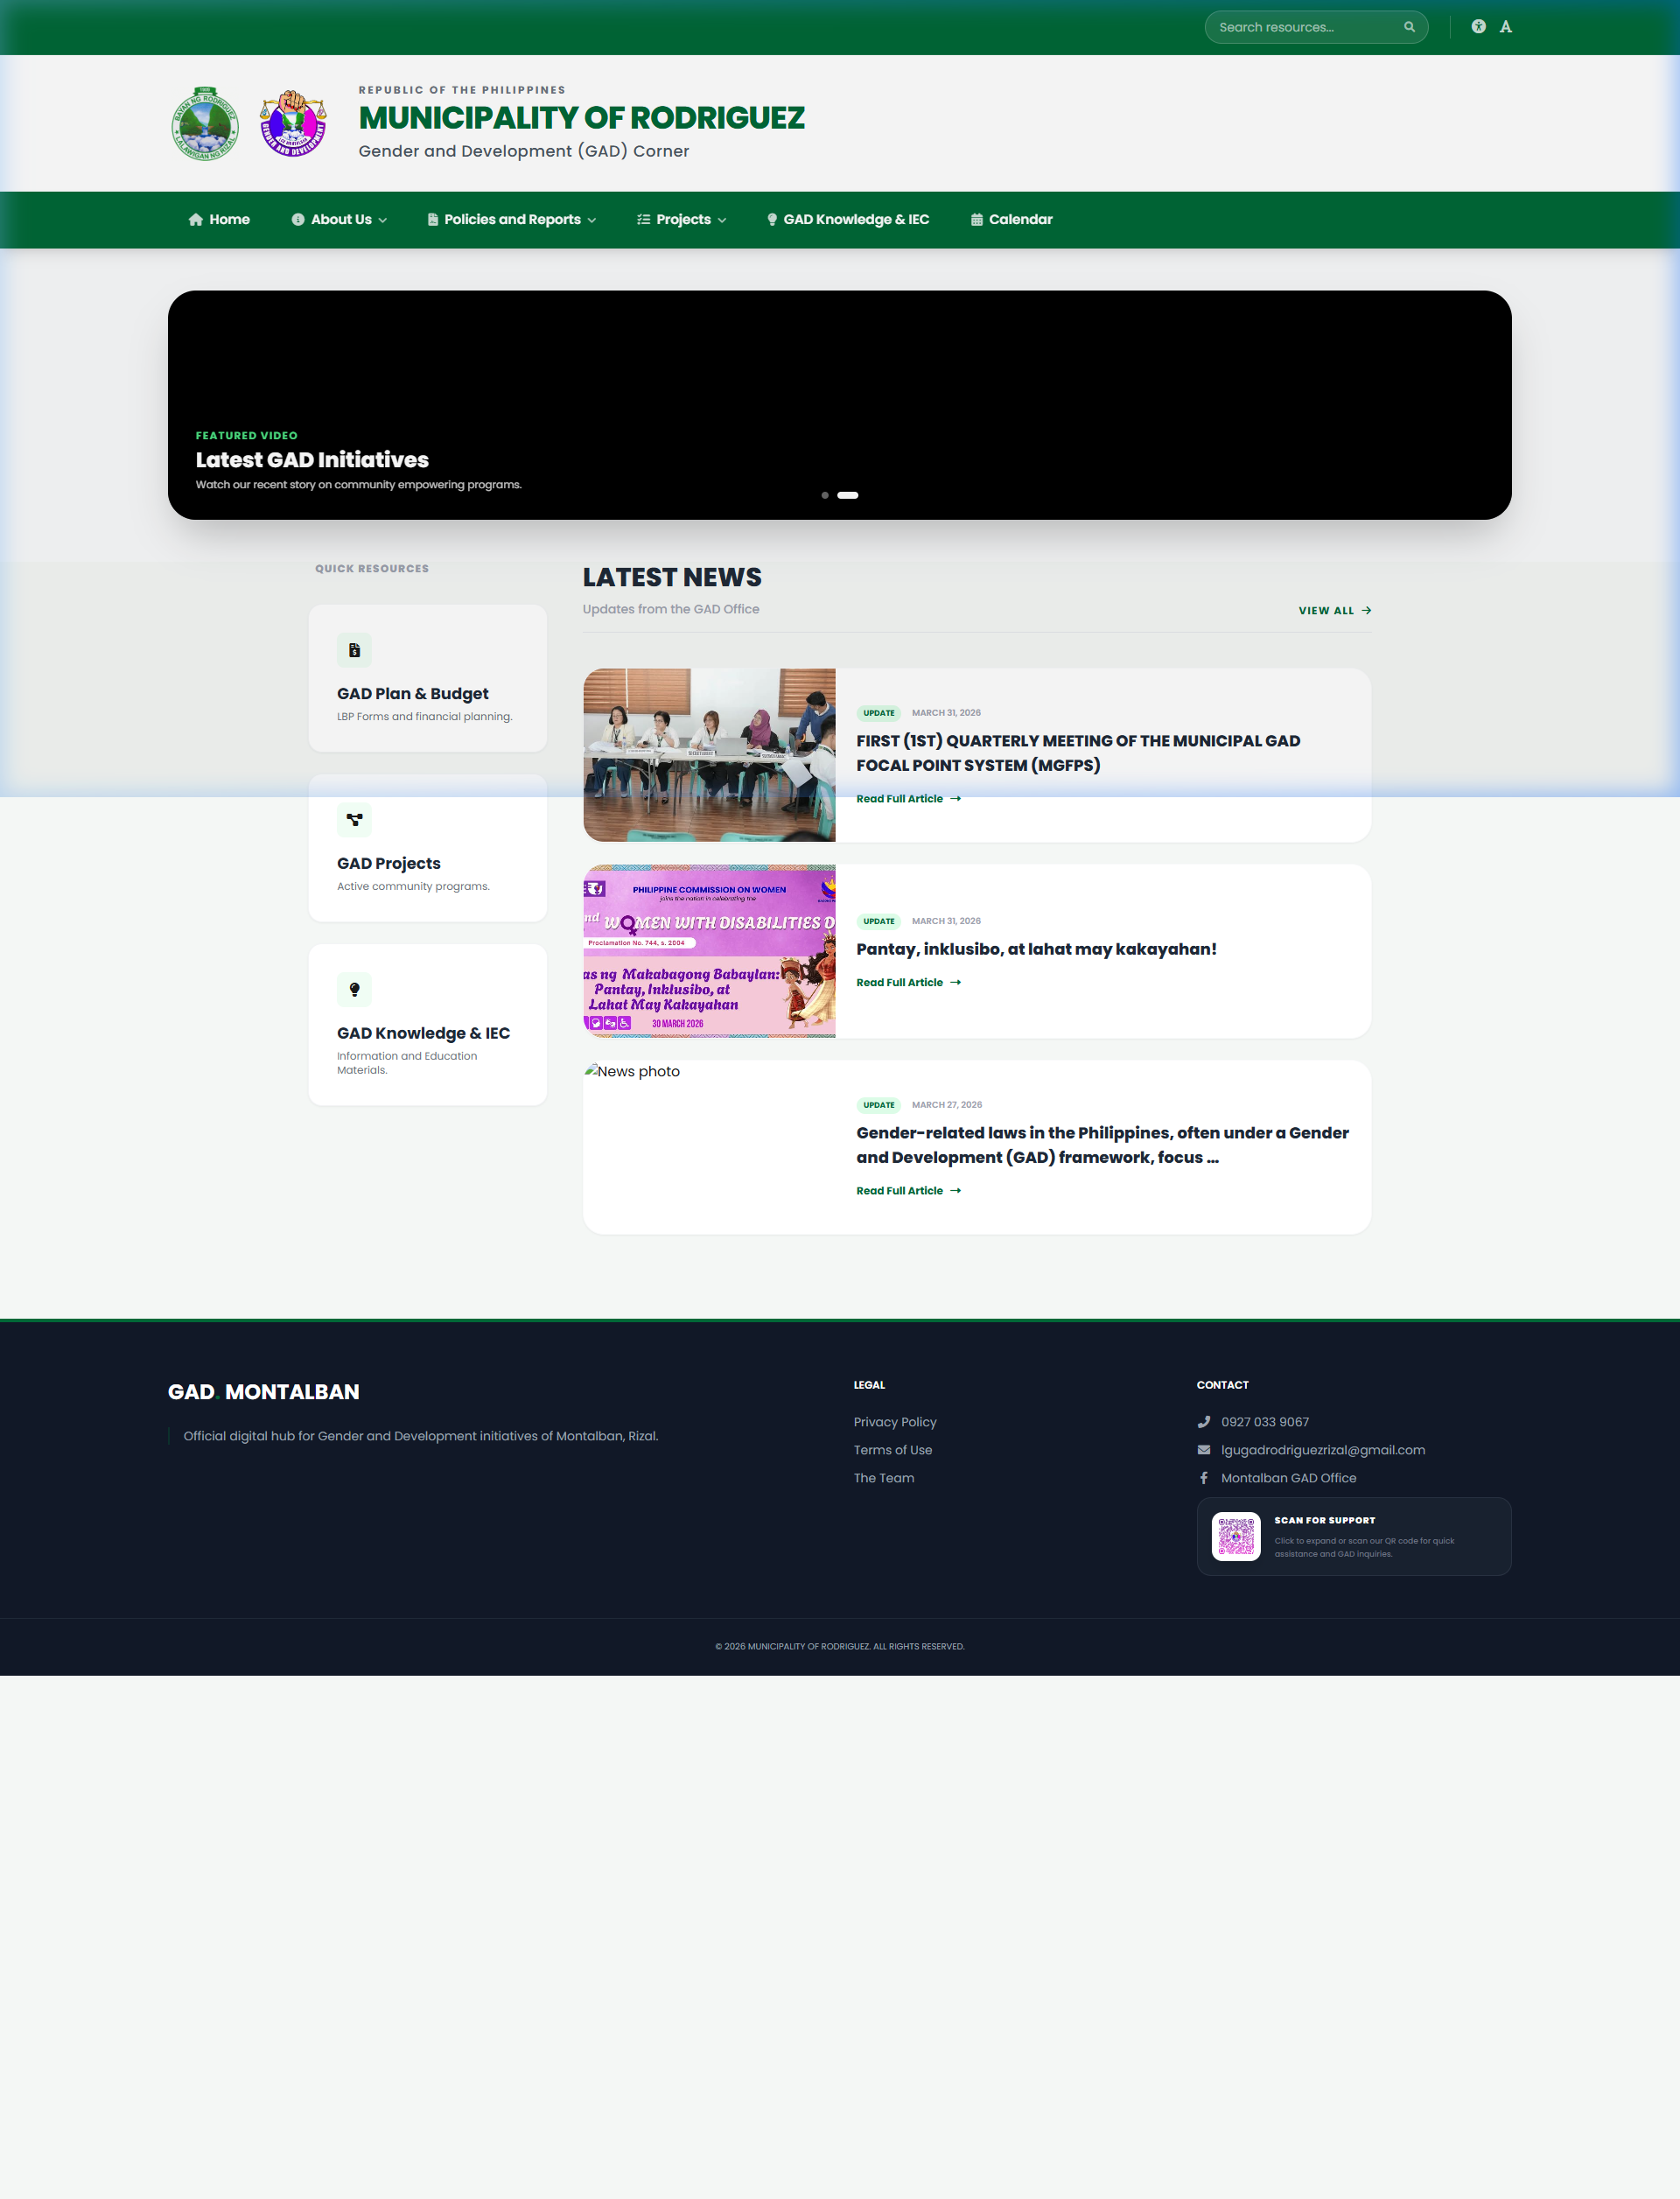
The GAD Corner Homepage

2. Policies
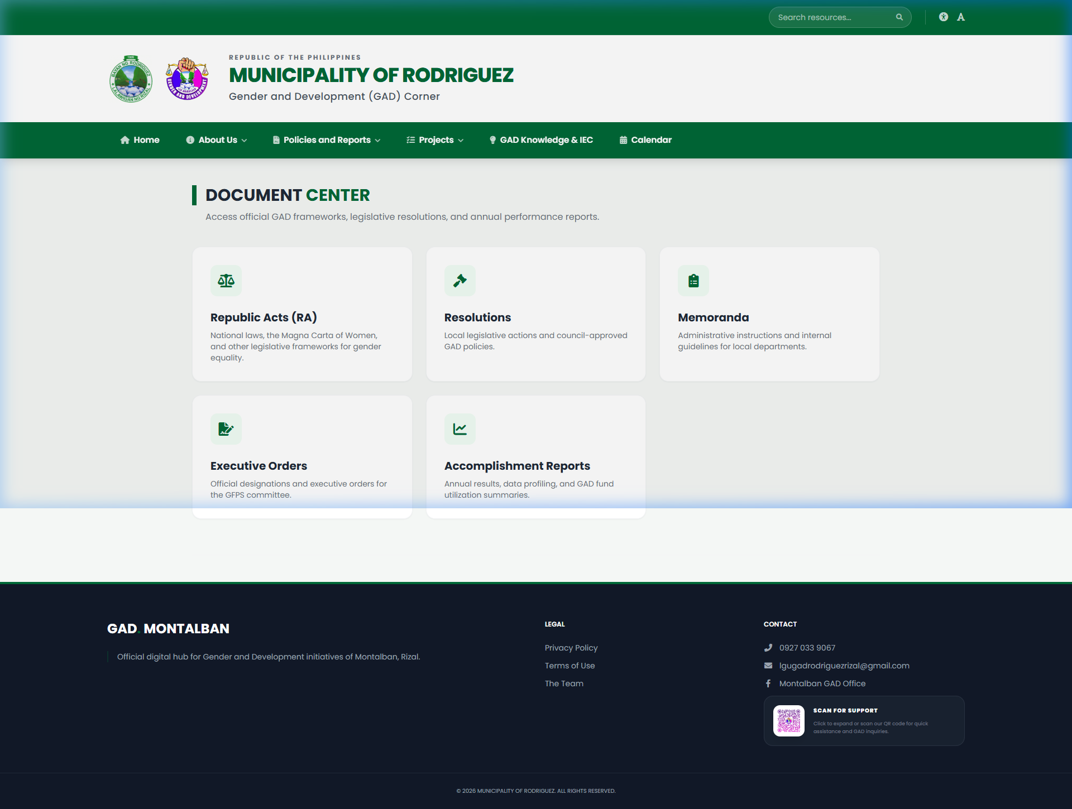
Digital Policy Repository

3. Calendar
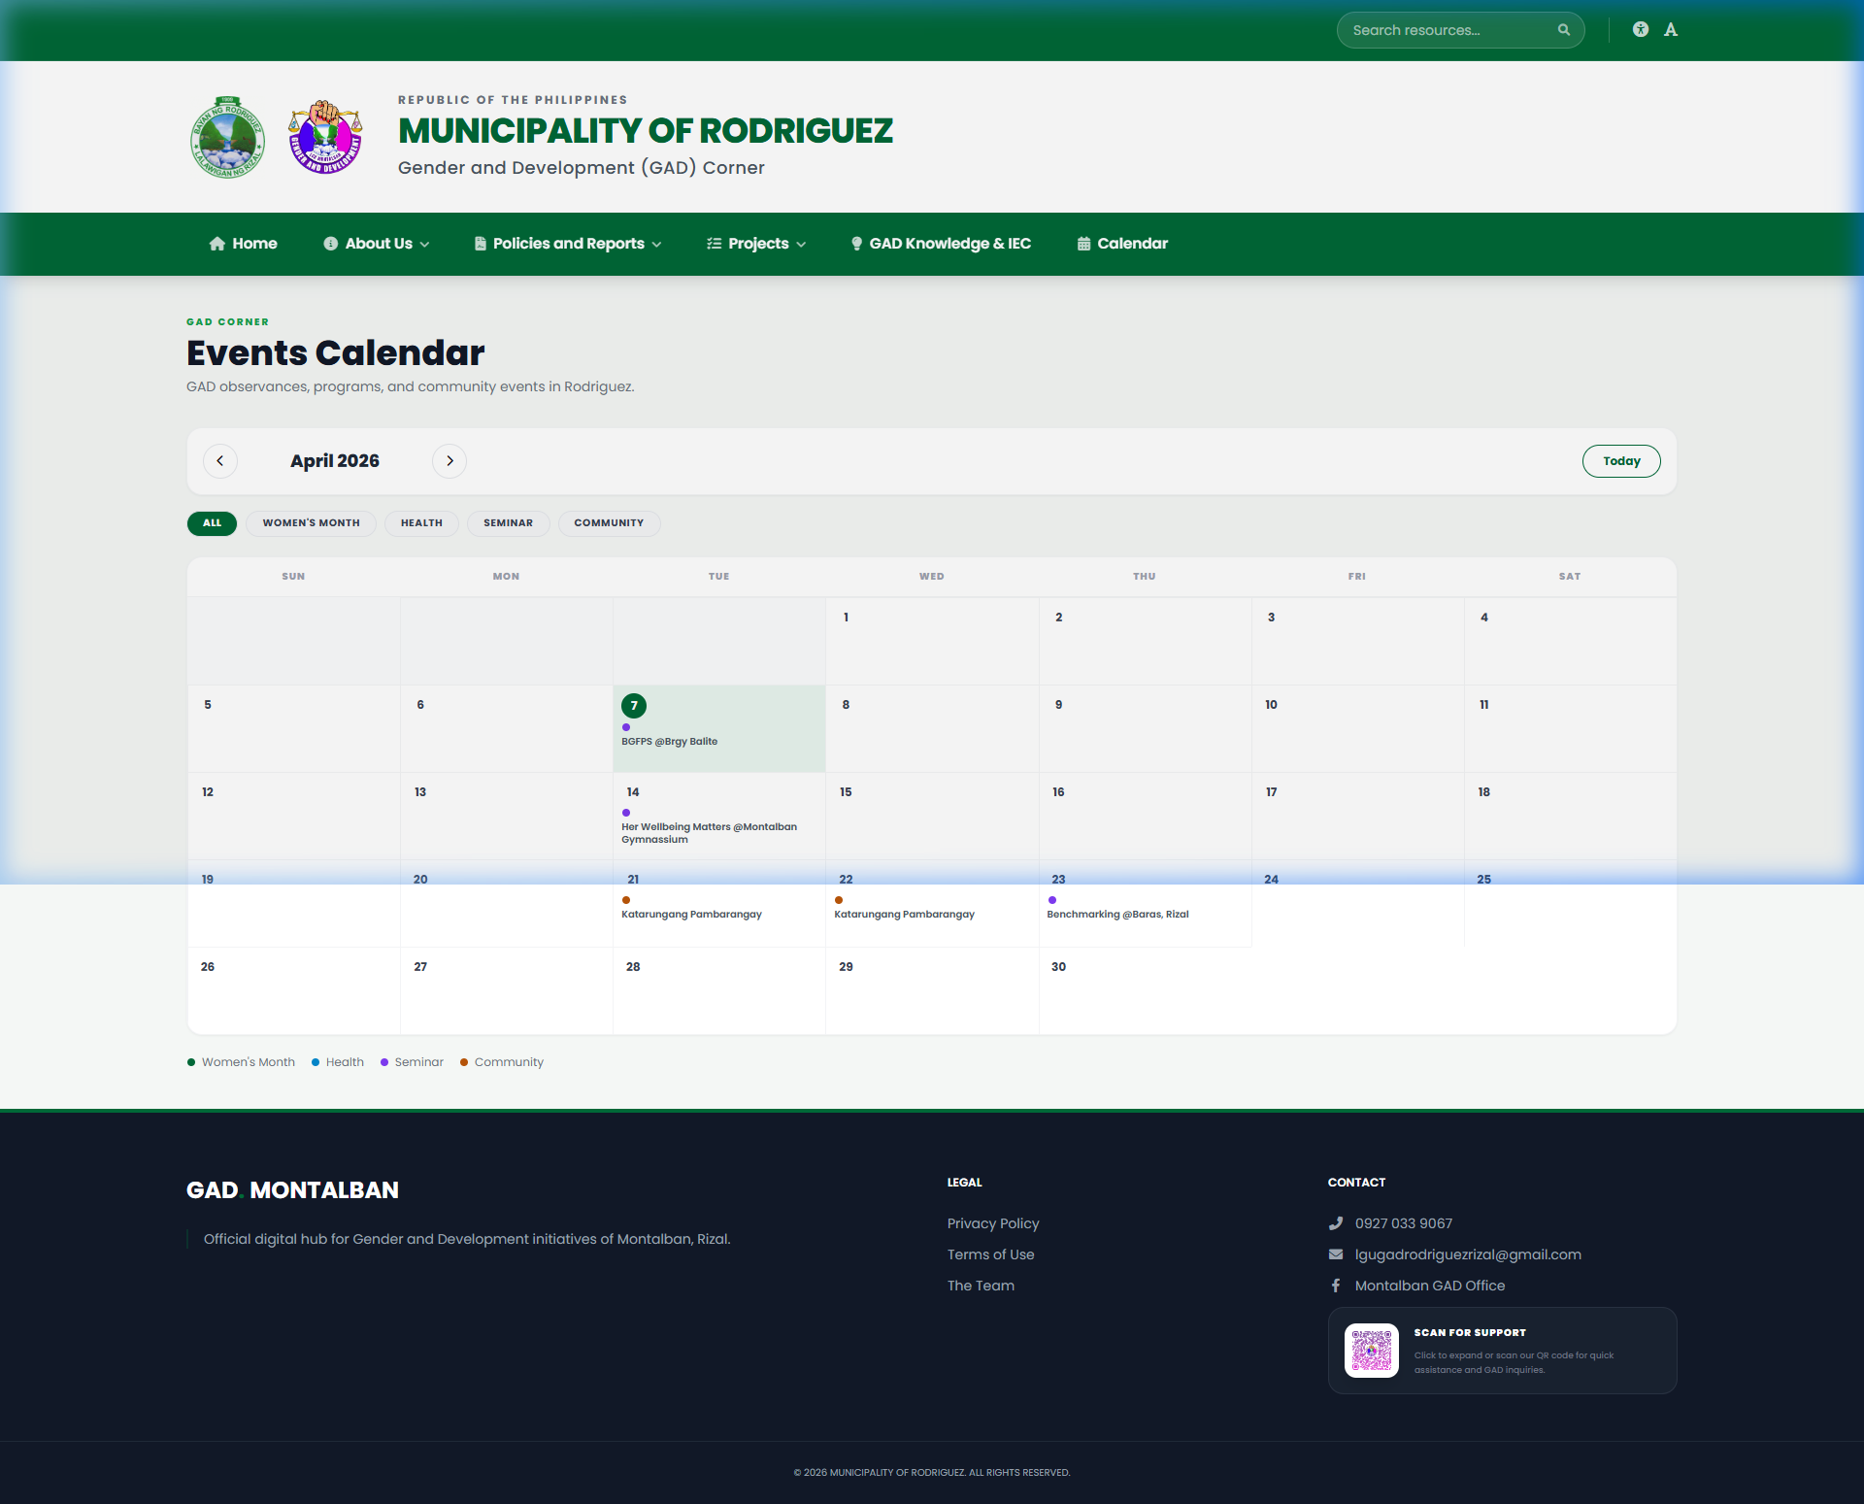
Community Calendar

4. Projects
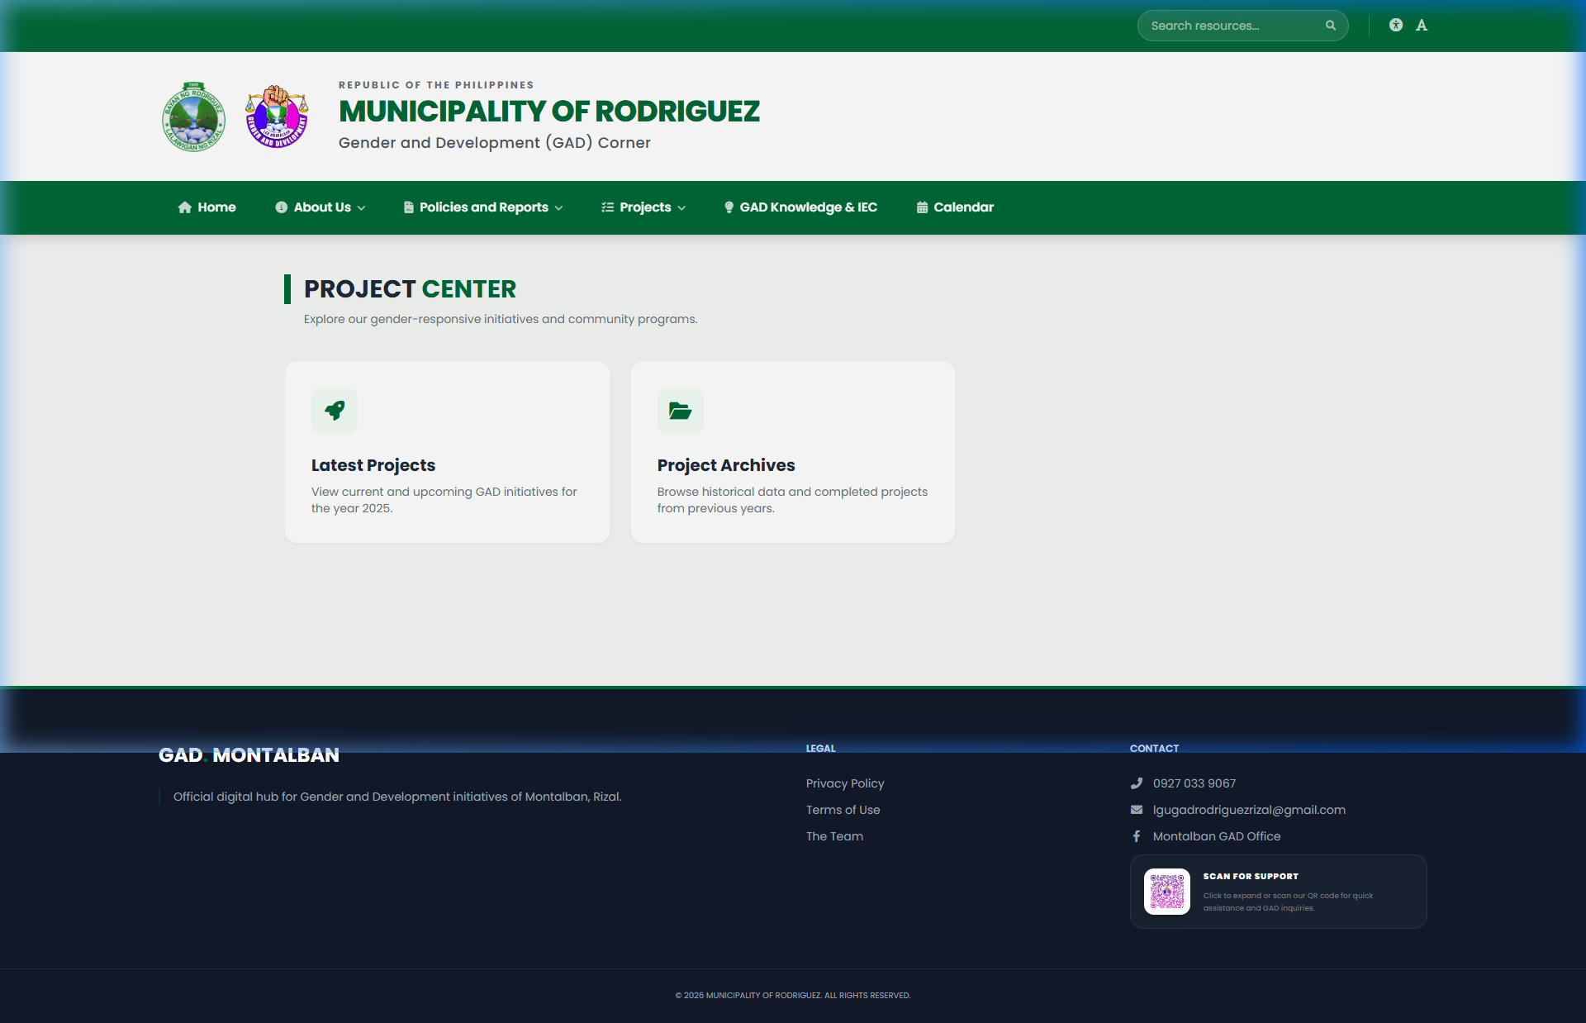
Active Projects

5. Knowledge Products
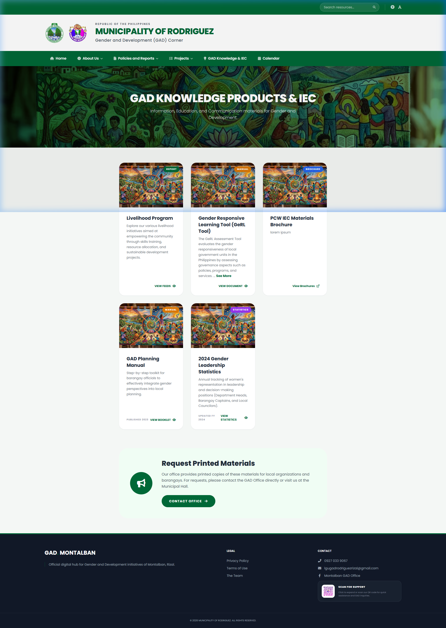
Learning materials

6. Livelihood
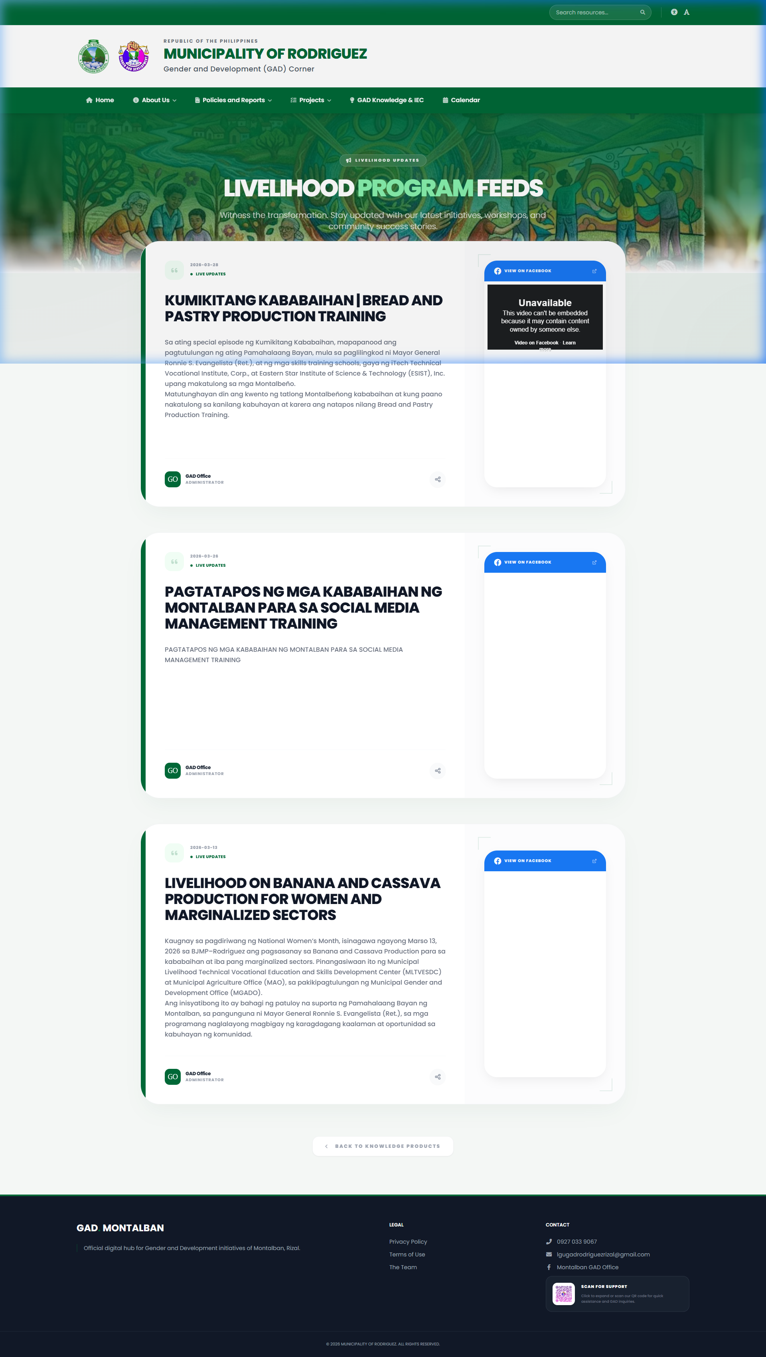
Social feeds

7. GFPS Structure
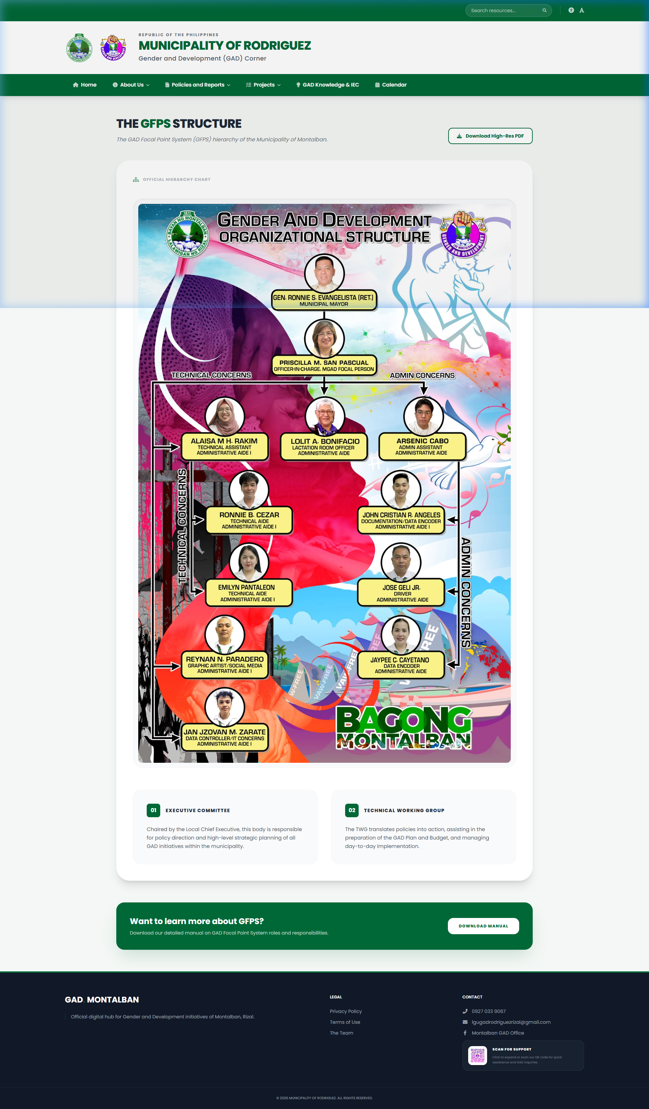
Organizational structure

