Problem 1: Gundala_6_4.m

For example-6.4:

Estimated posterior mean: 4.3050

Estimated posterior standard deviation: 0.4554

Output graph:

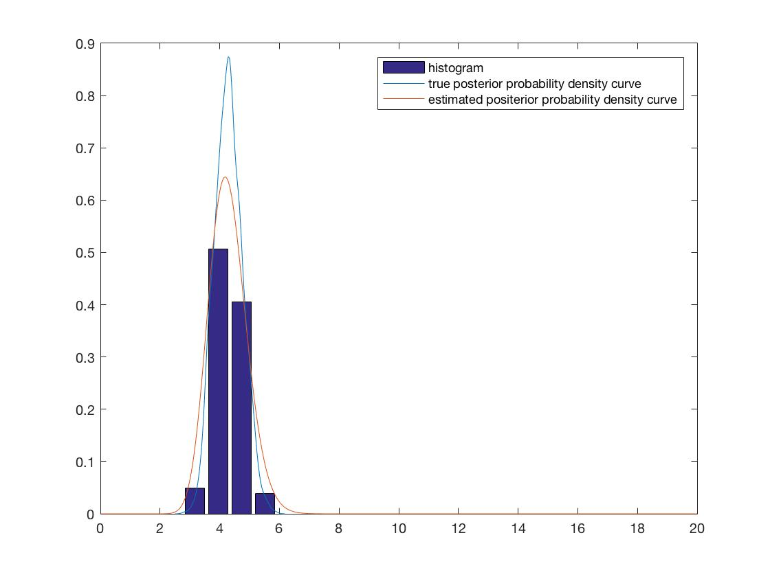

Problem 2:Gundala_6_3_a.m

I took a g function 2*exp(-abs(x)^3)

1. Variance was estimated to be 0.04 approx
2. Similar results as a
3. Similar and closer results as a
4. Performance wise rejection sampling took comparatively more time that the Philippe and Robert’s experiment.