HW7

Problem 6.6: Gundala_6_6.m

a. These are the intervals obtained for the five techniques

1. Standard Monte Carlo [2.4653,3.65]
2. Antithetic Monte Carlo [2.4653,5.2]
3. Importance Sampling [2.4653,3.69]
4. Importance Sampling with standardized weights [2.4653,3.68]
5. Control Variate [2.4653,3.76]

Problem 6.7: Gundala_6_7_m

a. Yes, the value for C, fair price for this option was approximately 2.113

b. Considering the analogous Asian option, the fair price was 1.0995

b. Using control variate strategy, the theta value remained same at 3.6978

d. Antithetic approach gave a fair price of about 0.6296

e. Somehow the estimators for Asian option were always higher than that of Antithetic approach

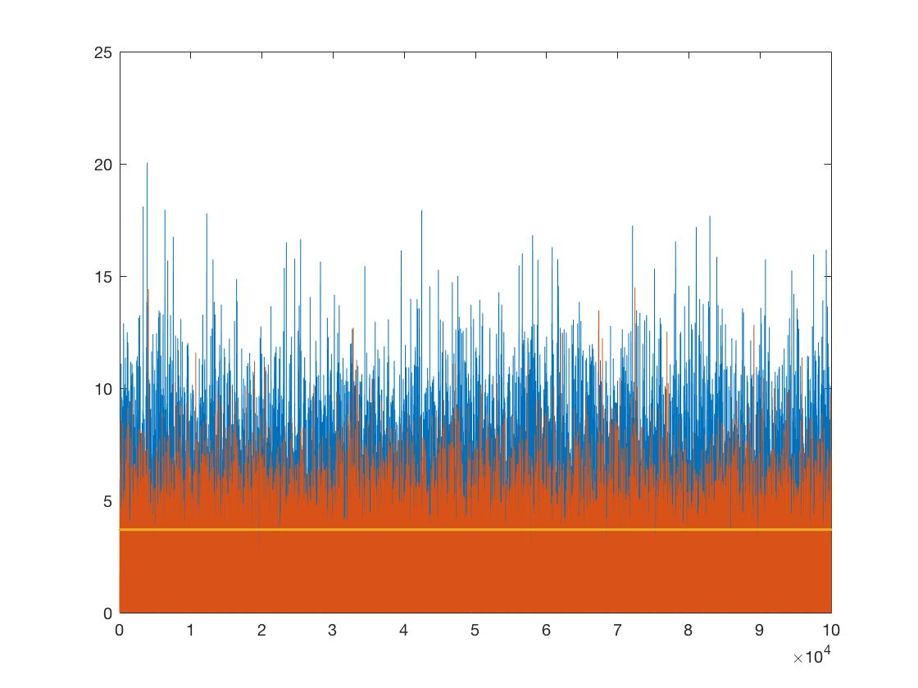

* Blue- Asian option
* Orange- Antithetic approach for Asian option
* Yellow- theta for control variate

problem 6.8: Gundala_6_8_m

I got almost closer mean values for monte carlo and Rao-blackwellized estimators.

But, comparing the performances of these two estimators,

Monte Carlo estimator performance was slower for intial instances and that for rao’s –Blackwellized estimators.

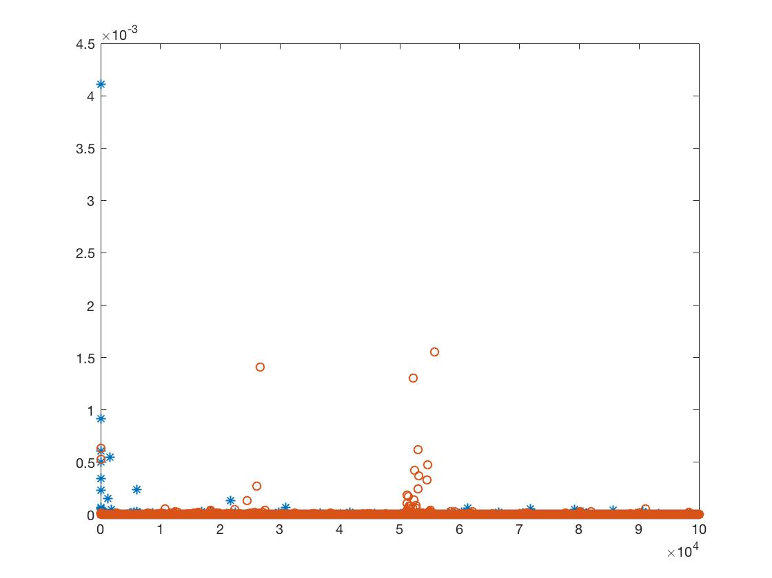

* Blue –Monte Carlo
* Orange –Rao’s -Blackwellized