Problem: 9.4 : Gundala_9_4.m

While, considering the equation give in the question and solving it to find a point where R==S, considered thetahat = beta(1)/(1-beta(2)) as the point of estimate.

**for bootstraping the cases:**

Bootstrap estimate of the bias is: 0.00000417

Bias corrected bootstrap estimate is: 0.00665816

standard error for corrected estimator is: 0.00000171

95 percent C.I using the simple bootstrap percentile method is: [ 0.006348, 0.007008 ]

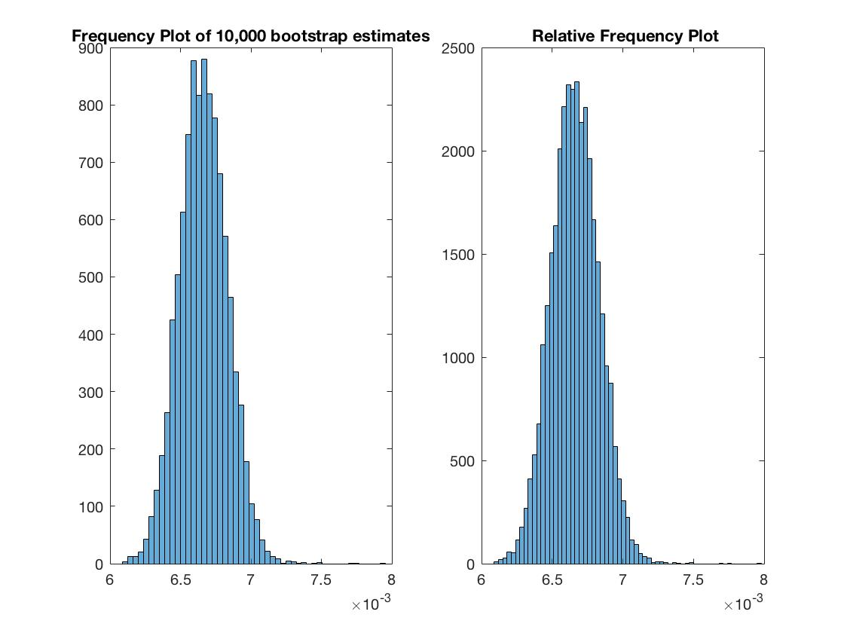

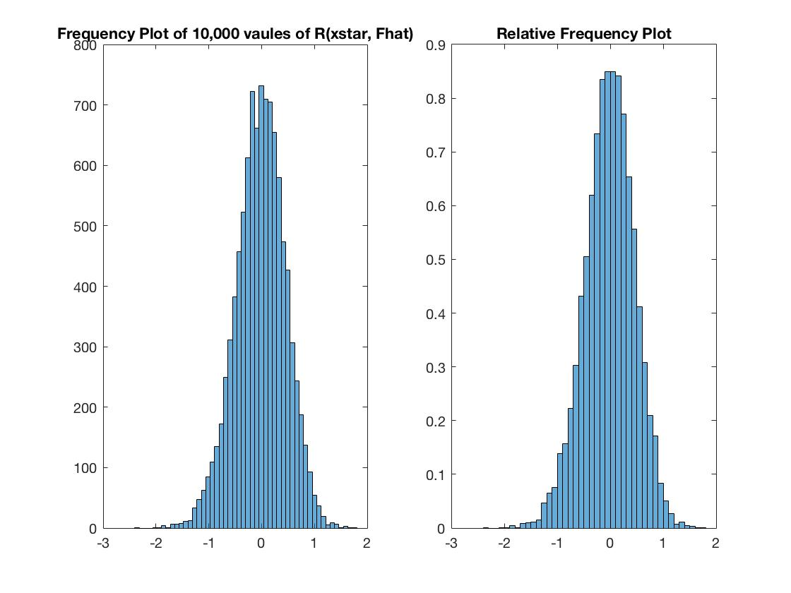

**for bootstrapping the residuals:**

Bootstrap estimate of the bias is: -0.00002547

Bias corrected bootstrap estimate is: 0.00671731

standard error for corrected estimator is: 0.00000168

95 percent C.I using the simple bootstrap percentile method is: [ 0.006341, 0.007001 ]

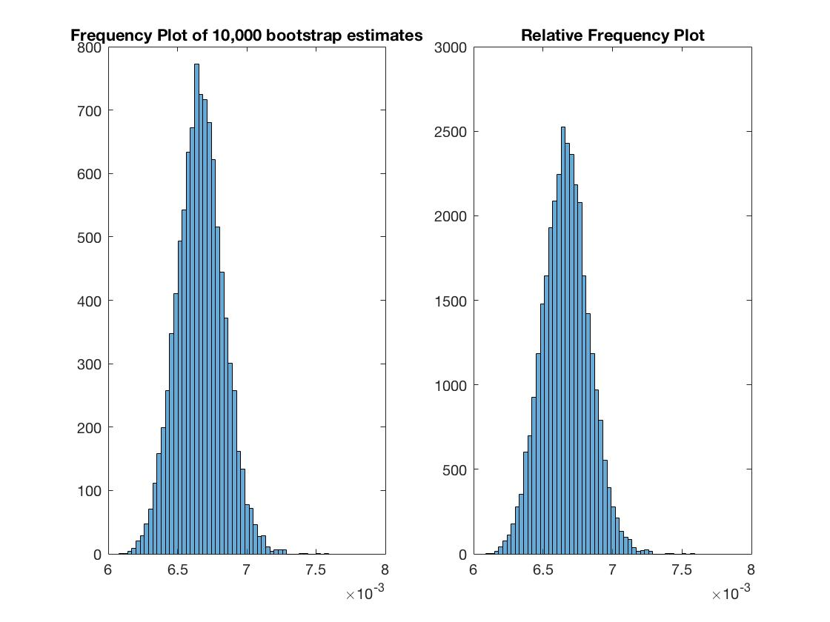

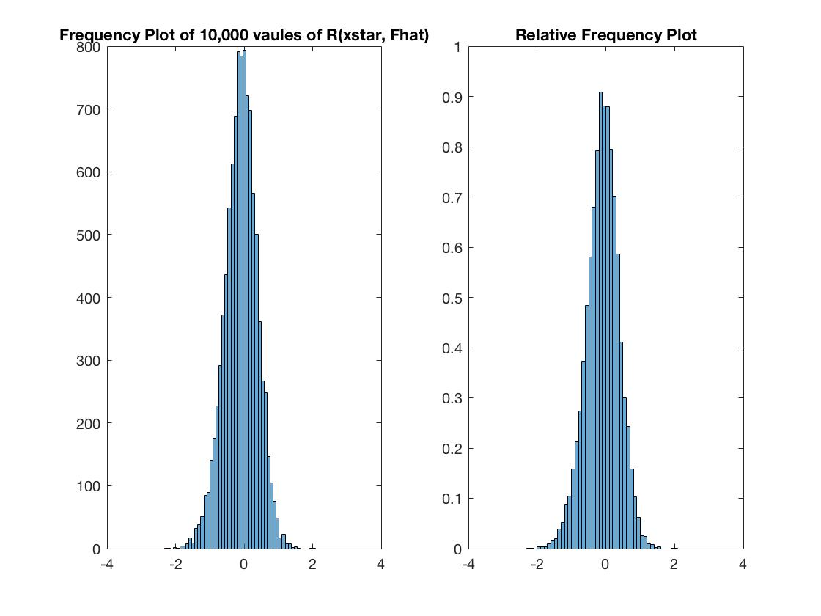

Honestly, I don’t see much difference between the results of two types of bootstrapping. But, much minutely, bootstrapping the residuals gave a much closer interval for the values.

Problem 9.5: Gundala_9_5.m

1. By using data on log scale, the following results are observed:

**for Stomach Cancer**

Bootstrap estimate of the bias is: 0.0006

Bias corrected bootstrap estimate is: 4.9673

**standard error for corrected estimator is: 0.0033**

95 percent bootstrap t C.I is: [ 4.233612, 5.801888 ]

exponentiating the t C.I is: [ 70.003871, 331.596172 ]

**for Breast cancer**

Bootstrap estimate of the bias is: -0.0025

Bias corrected bootstrap estimate is: 6.5611

**standard error for corrected estimator is: 0.0048**

95 percent bootstrap t C.I is: [ 4.258001, 7.415938 ]

exponentiating the t C.I is: [ 72.970037, 1652.591523 ]

c. By using simple bootstrap to the logged data and exponentiating the intervals:

**for Stomach Cancer**

95 percent C.I using the simple bootstrap percentile method is: [ 75.931778, 281.53229]

**for Breast cancer**

95 percent C.I using the simple bootstrap percentile method is:[256.13600, 1611.58443]

By using simple bootstrap to data on original scale:

**for Stomach Cancer**

Bootstrap estimate of the bias is: 0.6995

Bias corrected bootstrap estimate is: 285.3005

**standard error for corrected estimator is: 0.9248**

95 percent C.I using the simple bootstrap percentile method is: [123.88462, 483.26923]

**for Breast Cancer:**

Bootstrap estimate of the bias is: -5.5218

Bias corrected bootstrap estimate is: 1401.4309

**standard error for corrected estimator is: 3.6126**

95 percent C.I using the simple bootstrap percentile method is:[742.45455, 2148.59091]

Clearly, the standard error increased very much by incorporating the methods asked in 9.5.c. And so, the confidence intervals deviated a lot from the reliable results from 9.5.a. There are many outliers on the right.

Frequency plots for bootstrap t method on Stomach Cancer 9.5.a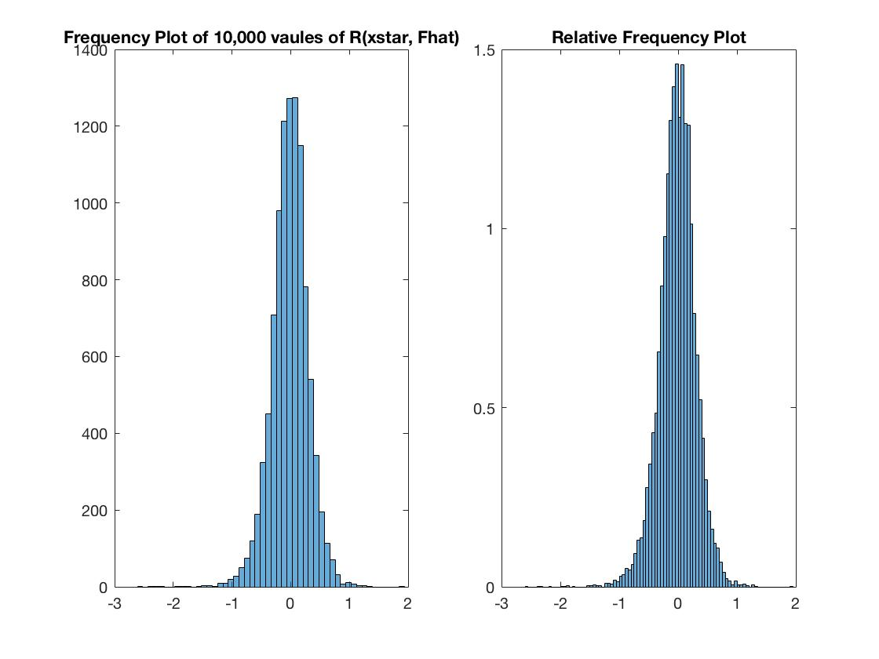

Frequency plots for simple bootstrap on Stomach cancer 9.5.c

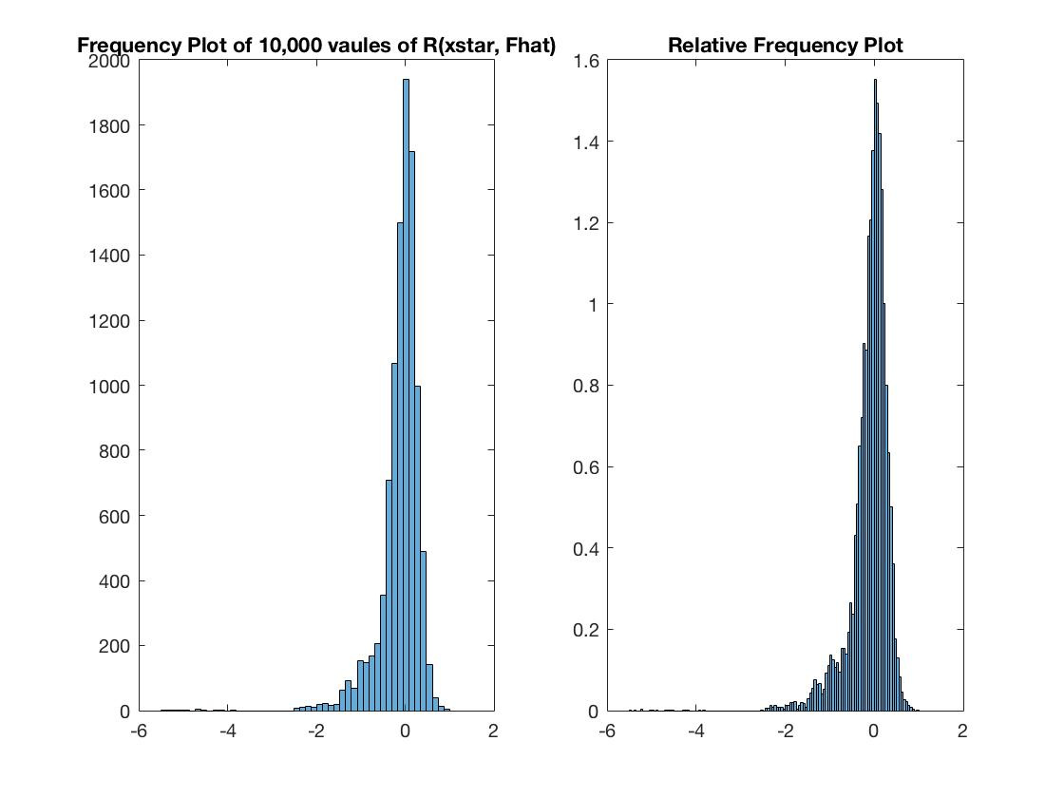

Frequency plots for bootstrap t method on Breast Cancer 9.5.a

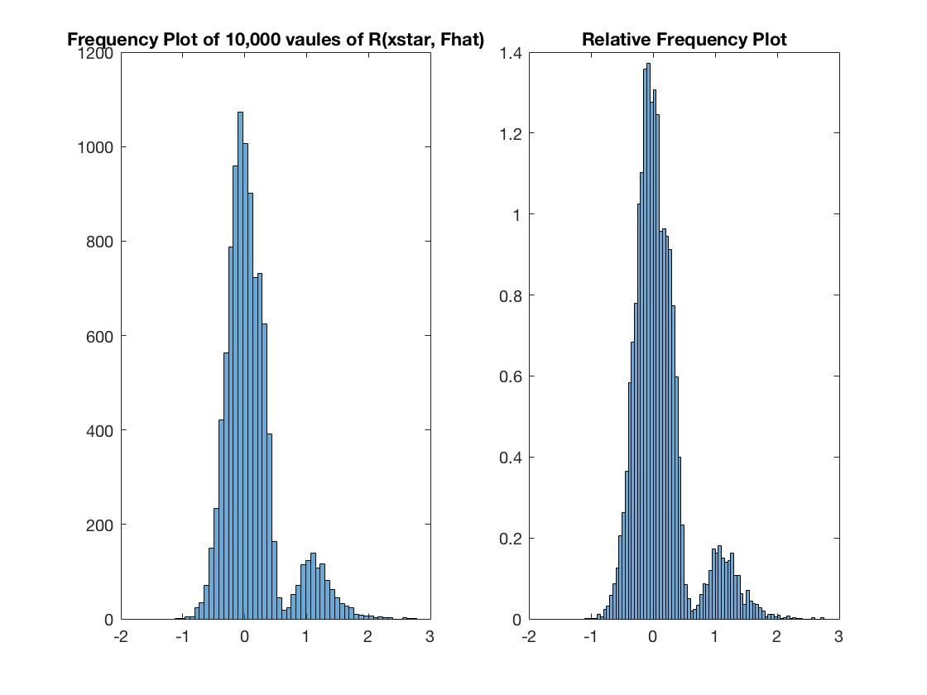

Frequency plots for simple bootstrap on Stomach cancer 9.5.c

