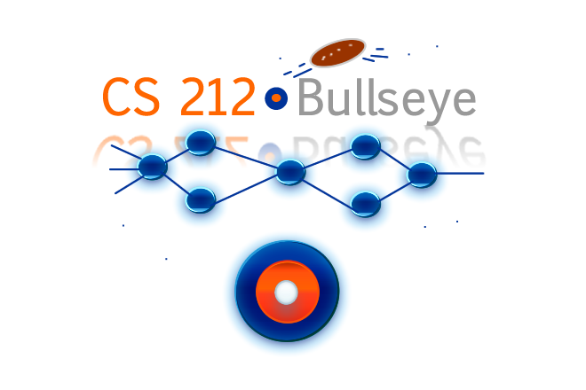

Ryan Flammer

Yevgeniy Khafizov
Won-Beom Kim
Christopher Kwan
Mike Mallon
James Peerless

May 1, 2008

Table of Contents

- Introduction
- Errata
- Screen Shots
- Contributions
- Design
- Testing
- Code Appendix

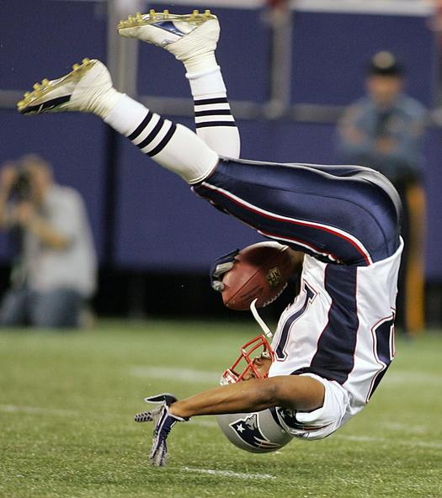

1. Introduction

The Bullseye View Project provides an engaging way to visualize and compare statistics among National Football League (NFL) teams.
The user can select any number of the 32 NFL teams and any number of metrics to compare among teams. Metrics include statistics such as number of touchdowns or percentage of passes completed. Teams along with their statistics are stored in a database, which is accessed by the project. Each team and its statistics is represented as a multicolored bullseye. The team itself is represented as the central hub of the bullseye. Each statistic is represented as a differently colored concentric ring around the hub.
Rings come in three thicknesses: thick, thin, and no ring. Whether of not a ring is displayed depends on the teams ranking in that statistic. Metrics are ranked using M-ordinal logic, whereby ordinal values are produced for each item. When selecting which metrics to compare, the user also selects what color should represent the metric and whether the metric should be ranked as BigGood (where the largest value has the highest rank, for example: number of touchdowns) or LittleGood (where the smallest value has the highest rank, for example: number of fumbles).
If six or more teams are compared, the team with the highest rank in a given metric is given a thick ring, the teams with second and third highest rank are both given thin rings, and the remaining teams are given no rings. If five or four teams are compared, only the first and second highest ranks are given rings. Finally, if fewer than four teams are compared, only the highest-ranking team is given a ring.
After displaying the bullseyes, the user has the opportunity to predict what three teams will win the most games based on their metrics. After selecting the teams, the user can compare his/her predictions with the program’s built in evaluation system, which consists of a Neural Net trained on NFL team statistics from past years. Finally, the user can choose to show the reality vector, which three teams actually won the most games. The user can play this game again and again, each time gaining insight. A scoring display shows the prediction records of the user and the neural net, so the user can gauge his or her improvement.
2. Errata

How the spec stands at delivery:

- Our team followed the original project specifications save for a few revisions.

- We decided against using an XML file to store parameters. We saw that it was an unnecessary step when we could access the database directly.

- To enhance the visual experience, we chose to give the user the option to display bullseyes in shapes other than circles, specifically squares and triangles.

- Rather than having default BigGood and LittleGood values for each of the metrics, we decided to give the user the option to allow them ultimate freedom to evaluate the teams in any way they see fit.

- We chose to have an unlimited amount of rings for precision comparison purposes.

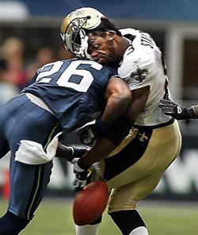
3. Screen Shots – The Project in Action
  - initial
  - one bullseye
  - many bullseyes
  - user
  - neural net
  - actual
  - database interface?

4. Contributions

 | Ryan Flammer  (CAS 2008) | Testing
 | Yevgeniy Khafizov  (CAS 2008) | Database
 | Won-Beom Kim  (CAS 2008) | Bullseye Graphics
 | Christopher Kwan  (CAS 2010) | Documentation
 | Mike Mallon  (CAS 2008) | Team Manager, Neural Net
 | James Peerless  (CAS 2009) | User Interface, M-Ordinal Logic

5. Design – the master plan

Class Diagram:

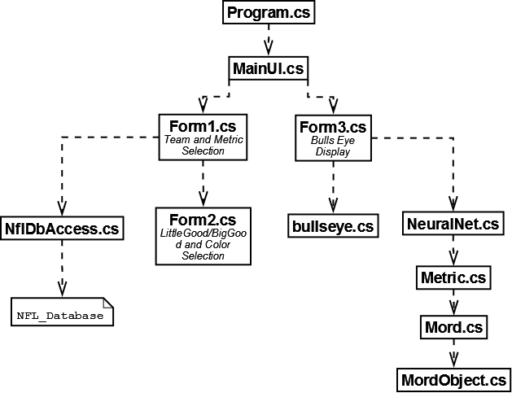
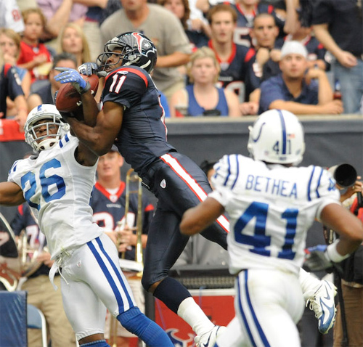
Class Descriptions:

Program.cs – Runs the application.

MainUI.cs – Launches the User Interface.

NflDbAccess.cs – Retrieves NFL team statistics from the database.

NFL_Database – Database containing information about 31 metrics for 32 teams.

Form1.cs – Displays team and metric selection options.

Form2.cs – Smaller window to customize color and LittleGood/BigGood for selected metrics.

Form3.cs – The space for displaying the bullseyes.

Bullseye.cs – Logic for determining how to display the bulleyes.

NeuralNet.cs – A Neural Net trained on NFL data from previous years.

Metric.cs – A list of MordObjects.

Mord.cs – Ranks an array of MordObjects.

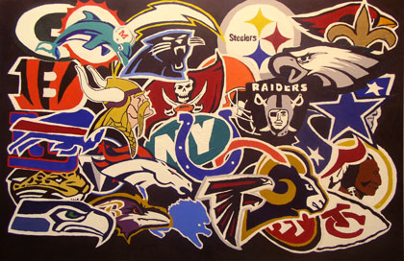
MordObject.cs – Represent a team and its metric values.
6. Testing – make sure it works

7. Code Appendix – look under the hood
8. Online Resources
  - full source code for the project is available on the CS212 FTP Server.
  - Resources used

