**FoxcodePlus - New features for IntelliSense Microsoft Visual FoxPro 9  
By Rodrigo D. Bruscain – Version Beta 3.13.2 – Last updated May 26, 2013**



FoxcodePlus does not replace VFP's IntelliSense; it enhances VFP’s IntelliSense where the default VFP does not adequately help or does absolutely nothing. The idea of FoxcodePlus is to bring a little of the functionality of Visual Studio IntelliSense to VFP. (In others words, to make it faster and avoid making mistakes when writing VFP code.)

See the new features below:

1. **Incremental IntelliSense for functions, commands, variables and so on.**

*As in Visual Studio, everything that is typed in the coding screen (Edit window), VFP incrementally searches the entire contents of the program and builds the IntelliSense. The incremental search happens upon each a key pressed. In “IntelliSense Manager”, you can choose in “****Incrementally search****” combobox how to increment the IntelliSense.*

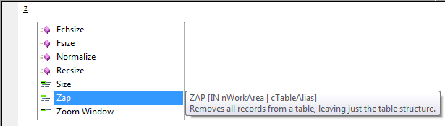

*Image 1.10*

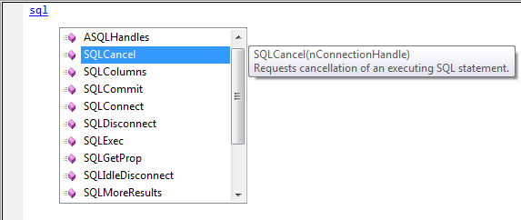

*Image 1.11*

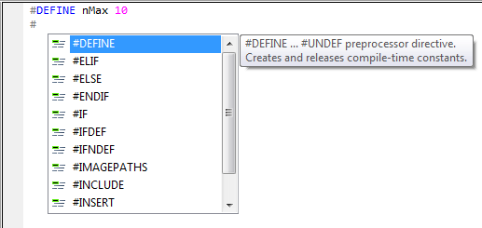  
*Image 1.12*

1. **Variables at write-time**  
   *Working with variables is now easier; IntelliSense captures all kinds of variable declarations. The tooltip indicates the type of the variable if the type has been specified.*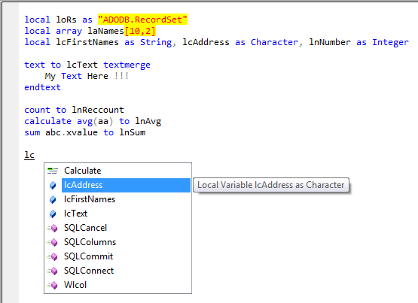

*Image 2.10*

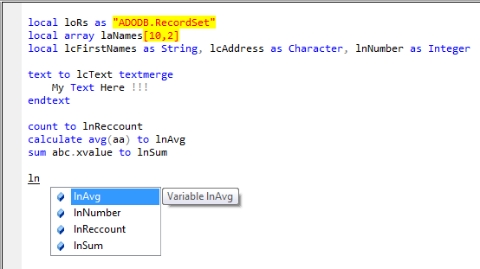

*Image 2.11*

1. **Accessing the list of variables at write-time.**

*If you want to know all the variables created up until where the cursor is, type "m.", and the IntelliSense will open in a "non-incremental" mode.*

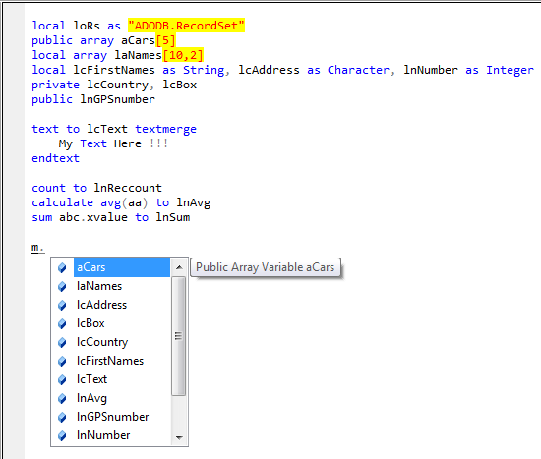

*Image 3.10*

1. **Constants at write-time**  
   *Constants created can also be accessed by IntelliSense. The tooltip displays the value of the constant.*  
   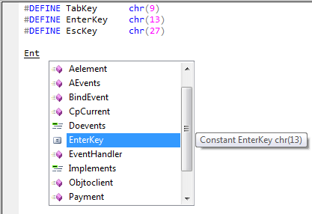  
   *Image 4.10*

*Constants in file.H included with command #INCLUDE can be accessed by IntelliSense. The image below shows us the constants inside CONST.H file and tooltip show us the constant name, value and file name.*

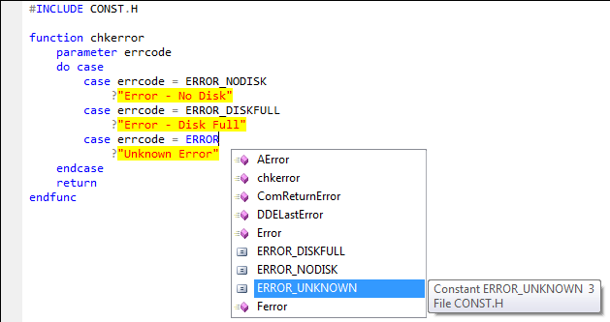

*Image 4.11*

1. **Tables at write-time and at run-time**  
   *Tables that are created and/or opened, as in the picture below, are also included in the IntelliSense. The tooltip shows the way the table was opened.*  
     
   *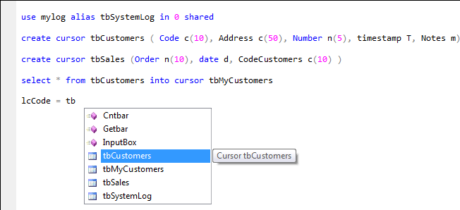Image 5.10*

*IntelliSense for tables in DataEnvironment Forms (VFP tables)*

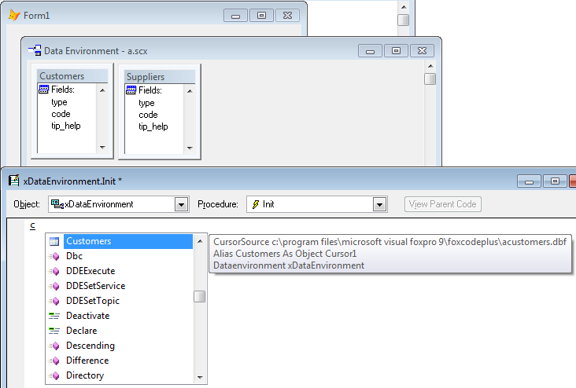

*Image 5.11*

*IntelliSense for tables in DataEnvironment Reports (VFP tables)*

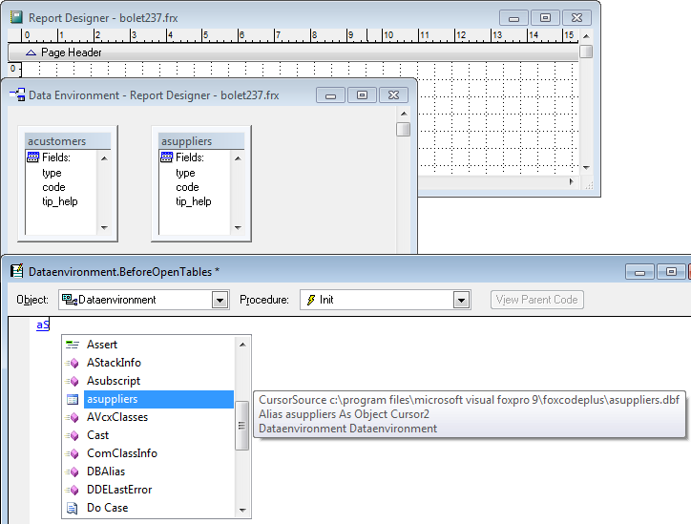

*Image 5.12*

1. **Fields at write-time and at run-time**  
   *Table fields are also included in the IntelliSense. The type of the field is displayed in the tooltip.*

*Note: Table fields created by "SELECT - SQL command" are not supported.*

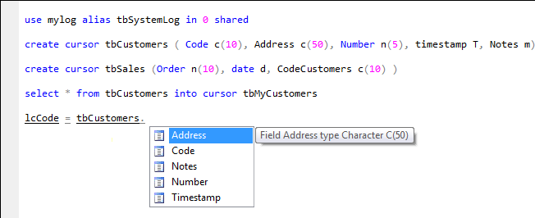  
*Image 6.10*

1. **Selecting a table with the command "Select" or all commands with the clause "IN"**

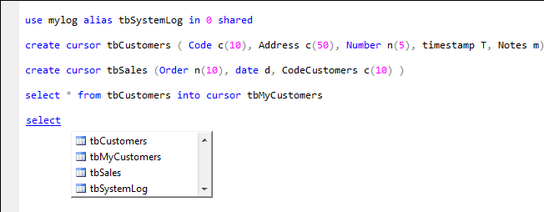

*Image 7.10*

*All commands for manipulating data in tables that contain the clause "IN" interact directly with IntelliSense, so all the tables created and/ or opened in the program code are presented.*

*Below is the list of supported commands with the clause "IN"*

|  |  |
| --- | --- |
| * Append * Replace * Blank * Calculate * Delete * Display * Flush * Go | Goto * List | * Recall * Seek * Select * Set Filter * Set Order To * Set Relation * Skip * Unlock * Zap |

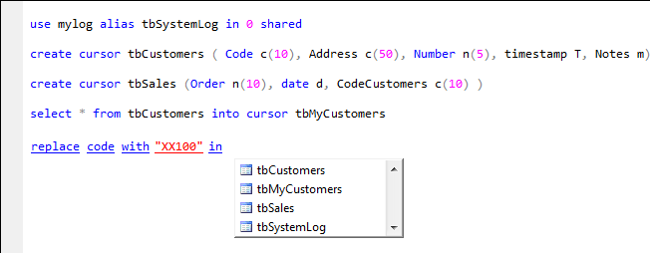

*Image 7.11*

1. **APIs at write-time and at run-time***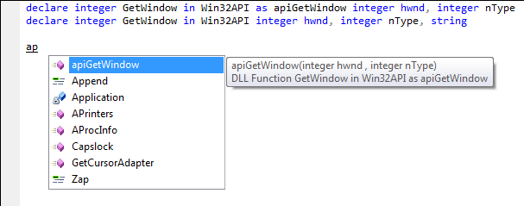*

*Image 8.10*

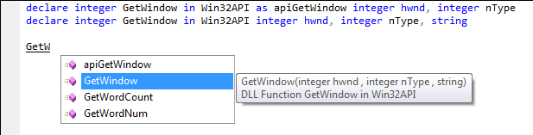

*Image 8.11*

1. **Functions and Procedures at write-time***Functions and Procedures created in the current PRG.*

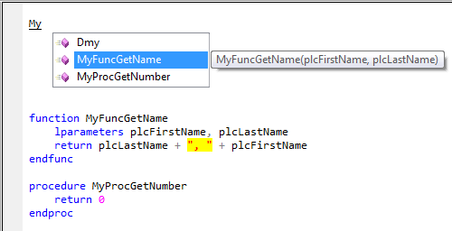  
*Image 9.10*

*Functions and Procedures created in the others PRGs invocated by SET PROCEDURE TO…  
SET PROCEDURE TO … in memory is also considered. 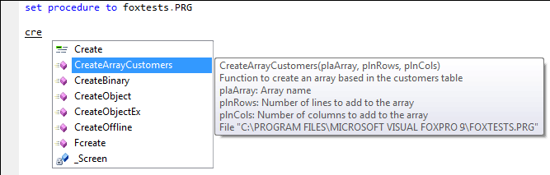Image 9.11*

1. **Classes at write-time**

*Classes created in the current PRG*  
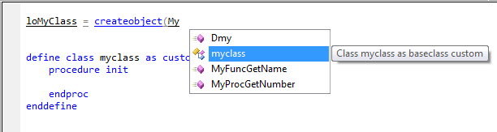  
*Image 10.10*

*Classes created in the others PRGs invocated by SET PROCEDURE TO...  
SET PROCEDURE TO … in memory is also considered.*  
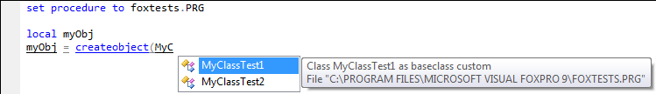

*Image 10.11*

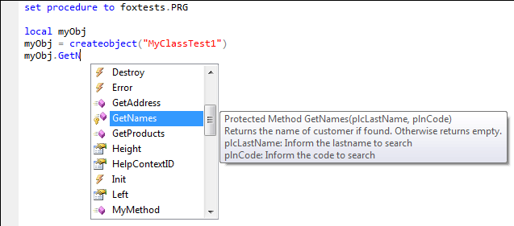

*Image 10.12*

*Classes created in VCX files invocated by SET CLASSLIB TO...*   
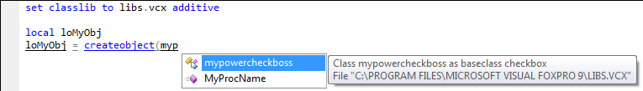

*Image 10.13*

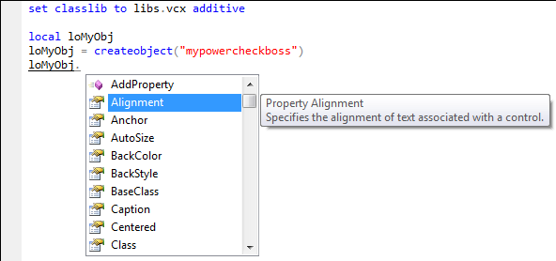  
*Image 10.14*

1. **Properties at write-time** *Beside the properties of the inherited class, the properties included in the class are also included in the IntelliSense. To access the properties, we use "this." In this case, IntelliSense opens in non-incremental mode.*

*NOTE: If the class is not inherited from a class or a standard, registered VFP ActiveX, only the properties and methods added to the class will be presented. If the inherited class is in another program, the inherited properties and methods are not included IntelliSense (for now).*  
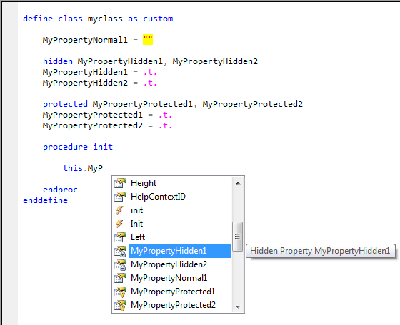  
*Image 11.10*

1. **Methods and Events at write-time**

*Besides the methods and events of the inherited default class, the new methods in the class are also included in the IntelliSense. To access the methods and events, use "this."*

*NOTE: If the class is not inherited from a class or a standard registered VFP ActiveX, only the methods and events and methods added to the class will be presented. If the inherited class is in another program, the inherited properties and methods are not included in the IntelliSense. (for now).*

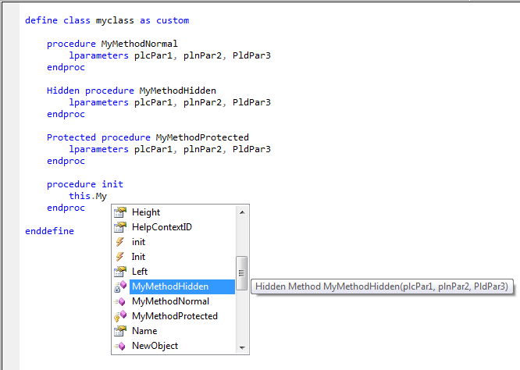

*Image 12.10*

1. **Summary Tooltip for functions, procedures, methods and events.***Pressing asterisk three times ("****\*\*\*****") in the line above where the function, procedure, method or event was created, automatically inserts a block summary. The summary is a way to document the program in a standardized way; in addition, it provides a custom tooltip.*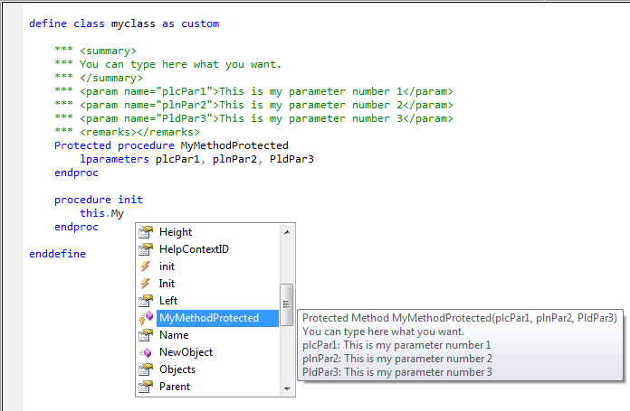  
   *Image 13.10*
2. **Class objects at write-time**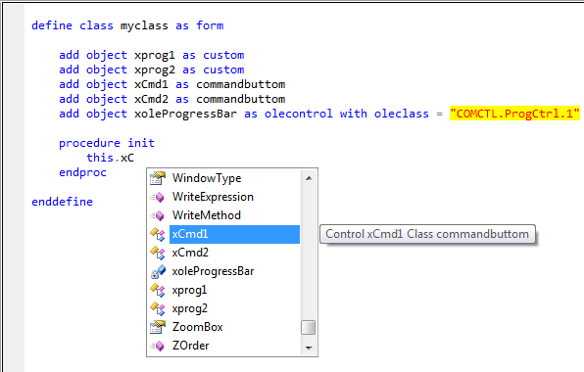

*Image 14.10*

1. **With ... ENDWITH with nesting infinity for any class or instantiated object at write-time and   
   at run-time.**  
   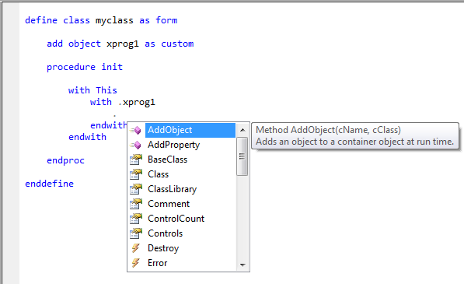  
   *Image 15.10*
2. **Objects instantiated in memory**   
   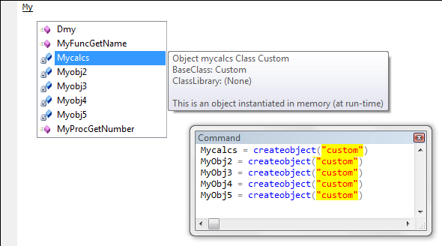  
   *Image 16.10*
3. **Incremental Shortcut to controls on the form or class designer.**

*Type just the control name; you don’t need to type "this." or "thisform."*

*When you select the item in IntelliSense, "this." or "thisform." is automatically inserted.  
For easy identification, the caption of the control is displayed on the IntelliSense tooltip,   
such as the propriety’s BaseClass and ClassLibrary.*

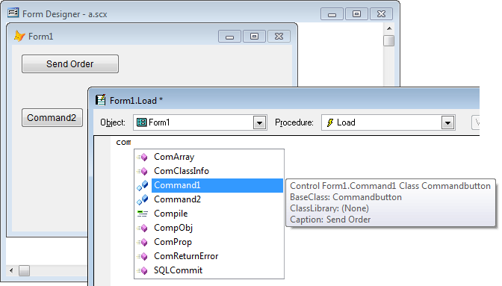*Image 17.10*

*In the tooltip the name of control is preceded by the parent name object. (e.g.* ***Form1****.Mypowercheckboss1)*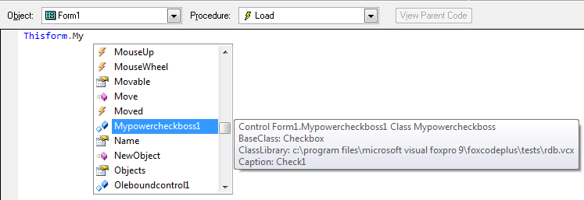

*Image 17.11*

1. **Replacement of the native IntelliSense in form and class designer.**

*If the “****Manage Controls at design-time****” option is marked in the “IntelliSense Manager”, FoxcodePlus will replace the native IntelliSense in the Form and Class Designer. When replaced, FoxcodePlus can directly interact with VFP and improve the information in tooltip and other features as well.*

1. **New IntelliSense for some commands**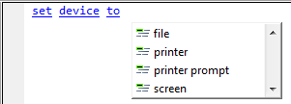*Image 19.10*

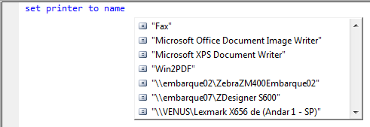  
*Image 19.11*

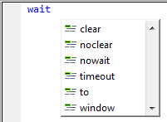  
*Image 19.12*

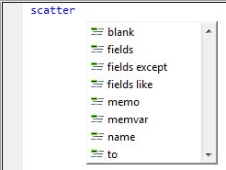  
*Image 19.13*

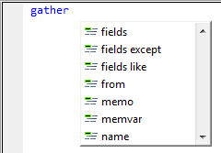  
*Image 19.14*

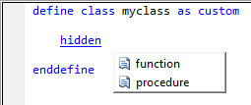  
*Image 19.15*

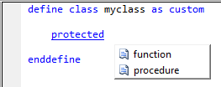  
*Image 19.16*

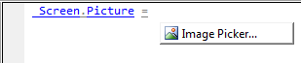  
*Image 19.17*



*Image 19.18*

  
*Image 19.19*

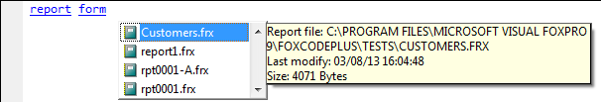

*Image 19.20*

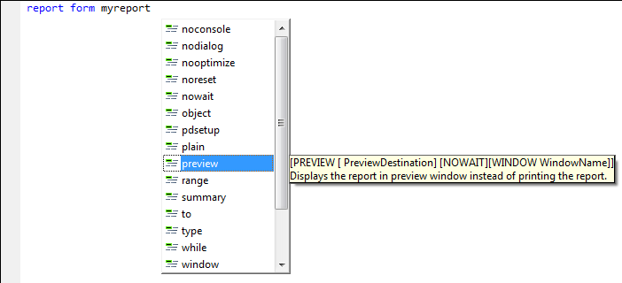

*Image 19.21*

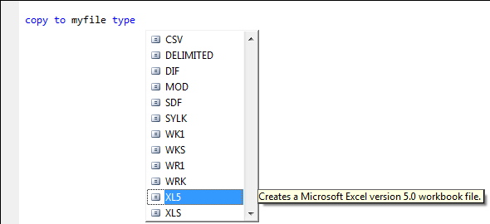

*Image 19.22*

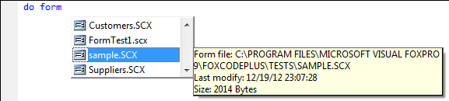

*Image 19.23*

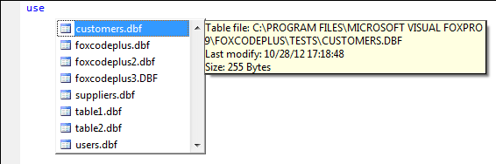

*Image 19.24*

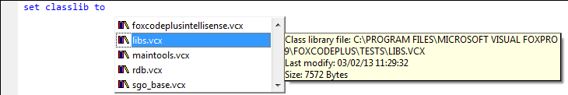

*Image 19.25*

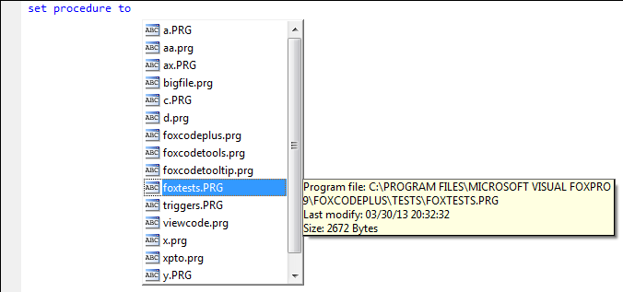

*Image 19.26*

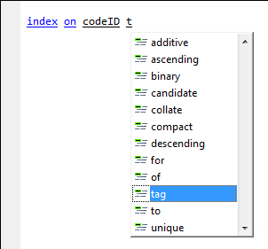

*Image 19.27*

1. **Code snippets**

*As in Visual Studio, the native and custom Code Snippets are included in the IntelliSense. For that, the “****Show code snippets****” option should be marked in the “IntelliSense Manager”.*

*The Code Snippet list can be consulted in the “IntelliSense Manager”:*

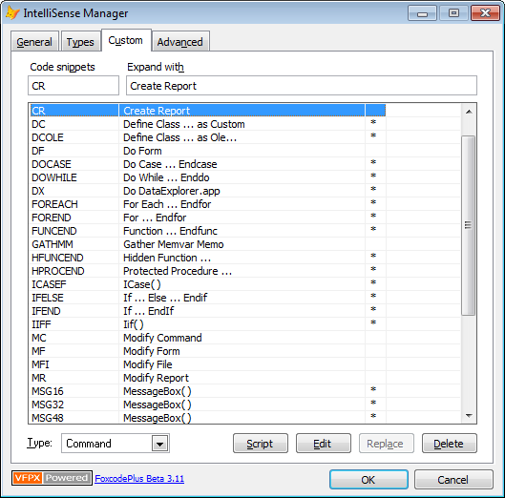  
*Image 20.10*

*If you select an item in the IntelliSense by pressing the SPACE key or type in the code snippet code and pressing SPACE beside the code, a code block is inserted to reduce typing.*

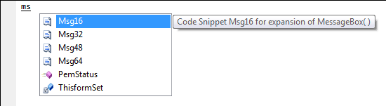

*Image 20.11*

messagebox("mymessage",16,"error")

1. **IntelliSense at write-time for the objects created with the CreateObject(), CreateObjectEx() and NewObject() functions**

*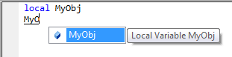  
Image 21.10*

*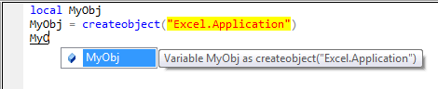  
Image 21.11*

*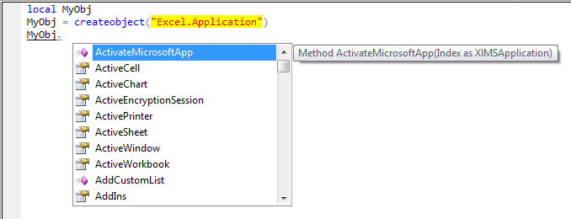Image 21.12*

*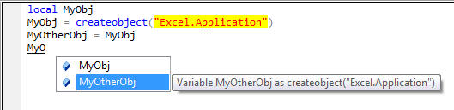  
Image 21.13*

*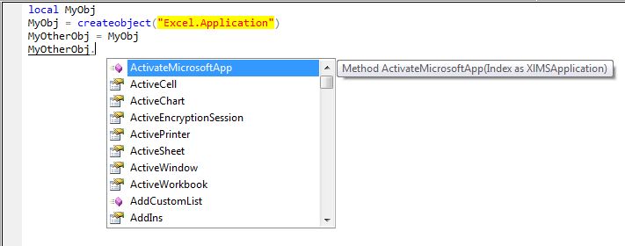Image 21.14*

*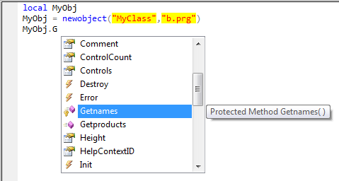  
Image 21.15*

*Support for _MemberData property indicating that the property had capitalization.*

*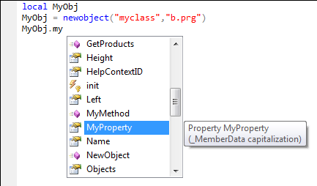  
Image 21.16*

1. **FOR EACH for collection objects at run-time and designer-time.**

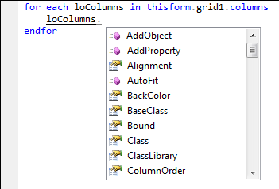

*Image 22.10*

1. **IntelliSense for collection objects at run-time and designer-time.**

*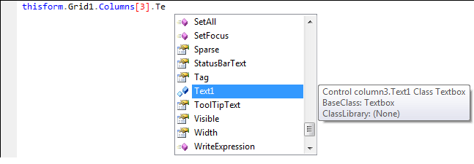  
Image 23.10*

1. **Referencing an object at run-time and designer-time to a variable at write-time**

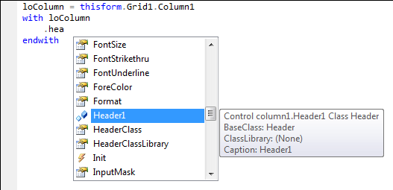

*Image 24.10*

1. **Documenting properties with custom tooltip**

*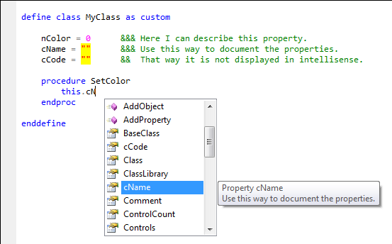  
Image 25.10*

*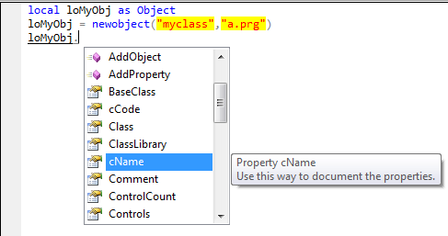  
Image 25.11*

1. **Help pressing F1**

*Pressing F1 to open IntelliSense, VFP will open the help positioned to the command, function, method or event positioned.*

1. **SELECT, INSERT, UPDATE and DELETE for database connected. (Tested with MS Sql Server)**

*This feature provides the IntelliSence bringing information from a database connect. It’s possible to work disconnected, however the IntelliSence display only the tables (no fields) included in the current sql-command.*

*NOTE: It’s necessary you put your SQL-Command in a TEXT…ENDTEXT block.*

*You can choose the options showed below in order to select the best way that you want to use it.   
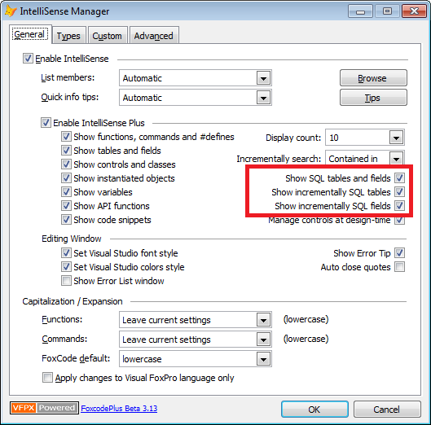*

*Image 27.10*

*SELECT – After the clause “FROM” and “JOIN” a list of tables and tables’ alias from the current database is shown (non-incremental mode)*

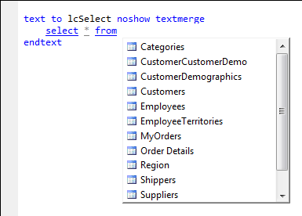

*Image 27.11*

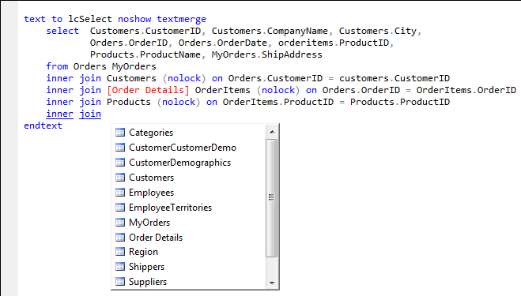

*Image 27.12*

*SELECT – As in* ***SQL Server Management Studio,*** *tables and tables’ alias are shown in the IntelliSense in incremental mode. All Fields that belong for each table included in SELECT are show as well.*

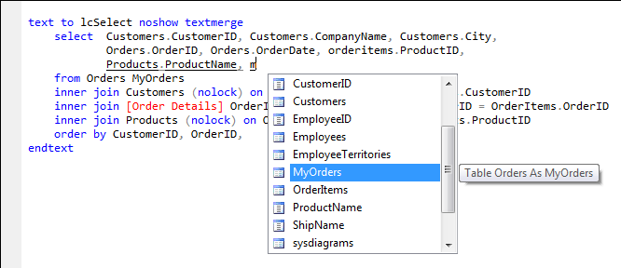

*Image 27.13*

*INSERT – IntelliSense for fields through the tables’ alias*

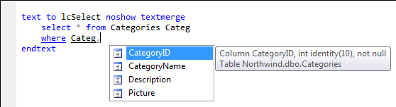

*Image 27.14*

*INSERT – After the clause “INTO” a list of tables from the current database is shown (non-incremental mode)*

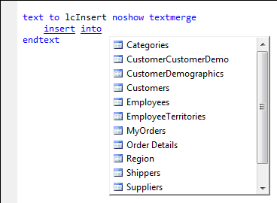

*Image 27.15*

*In incremental mode the fields that belong to the table defined after the clause “INTO” are shown.*

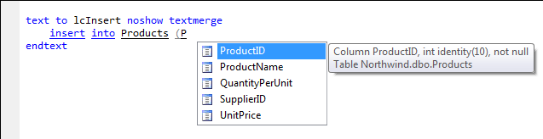

*Image 27.16*

*UPDATE – After the command “UPDATE”, a list of tables from the current database is shown   
(non-incremental mode)*

*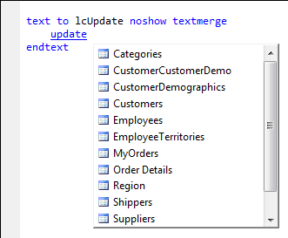  
Image 27.17*

*In incremental mode the fields that belong to the table defined after the command “UPDATE” are shown.*

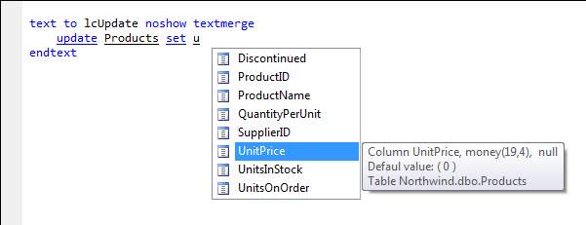

*Image 27.18*

*After de clause “WHERE”, in incremental mode the tables from the current database and fields that belong to the table defined after the command “UPDATE” are shown.*

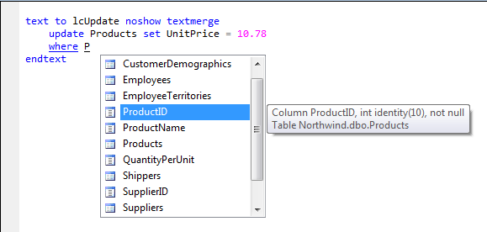

*Image 27.19*

*DELETE – After de clause “WHERE”, in incremental mode the tables from the current database and fields that belong to the table defined after the clause “FROM” are shown.*

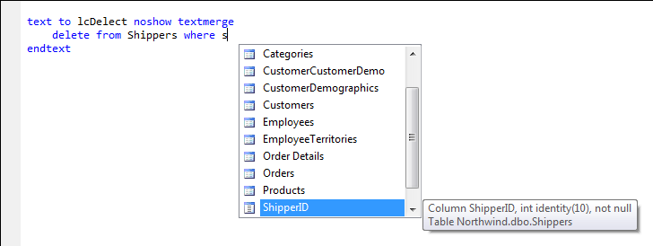

*Image 27.20*

1. **Signature of custom procedures, functions, methods and events.**

*Procedures and functions created in the current PRG or invoked by SET PROCEDURE TO... now can show a tooltip with the signature; in addition the summary is supported. That is, according to the positioned parameter, the tooltip respectively can show the number of the parameter and the information defined in the summary.  
NOTE: No support for native functions, nor for methods and events outside of a "Define Class ...". (By now)*

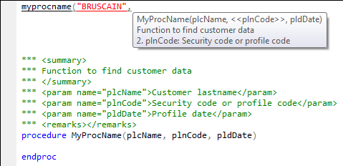

*Image 28.10*

*If the function contains more than the permitted number of parameters, an error will be shown at write-time.  
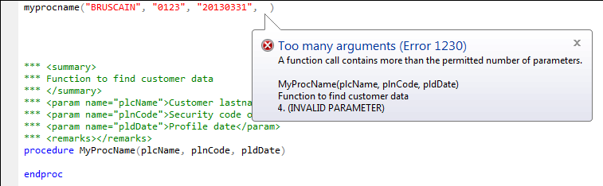*

*Image 28.11*

*For methods and events, the functionality is the same.*

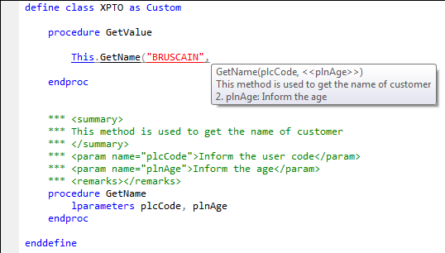

*Image 28.12*

1. **Error list**  
   *Display the program errors by compiling at write-time.*

*When you click on an error in the list, VFP will go to the program line containing the error.*

*NOTE: This option can slow VFP down, depending on the size of the PRG file.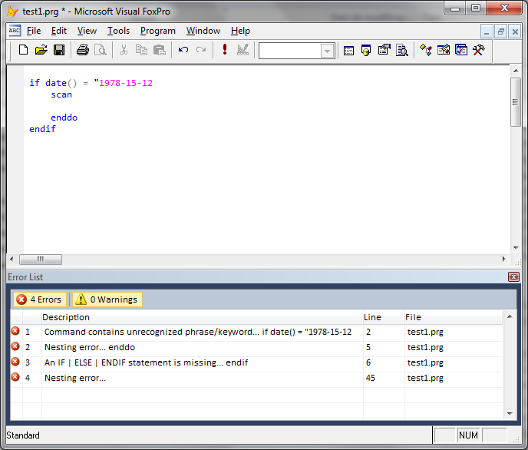Image 29.10*

*To activate the "Error List window”, select “Error List” from the “View” menu. You can also configure VFP to always start with the "Error List" window opened; to do that, mark the "****Show Error List window****" checkbox in the "IntelliSense Manager".*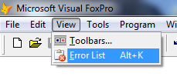  
*Image 29.11*

1. **Error Tip**  
   *Show some possible run-time errors in write-time. To display the errors in a tool tip, you need to check the “****Show Error Tip”*** *checkbox in the "IntelliSense Manager"  
   Bellow, the Errors Tips available:*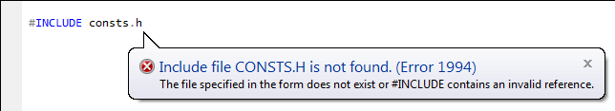  
   *Image 30.10*

*The message bellow can be showed for THIS, THISFORM and THISFORMSET*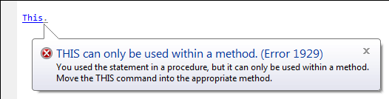  
*Image 30.11*

*The message bellow can be showed for PRG|MPR|QPR|FXP|APP|EXE* 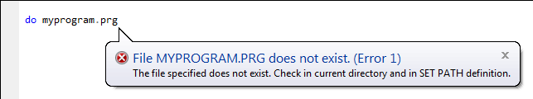  
*Image 30.12*

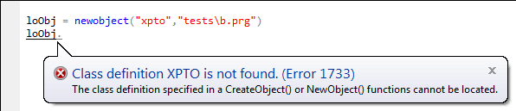  
*Image 30.13*

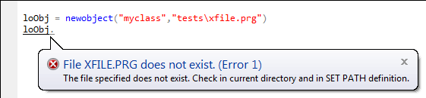  
*Image 30.14*

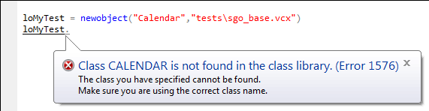  
*Image 30.15*

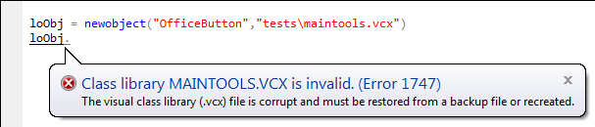  
*Image 30.16*

*Image 30.17*

*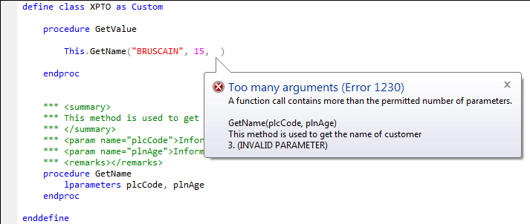Image 30.18*

1. **Installing FoxcodePlus (Only for Visual FoxPro 9)**

Files available:  
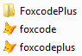

***If you already have installed FoxcodePlus 3.10 or a previous version, you must have to replace the files foxcode.app , foxcodeplus.app and whole directory ...\Foxcodeplus\*.*. Also, it’s necessary to do the step 7. If you have installed 3.11 or 3.12 you only have to replace foxcode.app and foxcodeplus.app.***

Follow the 7 steps below to install for the first time:

1. If VFP is open, close it.
2. Open the folder where Visual FoxPro 9 is installed.
3. Rename files FoxCode.App
4. Copy the new files available to the folder.
5. Open VFP and access the "IntelliSense Manager" as indicated below: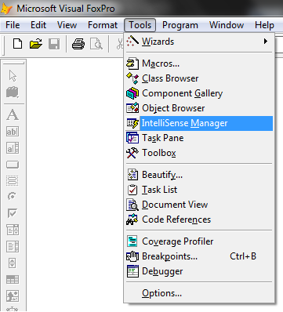

*Image 31.10*

1. Make the settings as below.

*The “IntelliSense Manager” now includes some new options as outlined below in red.*

*Activate the "****Enable IntelliSense Plus****" checkbox, select or deselect the options according to your choice.*

*By default, the "****Show Error List Window”*** *and "****Auto close quotes****" checkboxes are not marked.*

*NOTE 1: If your VFP is customized with a program like "STARTUP", it will be removed. To resolve this, you have to create a PRG file to call your program and FoxcodePlus.App*

*NOTE 2: The colors established by the "****Set Visual Studio colors style****" checkbox option can be reconfigured by the general editor of the VFP.*

*NOTE 3: When you activate the "****Enable IntelliSense Plu****s" checkbox, the CONFIG.FPW file will be created if it does not already exist, and it will be modified to run the correct FoxcodePlus.App.*

*NOTE 4: Not all the new features of FoxcodePlus work in the "Command Window".*

*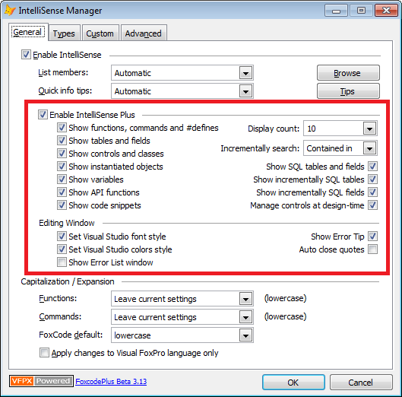  
Image 31.11*

1. The last step, FoxCode table update.

With this update you will keep your customizations in the FoxCode table. A backup of your FoxCode table will be created automatically and a log file will be generated to indicate all updates and additions in your FoxCode table.

The update will change some existing registers and will include new registers in your FoxCode. However, there is the possibility of the update override some customization if the customization has the same information in the "TYPE", "ABBREV" and "EXPANDED" fields.

If you have no customization in the FoxCode table, perfect. If you have, run the update and check if something that you have created has been overridden. In this case, you must manually adjust your FoxCode table.

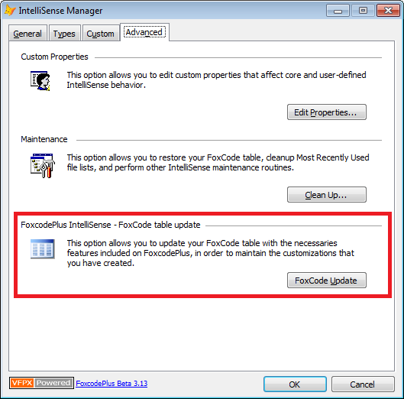

*Image 31.12*

Thank you everyone and have a good times.

Rodrigo Duarte Bruscain  
Visual Studio | Visual C# | MS SQL Server | Visual FoxPro  
 <https://www.mcpvirtualbusinesscard.com/VBCServer/rodrigobruscain/profile>  
 [www.linkedin.com/in/rodrigobruscain](http://www.linkedin.com/in/rodrigobruscain)