

Python Programming III

Offensive and Defensive Tool Construction

Table of Contents

Objectives 2

Background Reading 2

Important Information 2

Introduction 3

Problem 1 3

Problem 2 3

Problem 3 4

Offensive and Defensive Tool Construction

Python Programming III

Objectives

This lab focuses on the following objectives:

* Define a Python class.
* Create a Python object.
* Use class functions.
* Define class methods.
* Explain inheritance.

Background Reading

Read chapters 12–14 in *How to Think Like a Computer Scientist: Learning with Python*, available at [www.greenteapress.com/thinkpython/thinkCSpy.pdf](http://www.greenteapress.com/thinkpython/thinkCSpy.pdf).

Read the documentation for PID provided on D2L.

# Important Information

* For *every* lab or assignment, store all your work in your personal repository in a subdirectory named **mXX**, where XX is the module number. Carefully name the program as described in each problem.

# Introduction

In this lab, we will read and parse contents of the Linux */proc* pseudo-file system, namely the per-process part, */proc/[pid]/stat*.

Furthermore, **if you would like a challenge**, use the Python graphics library PIL and generate a process structure picture. You can then design a simple graphical user interface (GUI) to interact with the application, using GTK3 and the Glade GUI designer.

# Problem 1

Write a Python program named **m03p01.py** that must create a class called **LinuxProcess**. Within the class write methods to extract the fields below.

Test the class by writing code that gets the PID of the process you are executing. Apply the class methods and print the results using the format below:

Although **there are easier** ways, **YOU MUST PARSE** **/proc/<PID>/stat** file.

If you are looking for a bit more of a challenge also parse **/proc/<PID>/status** to extract some of the values requested below or add other interesting values that could be useful …

name: m03p01.py

pid: 2345

ppid: 340

rss: 0xfffffffffffffL

rsslim: 0xffffffffffffffffL

start_code: 0x400000

end_code: 0x6bb0f4

start_stack: 0x7fffdd658190

start_data: 0x8bbdc0

end_data: 0x9303f4

start_brk: 0x2872000

arg_start: 0x7fffdd658661

arg_end: 0x7fffdd65867d

env_start: 0x7fffdd65867d

env_end: 0x7fffdd658fec

# Problem 2

Write a Python program named **m03p02.py** that creates the **LinuxProcList** class. This class reads all the running processes from */proc* and generates an internal structure that represents the process tree. It also reads the command lines used to invoke each process. You will need to read at least the files */proc/[pid]/stat* and */proc/[pid]/cmdline* for each process. The methods in the class should meet the following criteria:

* LinuxProcList.proclist() returns a list of all process IDs,
* LinuxProcList.cmdline(pid) returns either a string containing the command line for the given process or *None*, and
* LinuxProcList.children(pid) returns a list of the children of the given process.

Although **there are easier** ways, **YOU MUST PARSE** **/proc/<PID>/stat and /proc/<PID>/cmdline** files. As you work through this example, you will see there are some opportunities for code reuse. It is imperative that your code MUST be modular; in other words you must create functions. You must create classes (with methods and possibly attributes).

# BONUS (10 pts)

Using the LinuxProcess and LinuxProcList classes, write a Python program named **m03p03.py** and devise a way to graphically display a process tree on the terminal, similar to the *ps* or *pstree* commands. Avoid displaying processes that do not have a command line (e.g., the pseudo-file */proc/[pid]/cmdline* returns an empty line). Use the Pycairo module, which wraps the Cairo graphics library.

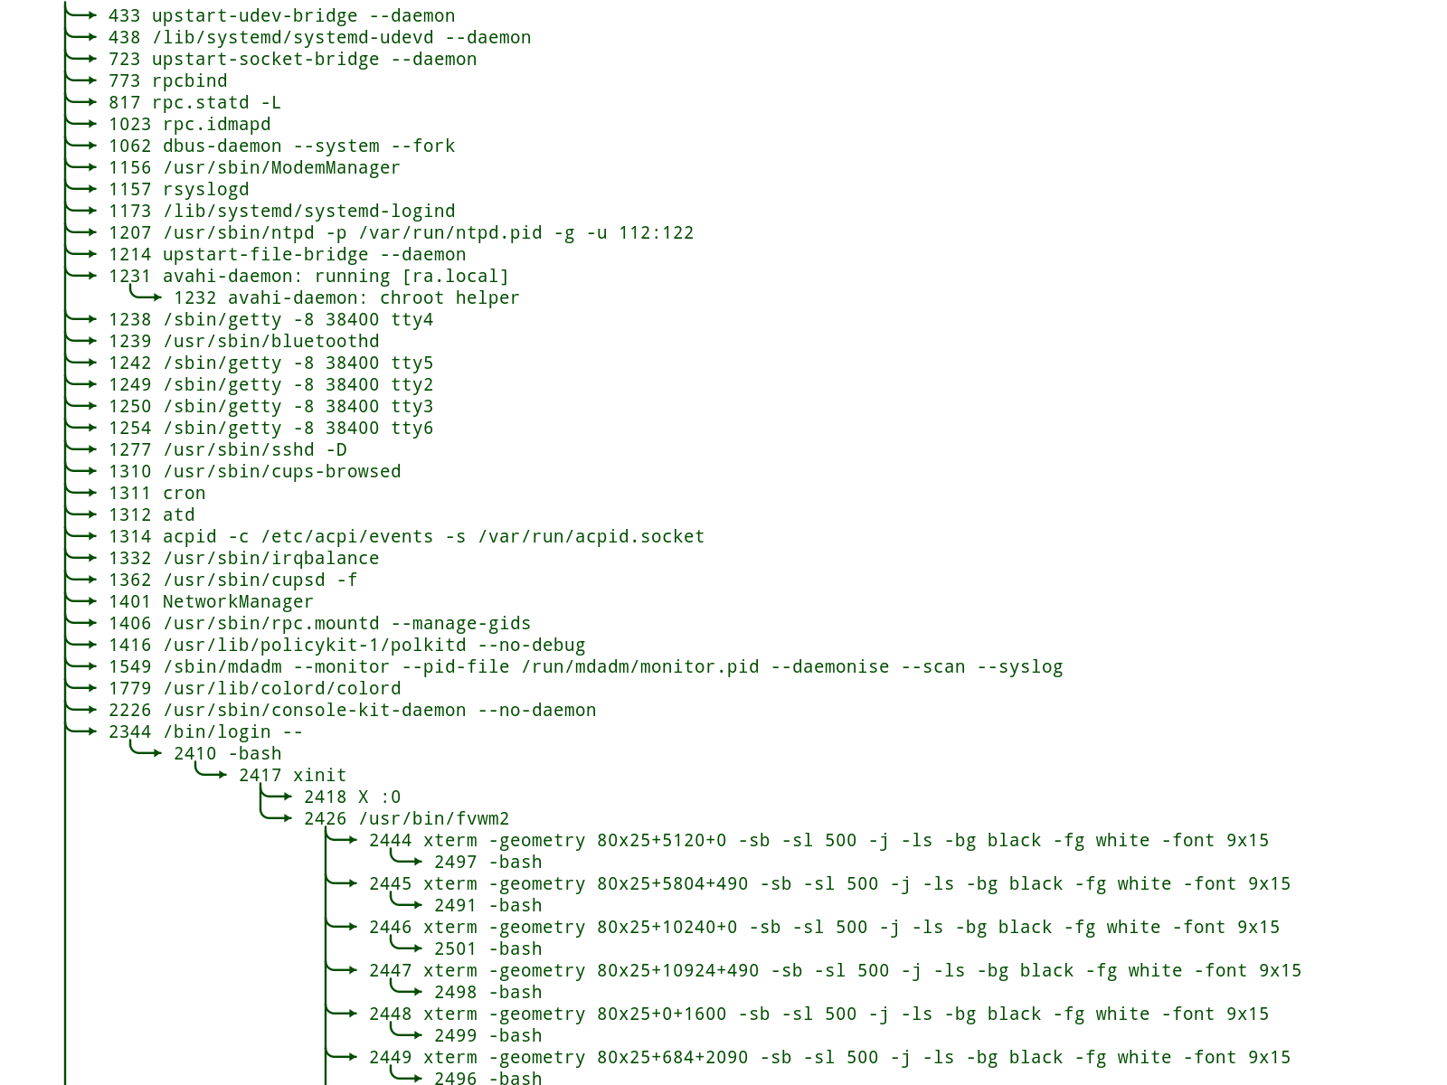The following is an example of the result:

**© 2017, Linux**  
Reproduced and used in accordance with SAIT’s Fair Dealing Policy (Schedule A, *Copyright of External Materials Procedure AC.2.12.1*); further distribution may infringe copyright.