OrcaSlicer切片流程分析

OrcaSlicer 切片架构分析

整体结构

目录结构
Plain Text
src/
├── libslic3r/ # 切片引擎核心库
│ ├── Print.hpp/cpp # 主切片控制器
│ ├── PrintObject.hpp/cpp # 打印对象处理
│ ├── Slicing.hpp/cpp # 切片算法实现
│ ├── Layer.hpp/cpp # 层数据结构
│ ├── Fill/ # 填充算法模块
│ │ ├── FillBase.cpp # 填充基础类
│ │ ├── FillGyroid.cpp # Gyroid数学填充
│ │ ├── FillLightning.cpp # Lightning快速填充
│ │ └── FillAdaptive.cpp # 自适应填充
│ ├── GCode/ # G代码生成模块
│ │ ├── GCodeProcessor.cpp # G代码处理器
│ │ ├── ToolOrdering.cpp # 工具排序
│ │ └── WipeTower.cpp # 清洁塔生成
│ ├── Geometry/ # 几何计算工具
│ ├── Support/ # 支撑算法
│ └── Arachne/ # Arachne轮廓算法
├── slic3r/ # GUI应用层
│ ├── GUI/ # 用户界面
│ └── Utils/ # 工具函数
├── OrcaSlicer.cpp # CLI主入口
└── platform/ # 平台特定代码
└── ... # 其他代码

架构层次图
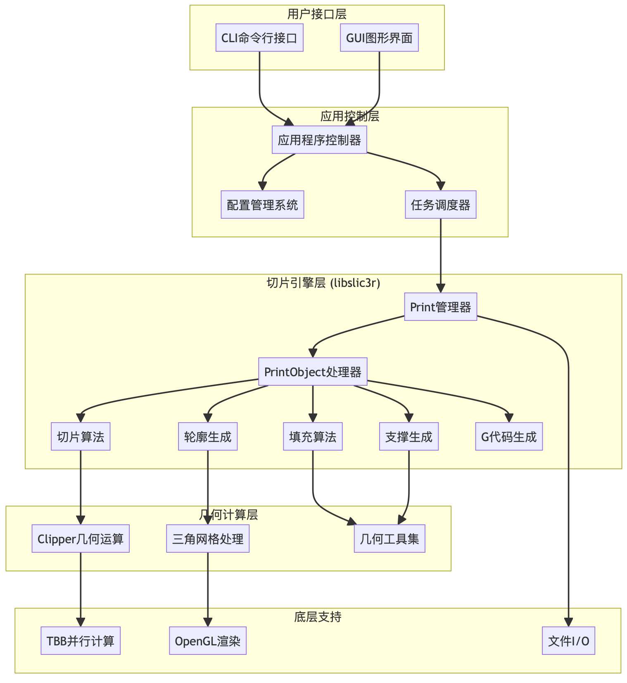

切片核心流程
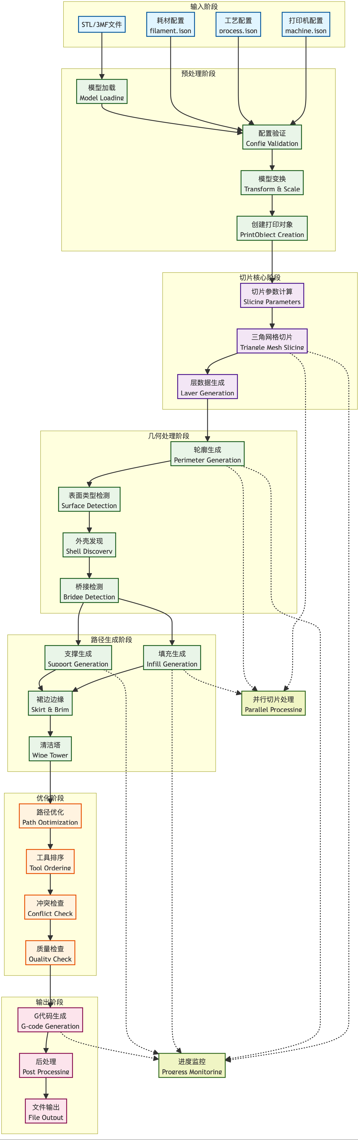

添加切片进度
使用管道监听
Plain Text
mkfifo slicer_pipe
cat slicer_pipe
cli切片
Plain Text
orcaSlicer \
--slice 0 \
--debug 1 \
--pipe slicer_pipe \
--load-settings machine.json \
--load-settings process.json \
--load-filaments filament.json \
--outputdir output/ \
model.stl

JSON
// 进度输出
{"message":"Slicing mesh","plate_count":1,"plate_index":1,"plate_percent":5,"total_percent":7}
{"message":"Generating walls","plate_count":1,"plate_index":1,"plate_percent":15,"total_percent":16}
{"message":"Generating infill regions","plate_count":1,"plate_index":1,"plate_percent":25,"total_percent":25}
{"message":"Generating infill toolpath","plate_count":1,"plate_index":1,"plate_percent":35,"total_percent":34}
{"message":"Generating support","plate_count":1,"plate_index":1,"plate_percent":50,"total_percent":48}
{"message":"Generating support","plate_count":1,"plate_index":1,"plate_percent":60,"total_percent":57}
{"message":"Generating support","plate_count":1,"plate_index":1,"plate_percent":69,"total_percent":65}
{"message":"Detect overhangs for auto-lift","plate_count":1,"plate_index":1,"plate_percent":71,"total_percent":66}
{"message":"Optimizing toolpath","plate_count":1,"plate_index":1,"plate_percent":75,"total_percent":70}
{"message":"Generating G-code","plate_count":1,"plate_index":1,"plate_percent":80,"total_percent":75}
{"message":"Slicing finished","plate_count":1,"plate_index":1,"plate_percent":100,"total_percent":93}
{"message":"All done, Success","plate_count":1,"plate_index":0,"plate_percent":100,"total_percent":100}
- Slicing mesh (5%) - 网格切片
- Generating walls (15%) - 生成墙壁
- Generating infill regions (25%) - 生成填充区域
- Generating infill toolpath (35%) - 生成填充路径
- Generating support (50-69%) - 生成支撑结构
- Detect overhangs (71%) - 检测悬垂
- Optimizing toolpath (75%) - 优化路径
- Generating G-code (80%) - 生成 G 代码
- Slicing finished (100%) - 切片完成

