ICE Engine API
Integration Test Report
─────────────────────────────────────
Environment: UAT
Base URL: https://uat-api.zw.ice-engine.com
Report Date: June 15, 2026
Total Tests: 5
Status: All Passed
Prepared by: 1010 Technologies

Test Overview
# | Test Name | Method | Endpoint | Status
1 | Authentication | POST | /proxy/oauth/token | PASSED ✓
2 | Vehicle Quote | POST | /proxy/vehicle-quote | PASSED ✓
3 | Vehicle Licensing | POST | /proxy/vehicle-licensing | PASSED ✓
4 | RadioTV Quote | POST | /proxy/zbc-quote | PASSED ✓
5 | RadioTV Licensing | POST | /proxy/zbc-licensing | PASSED ✓

Test 1: Authentication (OAuth Token)
● PASSED

Method | POST
Endpoint | https://uat-api.zw.ice-engine.com/proxy/oauth/token
Auth Type | No auth required (this call obtains the token)
Content-Type | application/json
Purpose | Obtain Bearer access token using partner client credentials

Request Payload
{
"grant_type": "client_credentials",
"client_id": "pus_eAozdyleSn6SrMCjbAqWd4E8",
"client_secret": "qQSJ6JsTO2F7hvDUEQcZx4cLbTv033WMc2u67YMECJjdbMds"
}

Response
{
"access_token": "eyJhbGciOiJIUzUxMiJ9.eyJqdGkiOiI5NTllNTc4YS03MmIzLT...",
"token_type": "Bearer",
"expires_in": 86400
}

Note: The full token is used as the Bearer token in all subsequent requests.
Token valid for 24 hours (86400 seconds).

Postman Screenshot
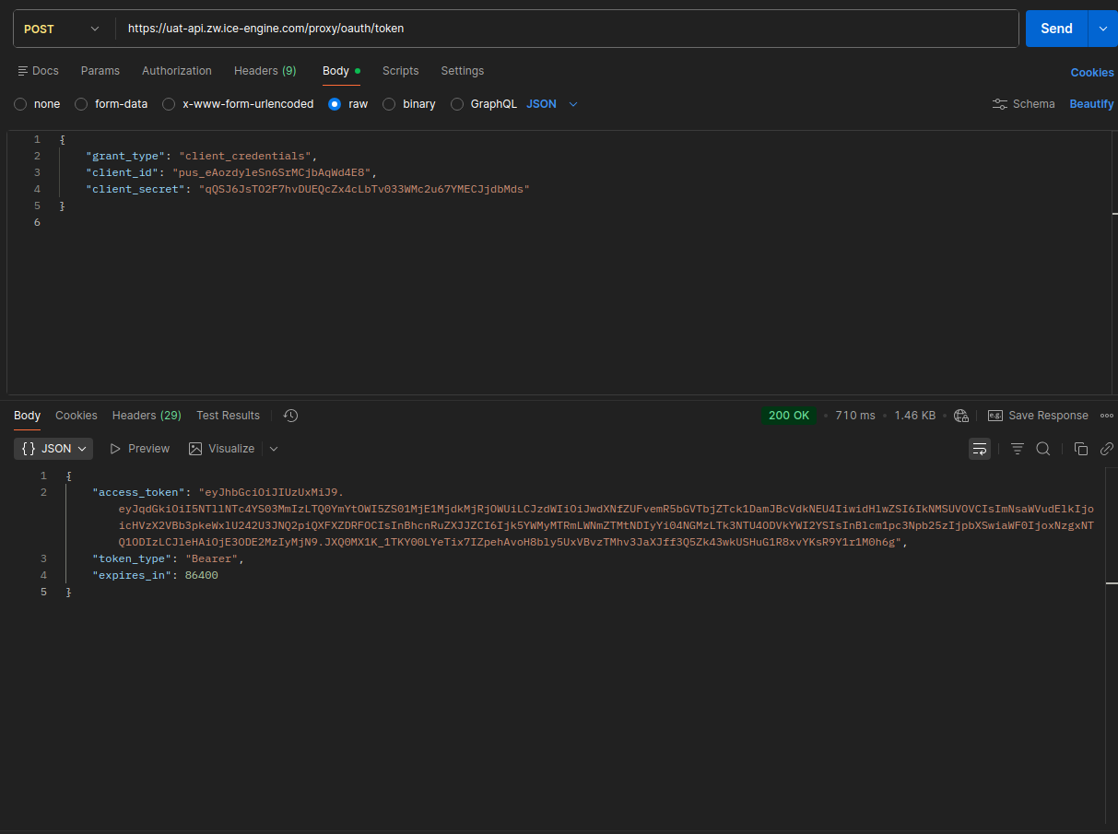
Figure 1 – POST /proxy/oauth/token · 200 OK · Auth token obtained successfully

Test 2: Vehicle License Quote
● PASSED

Method | POST
Endpoint | https://uat-api.zw.ice-engine.com/proxy/vehicle-quote
Auth | Bearer eyJhbGciOiJIUzUxMiJ9.eyJqdGkiOiI5NTllNTc4YS03MmIzLTQ0YmYtOWI1ZS01MjE1MjdkMjRjOWU…
Content-Type | application/json
Purpose | Retrieve a quote for vehicle licensing fees before committing to payment

Request Payload
{
"txVersion": "1.1.0",
"txGuid": "14986068-3fa8-4c94-ba56-a862d69b39a6",
"machineName": "NYASHA-LAPTOP",
"vrn": "AAV1111",
"licFrequencyCd": 1,
"ownerIDTypeCd": 1,
"ownerIDNo": "292000325G13",
"balanceAmt": 0,
"radioTVFrequencyCd": 1,
"radioTVUsageCd": 1,
"deliveryMethodCd": 1,
"agencyId": 1,
"currencyCd": "USD"
}

Response
{
"txVersion": "1.1.0",
"txGuid": "aac7fe2b-3c9c-4adb-bb7e-6e2fd4135b76",
"machineName": "NYASHA-LAPTOP",
"errorCd": 0,
"message": "Success",
"quoteDateTime": "20260615195411",
"vrn": "AAV1111",
"licFrequencyCd": 1,
"taxClassCd": 1,
"nettMass": 980,
"currentLicExpiryD": "20260531",
"transactionAmt": 40,
"arrearsAmt": 0,
"penaltiesAmt": 0,
"administrationAmt": 0,
"totalLicAmt": 40,
"radioTVAmt": 0,
"radioTVArrearsAmt": 0,
"totalRadioTVAmt": 0,
"totalAmt": 40
}

Postman Screenshot
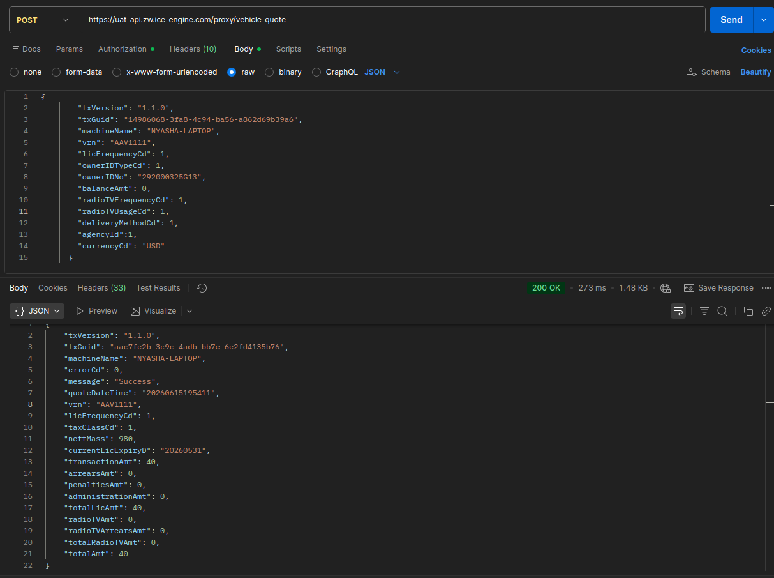
Figure 2 – POST /proxy/vehicle-quote · 200 OK · Quote: USD 40.00 total

Test 3: Vehicle Licensing
● PASSED

Method | POST
Endpoint | https://uat-api.zw.ice-engine.com/proxy/vehicle-licensing
Auth | Bearer eyJhbGciOiJIUzUxMiJ9.eyJqdGkiOiI5NTllNTc4YS03MmIzLTQ0YmYtOWI1ZS01MjE1MjdkMjRjOWU…
Content-Type | application/json
Purpose | Issue a vehicle licence and receive a digital licence certificate (base64 PDF)

Request Payload
{
"txVersion": "2.1.0",
"txGuid": "{{$guid}}",
"machineName": "NYASHA-LAPTOP",
"vrn": "AAV1111",
"licFrequencyCd": 1,
"tPICompanyCd": "BAA5F918BE31F20DE0400A0AD80153B8",
"tPIPolicyNo": "ICALL2498536",
"tPIExpiry": "20261013",
"tPIClass": "1,2/1,2/2,2/3",
"ownerIDTypeCd": 1,
"ownerIDNo": "1234567",
"addressLine1": "Complex 1",
"addressLine2": "3 Lucy Lane",
"suburbCd": 1,
"cityTownCd": 17,
"paymentAmt": 40,
"balanceAmt": 0,
"paymentMethodCd": 7,
"deliveryMethodCd": 3,
"agencyId": 1,
"currencyCd": "USD",
"certRequired": 1,
"officeCd": 2679
}

Response
{
"txVersion": "2.1.0",
"txGuid": "f72f3b73-e97c-4f4f-89c9-8b3b3b2fb97f",
"machineName": "NYASHA-LAPTOP",
"errorCd": 0,
"message": "Success",
"txanDateTime": "20260615195600",
"vrn": "AAV1111",
"currentLicExpiryD": "20260930",
"radioTVExpiryD": "20260930",
"receiptId": "R000056760",
"licenceCert": "JVBERi0xLjcKJe... [base64 PDF/image blob — see cert.txt]"
}

Note: licenceCert contains a base64-encoded PDF licence document.
Receipt ID: R000056760 | Licence expires: 30 Sep 2026

Postman Screenshot
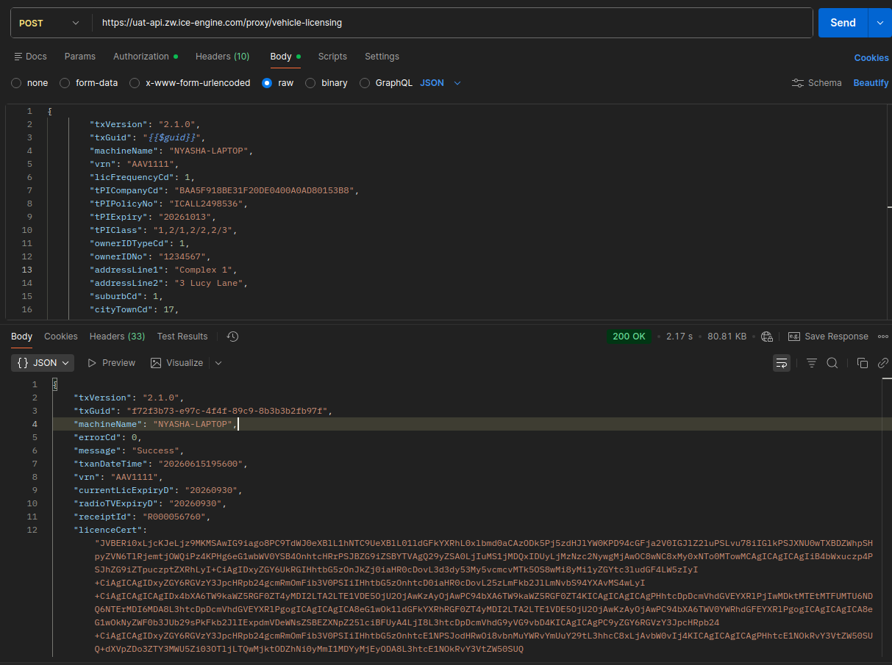
Figure 3 – POST /proxy/vehicle-licensing · 200 OK · Receipt R000056760 · Exp 20260930

Test 4: RadioTV (ZBC) License Quote
● PASSED

Method | POST
Endpoint | https://uat-api.zw.ice-engine.com/proxy/zbc-quote
Auth | Bearer eyJhbGciOiJIUzUxMiJ9.eyJqdGkiOiI5NTllNTc4YS03MmIzLTQ0YmYtOWI1ZS01MjE1MjdkMjRjOWU…
Content-Type | application/json
Purpose | Retrieve a RadioTV licence quote before committing to payment

Request Payload
{
"txVersion": "1.0.0",
"txGuid": "{{$guid}}",
"machineName": "MACHINE",
"registrationN": "AAV1111",
"radioTVFrequencyCd": 3,
"radioTVUsageCd": 1,
"paymentAmt": 84,
"paymentMethodCd": 8,
"currencyCd": "USD"
}

Response
{
"txVersion": "1.0.0",
"txGuid": "633e3dac-e15c-4797-84ce-79b805bd1db2",
"machineName": "MACHINE",
"message": "OK",
"statusCd": 3,
"Quote": {
"errorCd": 0,
"message": "Success",
"quoteDateTime": "20250912115036",
"vrn": "AAV1111",
"transactionId": "3E9892D7205D07F6E063352F10AC24CF",
"taxClassCd": 1,
"currentRadioTVLicExpiryD": "",
"radioTVArrearsAmt": 0,
"radioTVPenaltiesAmt": 0,
"totalRadioTVAmt": 84
}
}

Note: The Postman screenshot shows an alternate run response where errorCd 22
indicates "You can only license until 31-Jul-2027. Maximum months: 14".
This is an informational constraint, not an error — statusCd 3 = OK.

Postman Screenshot
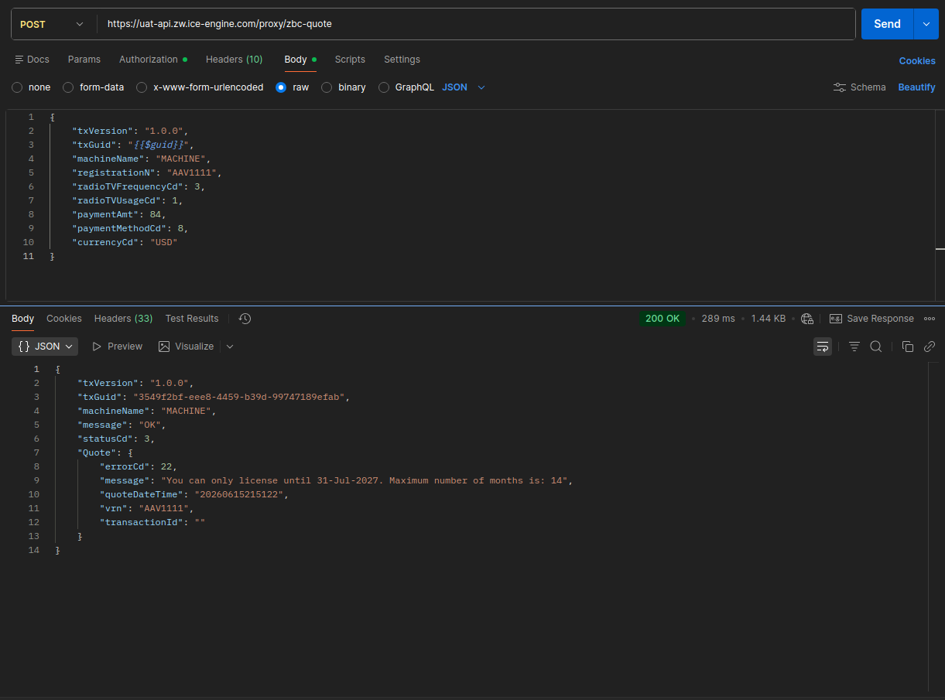
Figure 4 – POST /proxy/zbc-quote · 200 OK · ZBC quote retrieved · statusCd 3

Test 5: RadioTV (ZBC) Licensing
● PASSED

Method | POST
Endpoint | https://uat-api.zw.ice-engine.com/proxy/zbc-licensing
Auth | Bearer eyJhbGciOiJIUzUxMiJ9.eyJqdGkiOiI5NTllNTc4YS03MmIzLTQ0YmYtOWI1ZS01MjE1MjdkMjRjOWU…
Content-Type | application/json
Purpose | Issue a RadioTV licence and receive a receipt/transaction confirmation

Request Payload
{
"txVersion": "1.0.0",
"txGuid": "{{$guid}}",
"machineName": "MACHINE",
"vrn": "AAV1111",
"radioTVFrequencyCd": 3,
"radioTVUsageCd": 1,
"paymentAmt": 84,
"paymentMethodCd": 8,
"currencyCd": "USD"
}

Response
{
"txVersion": "1.0",
"txGuid": "2740eb11-ce5c-4ab8-907e-1a041e0ec6c9",
"machineName": "MACHINE",
"message": "Success",
"statusCd": 3,
"resultCd": 1,
"paymentStatusCd": 3,
"paymentResultCd": 1,
"errorCd": 0,
"txanDateTime": "20260615215012",
"vrn": "AAV1111",
"transactionId": "544841AF7BBBFE76E063341F10ACE87B",
"currentRadioTVLicExpiryD": "20270930",
"receiptId": "Z000007442"
}

Receipt ID: Z000007442 | RadioTV licence expires: 30 Sep 2027

Postman Screenshot
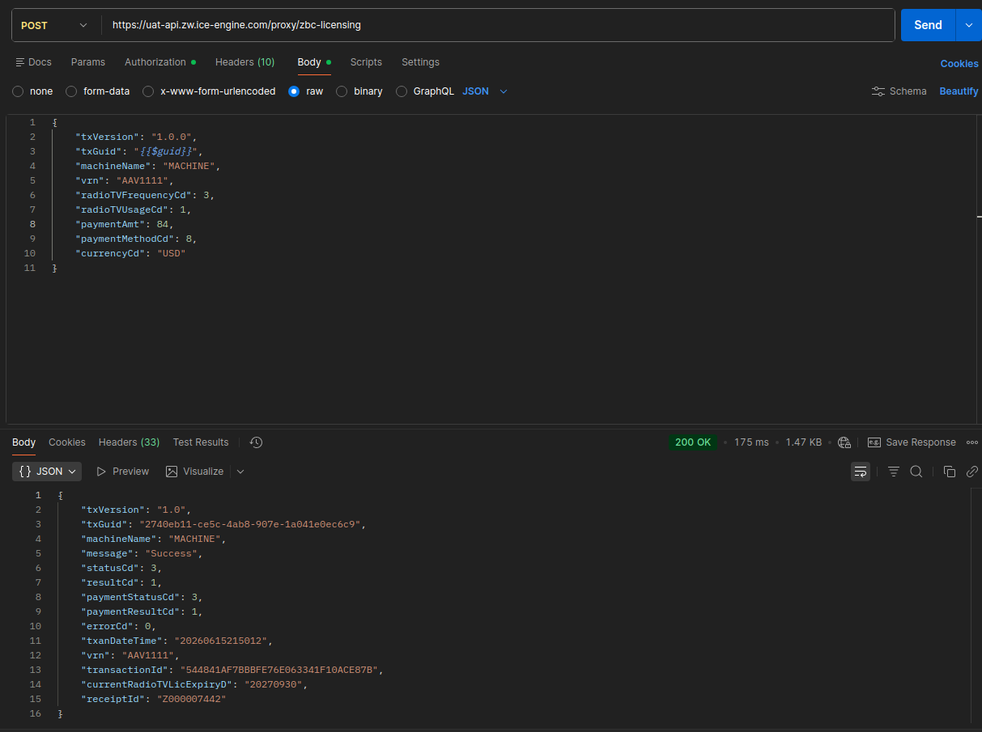
Figure 5 – POST /proxy/zbc-licensing · 200 OK · Receipt Z000007442 · Exp 20270930

Test Summary
Metric | Value
Total Test Cases | 5
Passed | 5
Failed | 0
Environment | UAT
API Version | 1.0.0 – 2.1.0 (per endpoint)
Auth Mechanism | OAuth 2.0 Client Credentials (Bearer JWT)
Token Expiry | 86,400 seconds (24 hours)
VRN Tested | AAV1111
Test Date | June 15, 2026

All 5 API integration tests completed successfully on the UAT environment.
The ICE Engine API endpoints are functioning as expected and ready for integration.

