Hello HSMA

# This is a top level header

This is my first Quarto report.

## This is a second level header

### This is a third level header

This is **bold** text and this is *italic* text.

* this is a list
* second
* third

1. this is an orderd list
2. second
3. third
4. fourth
5. fifth
6. lists can be nested
   * this is a nested list
   * second
   * third
   * fourth
7. but use gently!
   * this is a nested list

Github: <https://github.com/>

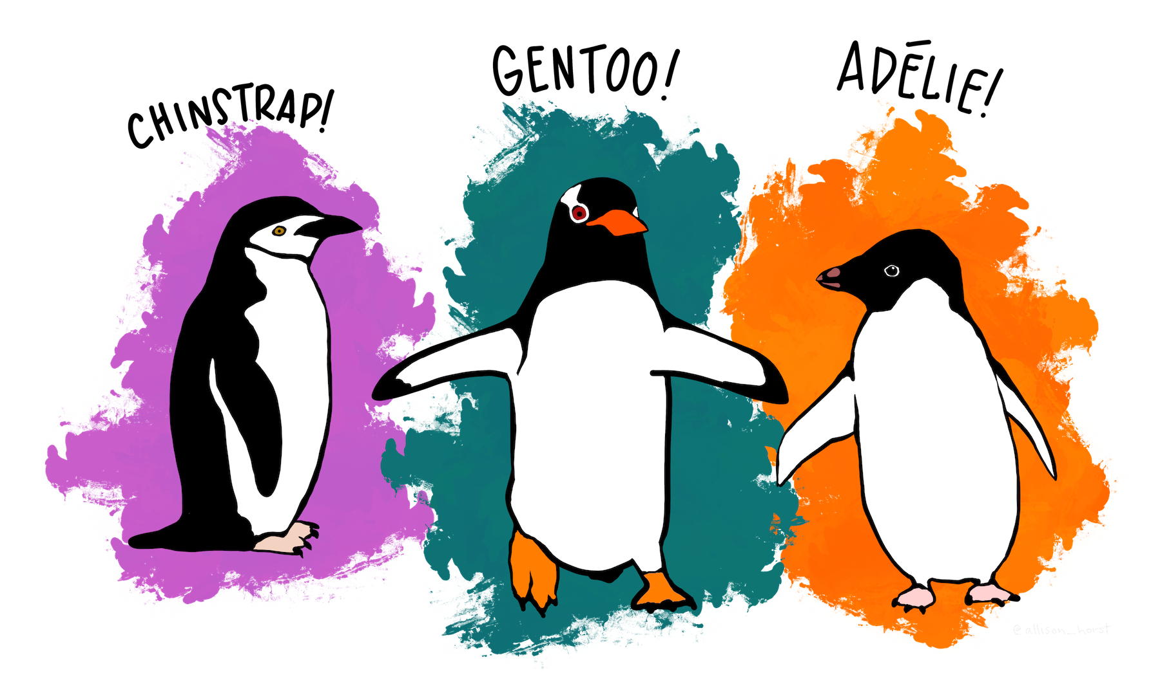  

|  | species | island | bill_length_mm | bill_depth_mm | flipper_length_mm | body_mass_g | sex | year |
| --- | --- | --- | --- | --- | --- | --- | --- | --- |
| 0 | Adelie | Torgersen | 39.1 | 18.7 | 181.0 | 3750.0 | male | 2007 |
| 1 | Adelie | Torgersen | 39.5 | 17.4 | 186.0 | 3800.0 | female | 2007 |
| 2 | Adelie | Torgersen | 40.3 | 18.0 | 195.0 | 3250.0 | female | 2007 |
| 3 | Adelie | Torgersen | NaN | NaN | NaN | NaN | NaN | 2007 |
| 4 | Adelie | Torgersen | 36.7 | 19.3 | 193.0 | 3450.0 | female | 2007 |

# This is next code cell

Unable to display output for mime type(s): text/html

Unable to display output for mime type(s): text/html

The average weight of a penguin is 4201.754385964912.

|  |
| --- |
| Note |
| Anything in this section is part of the note. |

But this is not.