Laila H.
Week 2 Assignment
6/2/26

Sharpened Problem Statement
Many young adults who are recent grads who want to exercise better money habits struggle to create and maintain a budget because they either don’t know where to start, don’t fully understand their current habits, or feel overwhelmed at the thought of sitting and breaking it all down using traditional budgeting methods. As a result, they remain unaware of where all their money goes overtime and have a difficult time paying off debt or reaching financial goals.

5 Whys Analysis
Why 1: Why don’t people fully understand their current spending habits?
Because they never learned how to identify patterns, they never tried to and underestimate the impact "small" purchases have overtime.
Why 2: Why have they never learned how to identify spending patterns, and why have they never tried to?
Fear. To face the truth and also because it's tedious and time consuming. That's a big part I'd like to fix. Something AI based that is linked to their bank and categorizes spending automatically.
Why 3: Why is the process tedious and time-consuming for them?
Multiple platforms, accounts and apps to reference.
Why 4: Why does reviewing their spending feel tedious and not worth the effort?
Feels tedious because it requires some self-accountability and not worth the effort because they're afraid they will fall back into old habits anyways and all of that work would be for nothing.
Why 5: Why do people expect themselves to fail at changing their money habits?
They never experience a win quickly enough to stay engaged. The process is ongoing and change comes after multiple better decisions over time.

Customer Segment and Discovery Prep
The specific demographic of people who feel this pain are young adults. More specifically, ages 18-30. These are people who are growing and accumulating financial responsibilities that require planning and good habits.

I plan on interviewing my cousin Rim who just moved states and acquired a large salary. I spent a weekend with her budgeting her money and since then she’s been doing well. Along with her, my brother in-law who also just moved states, got a new job and has a baby on the way.
Interview questions:
“If you had a personal accountant/finance manager free of charge, what would you want them to do for you?”
“What’s the most annoying part of managing money, in your experience?”
I would avoid interviewing people outside my target audience.

Early Competitive Scan
Direct competitors – Dave Ramsey, Mint app
Indirect competitors – Rocket money
Workarounds – traditional savings accounts, cash envelopes

Systems Map
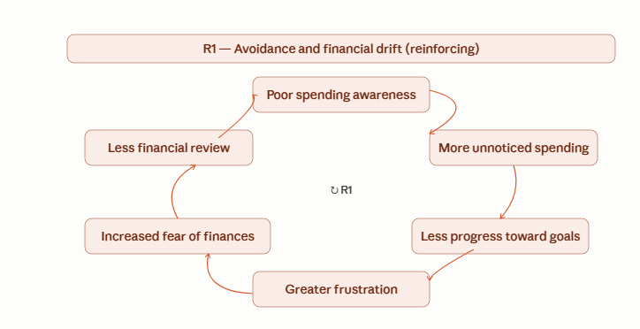

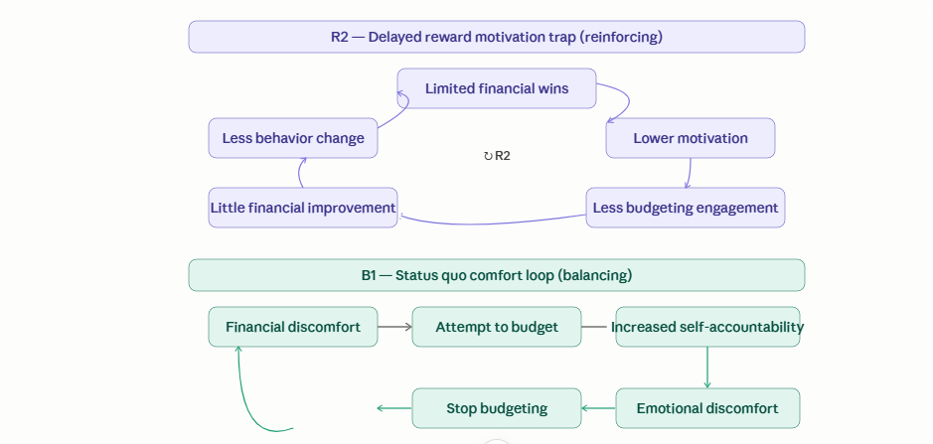

AI Conversation Log
https://chatgpt.com/share/6a1fa4f9-cf50-83ea-b030-09ad836c81c8
https://claude.ai/share/7259056f-910f-4f34-a84d-a7d2279bc0c1

