Project: IT Help Desk Management System

Real-World Scenario

Imagine you are a ServiceNow Administrator for a company called ABC Technologies.
Employees raise tickets for:
- Laptop Issues
- Email Issues
- VPN Access
- Software Installation
- Password Reset
- Hardware Requests
Your responsibility is to configure ServiceNow to manage the entire process.
What You Will Learn

Administration
- Users
- Groups
- Roles
- Departments
- Locations

ITSM
- Incident Management
- Request Management
- Service Catalog
- Knowledge Base

Automation
- Assignment Rules
- Notifications
- SLA
- Flow Designer

Reporting
- Reports
- Dashboards

Project Architecture

Employee
↓
Creates Ticket
↓
Assignment Rule
↓
Support Group
↓
Technician Works
↓
Ticket Resolved
↓
User Notification
↓
Dashboard Reporting
Phase 1: Company Setup

Step 1 Create Locations
Navigate:
All → Organization → Locations

As For my project requirement, first I’m creating Locations
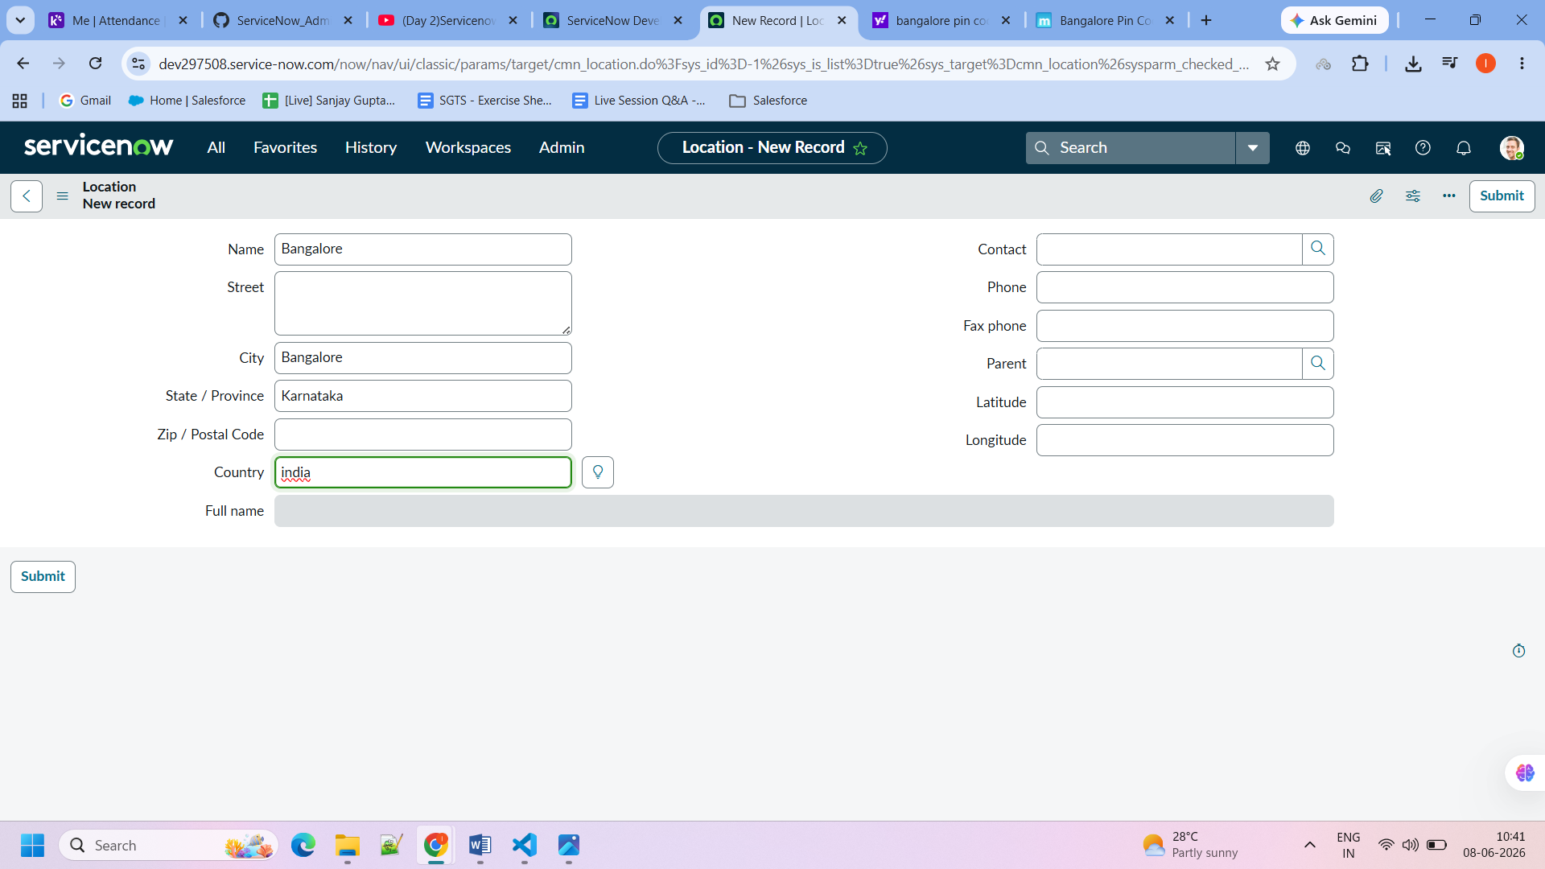
We need to enter location details.
Then click on submit.

Step 2: Create Departments

Why Departments?
Departments help categorize employees and route work.

Real-World Example
Department | Work
IT | Technical Support
HR | Employee Management
Finance | Payments & Budget
Sales | Customer Sales
Operations | Business Operations

Navigation
All → Organization → Departments
Click New.

