Activities Days 1-3

Visit Civic Centre at Sam Sharpe Square, Downtown. Telephone 1-876-952-5500.

Time 1 hour.

Cost: free

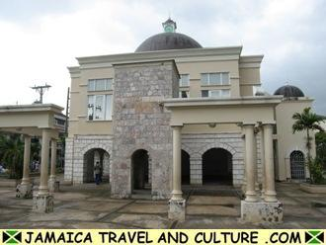

Doctors’s Cave Beach

Swim and enjoy Jamaica’s best beach.

Location: Gloucester Ave, Montego Bay, Jamaica.

Time: 3 hours

Cost: free

[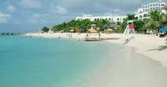](https://www.google.com/imgres?imgurl=https://upload.wikimedia.org/wikipedia/commons/a/ac/Doctors-Cave-Beach.jpg&imgrefurl=https://commons.wikimedia.org/wiki/File:Doctors-Cave-Beach.jpg&h=529&w=1011&tbnid=55QLtQiRAfrkSM:&tbnh=104&tbnw=200&usg=__vqAuFzy3bxcA-7IumeZTdEY9Hjw%3D&vet=1&docid=GFSBCJ3javVvSM&itg=1&sa=X&ved=2ahUKEwjkz670paHZAhUOiIMKHXz8BzUQ_B0wAHoECAAQBw)

Jamaica zipline adventure tours:

Longest Zipline in the Caribbean. Varies from 250 feet to 1,200 feet. They also pick up from the hotel.

Time: 3 hours (including transportation)

Cost: $90 per person $450 total

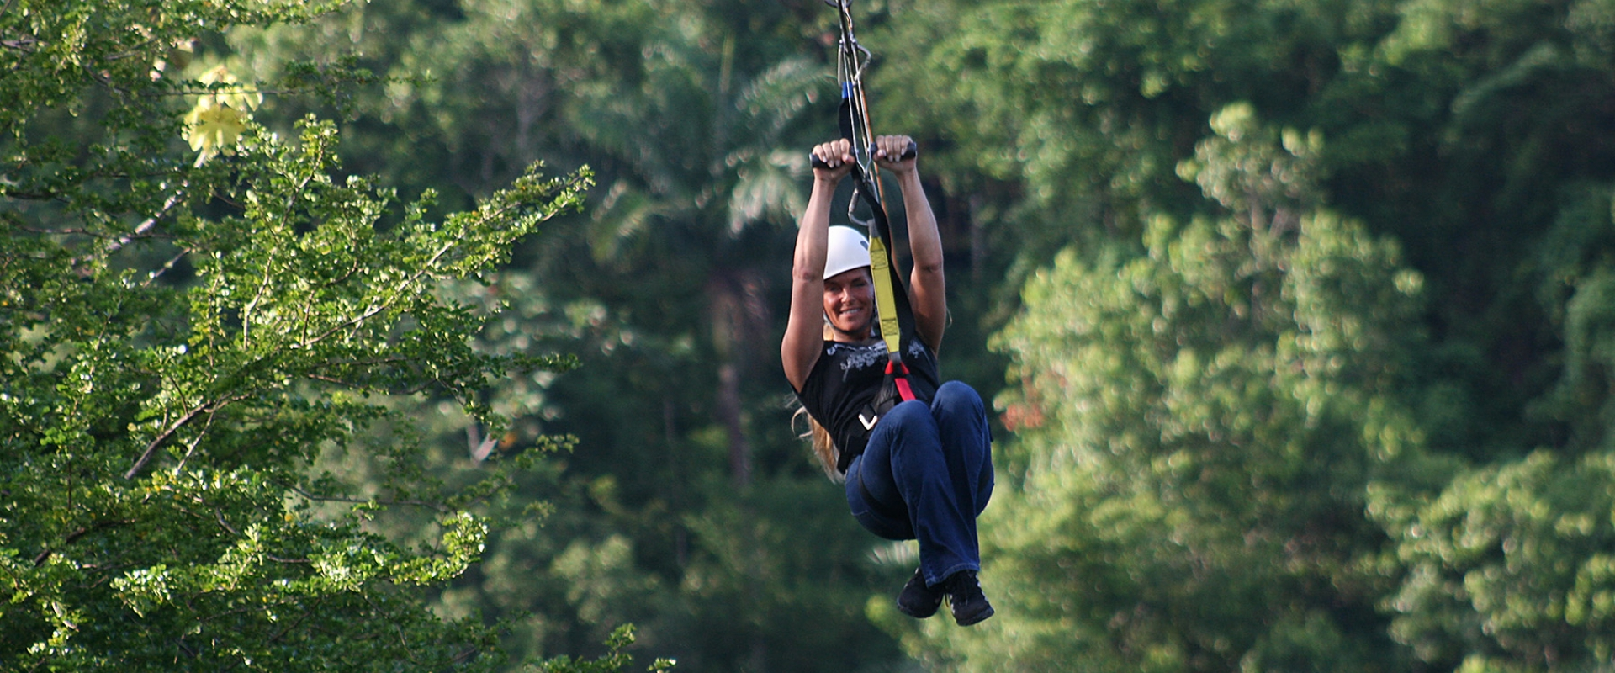

Rest!!!

It’s a vacation take some time to just relax and be lazy

Time: 3 hours

Cost: free.

Dead End Beach

In the Caribbean the more time we spend on the beach the happier I am.

Location: Kent Ave, Montego Bay, Jamaica

Time: 2 hours

Cost: free

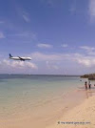

Fort Montego

Old British fort for which the town is named after and a market place. A cool place to visit and if anyone want to buy souvenirs this is a place to do so.

Cost: $20 for souvenirs per person, $100 total.