**COP 5615**

**DOS Project 1**

**Group Members:**

**Lipee Hathi Manali Sharma**

**UFID: 15389182 UFID: 79704810**

HOW TO RUN

1. Open both files BitCoin.scala and BitCoinRemote.scala

The BitCoin.scala will be compiled by the name BitCoin.scala and it can be run by BitMain.

The BitRemote.scala will be compiled by the name BitCoinRemote.scala and it can be run by BitCoinRemote.

1. Change Run configurations and make changes for each of these two files as shown below-

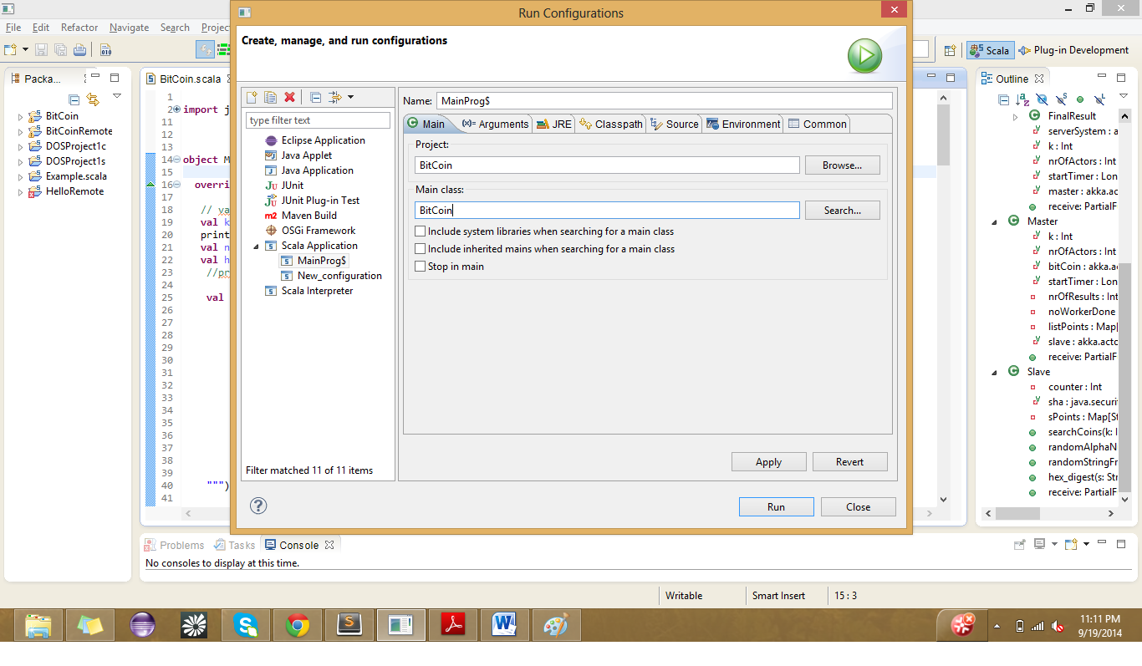

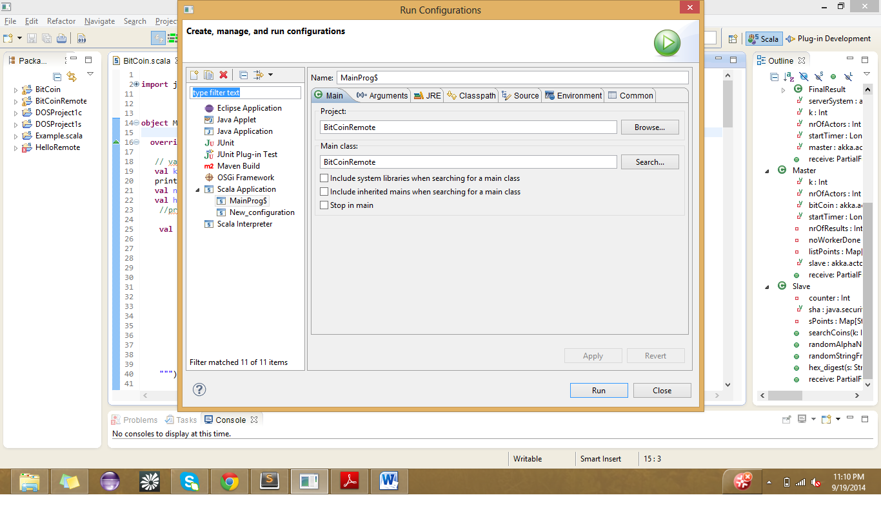

1. After applying these changes, run the BitCoin.scala file first and then BitCoinRemote.scala after say, 2-3 seconds.
2. BitCoin.scala takes k as parameter and BitCoinRemote.scala takes the ip address of the client machine as the input parameter.
3. You will be able to see the bitcoins in the console.

The bitcoins that will be generated by slaves on the client side are generated by string appended with

username: manalisharma

And bitcoins generated by slaves on the server side are from the strings which have been appended by

username: l.hathi

(as a convenient mode of distinguishing)

1. **Determination of Work Size Unit**

We initially declared the work size unit per slave to be a comparatively smaller value which ended up in less production of bitcoins and more frequent calls to the master. This led to more resources being used causing marginal delay in further communication.

After various other combinations we decided to provide each slave with 500000 inputs on every call.

On each call from the master to the slave, it calls a function searchCoins.

This function calls the random string generator function which passes variable string lengths. Once the string is received by searchCoins, it call the sha256 generator function:hex_digest.

After the hash is returned, it checks for the number of zeros. This value is received from command prompt and passed to the function.

These bitcoins are stored in a map with its corresponding input value and returned to the master.

This happens periodically. When the master gets maps from all the slaves it prints it out. Then it calls for termination of these slaves.

1. **Program Results for** <BitCoin.scala >

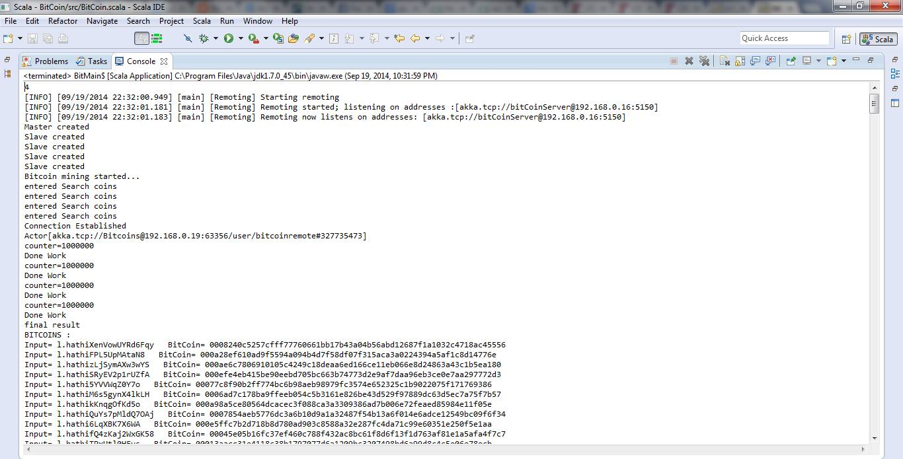

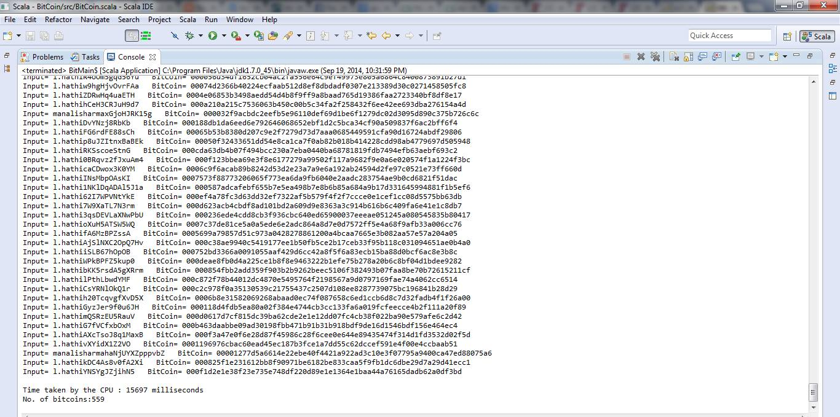

1. **Run Time Ratios :** 3.03

With k=4

real 0m26.781s

user 1m21.173s

sys 0m0.939s

**On 4 core machine**

**Ratio for k=5 is 3.56**

real 0m23.374s

user 1m13.284s

sys 0m0.868s

1. **Coin with most 0s:**

Number of zeros: 6

Input= manalisharmaVW9xZl0srTl9l BitCoin= 000000f6358dfcd17bab174e6b3ea708b6c097149199762472e0dc7e13f5d10f

Input= manalisharmaaO0wbzbWPXU BitCoin= 0000006e4d536df44b10854f19a0b8d8485f4da0fde9ad300e163e86f93cff55

1. **Number of working machines :** 2