

Testing Document

Team 29



University of Sussex

Table of Contents

Functional Requirements Testing: 3

Non-Functional Requirements Testing: 5

JUnit Testing 8

System Testing 9

User testing 31

|  |  |  |  |
| --- | --- | --- | --- |
| Functional Requirements Testing: | | | |
| **References** | **System Requirement** | **Type** | **check** |
| F1 | The client’s financial return shall be generated including the current investment, start date and to date, and percentage of return. | Mandatory | / |
| F2 | A 15-minute total net worth of client’s investment shall be calculated. | Mandatory | / |
| F3 | A 15-minute total shall be calculated and generated on the interface. | Mandatory | / |
| F4 | The system shall use Georgian calendar.  The simulation shall stop on 31/12/2017  The market shall be closed on the weekends, Christmas day, boxing day, good Friday and Easter Monday. | Mandatory | / |
| F5 | Share values shall remain static when the market is closed. | Mandatory | / |
| F6 | The market shall be open from 9Am every day and closes 4PM. | Mandatory | / |
| F7 | The system shall use a spreadsheet document to store initial cash and share assets.  The system shall be able to read CSV file extension as this is the spreadsheet extension. | Desirable | / |
| F8 | Each client joining the company shall be assigned to an available trader. | Desirable | / |
| F9 | The system shall use GMT time.  The system shall update the graph and trading information every 15 minutes. | Mandatory | / |
| F10 | The system shall only allow traders to trader within the client’s assets.  The client asset shall be records in the spreadsheet file. | Mandatory | / |
| F11 | The system shall store and show the clients asset every 15 minute and trading limit should be updated.  The random traders shall be allowed to trade around 1% of their assets available. | Mandatory | / |
| F12 | The system shall have two entities for random each seller at each mode. The first entity will be the percentage they are able to put on the market and the second entity is the percentage amount they are able to purchase.  The system shall only allow between 0 and 1% of client’s asset to be put on the market when the trader is in a balanced mode.  The system shall only allow between 0 and 1% of client’s asset to be bought on the market when the trader is in a balanced mode.  The system shall only allow between 0 and 2% of client’s asset to be purchased on the market when the trader is in an aggressive purchaser mode.  The system shall only allow up to 0.5% of client’s asset to be sold on the market when the trader is in an aggressive purchaser mode.  The system shall only allow up to 2% of client’s asset to be purchased on the market when the trader is in an aggressive seller mode.  The system shall only allow up to 2% of client’s asset to be sold on the market when the trader is in an aggressive seller mode.  The way a random trader knows how much they can sell and how much they can buy will be displayed on the screen in two-text field. This will be calculated and updated every 15 minutes as a trader can earn money and the percentage they can sell and buy will be different. Therefore, an up to date figure will be available every 15 minute. | Mandatory | / |
| F13 | The systems shall disallow the company to trade when hourly-generated shares total reach 0 then the system/programme will be to a halt and be declared as worthless. | Mandatory | / |
| F14 | The system should only allow shares to be bought and sold by traders for their assigned client. | Mandatory | / |

|  |  |  |  |
| --- | --- | --- | --- |
| Non-Functional Requirements Testing: | | | |
| **References** | **System Requirements** | **Types** | **check** |
| NF 1 | The system shall only issue a fixed number of shares | Mandatory | / |
| NF 2 | The sales and purchases shall be balanced using the shares purchased and shares sold formulas. | Mandatory | / |
| NF 3 | The random trader shall be able to buy and sell shares.  The simulation shall be able to have any number of random traders. | Mandatory | / |
| NF 5 | The simulation shall use the Excel document provided to us which contains the traded companies, clients and their worth.  The data shall be used to start the simulation. | Mandatory | / |
| NF 6 | The system shall have space which displays up to date information for the current share price, bull or bear market and the clients detail including the clients current worth. | Mandatory | / |
| NF 7 | The share prices shall rise when demand exceeds supply.  The share price shall fall when supply exceeds demand.  The share prices shall remain stable when demand is same as supply. | Mandatory | / |
| NF8 | Shares shall be rounded to 2 decimal places when bought or sold for each individual share.  The shares purchased shall be calculated suing the provided formula. | Mandatory | / |
| NF9 | The system shall use the formula to calculate the shares sold. | Mandatory | / |
| NF10 | The system shall update the share price when trades are made.  The price should rise for the next simulation period when share is an over demand.  The formula shall be used to calculate the increase in share price. | Mandatory | / |
| NF11 | In accordance to each simulation period, the decrease in share price will be equivalent to excess supply of share into current share price per each number of shares.  The system shall update the share price when trades are made.  The share price shall fall for the next simulation when share price is over supply.  The decrease in share price should be calculated using the formula. | Mandatory | / |
| NF12 | -The system shall have minimum two random generators.  -The system shall check for minimum 2 random traders before allowing trading to commence. | Mandatory | / |

# JUnit Testing

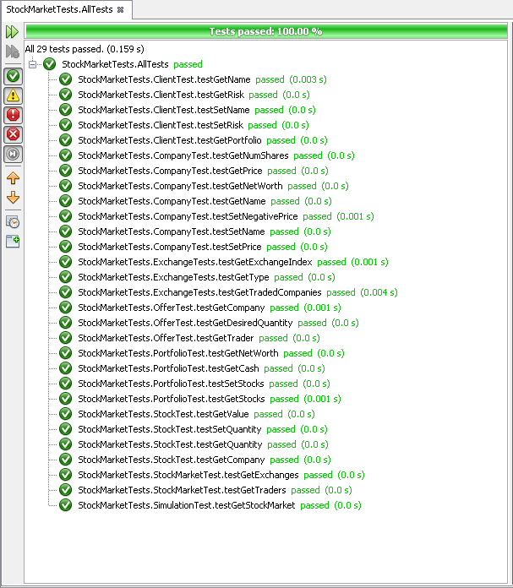

# System Testing

|  |  |  |  |  |  |
| --- | --- | --- | --- | --- | --- |
| **Test No** | **Input** | **Expected output** | **Actual Output** | **Pass/Fail** | **Evidence Number** |
| 1 | Load a valid csv initialization file. | Loads up the data onto the form. | Loads up the data onto the form. | Pass | 1a, 1b |
| 2 | Attempt to load invalid file. | Nothing will be loaded and the program will not crash. | Nothing loads and the program continues as normal. | Pass | 2a, 2b |
| 3 | Load a valid csv and then run the simulation at 15 minutes per second for 4 seconds. | 4 data points should be added, one for each second. | 4 data points were added to the graph. | Pass | 3a, 3b |
| 4 | Load a valid csv and then run the simulation at 150 minutes per second for 1 second. | 10 data points should be added to the graph, as an interval is 15 minutes and it runs 150 minutes per second. | 10 data points were added to the graph. | Pass | 4a, 4b |
| 5 | Load a valid csv, start the simulation and then stop it at 11am. | The graph should remain on 11am after it has been stopped. | Graph runs until 11am and then stops after the stop button was pressed. | Pass | 5a, 5b |
| 6 | Load a valid csv, run then stop the simulation then advance it by one interval. | The simulation should get the next data point only, starting from 10am it should add the extra point at 10:15am on the graph, and increase the simulation date. | Adds single data point at 10:15am and advances date. | Pass | 6a, 6b |
| 7 | Load a valid csv, run it for a period of time. | The graph on the 'Clients' tab should have a series for each client, with their names in the key underneath and their net worth plotted over time.  The graph on the 'Companies' tab should have a series for each company, with the company names in the key underneath and their net worth plotted over time.  The graph on the 'Exchanges' tab should have a series for each exchange, with their names underneath and their index plotted over time. | Everything was output as expected, all clients and their net worth were displayed in the clients tab. All companies and their net worth were displayed in the companies tab. All exchanges and their indices were displayed in the exchanges tab. | Pass | 7a, 7b, 7c |
| 8 | Load a valid csv, keep running the simulation from the start until every one of the first three days have a rise in the stock exchange index. | On the 4th day (January 5th) the market state should change to bull. | The market state changes to bull on the 4th day (January 5th). | Pass | 8a, 8b |
| 9 | Load a valid csv, run the simulation for a few intervals, stop it and then advance a single interval | The last date on the graph should match the simulation date under the simulation information heading. It should also still match it after a single interval has been advanced. | The dates match up and change as expected. | Pass | 9a, 9b |
| 10 | The exit option under the 'File' menu will be clicked. | The program will exit. | The program exited correctly. | Pass | 10a |
| 11 | Load a valid csv, run the simulation for a few intervals and then resize the form. | The graph should resize correctly. | The graph resizes correctly. | Pass | 11a |
| 12 | Load a valid csv, click the run to completion button. | The system should run until the end date of the simulation. | System does not run. | Fail | 12a |

Evidence Table

|  |  |
| --- | --- |
| Evidence Number | Evidence (picture) |
| 1a |  |
| 1b |  |
| 2a |  |
| 2b |  |
| 3a |  |
| 3b |  |
| 4a |  |
| 4b |  |
| 5a |  |
| 5b |  |
| 6a |  |
| 6b |  |
| 7a |  |
| 7b |  |
| 7c |  |
| 8a |  |
| 8b |  |
| 9a |  |
| 9b |  |
| 10a | O |
| 11a |  |
| 12a |  |

# User testing

We gave the finished system to a user and gave them reign over the program to see if they could find any issues or bugs. They did not discover any bugs or issues that had not previously been found.

The user comments were:

"The system ran very smoothly and without many bugs in the GUI, most of the bugs I noticed were in how the market responded. The biggest issue I found in the GUI was that the run to completion button did not work, although this wasn't an issue as I could just increase the speed to the top and run until the end of the simulation. The second biggest issue I found was that the graph would lag a lot when running for too long due to the amount of data points being added to it. My other issues were with the actual simulation, many of the companies or user net worth’s would tend to sky rocket for seemingly no reason. Other than these issues I thought the system was very useable and would only require a few tweaks to get working 100%".