Lucas Bolanos

# 

# 

# Youtube Link

# Purpose

Prove a remote accessible baby monitoring and soothing device. This aims to combine several of the common appliances parents tend to keep in their children’s bedrooms ranging from white noise machines and night lights to camera systems. By packaging all of these devices into one system, this aims to not only reduce clutter but offer a more convenient, efficient way to monitor one’s children and provide comfort and reassurance.

# Functionality

ESP2688

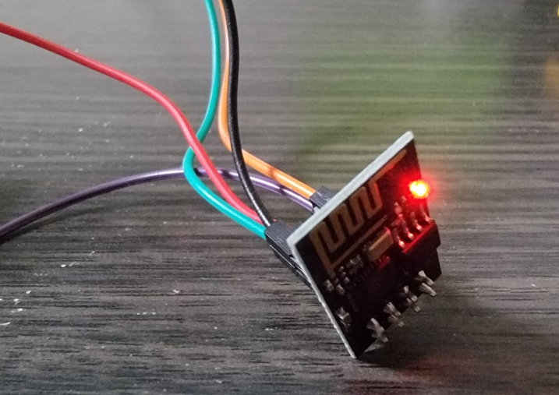

* Self-contained SOC with integrated TCP/IP protocol stack that can give arduino wifi access.

Arducam ESP32-CAM OV2640

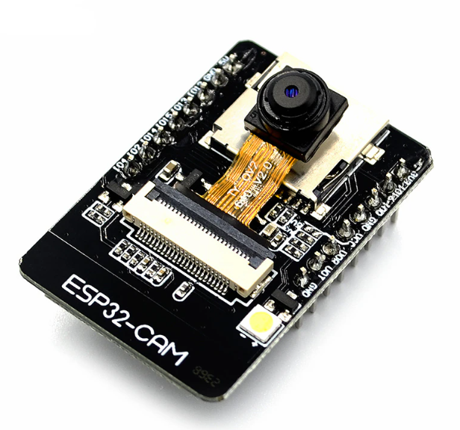

* Miniature camera used and wifi module used to stream video live to a web server that can be viewed..
* Records video data and encodes it into mjpeg format to be viewed via the smartphone application.

LED’s

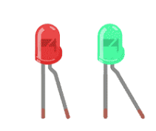

* Multiple LED’s used to simulate night light.

Passive Buzzer

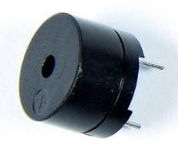

* Used to play soothing sounds and songs and simulate a sound machine for children.

# How tested

* Performed testing on both home networks and mobile hotspots.
* Tested multiple songs and sounds on the buzzer.
* Tested multiple light configurations with different levels of intensity.
* Tested camera module is various resolutions.
  + Tested single picture capturing vs video recording.
* Tested setting up different ESP8266 configurations and sending information between camera module and ESP-01.
* Tested different data encoding for video format.
* Tested different web server libraries.

# Challenges/Lesson Learned

This project taught me a massive amount in regards to live streaming video and what exactly goes into that process as a whole. I learned about setting up camera modules to work with different IDE’s and user interfaces. This directed me towards learning how to set up web servers and communication between wifi modules and camera modules in order to have the video data transmitted and sent to where it needed to be.

The biggest challenge for me was definitely learning how exactly to setup the communication between the camera module and the wifi module.

1. Camera Module Issues
   1. First issue had to do with the model camera I initially bought not being compatible with my Arduino Uno R3. Prior research I had done before buying that particular model seemed to indicate it should be a fairly straightforward process, with easy access to multiple libraries to aid me. However; I ran into several issues with the camera not properly sending data to the program I was using to monitor images on my desktop, and eventually with the camera module not responding at all. Ultimately it came down to digging into the documentation of each library I had been trying to use to discover that each library was incompatible with the architecture of the specific board I had been using, and that a different camera module entirely would be necessary which led to switching to the OV2640.
2. Camera/ESP Communication Issues
   1. The next big hurdle came down to figuring out how to have the camera properly send video information to the ESP32-CAM module in order to generate an accessible address for the Blynk application to use for its video streaming widget. Unfortunately, this seemed to become another camera bottleneck as well as many of the helpful libraries and guides online tended towards using an integrated wifi module with a camera rather than having two external modules trying to communicate with each other. This lead to having to generate my own solution to creating a web server for the camera to send it’s information too, using the IP address of the ESP32-CAM. This involved lengthy reading into multiple libraries literature, as well as much bug-fixing of very broken and outdated code in order to get it operational.