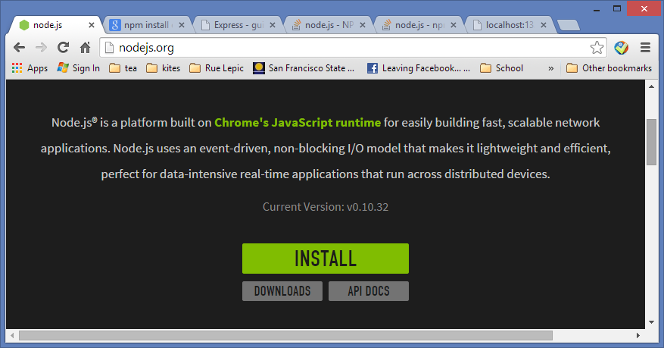

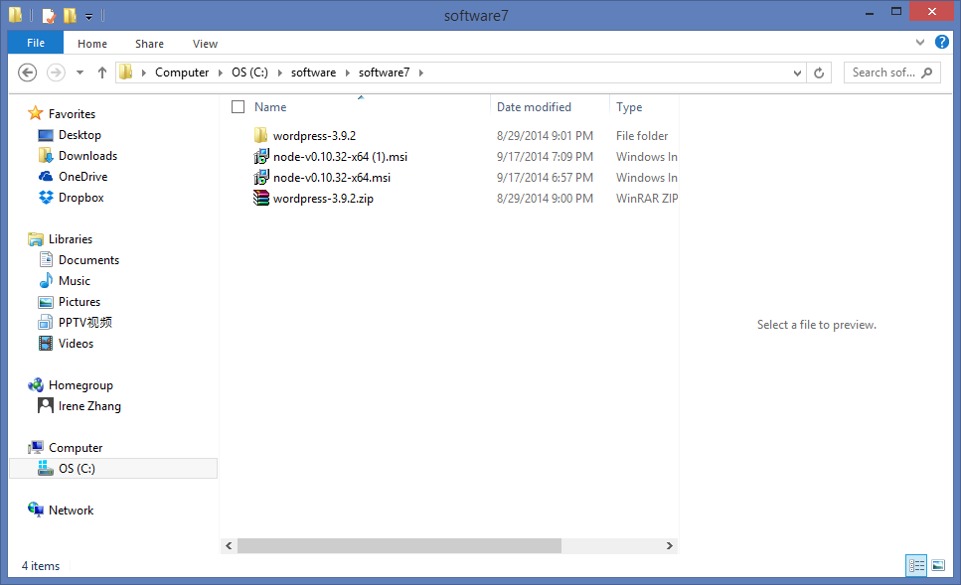

node -v

npm -v

app_server>npm install express

If not work, also can try:

sudo npm install express

npm install -g express

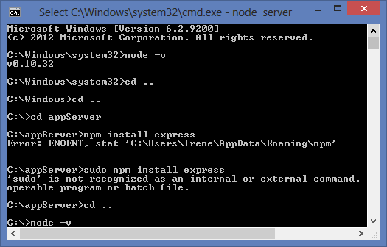

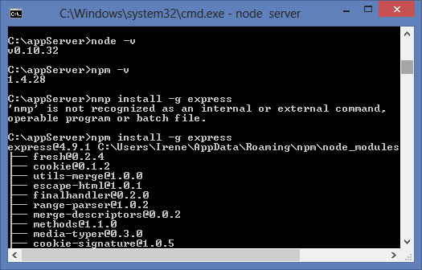

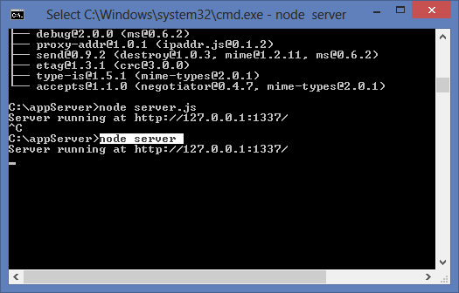

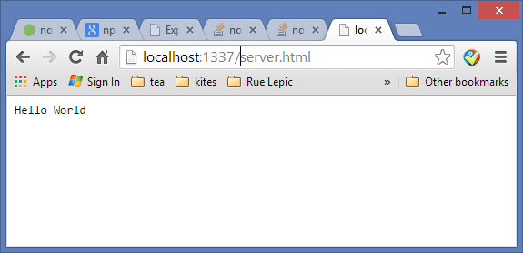

Can install express on the root directory

And run the server

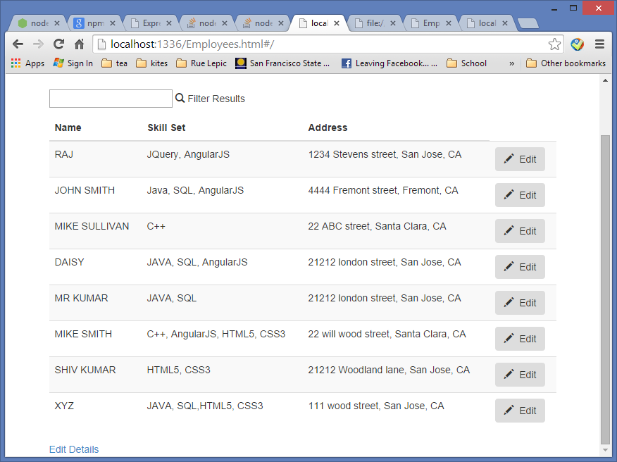

**Work Force Project**

**Environment**: angularJS, Express, Node.js, bootstrap, chart.js, d3.js, html5, CSS3, JavaScript, JSON

**Keywords and interview questions: know how to explain the following concepts with project, and coding elements.**

Node.js : server

angularJS: JavaScript framework

Single Page Application (SPA)

Model-View-Controller (MVC)

In Line Editing (Data Binding)

Scalable Vector Graphics (SVG)

Document-Object-Model (DOM)

Dependency Injection

Dynamic and Responsible Website

Directives:

Classic OOP: JAVA, C++

Prototypal OOP: JavaScript

AJAX: Asynchronous JavaScript and XML

HTML: Hyper Text Markup Language

XML: extensible Markup Language

CSS: Cascading Style Sheets

JavaScript:

JSON: JavaScript Object Notation

API: application programming interfaces

CDN: content delivery network or content distribution network

After installed nodejs and express

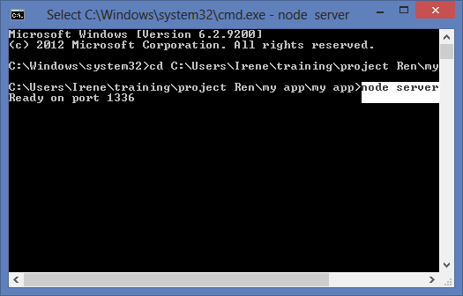

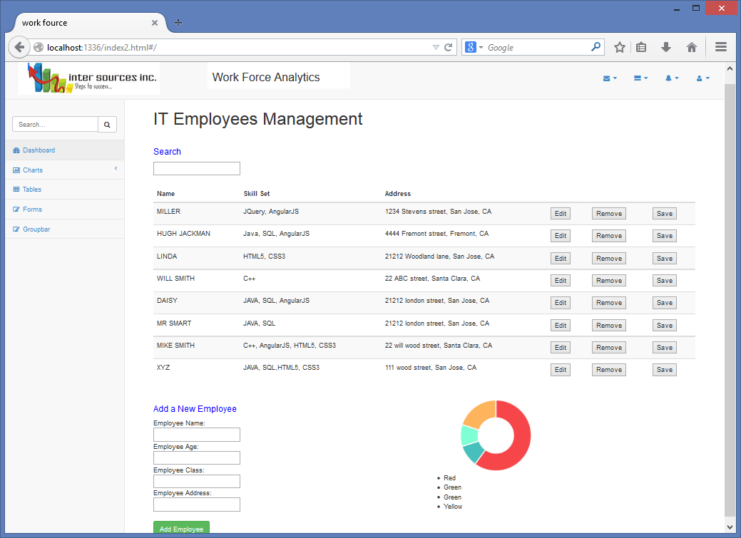

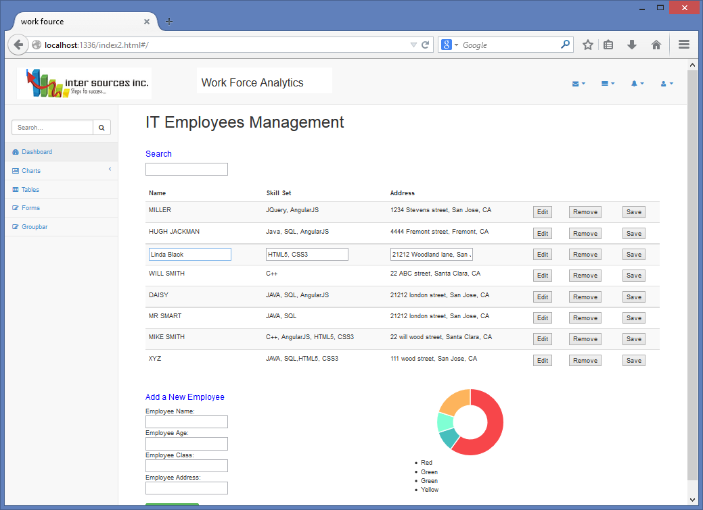

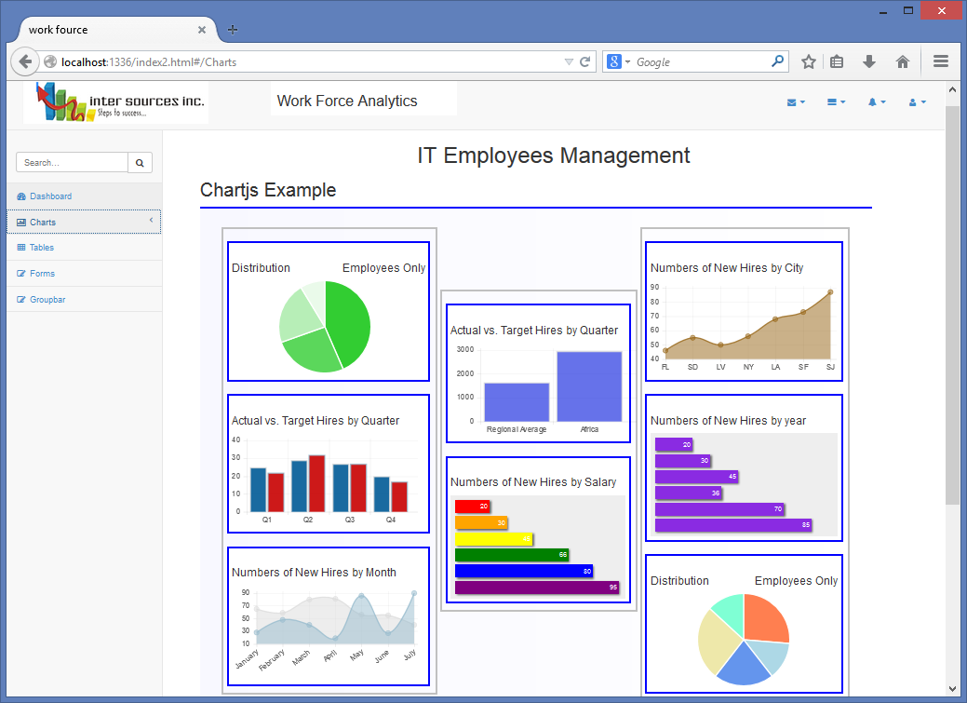

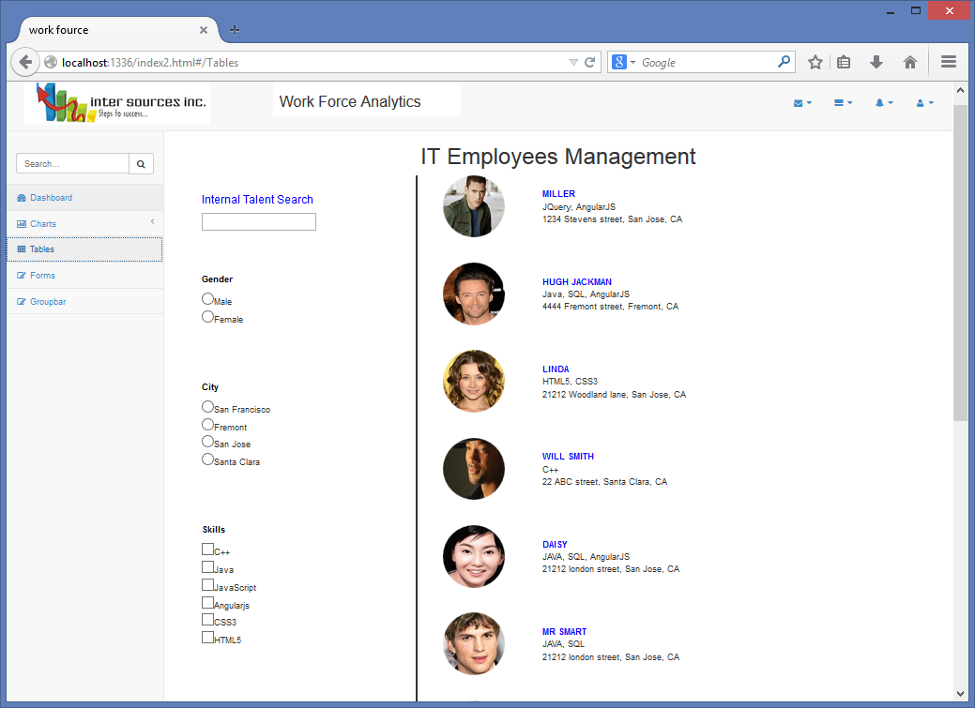

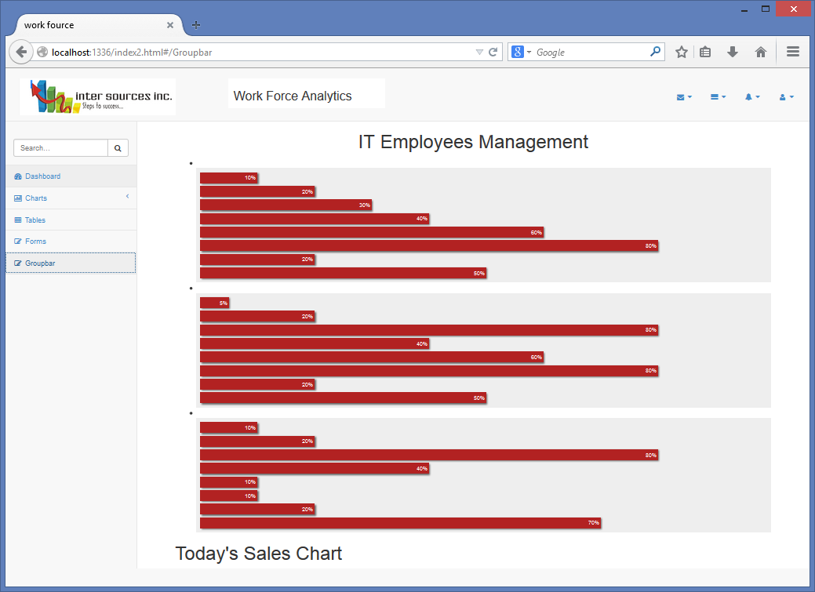

**Chart project with Node socket I/O**

