ECE260: Digital Electronics II
PS/2 to LCD Driver
Project Proposal
Louis Coyle II
3/10/2014

[Two drivers will be written in this project, a PS/2 keyboard driver and a LCD driver. The PS/2 driver will be connected to the LCD driver to demonstrate the functionality of both. This will allow the user to use a PS/2 keyboard as an input, and the pressed characters will be displayed on the LCD. Additionally, the user will be able to edit the strings on the display, similar to a simple text editor. Finally, if time permits, the user will be able to type and edit more than the two lines that can be displayed on the screen. ]

Table of Contents
Introduction 2
Specification 3
Methods, Techniques and Design 8
Design Verification 9
Schedule 11
References 12

Introduction

This project will primarily be an exploration of the PS/2 protocol. The protocol will be used to read output from a keyboard to an LCD. Displaying the pressed keys on the LCD and allowing the editing of these displayed characters provides a specific goal to achieve using this protocol. The possibility of easily readable output using a familiar input format is a great motivating factor.
This is in contrast to previous projects I have worked on, in which I’ve done things such as read output from UART on an oscilloscope, making it harder to read and less satisfying of a result. On the other hand, I have also gotten output from UART on a PC terminal, such as X-CTU or Putty, but in these cases the transmission of the UART data through USB to the terminal on the PC was abstracted from me, and I did not learn as much from it.
I’ve used UART in a few previous projects, using PIC and ARM Cortex microcontrollers. In both cases they already had library functions which more or less set up the GPIO pins for receiving and transmitting for me. Even if these microcontrollers didn’t have this set up for me, UART is a simple type of communication, and I feel that I’ve learned as much as I can from it at this point. PS/2 seems to be a natural step up from UART, as it adds some complexity to the interfacing between host and device, such as commands that the host can issue to the device.
I’m motivated to work on a protocol that is designed to interface between a keyboard and host. I also feel that learning how PS/2 works will allow me to better understand how more advanced protocols such as USB work. As a result, in the future I hope to be able to use other protocols for a wider range of purposes.

Specification
The received data from a PS/2 keyboard will be displayed on the onboard LCD, so that the user can write and edit two lines of 16 characters. This will require the use of the PS/2 protocol through a 6-pin mini DIN as well as interfacing to the CFAH1602B-TMC-JP, a 16x2 character display on the DE2 board. In order to interface to these, one must know the pinouts for each. The pinout for the 16x2 character display (Table 1) is readily available in its datasheet [3].
More specifically, since the connection to the pins will be made by synthesizing Verilog code, one must know how the DE2 board labels these pins. Table 2 shows the pin assignments from the DE2 board [4] to the LCD IC pins.
Table 1. 16x2 Character Display Pinout
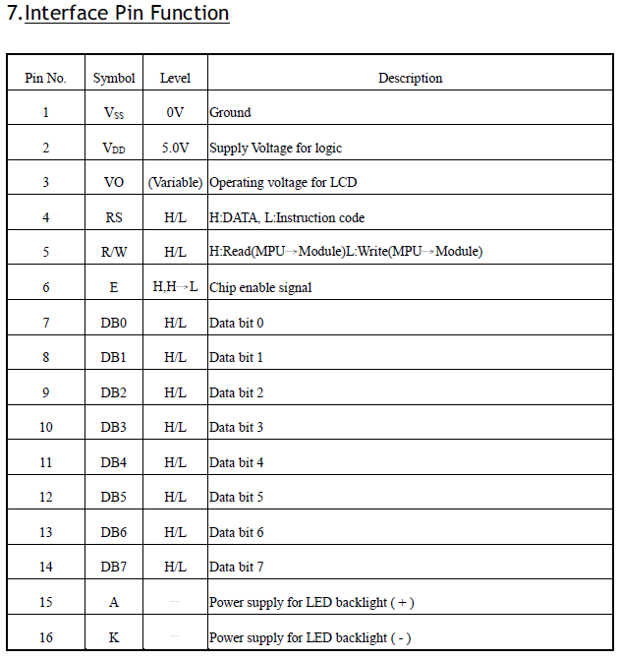
The signal names in these tables relate to the descriptions in the table (Table 1) quite clearly. With this information known, one can write Verilog code to synthesize a driver that initializes the device and operates within its accepted timing limits.
As I have already verified that my LCD driver from a previous project is capable of printing to the LCD, I know that it is within the accepted limits of the device for timing during and between instructions. Also, I know that the initialization procedure is acceptable to it. For this reason, I will not include figures for timing or initialization for the LCD. Nevertheless, they are available in the datasheet [3]. However, I will need to use commands for the display in order to add cursor functionality. Namely, the Display ON/OFF Control, Entry Mode Set, and Cursor or Display Shift commands. These are shown in Table 2 from the LCD datasheet [3], below.
Table 2 – LCD Instruction Table
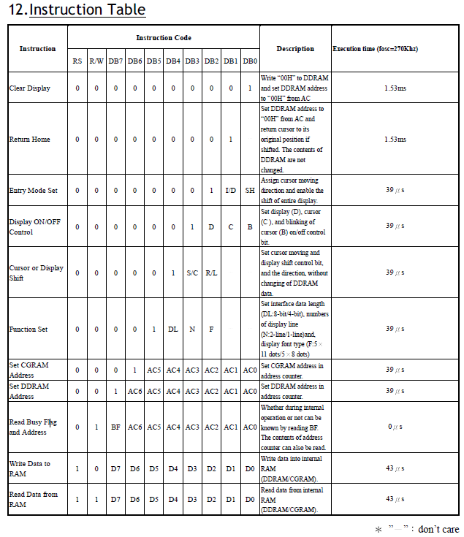
Before adding cursor functionality to the LCD, I would like to get the PS/2 driver at least writing the whole 16x2 character display without editing. In order to do this, one must understand the specification of the PS/2 electrical interface and protocol. Chapweske [1] has a great write-up on the PS/2 interface; a pinout for the PS/2 connector follows (Figure 1).
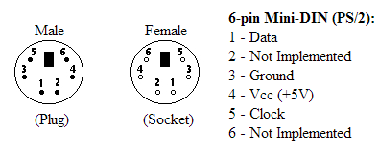
Figure 1. 6-pin Mini-DIN (PS/2) Pinout
Table 4 shows the assignments for the PS/2 socket pins, from the DE2 Manual [4]. The DIN acronym stands for DIN - (Deutsches Institut fuer Norm - German Standardization Organization). PS/2 is an acronym from IBM’s Personal System/2 series of computers, in which they introduced this standard as a replacement for the old AT connector. There is some compatibility between the two, but I won’t go into this, as even PS/2 is now considered legacy. However, it is worth mentioning that PS/2 is still included on most motherboards released today, as it still has its uses.
Table 3. PS/2 Pin Assignments
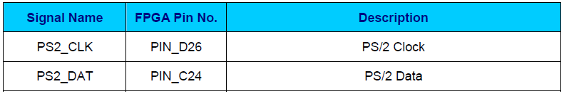
As with the LCD pins, the relation between the DE2 pin assignments (Table 3) and the pins on the physical plug is clear to see. With this in mind, we can inspect the electrical interface to the PS/2 socket on the DE2 board by looking at the schematic (Figure 2) from the DE2 manual [4].
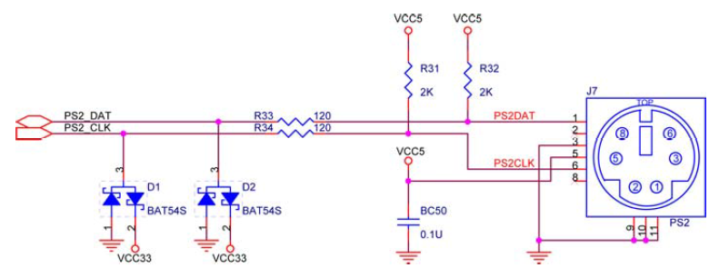
Figure 2. PS/2 Electrical Interface

In Figure 2 above we can see that the clock and data inputs are open-collector, with a 5V pull-up resistor. This means that the idle state of the lines is high, and they must be pulled low by the device in the case of the clock, or by either in the case of the data line.
Table 4. PS/2 Bus States (Device-to-Host)
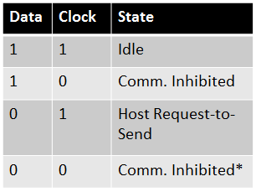
Table 4 shows the state of the bus for device-to-host transmission depending on the level of both the clock and data lines. In order for the device to begin transmitting data, the bus must first be in the idle state. The host may inhibit communication by pulling the clock low immediately after or before a transmission. This allows the host to stall the device before the next transmission, giving it time to process the previous data, if necessary. The host may also initiate host-to-device communication by first pulling the clock line low, stopping communication, then pulling the data line low and releasing the clock. Finally, the state in which both data and clock are low is still inhibiting communication, but it is sometimes seen during host-to-device communication, after the host receives an ‘ack’ from the device that it has received the previous transmission, it may pull the clock line low to inhibit transmission. This allows it time to process data for the next transmission.
With the bus in the idle state, the device may begin communication to the host, which is shown in Figure 3, from [1]. In this figure, we see that the data line changes when the clock is high, and becomes valid when the clock is low. Also, it shows that a transmission frame consists of 11 bits, a start bit which is always 0, 8 data bits, a parity bit (odd parity) and a stop bit which is always 1.
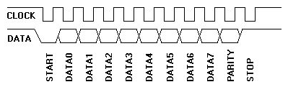
Figure 3. PS/2 Device-to-Host Communication
I have only described the device-to-host communication, as that is all I should need for this project, but the protocol is for bidirectional synchronous serial data, with a clock frequency 10 – 16.7 kHz, which is always supplied by the device. When a key is pressed, the device sends information to the host about that key, so that the host can take the appropriate action. This information is called a scan code, and for each key they are broken up into make and break codes [1], shown in Table 6 below.
Table 5. Make/Break Codes
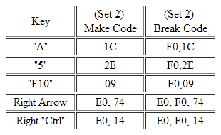
We can see that a scan code is not always the same as the ASCII code for a key. While the make code for a key is usually equivalent to its ASCII value, the break code is a two byte set of both F0 and the make code, for most keys. This make code is sent when the key is pressed and the break code is sent when the key is released. If a key is pressed and held for longer than the typematic delay, then that key becomes typematic, and it being sent automatically, over and over at the typematic rate. The device will continue sending this key’s make code until the key is released or another key is pressed.
The settings for the typematic delay and rate are set during the BAT (Basic Assurance Test) and can also be changed later by a host-to-device command set transmission. The BAT is a power on or software reset self-diagnostic check. During it, the keyboard turns on the status LEDs (scroll, num and caps lock), performs a diagnostic self-test, and sets a few things to their default values. These include typematic delay to 500ms, typematic rate to 10.9 cps, scan code set to 2, and typematic/make/break enabled for all keys. After this test, it turns of the LEDs and sends a 2’hAA for a success, or a 2’hFC for an error.
As the data is serial, a shift register will be used in order to read the bits into an 8 bit bus one at a time from the device. Also, the LCD must wait to transmit each character until it has been received from the keyboard, so that it does not continue sending the same character repeatedly, or immediately fill the screen with the unitialized bus. This connection between the devices and the two drivers will be shown in the block diagram on the next page.

Methods, Techniques and Design
As described previously, this project involves using a PS/2 keyboard to drive a 16x2 character LCD. I will be using a pre-made PS/2 keyboard (manufacturer and model yet to be determined), the PS/2 socket on the DE2 board, and the CFAH1602B-TMC-JP 16x2 character display on the DE2 board. The connection of these devices will be synthesized to the FPGA using Verilog code. A high-level block diagram of this connection is shown in Figure 4.
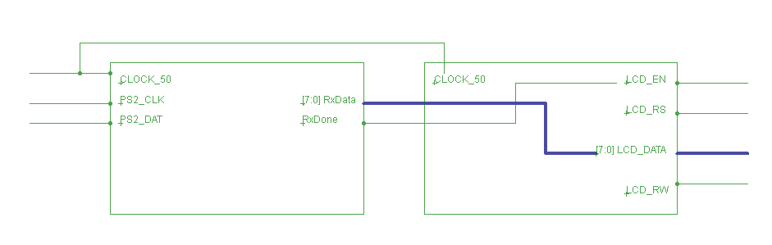
Figure 4. High-Level Block Diagram
This diagram shows the connection between the PS/2 driver on the left and the LCD driver on the right. The data received from the keyboard gets processed by the PS/2 driver and is always sent to the LCD driver. However, the LCD will only transmit the data when the RxDone bit is set. This RxDone bit is controlled by the stop signal for a PS/2 frame. The implementation hasn’t changed drastically so that the diagram needs to be redrawn. All of the additions were made in a fashion that retained the original top-level design. These additions include, a power on reset delay timer for the PS2 module, so that it waits to start sending characters until the LCD module has fully initialized, handling of the shift key modifier inside of the PS2 module, handling of arrow keys, enter and escape in the LCD module, and addition of a cursor to the LCD.
These additions allow the user to edit the text by moving the cursor to the character they would like to change with the arrow keys, and then pressing the key for the character they would like to replace the character at the cursor with. The user can also press escape to clear the whole screen, or enter to immediately move the cursor to the next line.

Design Verification
I intend to test the functionality of my design in stages. First, I’d like to verify the functionality of both my LCD and PS/2 drivers separately. I have already verified that my LCD driver is capable of displaying strings hardcoded into the Verilog file. I believe this is sufficient verification for the LCD and will move on to implementing the PS/2 driver before connecting the drivers together.
Before testing my PS/2 keyboard driver, I will verify that that the keyboard functions by connecting it to a desktop PC. Then, I will connect directly to the pins on the PS/2 connector using a power supply and an oscilloscope to better understand the signals coming from the device. I will refer to [1] if I have any problems at this stage, and for verification of the signals. Figure 5, from [1] demonstrates the signal I should expect for a scan code of the ‘Q’ key being sent from a keyboard to the computer. Channel A is the clock signal, and channel B is the data signal.
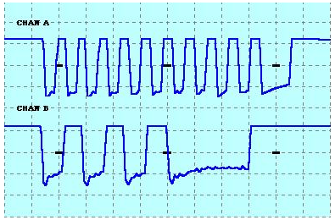
Figure 5. ‘Q’ Scan Code
With a better understanding of the electrical interface and the communication protocol, I will begin to write and test the PS/2 driver. First, I will write a simple Verilog file, connecting the project to the PS/2 and blinking an LED when the data line changes. With the basic connection completed, I will then read the serial data into registers, allowing the most recently pressed character to be used. In order to verify this functionality, I will output the most recently pressed character to the seven-segment displays. Rose [2], from University of Toronto, made an ASCII keycode map (Figure 6) that makes this verification more convenient.
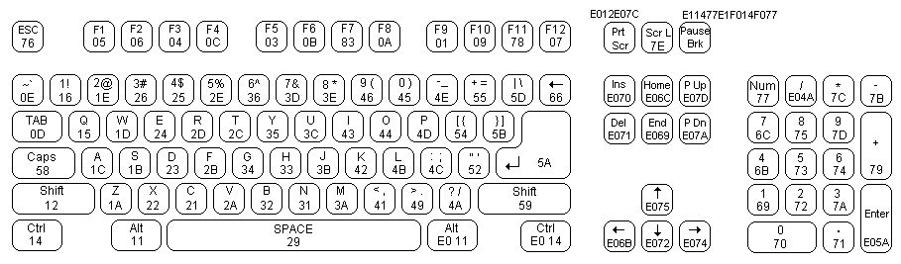
Figure 6. ASCII Keycode Map
Once I have verified that all keys display the correct hex value when pressed, I will move to connecting the two drivers together. To begin, I’d like to test that I can get a pressed key to show up on the LCD at all. I expect that I’ll run into a problem here, as previously my LCD driver expected the strings to be hardcoded. Nonetheless, I’ll start by getting one character to print (either just once or repeatedly).
The next stage will be to have the LCD driver wait to print a character on the screen until the keyboard input is new. I will test this by attempting to fill the screen with characters as they are pressed. Finally, I will enable the cursor using the Display ON command, as shown in Table 3 in the specification, from [3], to allow moving of the cursor using the arrow keys, and inserting new characters. I intend for this to function like a simple text editor, and will verify that it does by allowing a colleague to use it. This method is still subjective, but better than testing it myself.

Schedule
Table 6. Schedule
3/10/14 – 3/16/14 | Submit formal project proposal, complete project proposal presentation, and begin PS/2 driver implementation.
3/17/14 – 3/23/14 | Proof of concept PS/2 driver completed: most recently pressed key’s ASCII value displayed in hexadecimal on seven-segment displays.
3/24/14 – 3/30/14 | Complete first project presentation; begin connecting PS/2 driver to LCD driver: at least a single character from keyboard displayed, either once or repeatedly.
3/31/14 – 4/6/14 | PS/2 driver connected to LCD driver: pressed keys show up on LCD, allowing writing of a complete 16x2 screen.
4/07/14 – 4/13/14 | Editing functionality added: user can navigate cursor using arrow keys, delete characters before cursor using backspace, and insert characters after the cursor.
4/14/14 – 4/20/14 | Submit final project report, verify design, and add editing of multi-line files if time permits.
4/21/14 – 4/27/14 | Complete final project presentation and add editing of multi-line files if time permits.

References
[1] | A. Chapweske, "The PS/2 Mouse/Keyboard Protocol," 9 May 2003. [Online]. Available: http://www.computer-engineering.org/ps2protocol/. [Accessed 10 March 2014].
[2] | J. Rose, "PS/2 Controller," University of Toronto, 12 October 2013. [Online]. Available: http://www.eecg.toronto.edu/~jayar/ece241_08F/AudioVideoCores/ps2/ps2.html#id479502. [Accessed 10 March 2014].
[3] | Crystalfontz America, Inc., 16x2 Character Display, Valleyford, WA 99036: Crystalfontz America, Inc., 2014.
[4] | Altera Corporation, "DE2 User Manual," 2006.

