An 8-bit computer with simple I/O Capability

Power and Ground Connections not shown

Memory mapped wherever possible

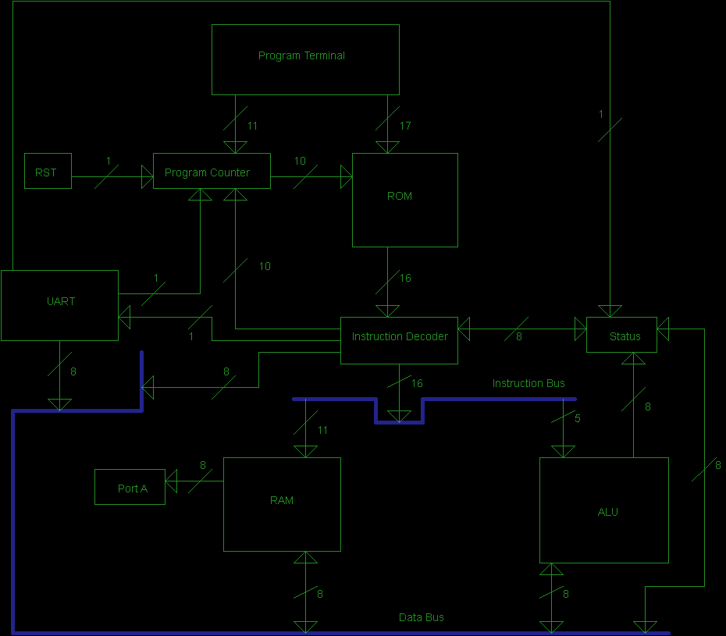

The instruction set for the 8-bit computer
The format is 5-bit opcode + 11-bit RAM address
All ALU operations update the status register

NOP (0x00)
Fetch:
No operation.
Execute:
No operation.
Store:
No operation.
Goto (0x01)
Fetch:
No operation.
Execute:
Writes 10 least significant bits of instruction word to the program counter.
Store:
No operation.
Greater (0x02)
Fetch:
ALU reads the instruction.
Execute:
ALU executes the operation (operand one > operand two).
Store:
ALU writes the result to the true flag of the status register.
Less (0x03)
Fetch:
ALU reads the instruction.
Execute:
ALU executes the operation (operand one < operand two).
Store:
ALU writes the result to the true flag of the status register.
Equal (0x04)
Fetch:
ALU reads the instruction.
Execute:
ALU executes the operation (operand one == operand two).
Store:
ALU writes the result to the true flag of the status register.
BranchIfTrue (0x05)
Fetch:
Instruction decoder reads the true flag of the status register.
Execute:
If true flag is one, writes 10 least significant bits of instruction word to the program counter. Otherwise, no operation.
Store:
No operation.

Increment (0x06)
Fetch:
ALU reads the instruction on the bus and RAM is addressed.
Execute:
ALU executes the operation on operand one and writes the value to the bus.
Store:
RAM latches the value on the bus internally.
Load (0x07)
Fetch:
RAM is addressed.
Execute:
Data is written to the data bus.
Store:
No operation.
Twiddle (0x08)
Fetch:
ALU reads the instruction on the bus and RAM is addressed.
Execute:
ALU executes the operation (~operand one) on operand one and writes the value to the bus.
Store:
RAM latches the value on the bus internally.

LogicAnd (0x09)
Fetch:
ALU reads the instruction.
Execute:
ALU executes the operation (operand one && operand two).
Store:
ALU writes the result to the true flag of the status register.
LogicOr (0x0A)
Fetch:
ALU reads the instruction.
Execute:
ALU executes the operation (operand one || operand two).
Store:
ALU writes the result to the true flag of the status register.
LogicNegate (0x0B)
Fetch:
ALU reads the instruction.
Execute:
ALU executes the operation (!operand one).
Store:
ALU writes the result to the true flag of the status register.
BitAnd (0x0C)
Fetch:
ALU reads the instruction.
Execute:
ALU executes the operation (operand one & operand two).
Store:
ALU writes the result of the operation to the data bus.

BitOr (0x0D)
Fetch:
ALU reads the instruction.
Execute:
ALU executes the operation (operand one | operand two).
Store:
ALU writes the result of the operation to the data bus.
Add (0x0E)
Fetch:
ALU reads the instruction on the bus and RAM is addressed.
Execute:
ALU executes the operation and writes the value to the bus.
Store:
RAM latches the value on the bus.
Sub (0x0F)
Fetch:
ALU reads the instruction on the bus and RAM is addressed.
Execute:
ALU executes the operation and writes the value to the bus.
Store:
RAM latches the value on the bus.
Mult (0x10)
Fetch:
ALU reads the instruction on the bus and RAM is addressed.
Execute:
ALU executes the operation and writes the value to the bus.
Store:
RAM latches the value on the bus.
Div (0x11)
Fetch:
ALU reads the instruction on the bus and RAM is addressed.
Execute:
ALU executes the operation and writes the value to the bus.
Store:
RAM latches the value on the bus.
ShiftLeft (0x12)
Fetch:
ALU reads the instruction on the bus and RAM is addressed.
Execute:
ALU executes the operation (operand one << 1) and writes the value to the bus.
Store:
RAM latches the value on the bus.

ShiftRight (0x13)
Fetch:
ALU reads the instruction on the bus and RAM is addressed.
Execute:
ALU executes the operation (operand one >> 1) and writes the value to the bus.
Store:
RAM latches the value on the bus.

Store (0x14)
Fetch:
RAM is addressed.
Execute:
The data bus is latched into the RAM.
Store:
No operation.

ClearReg (0x15)
Fetch:
RAM is addressed.
Execute:
The RAM location is set to 0.
Store:
No operation.
BitSet (0x16)
Fetch:
ALU reads the instruction.
Execute:
ALU reads the bit to set from data bus and executes the operation on operand one.
Store:
ALU writes the result of the operation to the data bus.
BitClear (0x17)
Fetch:
ALU reads the instruction.
Execute:
ALU reads the bit to clear from the data bus and executes the operation on operand one.
Store:
ALU writes the result of the operation to the data bus.
LoadALU1 (0x18)
Fetch:
ALU reads the instruction and RAM addressed.
Execute:
Data is written to the data bus.
Store:
ALU latches the value from the data bus into operand one.

LoadALU2 (0x19)
Fetch:
ALU reads the instruction and RAM addressed.
Execute:
Data is written to the data bus.
Store:
ALU latches the value from the data bus into operand two.

LoadLiteral (0x1A)
Fetch:
No operation.
Execute:
Writes literal to the data bus.
Store:
No operation.

LoadStatus (0x1B)
Fetch:
Status latches value to data bus.
Execute:
No operation.
Store:
No operation.

StoreStatus (0x1C)
Fetch:
Status latches value from data bus.
Execute:
No operation.
Store:
No operation.

LoadUART (0x1D)
Fetch:
UART fetch bit is set high.
Execute:
UART module latches register to data bus.
Store:
No operation.

Louis Coyle
ECE300
Computer Project

Written Description of Computer Function

1. How data goes in and out of ROM.

Data is written from the ROM to the output latch when the program counter addresses it. The instruction decoder then fetches and executes the instruction. Data is written to the ROM through the program terminal. When the addressing bit is high, the 10 least significant bits of the program terminal inputs will be read as an address by the program counter. When the writing bit is high, the least significant 16-bits get read as a value to be written to the currently addressed location in ROM.

2. How data goes in and out of RAM.

For certain instructions, the instruction decoder addresses the RAM, using the 11 least significant bits of the current instruction. Upon a load instruction, the addressed data would then be written to the data bus. Upon a store instruction, the data on the data bus would be written to the addressed location.

3. How the STATUS register is accessed by the hardware and the end-user of the computer.

The status register is connected to the data bus and can read and write to it. It is also connected to the instruction decoder, which can read and write to the status register, and to the ALU, which can write to it. Finally, the UART receiver can also set the UART received bit in the status register. Because the status register has read/write access to both the instruction decoder and the data bus, the end user can use certain instructions in order to access the status register. For example, the LoadStatus instruction writes the status to the data bus. This allows the user to load the data into RAM or the ALU and do as they please with it.

4. How any internal clock cycles are derived and the function of each (in cases where instructions cannot be executed in 1 clock cycle). It should be clear that you are not limited to copying the 3-cycle/instruction format of the 2-bit computer if you wish to do something else.

The computer uses the three cycles per instruction. These are the fetch, execute and store cycles. Each of these cycles is triggered by a separate clock, with the clocks designed so that when &'d together, they produce a constant 0. Only one clock is high at a time, fetch first, then execute, and then store. These clocks are derived from the main clock, so that the three cycles always execute before the next instruction is loaded.

5. The list of machine-language instructions that the code from the assignment must compile to in order to execute on the computer.

address instruction operand (opcode) [PORTA is memory mapped to 0x7FF]

0x00 LOADLITERAL 0x01 (0x1A)
0x01 STORE 0x000 (0x14) // store the mask for receive bit
0x02 LOADLITERAL 0xFF (0x1A)
0x03 STORE 0x001 (0x14) // store 255 in operand two of ALU
0x04 LOADALU2 0x001 (0x19)
0x05LOADLITERAL 0x00 (0x1A)
0x06 STORE 0x002 (0x14) // store j = 0
0x07 LOADALU1 0x000 (0x18) // load the mask for the receive bit
0x08 LOADSTATUS (0x1B)
0x09 STORE 0x003 (0x14) // store the STATUS register
0x0A LOADALU2 0x003 (0x19) // and load STATUS
0x0B BITAND (0x0C) // mask out all other bits besides receive
0x0C STORE 0x005 (0x14) // and store the value of receive bit
0x0D LOADALU1 0x005 (0x18) // load the value of receive bit
0x0E BITAND (0x0C) // if (STATUS & RECEIVE_BIT)
0x0F BRANCHIFTRUE 0x13 (0x05)
0x10 LOADUART (0x1D)
0x11 STORE 0x7FF (0x14) // PORTA = UART
0x12 GOTO 0x18 (0x01) // finish the for loop
0x13 LOGICNEGATE (0x0B) // ~j
0x14 BITAND (0x0C) // STATUS & ~RECEIVE_BIT
0x15 STORESTATUS (0x1C) // STATUS = result of above
0x16 LOADLITERAL 0x00 (0x1A)
0x17 STORE 0x7FF (0x14) // PORTA = 0x00
0x18 LOADALU2 0x001 (0x19) // 255
0x19 LOADALU1 0x002 (0x18) // j
0x1A LESS (0x03) // check if j < 255
0x1B INCREMENT 0x002 (0x06) // ++j
0x1C BRANCHIFTRUE 0x007 (0x05)// back to top of for loop if j < 255
0x1D GOTO 0x02 (0x01) // while (1)

6. If you have any disagreements with the group’s overall design, describe them and state how your ideas would have been an improvement.

Overall, I do agree with the design for the project. Its intent was to be a simple computer that we would be able to implement in Verilog and understand intimately as a result. However, trying to keep a computer as minimal as possible means that some convenient things get left out.

As an example, if the UART receiver sets the UART Received bit when its shift register is full, this allows the user to check the received bit to know if a new message has come in. This is good, because the user can then check when to latch the received data to the data bus, clear the received bit and do whatever they want with the data. However, in order to be sure that characters aren't being missed or overwritten, the computer needs to be able to process each character before the next character starts being sent.

In order to improve the situation, the UART Receiver could be made more complicated. For example, an extra register could be added to store the character from the shift register when the data is ready. This would give the computer more time to process each character (it would give it the amount of time it takes to receive a character, at a minimum). Further, a LIFO buffer could be added in the same way, giving the computer an even longer time to process the characters. These ideas would allow more instructions between polling of the UART Received bit before loss of data.

UART Hardware Receiver Schematic

