**PRESSURE CONCENTRATION DURING COVID-19**

**Average concentration of Pressure, TP. HCM**

**Table 1**

Min. 1st Qu. Median Mean 3rd Qu. Max.

1003 1008 1010 1047 1011 3259

**Gaussian regression model**

**regression analysis**

A minimum of three variables are required for an ITS analysis:

T: the time elapsed since the start of the study in with the unit representing the frequency with which observations are taken (e.g. month or year);

ii. Xt : a dummy variable indicating the pre-intervention period (coded 0) or the post-intervention period (coded 1);

iii. Yt : the outcome at time t.

In standard ITS analyses, the following segmented regression model is used:

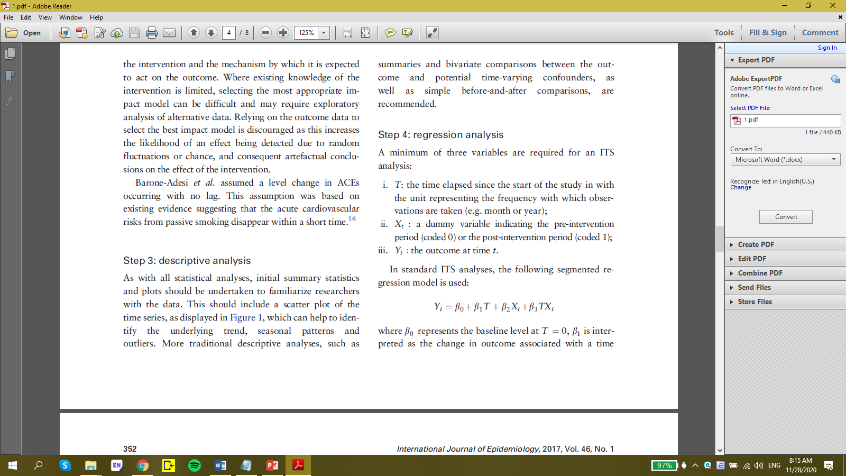

where β0 represents the baseline level at T = 0, β 1 is interpreted as the change in outcome associated with a time change leading to a level change unit increase (representing the underlying pre-intervention

trend), b2 is the level change following the intervention and b3 indicates the slope change following the intervention (using the interaction between time and intervention: *TXt* ).

**Examples of impact models used in ITS**



Figure 1: (a) Level change; (b) Slope change; (c) Level and slope change; (d) Slope change following a lag; (e) Temporary level change; (f) Temporary slope

**Model checking and autocorrelation**

***Check the residuals by plotting against time***

Table 2: Check the residuals by plotting against time

Deviance Residuals:

Min 1Q Median 3Q Max

-227.98 -13.47 0.05 6.56 2022.94

Table 3:

Estimate StdErr z P exp(Est.) 2.5% 97.5%

(Intercept) 997.904 73.906 13.502 0.000 Inf Inf Inf

GCXH 220.341 102.087 2.158 0.031 4.932165e+95 6.26181e+08 3.88486e+182

timeelapsed 0.401 2.197 0.182 0.855 1.493000e+00 2.00000e-02 1.10671e+02

Figure 2: Interrupted time series with level change regression

***Check for autocorrelation by examining the autocorrelation and partial autocorrelation***

***Functions***

Figure 3: Check for autocorrelation

Figure 4: Check for partial autocorrelation

Có sự tự tương quan giữa các biến quan sát trong thời gian 3 ngày đầu tiên.

> summary(model1)$dispersion

[1] 79839.78

*we parameterize it as an interaction between time and social distancing period*

> model4 <- glm(data$CO ~ GCXH*timeelapsed, family=gaussian, data)

Deviance Residuals:

Min 1Q Median 3Q Max

-655.33 -1.61 0.14 1.02 1690.56

Estimate StdErr z P exp(Est.) 2.5% 97.5%

(Intercept) 1011.374 68.283 14.812 0.000 Inf Inf Inf

GCXH -3734.254 1195.482 -3.124 0.002 0.000000e+00 0.000000e+00 0.000000e+00

timeelapsed -0.075 2.031 -0.037 0.970 9.280000e-01 1.700000e-02 4.969500e+01

GCXH:timeelapsed 95.443 28.763 3.318 0.001 2.820371e+41 9.273666e+16 8.577507e+65

(figure 5).

Figure 5: Interrupted time series with slope change regression

**Figure 6:** Interrupted time series with level change and slope change regression model

* test if the change-in-slope improve the fit

Model 1: data$CO ~ GCXH + timeelapsed

Model 2: data$CO ~ GCXH * timeelapsed

Resid. Df Resid. Dev Df Deviance F Pr(>F)

1 57 4550867

2 56 3803095 1 747773 11.011 0.001596 **