
PROJECT 2 PART 3
LIBRARY MANAGEMENT BASE SYSTEM

December 2, 2024
Louis DO
DANIEL BONTA
TEAM 20
CSE 3330-003

HONOR CODE
I pledge, on my honor, to uphold UT Arlington’s tradition of academic integrity, a tradition that values hard work and honest effort in the pursuit of academic excellence.
I promise that I will submit only work that I personally create or that I contribute to group collaborations, and I will appropriately reference any work from other sources. I will follow the highest standards of integrity and uphold the spirit of the Honor Code.

Signatures
Louis Do – 1002072156
Daniel Bonta – 1001820190

Introduction
The main priority of this project is to design and alter the database that was given, the Library Base Management System. In this phase, number 3, we will be creating SQL queries, as well as a GUI application that can interact with the queries. Using the CREATE TABLE as intended, and execute different SQL queries so the table can be populated with new stuff into the tables. Afterwards, the GUI interface will be used to interact wth the LMS database and let us interact with any SQL queries we wish to do so.

LMS CREATE DATABASE TABLES

CREATE TABLE IF NOT EXISTS PUBLISHER (
publisher_name VARCHAR(255) PRIMARY KEY,
phone VARCHAR(20) NOT NULL,
address TEXT NOT NULL
);

CREATE TABLE IF NOT EXISTS LIBRARY_BRANCH (
branch_id INTEGER PRIMARY KEY AUTOINCREMENT,
branch_name VARCHAR(255) NOT NULL,
branch_address TEXT NOT NULL
);

CREATE TABLE IF NOT EXISTS BORROWER (
card_no INTEGER PRIMARY KEY AUTOINCREMENT,
name VARCHAR(255) NOT NULL,
address TEXT NOT NULL,
phone VARCHAR(20) NOT NULL
);

CREATE TABLE IF NOT EXISTS BOOK (
book_id INTEGER PRIMARY KEY AUTOINCREMENT,
title VARCHAR(255) NOT NULL,
book_publisher VARCHAR(255) NOT NULL,
FOREIGN KEY(book_publisher) REFERENCES PUBLISHER(publisher_name)
);

CREATE TABLE IF NOT EXISTS BOOK_AUTHORS (
book_id INTEGER NOT NULL,
author_name VARCHAR(255) NOT NULL,
PRIMARY KEY(book_id, author_name),
FOREIGN KEY(book_id) REFERENCES BOOK(book_id)
);

CREATE TABLE IF NOT EXISTS BOOK_LOANS (
book_id INTEGER NOT NULL,
branch_id INTEGER NOT NULL,
card_no INTEGER NOT NULL,
date_out DATE NOT NULL,
due_date DATE NOT NULL,
returned_date DATE NOT NULL,
PRIMARY KEY(book_id, branch_id, card_no),
FOREIGN KEY(book_id) REFERENCES BOOK(book_id),
FOREIGN KEY(branch_id) REFERENCES LIBRARY_BRANCH(branch_id),
FOREIGN KEY(card_no) REFERENCES BORROWER(card_no)
);

CREATE TABLE IF NOT EXISTS BOOK_COPIES (
book_id INTEGER NOT NULL,
branch_id INTEGER NOT NULL,
no_of_copies INTEGER NOT NULL,
PRIMARY KEY(book_id, branch_id),
FOREIGN KEY(book_id) REFERENCES BOOK(book_id),
FOREIGN KEY(branch_id) REFERENCES LIBRARY_BRANCH(branch_id)
);

METHOD TO IMPORT/LOAD DATA INTO TABLES

We will use the sqlite3 command .import to provide every single table that we need with its corresponding .csv data file.
- .import -csv -skip 1 ./LMSDataset/Publisher.csv Publisher
- .import -csv -skip 1 ./LMSDataset/Library_Branch.csv Library_Branch
- .import -csv -skip 1 ./LMSDataset/Borrower.csv Borrower
- .import -csv -skip 1 ./LMSDataset/Book.csv Book
- .import -csv -skip 1 ./LMSDataset/Book_Authors.csv Book_Authors
- .import -csv -skip 1 ./LMSDataset/Book_Loans.csv Book_Loans
- .import -csv -skip 1 ./LMSDataset/Book_Copies.csv Book_Copies

Task 1
- Type in sqlite3 into command prompt
- Execute the following after sqlite3 is opened
  - .open lbms.db
  - .read tables.sql
  - .mode column
  - .header on
  - .read load.sql
  - .read task1.sql
  - .quit
Task 2
- Have to run the Task 1 SQL queries before attempting Task 2 (Otherwise some queries won’t work)
(THIS IS ITS NEVER BEEN IMPORTED YET)

  - Type in sqlite3 into command prompt
  - Execute the following after sqlite3 is opened
    - .open lbms.db
    - .read tables.sql
    - .mode csv
    - .read load.sql
    - .read task1.sql
    - .schema
    - .quit

- For this Task, do “python gui.py” in the terminal.

TASK 1 SQL QUERIES

Query 1
Add an extra column ‘Late’ to the Book_Loan table. Values will be 0-for non-late retuns, and 1-for late returns. Then update the ‘Late’ column with '1' for all records that they have a return date later than the due date and with '0' for those were returned on time

ALTER TABLE Book_Loans
ADD Late INT;
UPDATE Book_Loans
SET Late = CASE
WHEN Book_Loans.Returned_date BETWEEN
Book_Loans.date_out AND Book_Loans.due_date THEN 0
ELSE 1
END;
SELECT * FROM Book_Loans;
SELECT COUNT(*) AS Total_Rows_Returned_Q1 FROM Book_Loans;

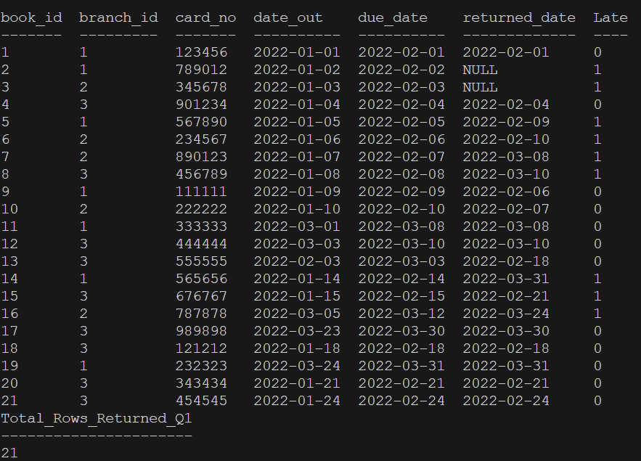

Query 2
Add an extra column ‘LateFee’ to the Library_Branch table, decide late fee per day for each branch and update that column

ALTER TABLE Library_Branch
ADD LateFee DECIMAL(10, 2);
UPDATE Library_Branch
SET LateFee = CASE
WHEN Library_Branch.branch_id = 1 THEN 1.50
WHEN Library_Branch.branch_id = 2 THEN 1.00
WHEN Library_Branch.branch_id = 3 THEN 0.75
ELSE 1.25
END;
SELECT * FROM Library_Branch;
SELECT COUNT(*) AS Total_Rows_Returned_Q2 FROM Library_Branch;

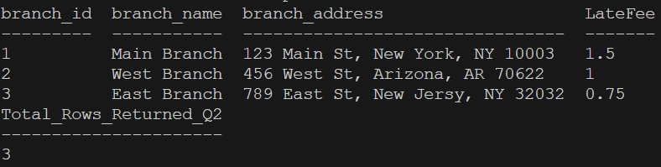

Query 3
Create a view vBookLoanInfo that retrieves all information per book loan. The view should have the following attributes: (GIVEN IN DOC)

CREATE VIEW vBookLoanInfo AS
SELECT
BW.card_no AS Card_No,
BW.name AS [Borrower Name],
B_L.date_out AS Date_Out,
B_L.due_date AS Due_Date,
B_L.Returned_date AS Returned_Date,

CAST(
(JulianDay(B_L.Returned_date) - JulianDay(B_L.date_out)) AS INTEGER
) AS TotalDays,

Bk.title AS [Book Title],

CASE
WHEN (B_L.Returned_date BETWEEN B_L.date_out AND B_L.due_date)
THEN 0
ELSE CAST(
(JulianDay(B_L.Returned_date) - JulianDay(B_L.due_date)) AS INTEGER
)
END AS [Number of days returned late],

L_B.branch_id AS [Branch ID],

CASE
WHEN (B_L.Returned_date BETWEEN B_L.date_out AND B_L.due_date)
THEN 0
ELSE L_B.LateFee * CAST(
(JulianDay(B_L.Returned_date) - JulianDay(B_L.due_date)) AS INTEGER
)
END AS LateFeeBalance

FROM Borrower AS BW
JOIN Book_Loans AS B_L ON BW.card_no = B_L.card_no
JOIN Book AS Bk ON B_L.book_id = Bk.book_id
JOIN Library_Branch AS L_B ON B_L.branch_id = L_B.branch_id;

SELECT * FROM vBookLoanInfo;
SELECT COUNT(*) AS Total_Rows_Returned_Q3 FROM vBookLoanInfo;

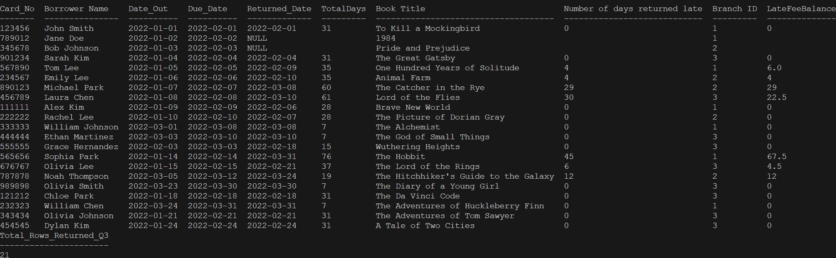

TASK 2

Query 1
User checks out a book, add it to Book_Loan, the number of copies needs to be updated via trigger in the Book_Copies table. Show the output of the updated Book_Copies.

Code/Query for query 1:
# Retrieve book_id of the selected book title
cursor.execute("SELECT book_id FROM BOOK WHERE title = ?", (book_title,))

# Get branch_id with available copies for a selected book
cursor.execute("SELECT branch_id, no_of_copies FROM BOOK_COPIES WHERE book_id = ? AND no_of_copies > 0", (book_id,))

# Add a new book checkout to Book_Loans
cursor.execute(
"INSERT INTO BOOK_LOANS (book_id, branch_id, card_no, date_out, due_date, Returned_date) VALUES (?, ?, ?, ?, ?, ?)",
(book_id, branch_id, card_number, date_out, due_date, returned_date)
)

# Update Late column of Book_Loans
cursor.execute(
"UPDATE BOOK_LOANS SET Late = CASE WHEN Returned_date BETWEEN date_out AND due_date THEN 0 ELSE 1 END"
)

# Update number of copies in Book_Copies
cursor.execute(
"UPDATE BOOK_COPIES SET no_of_copies = no_of_copies - 1 WHERE book_id = ? AND branch_id = ?",
(book_id, branch_id)
)

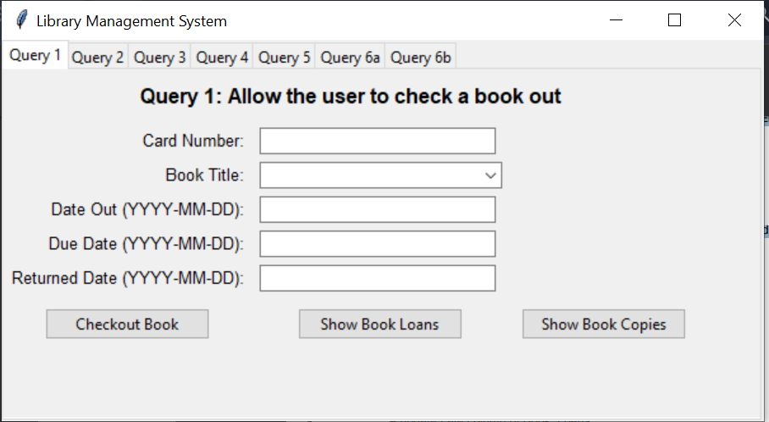
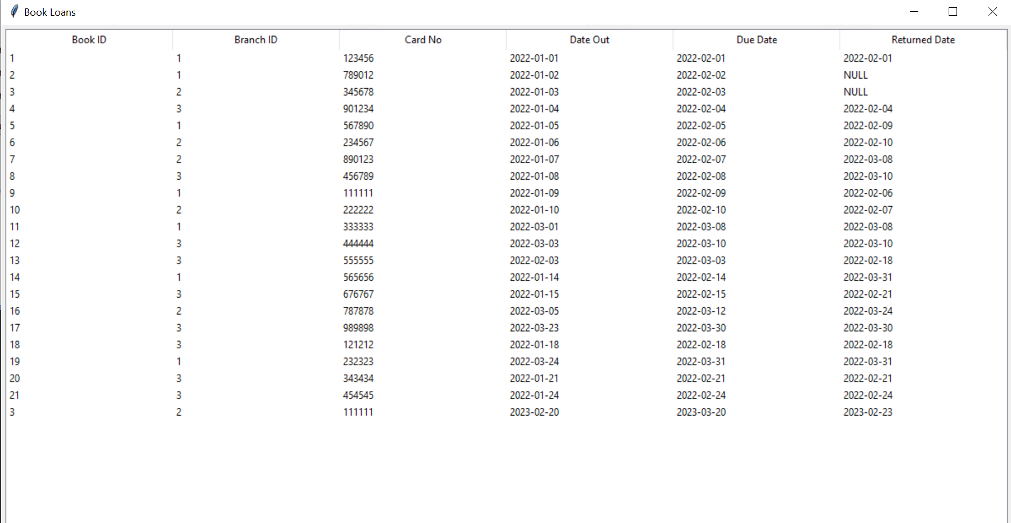
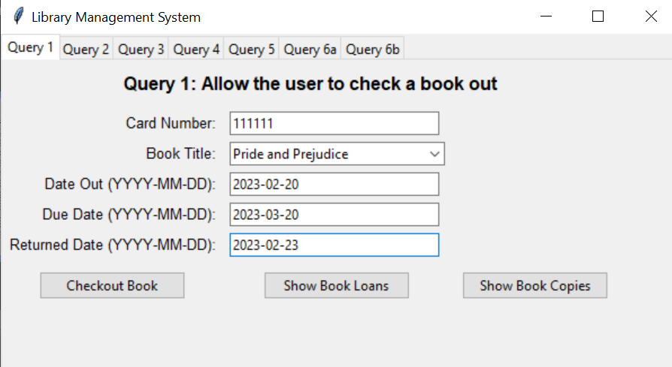
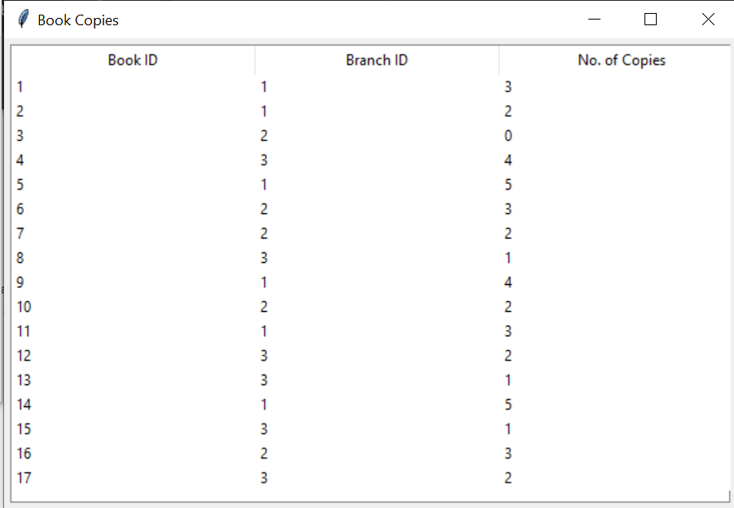
Query 2

Code/Query for query 2: Add information about a new Borrower. Do not provide the CardNo in your query. Output the card number as if you are giving a new library card. Submit your editable SQL query that your code executes.
# From add_borrower(): Add a new borrower to the database
cursor.execute(
"INSERT INTO Borrower (name, address, phone) VALUES (?, ?, ?)",
(name, address, phone),
)

# From add_borrower(): Get the last inserted card number
cursor.execute("SELECT last_insert_rowid();")
card_no = cursor.fetchone()[0]

# From show_borrowers(): Get and display all borrowers, sorted by card number
cursor.execute("SELECT card_no, name, address, phone FROM Borrower ORDER BY card_no ASC")
rows = cursor.fetchall()
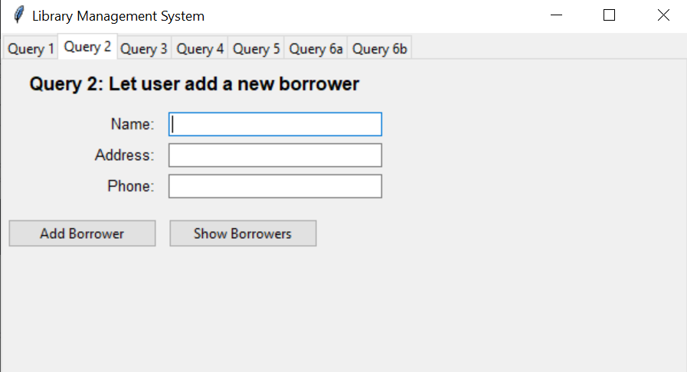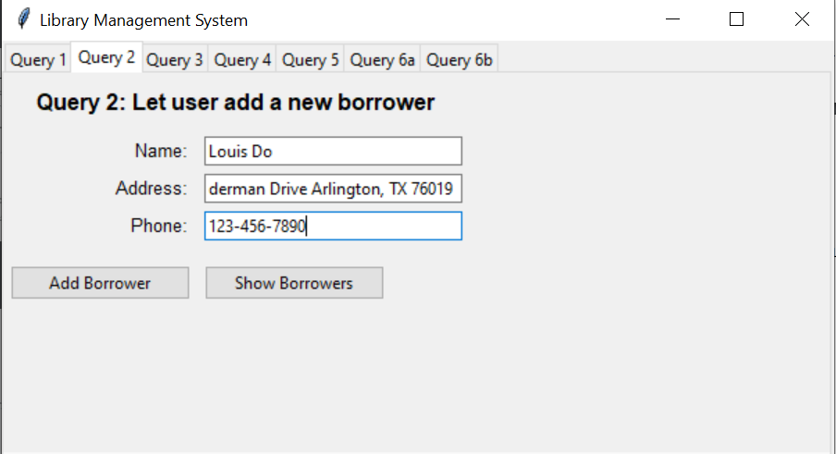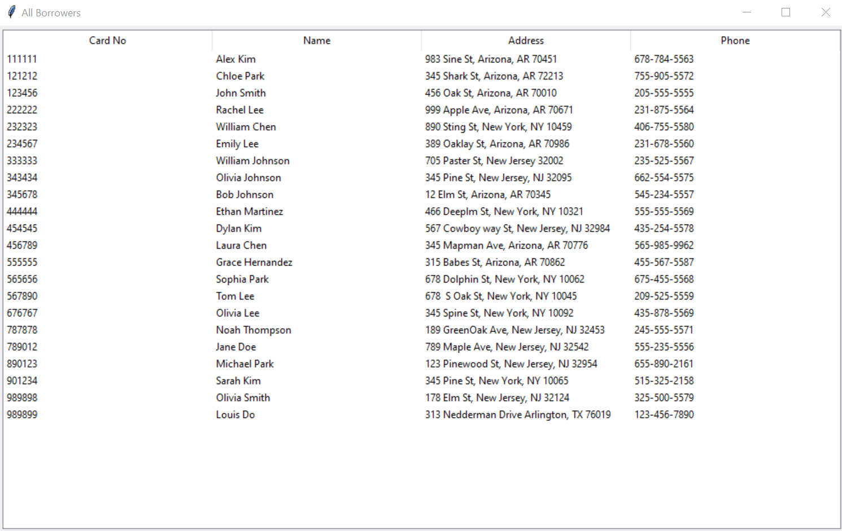

Query 3
Add a new Book with publisher (use can use a publisher that already exists) and author information to all 5 branches with 5 copies for each branch. Submit your editable SQL query that your code executes

# From add_book(): Put a new book with title and publisher into BOOK
cursor.execute("INSERT INTO BOOK(title, book_publisher) VALUES (?, ?)", (book_title, book_publisher))
conn.commit()

# From add_book(): Get the book_id of the newly added book
cursor.execute("SELECT book_id FROM BOOK WHERE title = ? AND book_publisher = ?", (book_title, book_publisher))
selected_book_id = cursor.fetchone()[0]

# From add_book(): Insert the book's author into BOOK_AUTHORS
cursor.execute("INSERT INTO BOOK_AUTHORS(book_id, author_name) VALUES (?, ?)", (selected_book_id, author_name))
conn.commit()

# From add_book(): Get the total number of library branches
cursor.execute("SELECT COUNT(*) FROM LIBRARY_BRANCH")
branch_count = cursor.fetchone()[0]

# From add_book(): Add 5 copies of the book to each library branch
for i in range(1, branch_count + 1):
cursor.execute("INSERT INTO BOOK_COPIES(book_id, branch_id, no_of_copies) VALUES (?, ?, ?)", (selected_book_id, i, 5))
conn.commit()

# From show_books_information(): Get all book-related information
cursor.execute('''
SELECT B.book_id, B.title, B.book_publisher, BA.author_name, BC.branch_id, BC.no_of_copies
FROM BOOK B
JOIN BOOK_AUTHORS BA ON B.book_id = BA.book_id
JOIN BOOK_COPIES BC ON BC.book_id = B.book_id
''')
rows = cursor.fetchall()

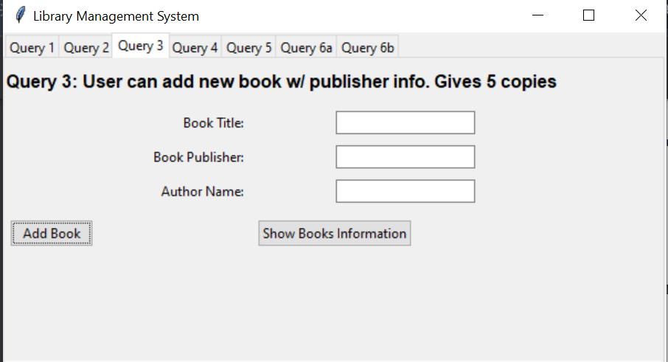
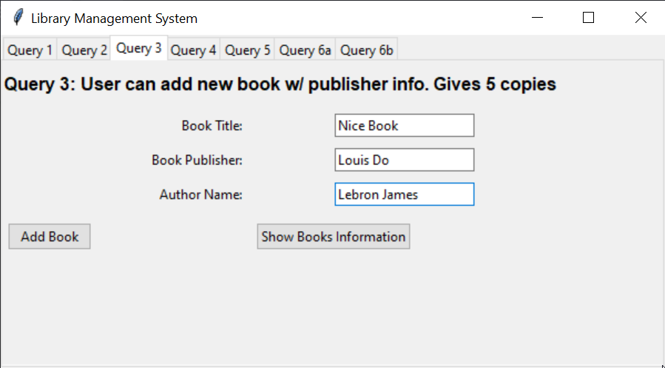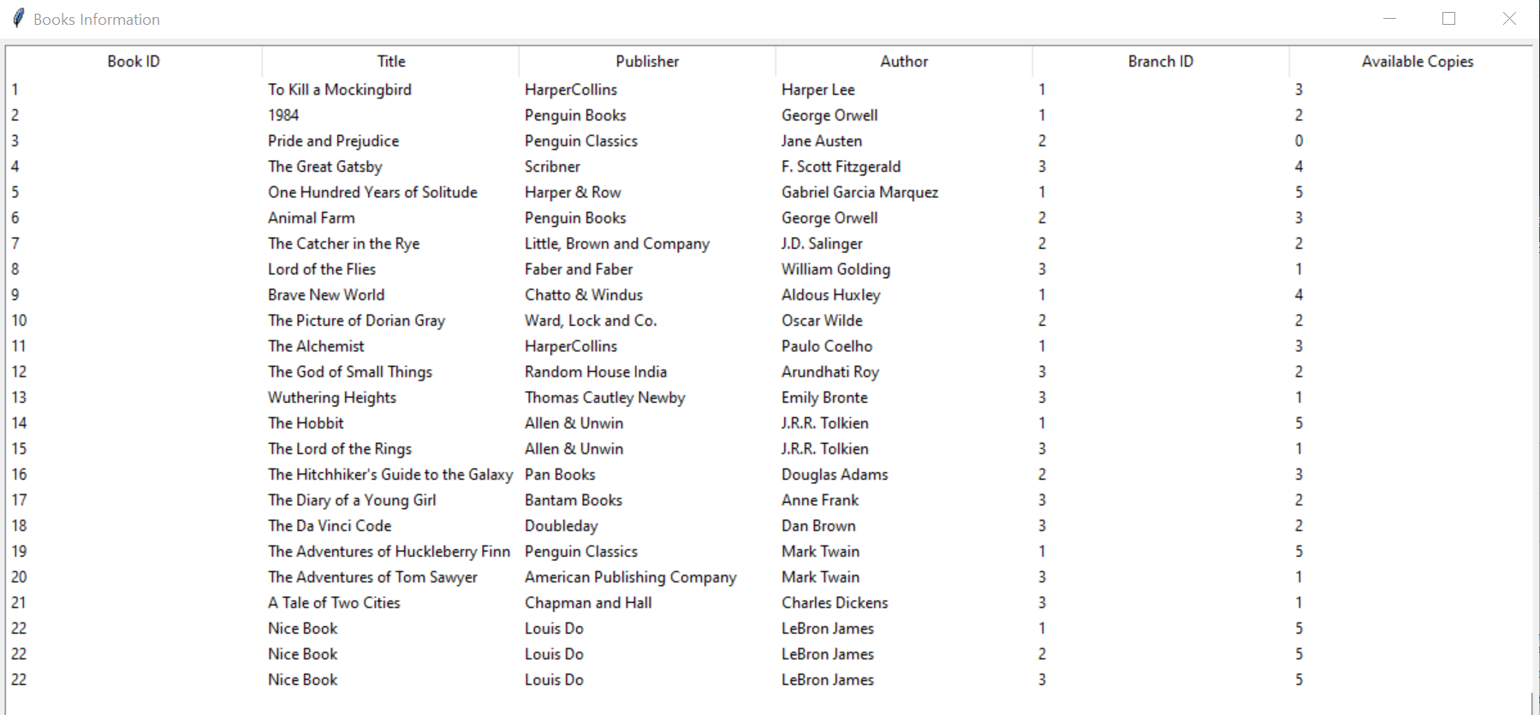

Query 4
Given a book title list the number of copies loaned out per branch

# From update_books(): Get all book titles for the dropdown menu
cursor.execute("SELECT title FROM BOOK")
books = [row[0] for row in cursor.fetchall()]

# From show_book_copies_loaned(): Retrieve the number of copies loaned per branch for the selected book
cursor.execute('''
SELECT Bk.book_id, Bk.title, B_L.branch_id, L_B.branch_name, COUNT(*) AS num_of_copies_loaned
FROM Book AS Bk
NATURAL JOIN Book_Loans AS B_L
NATURAL JOIN Library_Branch AS L_B
WHERE Bk.title = ?
GROUP BY Bk.book_id, Bk.title, B_L.branch_id, L_B.branch_name
''', (book_menu.selected_book_title,))
rows = cursor.fetchall()

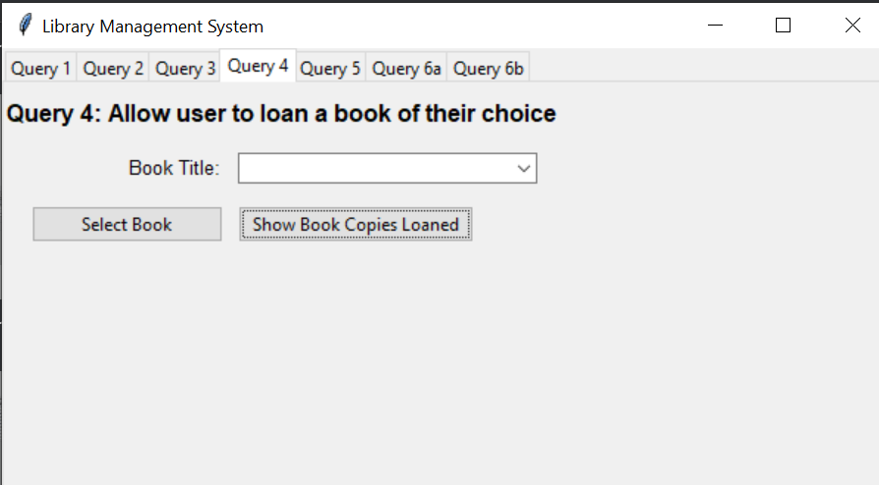

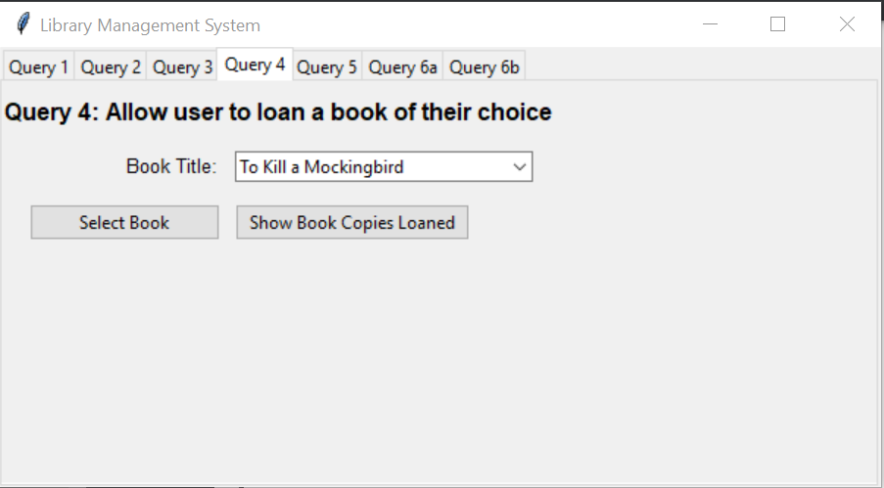

Query 5
Given any due date range list the Book_Loans that were returned late and how many days they were late. Submit your editable SQL queries that your code executes

# From submit_range_due(): Keep the due date range entered by the user
date_due_range.extend([date1, date2])

# From show_book_loans_days_late(): list book loans returned late within a due date range give
cursor.execute('''
SELECT B_L.book_id, B_L.branch_id, B_L.card_no, B_L.date_out, B_L.due_date, B_L.Returned_date,
CASE
WHEN (B_L.Returned_date BETWEEN B_L.date_out AND B_L.due_date) THEN 0
ELSE CAST((JulianDay(B_L.Returned_date) - JulianDay(B_L.due_date)) AS INTEGER)
END AS num_of_days_late
FROM Book_Loans AS B_L
WHERE (B_L.due_date BETWEEN ? AND ?) AND (num_of_days_late != 0)
''', (date1, date2))
rows = cursor.fetchall()

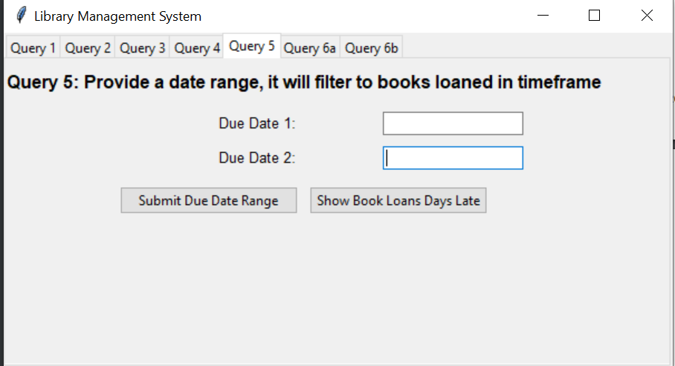
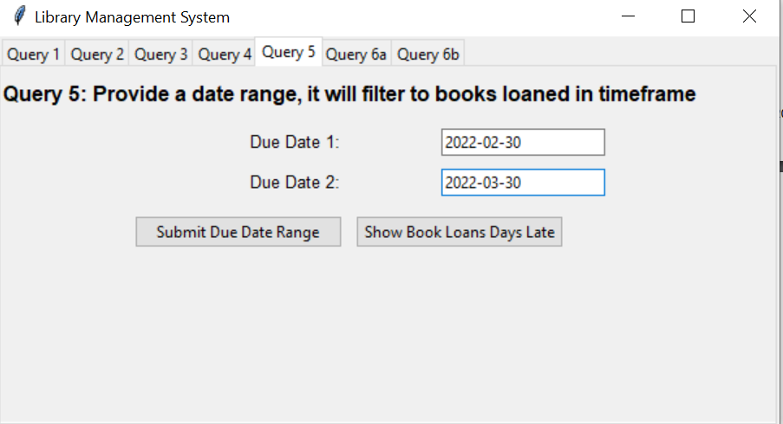
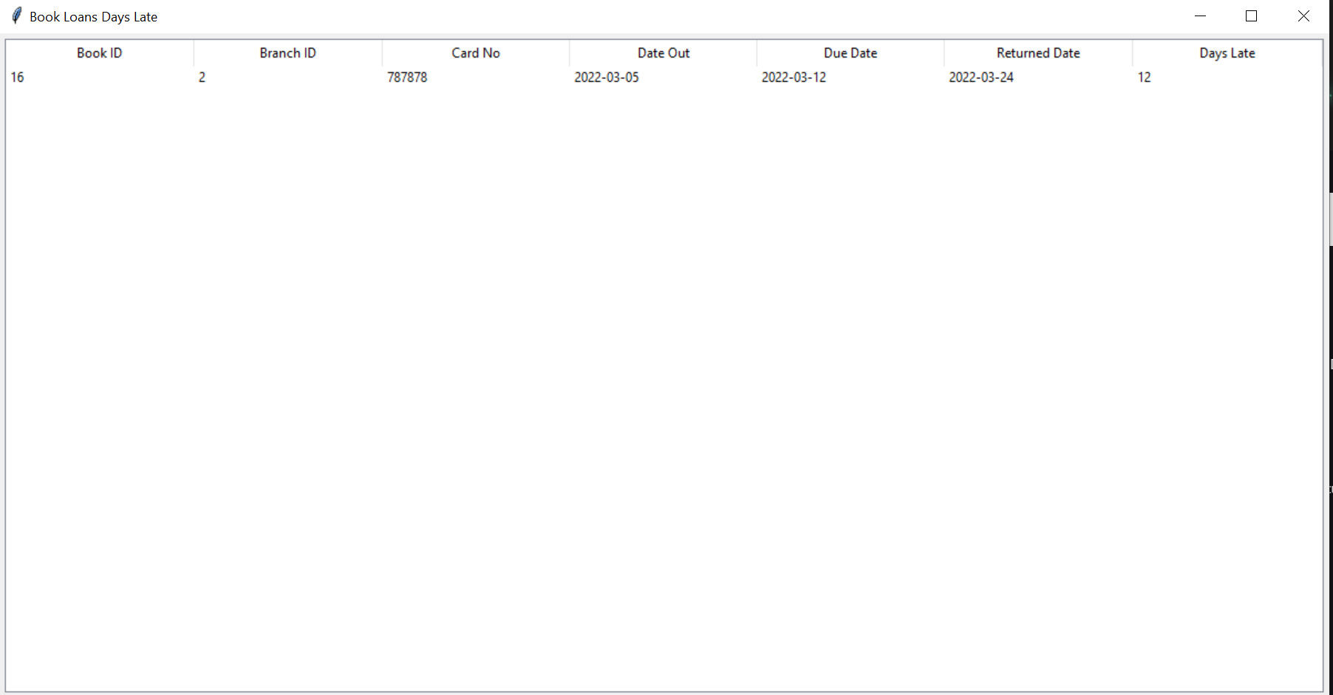
Query 6a

# From show_late_fee_balances: list borrower ID, name, and LateFeeBalance optional filters
cursor.execute(f"""
SELECT
Card_No,
[Borrower Name],
CASE
WHEN LateFeeBalance < 0 THEN 0
ELSE LateFeeBalance
END AS LateFeeBalance
FROM vBookLoanInfo
{filter_query}
ORDER BY
CASE
WHEN ? = '' THEN LateFeeBalance
ELSE Card_No
END ASC;
""", filter_parameters)

# Fetch the result set
rows = cursor.fetchall()

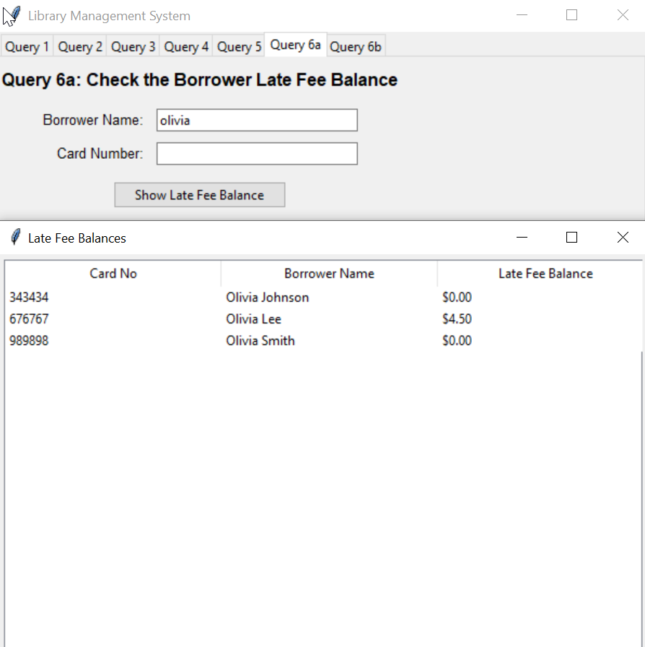
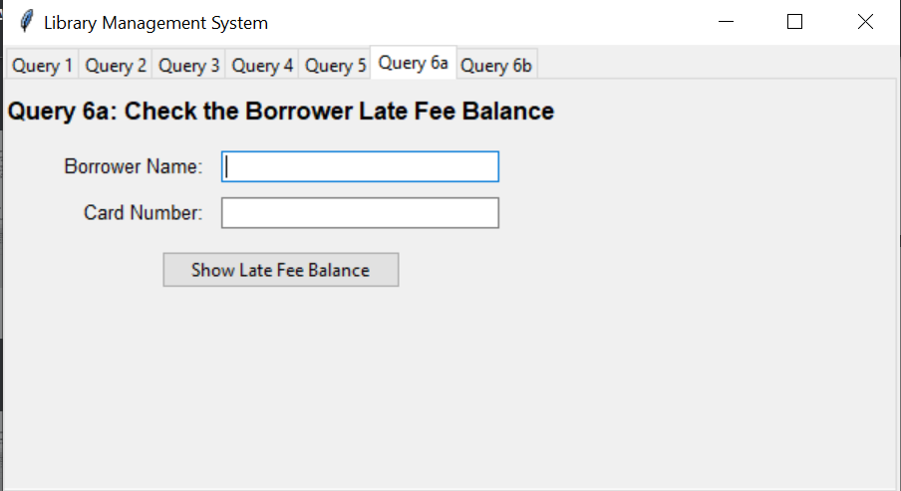

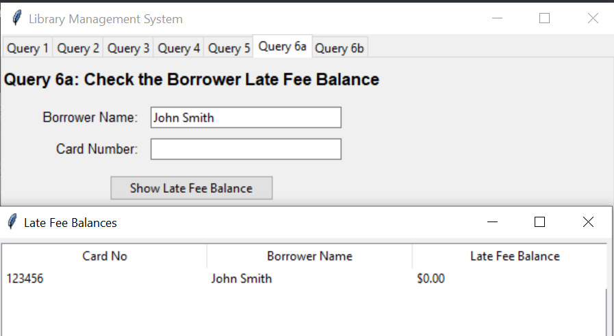
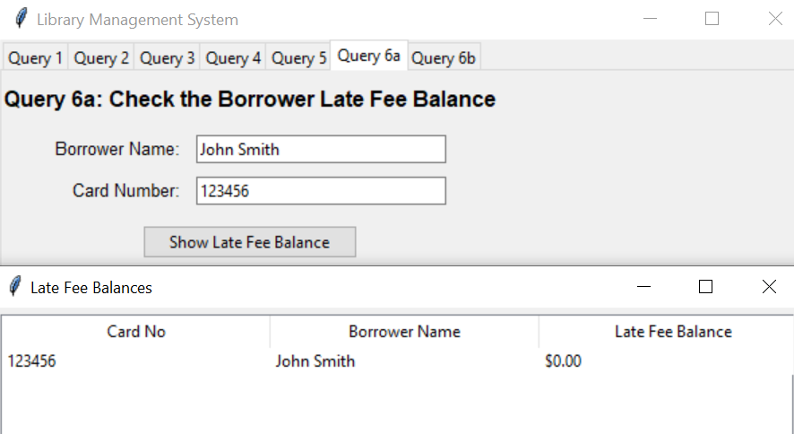
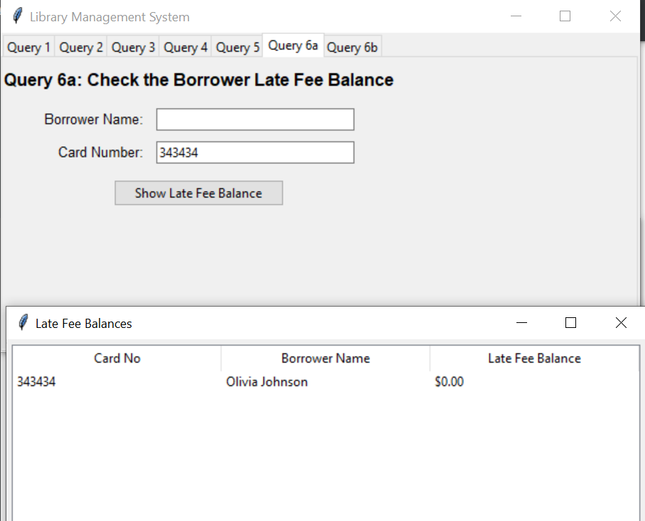
Query 6b

# From select_Filtered_books(): Put it together here because it makes more sense. Filters book
cursor.execute('''
SELECT
Bk.book_id AS "Book ID",
vBLI.[Book Title] AS "Book Title",
vBLI.Date_Out AS "Date Out",
vBLI.Due_Date AS "Due Date",
vBLI.Returned_date AS "Returned Date",
CASE
WHEN vBLI.Due_Date IS NOT NULL THEN CAST((JulianDay(vBLI.Due_Date) - JulianDay(vBLI.Date_Out)) AS INTEGER)
ELSE 'N/A'
END AS "Total Days Loaned",
vBLI.[Number of days returned late] AS "Days Returned Late",
vBLI.[Branch ID] AS "Branch ID",
CASE
WHEN vBLI.LateFeeBalance IS NULL OR vBLI.LateFeeBalance <= 0 THEN 'Non-Applicable'
ELSE '$' || printf("%.2f", vBLI.LateFeeBalance)
END AS "Late Fee Balance"
FROM
vBookLoanInfo AS vBLI
JOIN
Book AS Bk ON vBLI.[Book Title] = Bk.title
WHERE
vBLI.Card_No = ?
''', tuple(query_parameters))

# From select_all_books(): Put it together here because it makes more sense. No filter
SELECT
Bk.book_id AS "Book ID",
vBLI.[Book Title] AS "Book Title",
vBLI.Date_Out AS "Date Out",
vBLI.Due_Date AS "Due Date",
vBLI.Returned_date AS "Returned Date",
CASE
WHEN vBLI.Due_Date IS NOT NULL THEN CAST((JulianDay(vBLI.Due_Date) - JulianDay(vBLI.Date_Out)) AS INTEGER)
ELSE 'N/A'
END AS "Total Days Loaned",
vBLI.[Number of days returned late] AS "Days Returned Late",
vBLI.[Branch ID] AS "Branch ID",
CASE
WHEN vBLI.LateFeeBalance IS NULL OR vBLI.LateFeeBalance <= 0 THEN 'Non-Applicable'
ELSE '$' || printf("%.2f", vBLI.LateFeeBalance)
END AS "Late Fee Balance"
FROM
vBookLoanInfo AS vBLI
JOIN
Book AS Bk ON vBLI.[Book Title] = Bk.title
ORDER BY
vBLI.LateFeeBalance DESC;
''')

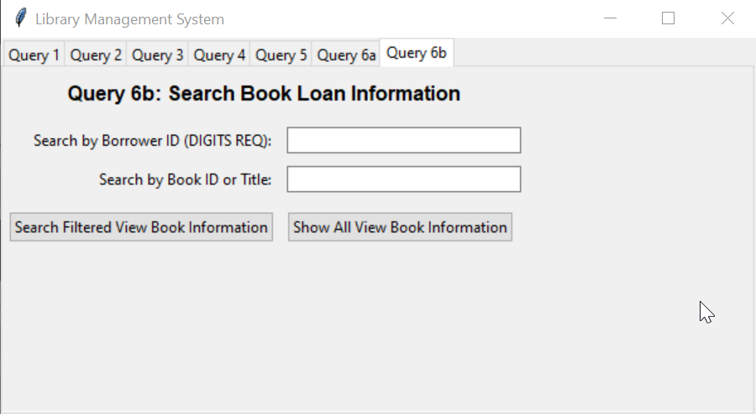
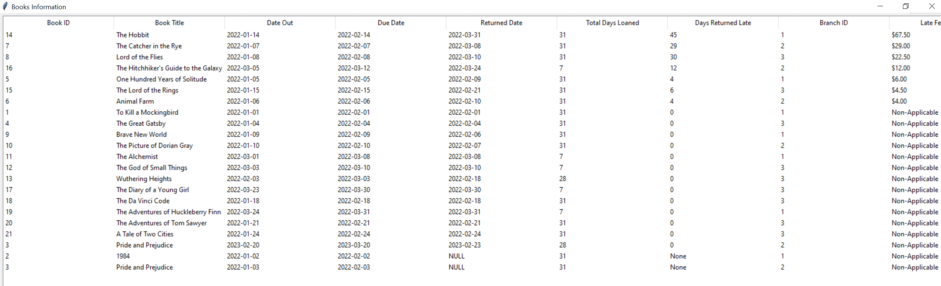

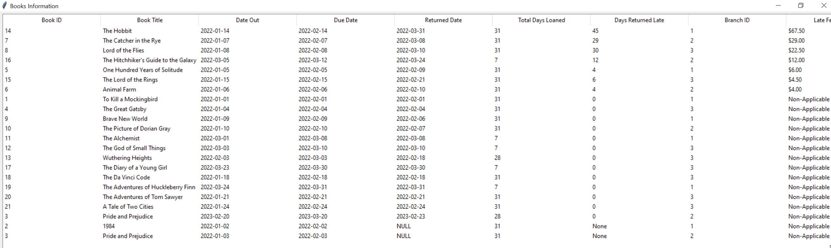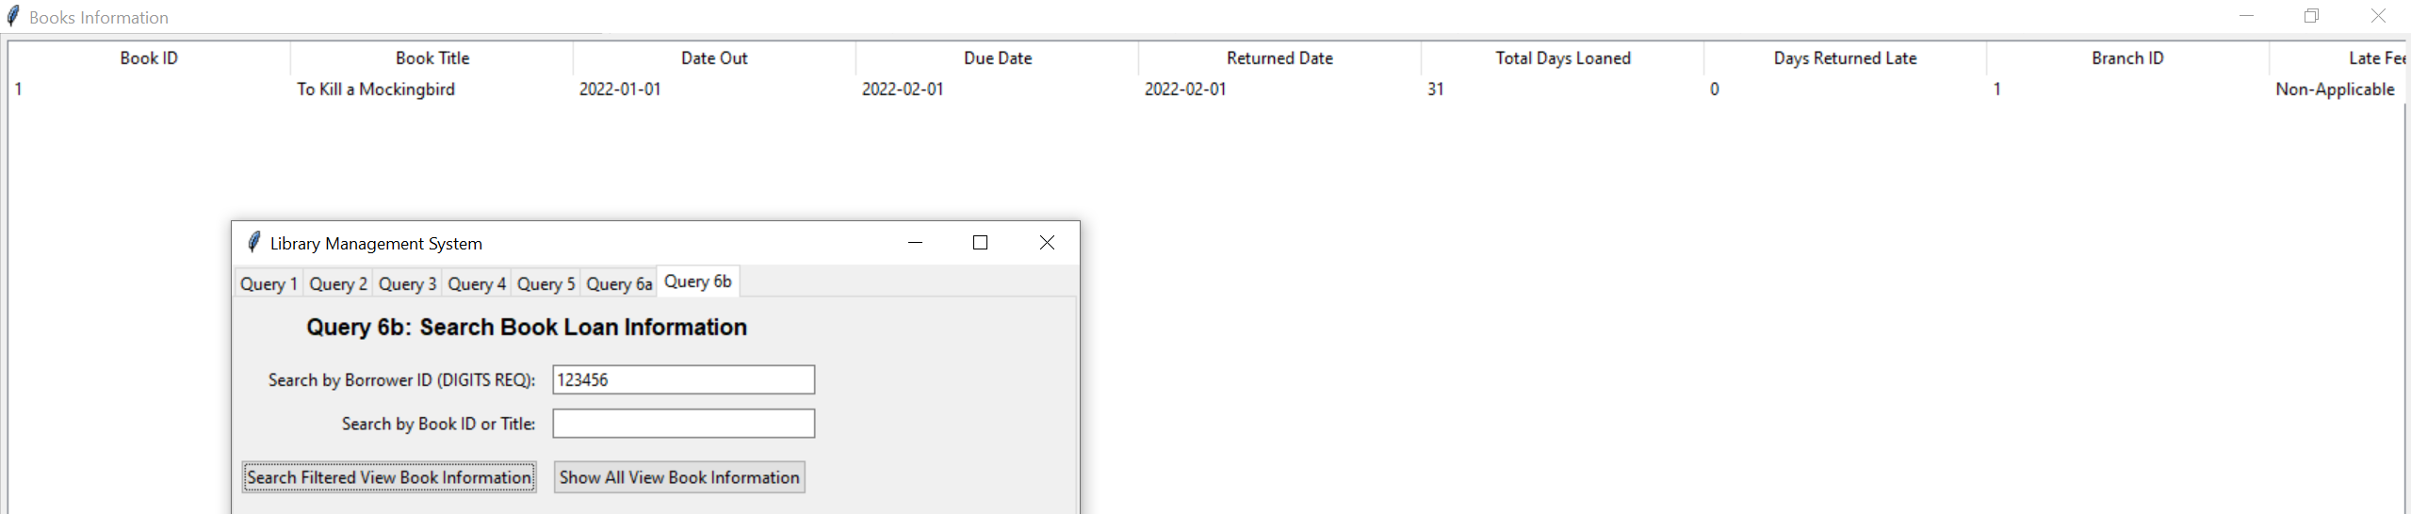

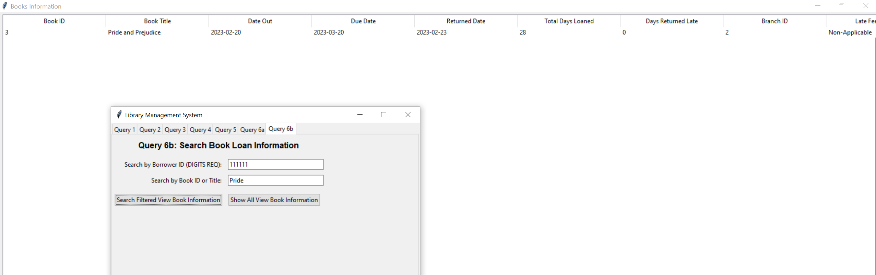
Contribution List
- Brainstorming
  - Louis Do, Daniel Bonta
- Report.pdf file
  - Louis Do, Daniel Bonta
- SQL Create Statement Code
  - Louis Do
- Guide on how to execute program
  - Daniel Bonta
- Load Data into Tables
- Task 1: SQLite queries
  - Louis Do
- Task 2: GUI Interface Queries
  - Query 2,3,5,6a,6b – Louis Do
  - Query 1,4 – Daniel Bonta
- Python GUI
  - Louis Do, Daniel Bonta
- Contribution List
  - Louis Do, Daniel Bonta

