challenge

Lin He

August 23, 2017

loading ggplot2 package

library(ggplot2)

read the portal data

## record_id month day year plot_id species_id sex hindfoot_length weight  
## 1 845 5 6 1978 2 NL M 32 204  
## 2 1164 8 5 1978 2 NL M 34 199  
## 3 1261 9 4 1978 2 NL M 32 197  
## 4 1756 4 29 1979 2 NL M 33 166  
## 5 1818 5 30 1979 2 NL M 32 184  
## 6 1882 7 4 1979 2 NL M 32 206  
## genus species taxa plot_type  
## 1 Neotoma albigula Rodent Control  
## 2 Neotoma albigula Rodent Control  
## 3 Neotoma albigula Rodent Control  
## 4 Neotoma albigula Rodent Control  
## 5 Neotoma albigula Rodent Control  
## 6 Neotoma albigula Rodent Control

create a plot

ggplot(reduced, aes(x=weight))+geom_histogram(bins=8)

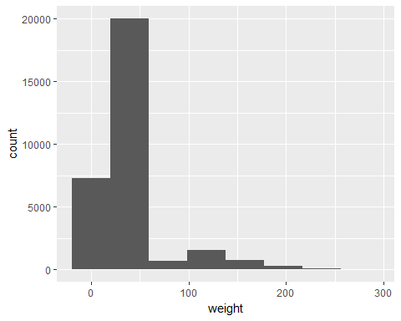

round up=4.56