3D hybrid-parametric inversion of AEM data accelerated by tiling
Introduction
Airborne electromagnetic (AEM) surveys now routinely collect tens to hundreds of thousands of soundings with tight line spacing and broad bandwidths, yet these data are still most often inverted under a 1D layered-earth assumption. This choice is reasonable in many settings, is fast, and is supported by well-established algorithms. However, in geologically complex settings, the 1D assumption breaks down, introducing artifacts, such as “pant-leg” features over conductive targets. Because conductivity structures are inherently three-dimensional, the goal is a 3D conductivity model.
A full 3D inversion can account for these effects, but it is still rarely carried out in practice. The primary barrier is computational: 3D time-domain EM (TDEM) simulations and the associated sensitivity computations are expensive, particularly when a survey contains many sources. Domain-decomposition approaches address this. By separating the inversion mesh from the forward meshes and assigning each source a small local mesh with far fewer cells, the forward simulations and sensitivity calculations can be distributed and computed in parallel (Cox et al., 2010; Yang et al., 2014). OcTree meshes complement this by allowing refinement in regions of interest and rapid coarsening elsewhere.
A further challenge with 3D inversions is the influence of the sensitivity on the structure of the recovered model; in particular, “ring”-like structures are often recovered instead of compact conductors. Parametric and hybrid-parametric inversion approaches, such as that introduced by McMillan et al. (2015), can help overcome this by parameterizing the inversion model in terms of a specific geometry (e.g. an ellipsoid) and then using the result to warm-start a full 3D inversion.
Here, we combine a tiled 3D forward simulation on OcTree meshes with a hybrid-parametric inversion workflow to demonstrate the recovery of a compact target in a heterogeneous background. The work is implemented within the open-source SimPEG project (Cockett et al., 2015; Heagy et al., 2017).
Forward simulation
We adopt the domain-decomposition strategy of Yang et al. (2014), implemented here on OcTree meshes. The model is defined on a single global inversion mesh, while each source is simulated on its own small local (“tiled”) mesh. A mapping carries the conductivity from the global mesh to each local mesh; here it computes the log-average of the global-cell conductivities that fall within each local cell. The per-source simulations are parallelized using Python’s built-in multiprocessing, although a dask-based scheduler could also be used.
We demonstrate the approach on the synthetic model shown in Figure 1, which mimics a common problem in mineral exploration: a dipping conductive, mineralized target (5 S/m, 200 Ωm, dipping at 45°) is embedded in a 1000 Ωm halfspace, and lies beneath a conductive overburden (150 Ωm) whose thickness varies from zero at its edges to about 60 m near its centre. The overburden blankets the shallow, up-dip end of the target. The survey is a central-loop AEM system (step-off waveform, 30 m flight height) recording the vertical db/dt at 20 log-spaced time channels between 2×10⁻⁵ and 2×10⁻³ s, along five lines spaced 100 m apart. For the 3D inversions, we use an 80m along-line spacing.
The global OcTree mesh uses 20 m base cells over an 8 km domain, refined at the receivers and over the target, for ~52,300 cells. We simulate a 5-line survey with 40m along-line spacing giving a total of 100 soundings. Each per-source tile mesh shares the same base cell size but is refined only beneath its source, giving ~5,500 cells per tile, about one-tenth of the global mesh. To solve the TDEM problem, Maxwell’s equations are discretized in space with a mimetic finite-volume method on the OcTree mesh and backward-Euler for the time-stepping (Haber, 2014). We use a direct solver (Pardiso) for the forward. Per sounding, a single forward takes 2.7 s on a tile mesh versus 96 s on the global mesh, roughly 35× faster. The independent per-source solves distribute across a worker pool; running 48 workers in parallel, the full 100-sounding forward completes in ~16 s versus ~25 min on the global mesh (~90×), at comparable peak memory (~13.5 vs ~11.3 GB). The tiled run’s memory is dominated by holding all per-sounding meshes and operators in RAM, which grows with survey size; building each tile lazily within its worker would reduce this and is an area for future work.
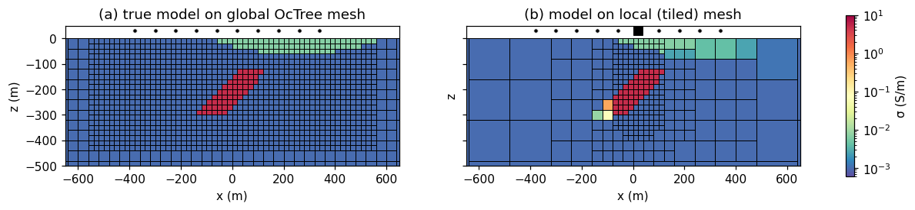
Figure 1. The synthetic model of dipping-conductor model on (a) the global OcTree mesh, with 20 m base cells, and (b) a single per-source local (tiled) mesh, refined only beneath its transmitter (black square at the surface).
Sensitivity computation
Sensitivities are propagated through SimPEG’s “mapping” objects which define a transformation of the model, and their associated derivatives (Kang et al., 2015). Writing the predicted data for source i as
d_{i} = F_{i}(σ_{i}), σ_{i} = M_{i}(m), (1)
where F_{i} is the forward simulation on the local mesh of source i, σ_{i} is the conductivity on the tile mesh for that source, and M_{i} is the composition of mappings that takes the inversion model m to σ_{i}. By the chain rule, the sensitivity (Jacobian) of the data with respect to the model is
J_{i} = ∂d_{i} / ∂m = ( ∂F_{i} / ∂σ_{i} )( ∂M_{i} / ∂m ). (2)
When M_{i} is a composition M_{i} = M^{(K)} ∘ ⋯ ∘ M⁽¹⁾, its Jacobian is the ordered product of the component Jacobians, ∂M_{i} / ∂m = J^{(K)} J^{(K−1)} ⋯ J⁽¹⁾. In SimPEG, each mapping supplies both its forward action and the action of its Jacobian (and its transpose), so these, together with the sensitivity-times-vector operations of the forward simulation provide the necessary components for computing model updates.
For the voxel inversions the model m is the log-conductivity on the active cells of the global mesh. For source i, the tile map T_{i} maps this global model to the active cells of that source’s local mesh, taking the volume average over the global cells that fall within each local cell, so that the local conductivity is
σ_{i} = A_{i} exp( T_{i} m ), (3)
where exp(·) is the elementwise exponential and A_{i} injects the fixed air cells. The sensitivity is then:
J_{i} = ( ∂F_{i} / ∂σ_{i} ) A_{i} diag( exp( T_{i} m ) ) T_{i}. (4)
Because the model is mapped onto each local mesh, the physics Jacobian ∂F_{i} / ∂σ_{i} is only ever formed and applied on the small local mesh; the expensive sensitivity computation is therefore confined to the per-source local tile meshes and never computed on the full global mesh.
For the parametric stage, a low-dimensional parameter vector p (the 11 ellipsoid parameters) generates the global model, m = P(p), and a single additional factor extends the chain:
J_{i} = ( ∂F_{i} / ∂σ_{i} ) A_{i} diag( exp( T_{i} P(p) ) ) T_{i} ( ∂P / ∂p ), (5)
where the parametric Jacobian ∂P / ∂p is obtained by automatic differentiation through SimPEG’s PyTorch mapping (Weis, 2024). Because the mappings compose, the same tiled simulation code is reused unchanged when switching between the voxel and ellipsoid parameterizations.
Inversion
We compare three inversion workflows applied to the same synthetic data. The observed data are the forward response of the true model simulated in 3D, with no noise added. We assign a relative uncertainty of 5% to the full 3D inversions and 10% to the stitched 1D inversion and the parametric first stage, with a 10 ⁻¹² V/m² noise floor for all inversions.
Stitched 1D. Each sounding is inverted independently with a layered (1D) forward simulation, and the recovered columns are stitched into a section as shown in Figure 2b. The background is recovered well, but the dipping target is smeared and strongly under-recovered (recovered σ_{max} = 0.12 S/m against a true 5 S/m), and the characteristic “pant-leg” artifact appears beneath the target edges. The data fits are shown in Figure 3a. The observed data are in black. The blue lines show the data predicted by 1D simulation, where we can see that the inversion struggled to fit the soundings directly over the target.
We perform one additional step and run a 3D simulation of the recovered 1D model. Those data are shown in orange in Figure 3a. The 3D response matches the data on the far left, where the earth behaves like a halfspace and the 1D assumption holds, but departs from it over the target, where the response is genuinely 3D, and on the right, where the conductive overburden introduces 3D effects. Because each sounding is fit independently with 1D physics, the data can be fit even though the model is inconsistent with the 3D response, so a good 1D fit does not on its own validate the interpretation.
Cold-started 3D. Here, we run a basic, uninformed inversion without sensitivity weighting to illustrate a “failure mode” that can occur when aiming to recover a highly conductive, compact target. This inversion starts from a uniform halfspace. It fails to converge after 20 iterations. The data misfit stalls roughly 20x above its target, the conductor never forms, and strong “ringing” sensitivity artifacts develop (Figure 2c). This inversion fits the early-time channels but fails to fit the later times over the target. Note that other strategies, such as using sensitivity weighting, could help improve recovery. In this abstract, we choose to illustrate a warm-starting approach with a parametric inversion.
3D hybrid-parametric. This inversion is performed in two stages. First, we focus on fitting the late-time behaviour due to the target of interest. We consider only the latest five time channels, in which the overburden response has largely decayed. With these data, we invert for a single conductive ellipsoid in a halfspace (11 parameters) using the tiled code. The starting model is a horizontal disk with semi-axes 100 m, 100 m, 50 m located at (0 m, 0 m, -200 m) and a conductivity of 5 S/m. The initial mistfit is a factor of eight times larger than the target misfit for this stage. The converges in four iterations (about 3 min each) and recovers reasonable values for the location and orientation of the target, dipping at 39° with semi-axes of 140 m, 120 m and 56 m, as well as the conductivity: 3.6 S/m.
The parametric model cannot represent the conductive overburden. To fit the data over all time channels, we perform a second inversion. We map the recovered ellipsoid onto the global voxel mesh and use it as both the starting and the reference model for a full 3D inversion that now includes all 20 time channels. Apart from this starting and reference model, the full 3D inversion is set up exactly like the cold-started run above: the same mesh, tiled simulation, data, regularization, and β-cooling schedule. This inversion converges in nine iterations, requiring a few minutes per iteration of computation time. The result in Figure 2d shows that the inversion recovers a coherent, clearly dipping conductor at the correct depth and location with no ringing artifacts. The overburden appears as a near-surface conductive band. The corresponding data fits are shown in Figure 3c. In contrast to the other two workflows, this model fits the observed data at both early and late times: the early times constrain the overburden and the late times the target, and both are recovered.
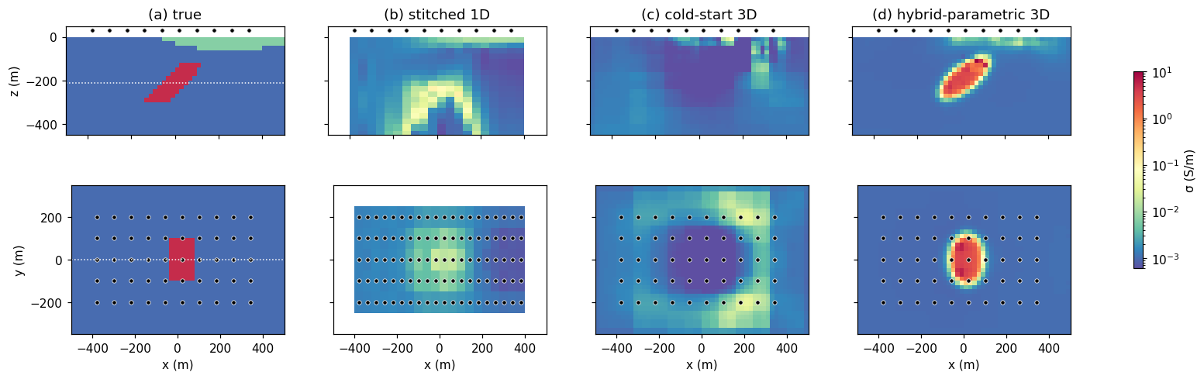
Figure 2. Recovered conductivity models, shown as a depth section along the central line (top row) and a plan view at the target depth (bottom row); dots mark sounding locations. (a) True model; (b) stitched 1D; (c) cold-started 3D; (d) two-stage hybrid-parametric 3D.
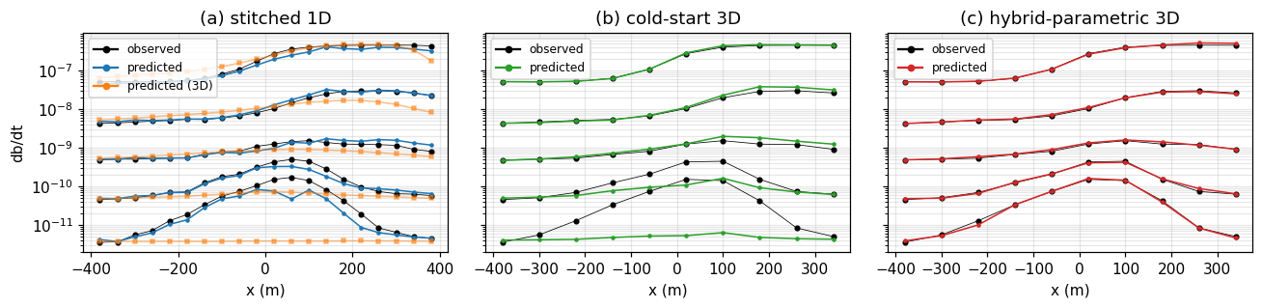
Figure 3. Observed (black) and predicted (coloured) db/dt decays along the central line for (a) the stitched 1D, (b) cold-started 3D, and (c) two-stage hybrid-parametric inversions. In (a), “predicted” (blue) is the 1D forward of the stitched model and “predicted (3D)” (orange) is a 3D forward simulation of that same model. For ease of comparison, only every fourth time channel is plotted.
Conclusions
Tiling substantially reduces the cost of the forward and sensitivity computations that dominate each step of a 3D AEM inversion, making a targeted 3D inversion tractable on modest hardware. It remains more expensive than 1D inversion, but for focussed 3D problems it is manageable. A key strength of the framework is its flexibility: because the parametric and voxel inversions are built from the same composable mappings, a low-dimensional parametric inversion can supply the prior that warm-starts the full 3D inversion. For the example presented here, that enabled the recovery of a 3D model that fit the early- and late-time data, whereas a naive cold start from a halfspace did not converge. Sensitivity weighting or other strategies may also improve the cold-start result; the warm start is simply one effective option that the shared parametric/voxel framework makes natural.
The data fits point to a broader use of the tiled code. The apparent success of a 1D inversion in fitting its own data does not guarantee that the recovered model is consistent with the 3D physics. A 3D forward simulation of the stitched 1D inversion result is a simple and informative check on where the 1D assumption holds. Where discrepancies arise, they indicate where a targeted 3D inversion of the kind shown here is warranted.
This framework’s flexibility makes it easy to experiment with alternative parameterizations and priors. The tiling strategy is general enough to support other physics, for example airborne frequency-domain EM and potentially natural-source EM, although the different nature of the sensitivities in those problems will require testing.
References
Cockett, R., Kang, S., Heagy, L.J., Pidlisecky, A. and Oldenburg, D.W. [2015] SimPEG: An open source framework for simulation and gradient based parameter estimation in geophysical applications. Computers & Geosciences, 85, 142–154.
Cox, L.H., Wilson, G.A. and Zhdanov, M.S. [2010] 3D inversion of airborne electromagnetic data using a moving footprint. Exploration Geophysics, 41, 250–259.
Haber, E., [2014] Computational Methods in Geophysical Electromagnetics. Society for Industrial and Applied Mathematics.
Heagy, L.J., Cockett, R., Kang, S., Rosenkjaer, G.K. and Oldenburg, D.W. [2017] A framework for simulation and inversion in electromagnetics. Computers & Geosciences, 107, 1–19.
Kang, S., Cockett, R., Heagy, L.J. and Oldenburg, D.W. [2015] Moving between dimensions in electromagnetic inversions. SEG Technical Program Expanded Abstracts 2015, 5000–5004.
McMillan, M.S., Schwarzbach, C., Haber, E. and Oldenburg, D.W. [2015] 3D parametric hybrid inversion of time-domain airborne electromagnetic data. Geophysics, 80, K25–K36.
Weis, J.M. [2024] A differential equation-based framework for magnetic inversions to address challenges with high susceptibility and remanence. Ph.D. thesis, University of British Columbia.
Yang, D., Oldenburg, D.W. and Haber, E. [2014] 3-D inversion of airborne electromagnetic data parallelized and accelerated by local mesh and adaptive soundings. Geophysical Journal International, 196, 1492–1507.

