The Importance of Open Access in Scientific Publications
Release 0.00

Galileo Galilei¹, Giordano Bruno² and Anthony Leeuwenhoek³

January 6, 2006
¹Pisa University, Tower drive
²Rome University, Inquisition street
³Netherlands Pragmatic University, Port street
Abstract

This document describes a new algorithm implemented using the Insight Toolkit ITK www.itk.org.
The code of the algorithm is written following the ITK CodingStyle as described in the directory
Insight/Documentation/Style.pdf
This paper is accompanied with the source code, input data, parameters and output data that the authors
used for validating the algorithm described in this paper. This adheres to the fundamental principle
that scientific publications must facilitate reproducibility of the reported results.

Contents
1 Principals of Solar Spot Detection 2
2 Why Image Processing Papers must include Source Code, Images and Parameters 2
3 Pointing to other material 2
4 Software Requirements 3
A This is an Appendix 3

Using filters from the Insight Toolkit, we develop an algorithm for detecting and tracking thje movement of solar spots. As it is widely known, celestial objects such as the sun are ethereal and perfect, and therefore can not harbor artifacts such as spots. However, observations performed with our open source telescope have revealed the presence of such spots. The spots seems to continuously change positions on the solar surface.
Automatic detection and tracking of the solar spot movements are of fundamental importance for allowing the authors to dedicate more time to perfectioning optical instruments and less time to the supervised acquisition of reliable data.
The reader should be warned that direct observation of the sun without proper equipment may result in personal injury, loss of vision and burned brains.

Principals of Solar Spot Detection
Solar spots can be classified as the darkest objects present on an image of the solar surface. Algorithms such as watersheds, statistical classification and mathematical morphology are suitable for automatically detecting these features in images of the solar surface.

Why Image Processing Papers must include Source Code, Images and Parameters
Modern Image Processing is most of the time performed with computers. An attempt to replicate the results of an algorithm described in a paper entails to reimplement the algorithm into source code. This task is far from trivial and consumes months of work. The final result can not be guarranted to be equivalent to the actual code that was used for testing the algorithm when the paper was written, and therefore it cannot be considered a baseline for comparing the algoritm with other algorithms availble to the reader.
Papers to the Insight Journal are written in the spirit of facilitating and encouraging readers to perform replication of work. In this sense, the Insight Journal is compliant with essential concepts of the scientific method.
Since the code is included with the paper, less time has to be spent in describing the code, and more time can be used for describing how to use the algorithm in particular types of images. For questions on the basis of the scientific method the reader is refered to [2, 1].

Pointing to other material
The format of this LaTeX file, allows authors to include code snippets, like the following
typedef itk::Image< unsigned char, 3 > ImageType;
ImageType::Pointer image = ImageType::New();
and to cite the online documentation of the Insitght Toolkit, for example, the link to the doxygen documentation of the ImageToImageFilter
itk::ImageToImageFilter
LaTeX macros are also available for typesetting code in familiar courier fonts. Like the following method of an ITK class.
SetNumberOfIterations()

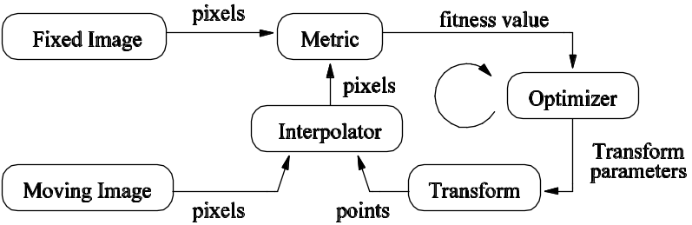
Figure 1 The basic components of the registration framework are two input images, a transform, a metric, an interpolator and an optimizer.

Software Requirements
You need to have the following software installed:
• Insight Toolkit 2.4.
• CMake 2.2
Note that other versions of the Insight Toolkit are also available in the testing framework of the Insight Journal. Please refere to the following page for details
http://www.insightsoftwareconsortium.org/wiki/index.php/IJ-Testing-Environment

This is an Appendix
Appendix type stuff goes in here.

Reference
[1] K. Popper. Open Society and Its Enemies. Princenton University Press, 1971.
[2] K. Popper. The Logic of Scientific Discovery. Routledge, 2002.

