Train HyADS to CMAQ-DDM coal impacts

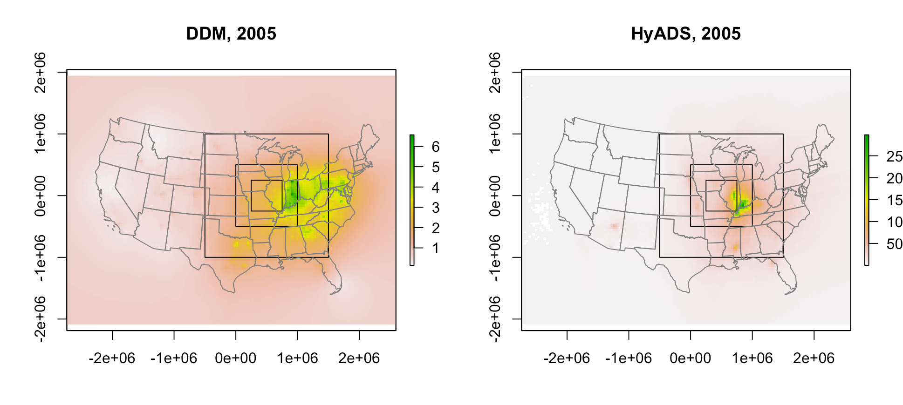

**Notes**

* Dummy HyADS data (did not finish putting it all on a grid)
* Squares are different size training regimes for spLM benchmarking
  + Small:
  + Medium:
  + Large:
  + Total:
* Models trained with example priors, tuning, etc.

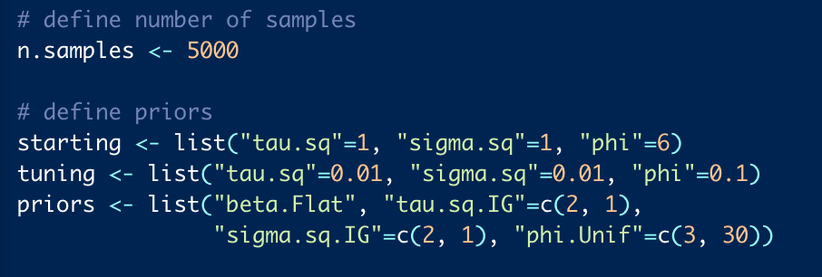

* Models trained on 90% of data, evaluated against 10% holdout
* Include temperature and precipitation as covariates (just to test if I could, can add more later)

**Model 1: medium square, no knots**

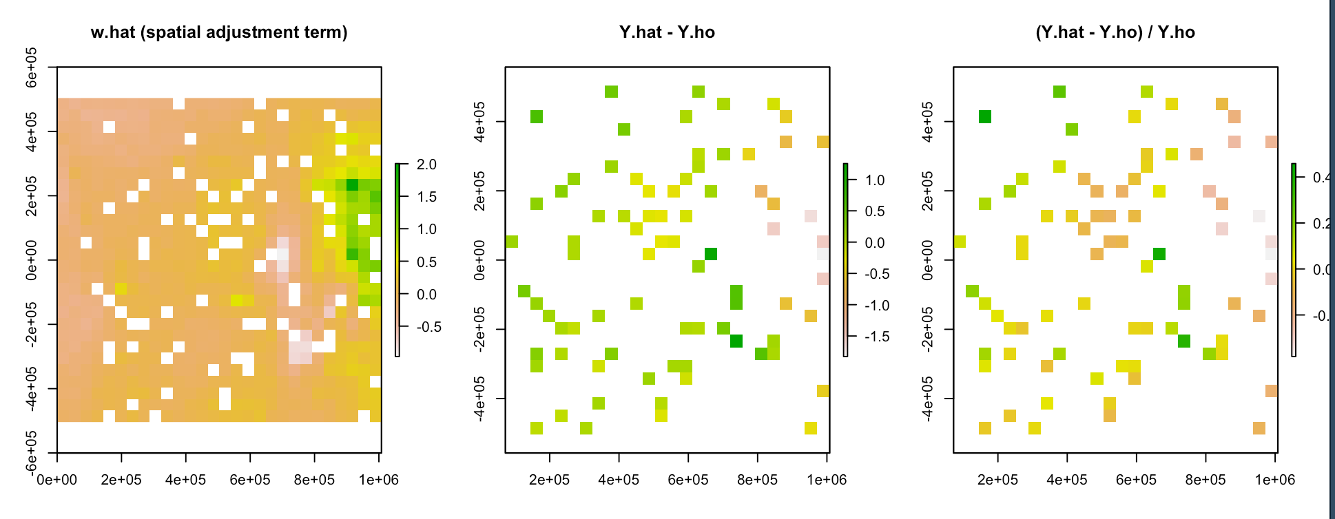

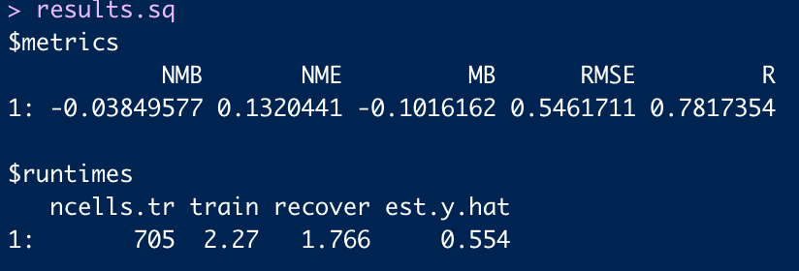

**Model 2: medium square, 25 knots**

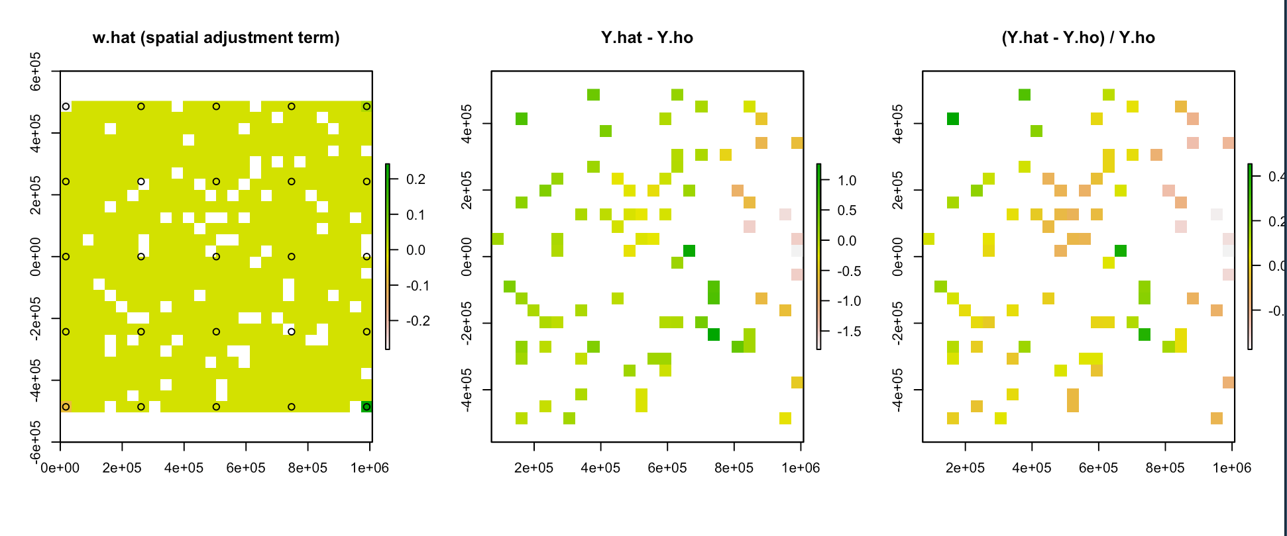

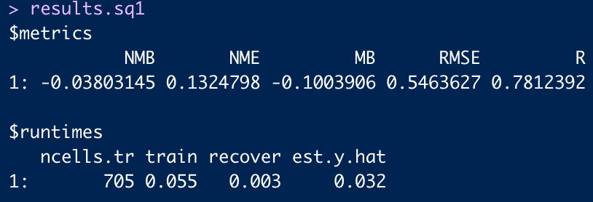

**Model 3: medium square, 25 knots (not aligned with domain)**

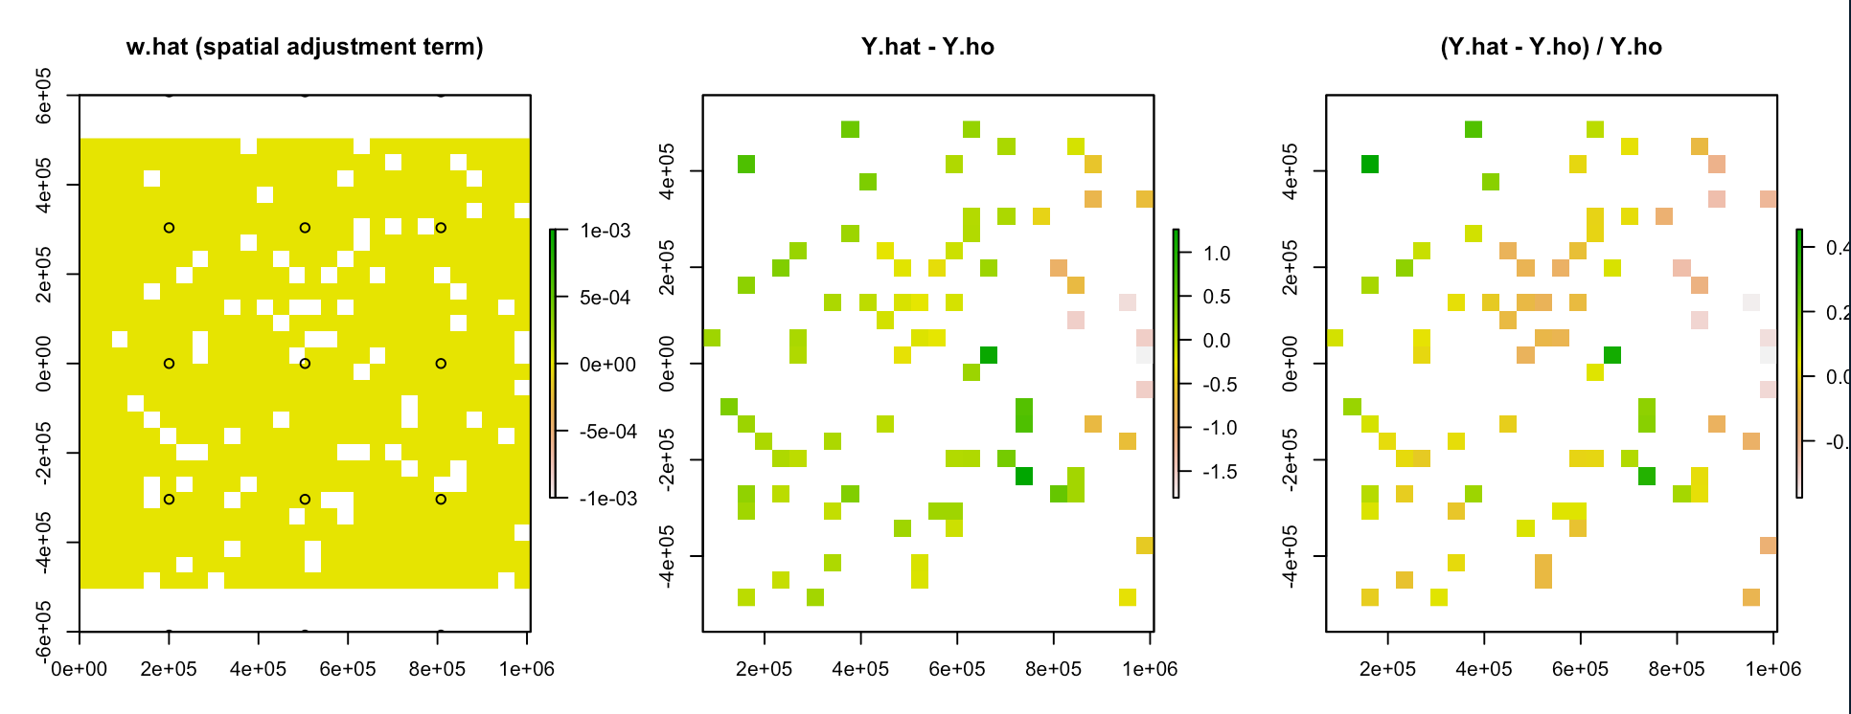

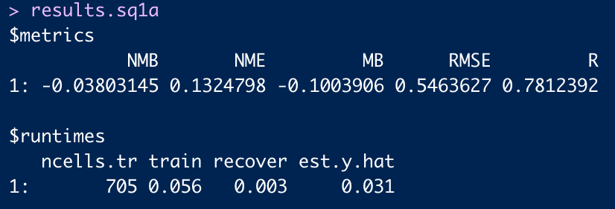

**Model 4: medium square, 400 knots (not aligned with domain)**

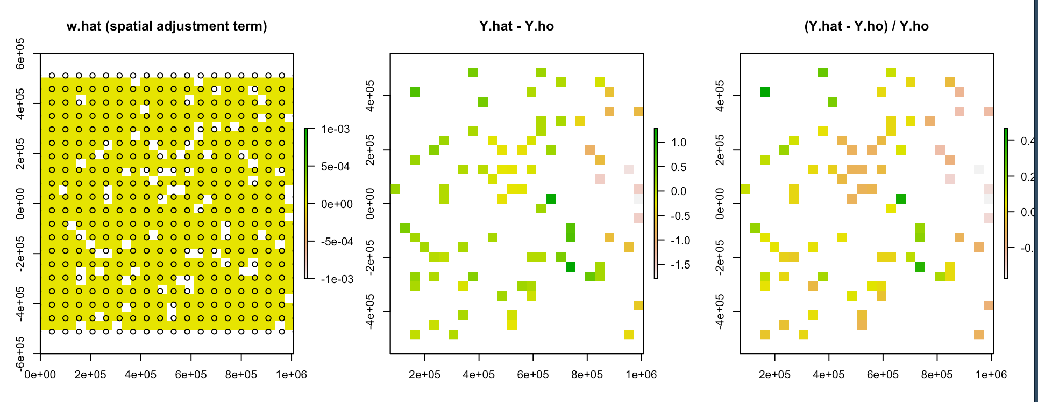

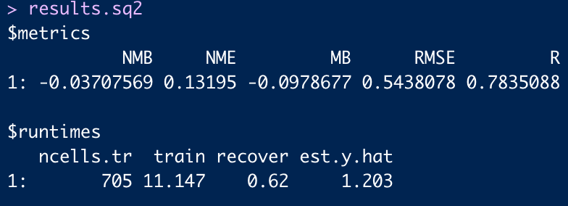

**Model 5: small square, no knots**

