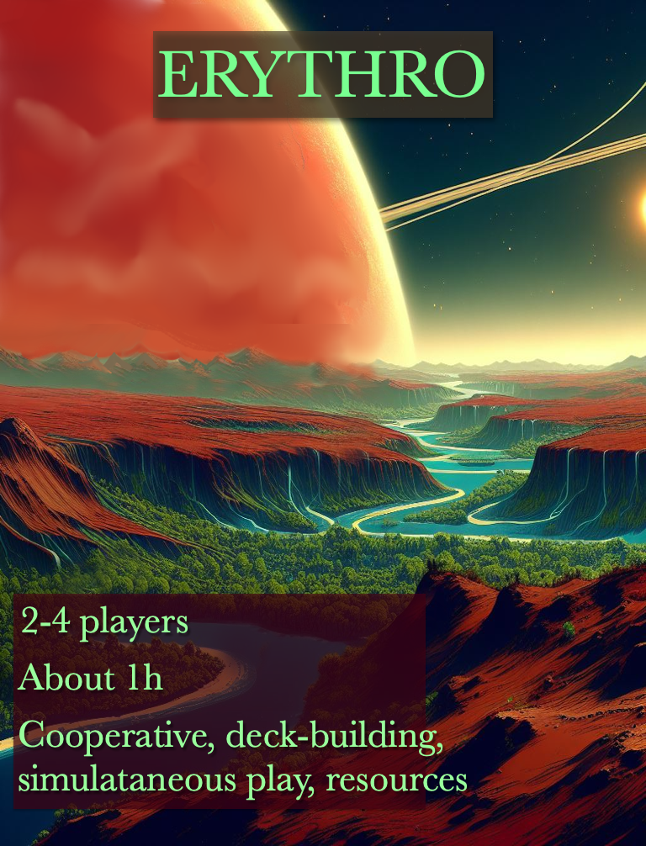
Erythro

Game principles
In Erythro, you help a planet defend itself against a mining operator who is polluting its soil. Cooperate to destroy the mines of the operator and clean up the soil before it becomes contaminated.
Players embody ambassadors of the planet who try to save it. Each ambassador masters 2 elements among water, fire, earth, and air. He can only collect influence for these two elements. The ambassadors are in perpetual communion with the planet, which allows them to trigger terrible natural disasters allowing them to destroy mines and repel the invader. Players build sanctuaries dedicated to one of the 4 elements, collect elementary influence, and depollute the surface of the planet. They also use their influence to learn new skills.

Material
- Player cards : 8*4 action cards in the base decks, 24 contamination cards, 61 advanced action cards (each action card corresponds to one element)
Sanctuary token
- 40 mine cards
- 4 mini-boards for characters
- Cubes to mark mine progression and resources of each player
- 1 meeple/standee per player
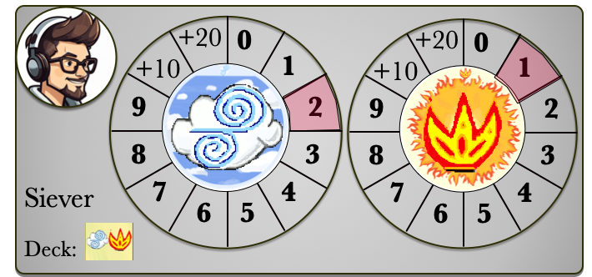Character mini-board (recto)
- 16 numbered terrain tiles
- 16 numbered tokens and a bag
- 40 pollution tokens .
- 32 sanctuary tokens.
- 1 dome tile
- An information sheet for each adversary (3 in total)
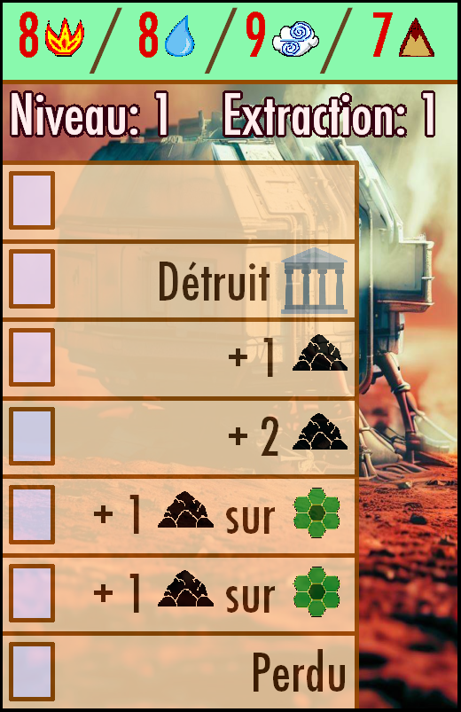Mine
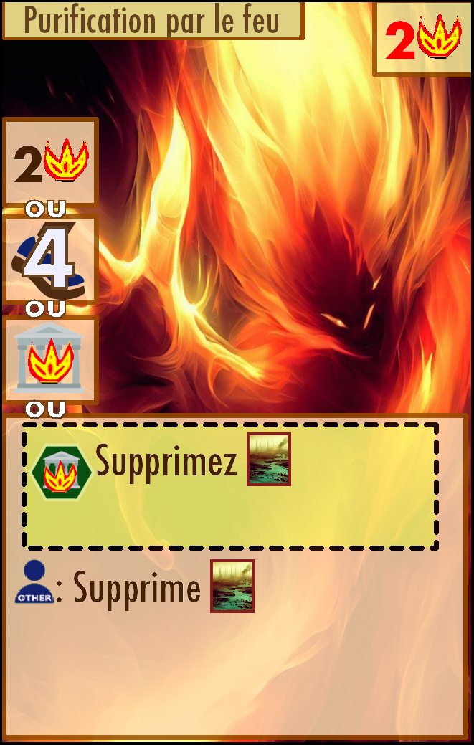Advanced action card “fire”
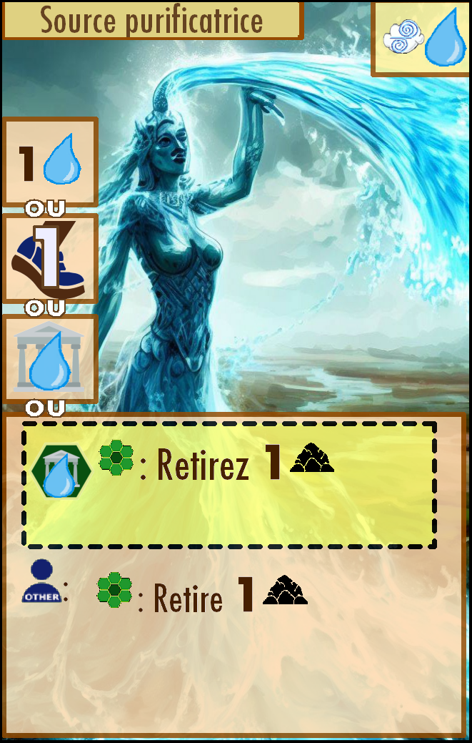Action card of the base-deck “air-water”
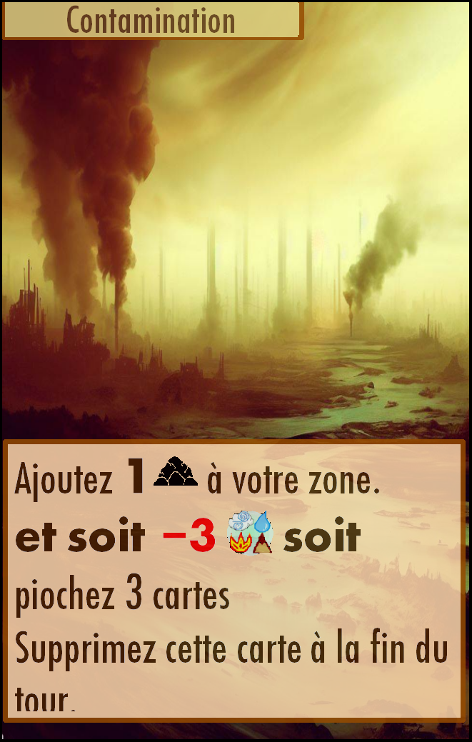Contamination card
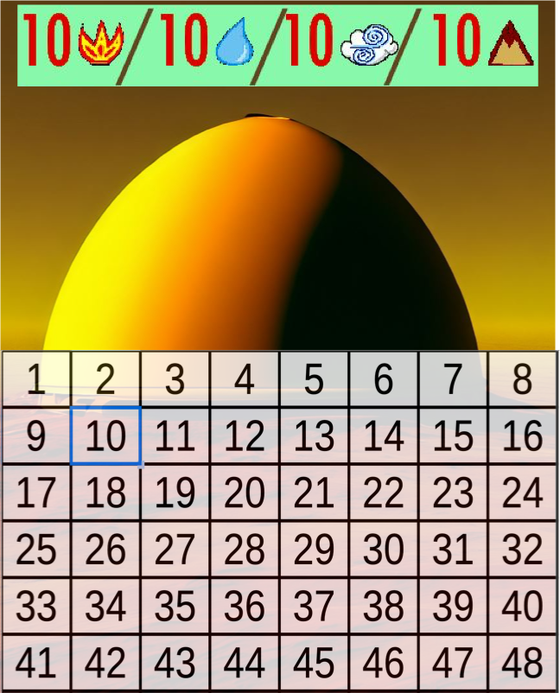Dome tile

Setup (see the 2 figures below)
See the section “Game concepts” for more details about placing mines/pollution/...
- Make 4 decks of advanced action cards, one for each element (water/earth/fire/air). These cards can be acquired during the game. Shuffle these decks and reveal 2 cards of each deck so that available cards all have a cost lower or equal to 4.
- Assemble the terrain tiles according to the number of players (see the figure below).
- Place in the bag the numbered tokens corresponding to the terrain tiles assembled above.
- Choose an adversary and a difficulty level. The adversary information sheet contains setup guidelines, victory and loss conditions, and any rule specific to the adversary.
  - Build a mine card deck depending on the indications on the adversary information sheet.
  - Place initial pollution tokens depending on the indications of the adversary information sheet.
- Reveal as many initial mines from the mine deck as indicated on the adversary information sheet (in general one mine per player).
- Place pollution tokens and cubes nearby. Also place a pile of contamination cards (5 cards per player, recalled on the adversary information sheet).
- Each player picks a character; with 2 players, you must ensure that the 4 elements are represented, with more players there is no restriction :
  - Each player picks the mini-board of their character and places 2 cubes on the number 1 and 2 of the two discs, on the highlighted squares (each player starts with 1 or 2 influence in each element).
  - Each player picks the initial deck corresponding to their character (see the elements on the top-right corner), shuffles the deck and draws 5 initial cards into his/her hand.
  - Each player creates an initial discard pile with a single contamination card.
- Each player draws a numbered token in the bag and places their meeple on the corresponding tile.
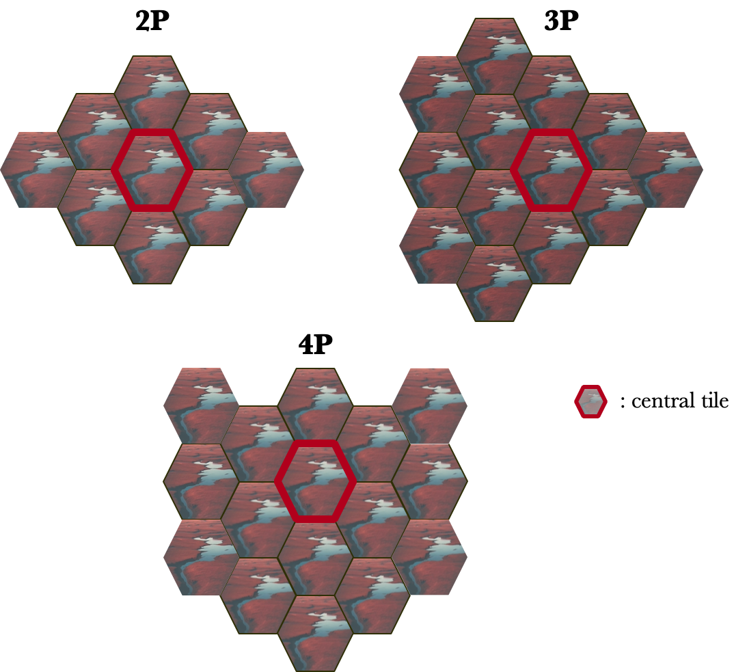Assembling the terrain tiles depending on the player count.

Gameplay overview
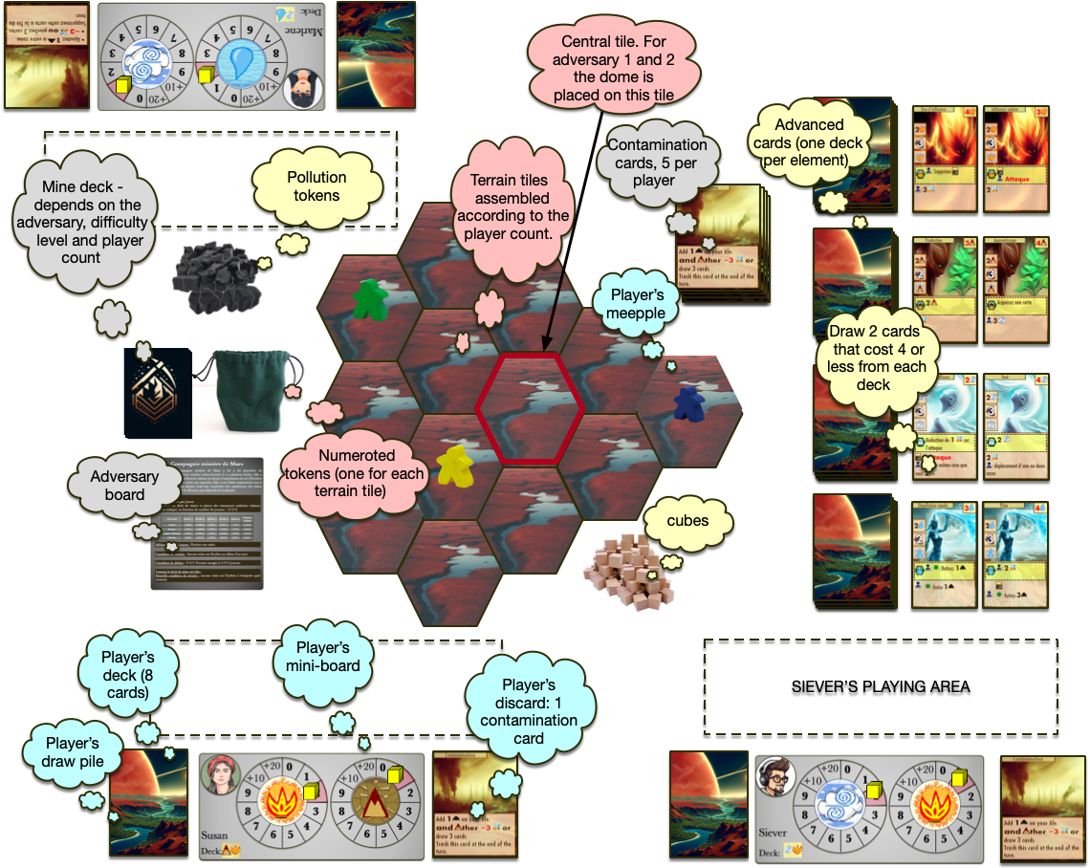Setup for 3 players.
The game plays in successive rounds made of the following phases.
- Player’s phase: Each player plays 4 cards from their hand.
- Discard: Each player can keep at most one card in their hand, the others are discarded.
- Mine phase: Each mine progresses and perform the corresponding actions (often adding pollution).
- Adversary phase: optional, described on the adversary information sheet if it exists.
- Acquisition phase each player can acquire one of the available advanced card.
- Draw: Each player draws cards so that they have 5 cards in hand.

The game finishes immediately as soon as victory or loss conditions are met, players have then either won or lost depending on the outcome.
- Victory conditions always depend on the adversary.
- Loss conditions are the following :
  - A mine reaches the step “Lost” in the mine progression scale.
  - Each adversary has specific loss conditions that include a number of maximal number of contaminated tiles (if this number is reached, players have lost).
  - A player cannot play: he only has contamination cards and is on a contaminated tile (very rare).

Game concepts
Generally speaking, the adversary’s actions should be carried out as much as possible. On the contrary, a player can only trigger an action if he can fully carry it out.
If there is a contradiction between the text of a card and the rule, the text of the card prevails. Likewise, the text of the adversary's information sheet takes precedence over the rule.

Draw/discard a card (standard deck-building mechanism) .When players must draw one or more cards, they take them from the top of their draw pile. To discard means to put the card in their discard pile. If a player has to draw a card and their draw pile is empty, they shuffle the cards from their discard pile to form a new draw pile before drawing.

Shuffling your cards triggers an action of the adversary (often, this adds a new mine). If several players shuffle at the same time, the action is triggered once for each player shuffling.
Example: I have to draw 3 cards to complete my hand at the end of the round, I only have 2 left in my draw pile. I add these 2 cards to my hand then shuffle my discard pile to draw one more, against the Mars mining company or the Earth mining investment alliance this adds a mine.

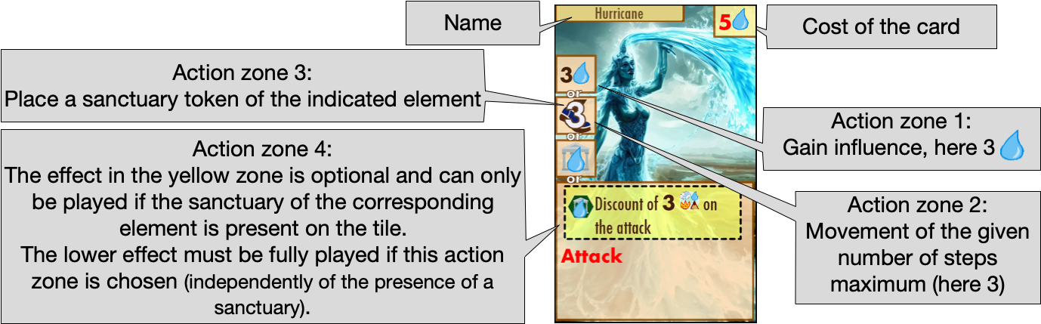
Action cards.

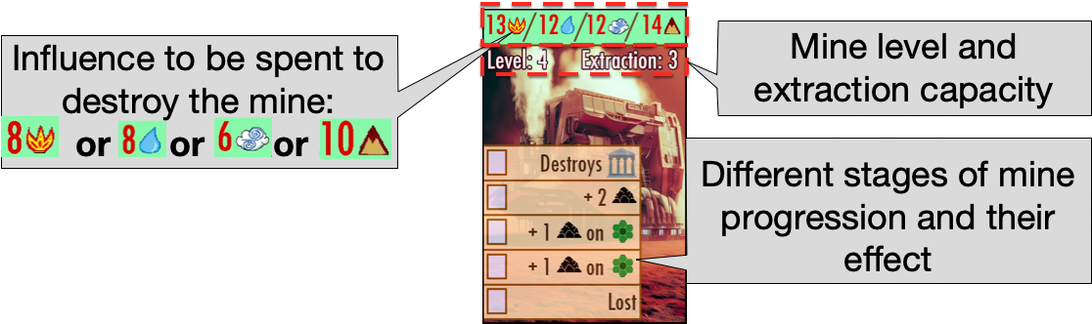
Mine cards.
Note: Extraction capacity is used by one of the adversaries

Acquiring an action card. During the acquisition phase but also when playing some cards, players will be able to “acquire a card”. There are 8 cards available for purchase. The acquisition cost of each card is written at the top right corner. Spend as much influence as the card's acquisition cost to add it to your hand. Add a new card to the available card market so you always have 2 cards to choose from for each element.

Take a contamination card: 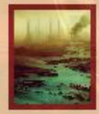 When a player must take a contamination card, he takes it from the contamination card pile and places it in his hand.

Trash a . Some actions allow players to destroy a card. In this case the player takes a contamination card from his hand or his discard pile and puts it back in the corresponding pile.
Contaminated tile.
When a land tile receives a 4th pollution token it becomes contaminated. Immediately remove any sanctuary tokens there. The following rules apply to contaminated land.
- It is not possible to add or remove a pollution token from a contaminated tile. If an action by the opponent or a mine requires adding pollution to this space, ignore the action. A player cannot take an action that requires adding or removing a pollution token on this tile.
- There cannot be a sanctuary on a contaminated tile.
- A new mine cannot appear on a contaminated tile.

Adversary actions.
When the adversary must place a pollution token or a mine, take a numbered token in the bag and place the mine or the pollution on the corresponding tile. If the bag is empty, put back all the tokens in the bag before taking a token. When a hew mine appears, place a cube on the first of the action lines of the mine and perform the action on the right if there is one.
Warning: if the randomly chosen tile already has a mine or the dome or is contaminated, do not add the element on this tile, draw another token.

Attacking a mine.
The “Attack” keyword (in red) on the action cards means attacking a mine or the dome. The player chooses one element (air/earth/fire/water) and spends a number of influence points depending on the mine and the chosen element, the cost is shown on the top of the mine card (see figure). The destroyed mine is removed from the game. For some adversaries this can trigger an immediate effect. Attacking the dome also has an effect that depends on the adversary.

  - A round
The player’s phases (phase 1, 2, 5, and 6) are played by all players simultaneously; all the players must have finished a phase before starting the next one. The phase of the mine and of the adversary (phase 3 and 4) are played once per round.

Player’s phase
In this phase players must play exactly 4 cards from their hand. There are two types of cards: action cards and contamination cards. Reserve a playing area to place the played cards to ensure that 4 cards are played in each round. Players play their 4 cards in the order they wish. If the actions of 2 cards conflict, players must fully resolve one card before playing another, otherwise actions can be played simultaneously.

Playing an action card.
Each action card has 4 different action zones. To play a card you must choose an action zone on this card and perform the corresponding action.

The top 3 zones have a simple effect:
- The first zone allows one to gain a certain number of influence points in an element.
- The second action zone allows one to move, up to the maximum distance indicated.
- The third zone allows one to place a sanctuary of the indicated element, two conditions must be verified to perform this action:
  - there cannot be 2 sanctuaries on the same tile and
  - a contaminated tile cannot have a sanctuary.
- The 4th zone offers a more complex effect, it must be done from top to bottom. The yellow part at the top of the area can only be performed if a sanctuary of the correct element is present, it is optional but played first and cannot be played partially. The effects in the bottom part must all be fully realized.

Players must fully realize any chosen action, except the following:
- Movement can be partially achieved (but at least one step must be done).
- An action that removes pollution tokens can be used to remove fewer tokens (but at least one).
- If it is written that a player can perform an action then it is not obligatory.
The table below describes the main effects of the cards (based on examples).
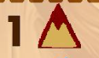 | Increase of 1 point your influence in the “earth” element
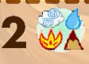 | Increase of 2 points your influence in the element(s) you want.
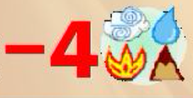 | Decrease your influence of 4 points in the element(s) you want (loose influence).
 | Attack (see “game concepts”)
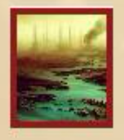 | Take a contamination card.
 | Remove 2 pollution tokens
 | The effect on the right must be applied to another player than the one playing the card
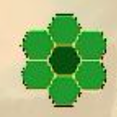 | The effect on the right applies either on the tile of the player or on an adjacent tile (often used for removing pollution tokens). If used to remove several tokens they can be on different tiles
 | Move 2 steps or less
 | The effect on the right applies either on the tile of another player or on a tile adjacent to that player.

Playing a contamination card.
When a player plays a contamination card they performs all the actions written on the card.
They must therefore place a pollution token on their tile and choose:
- Either spend 3 influences of the elements of their choice
- Or draw 3 cards.
The contamination card is placed in the play area but will go into the pile of contamination cards during the discard phase. Place the card face down to remind you that it does not go into your discard pile. The contamination card is one of the 4 cards played this round. A contamination card cannot be played when the player is on a contaminated tile.

Discard phase
Players discard cards from their hand so that they only have one or none left in hand. Players also discard the cards played this turn (except contamination cards that are returned to the contamination pile).

Mine phase
Each mine progresses: for each mine on the planet, advance the cube present on the mine one space down and perform the action on the line reached by the cube. Possible actions are described below
 | If there is a sanctuary on the tile of the mine, it is removed and returned to the stock
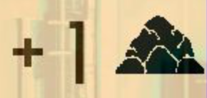/ 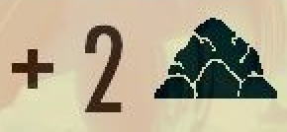 | Add one/two pollution tokens on the tile of the mine
 | Add a pollution token on the tile of the mine and on all the tiles adjacent to the tile of the mine.
If a mine action cannot be realised entirely, you should realise it as much as possible.

Adversary phase
Some opponents have specific actions that take place during this phase. Refer to the adversary’s information sheet.

Acquisition phase:
Each player can acquire a card (see acquiring a card in the “general concepts” section above).

Draw:
Each player draw cards until they have 5 cards in hand.
Then the players start a new round

Organisation and strategy notes:
- Buying cards is one of the strongest actions in the game, don't neglect it. Even an uninteresting card allows you to have more cards in your deck and trigger a deck reshuffle less often. Also, managing timing so as not to shuffle your deck too early is crucial!
- Timing the actions of the different players is often the key to victory.
- Actions that involve other players are often stronger, try to take advantage of them.
- Don’t forget to take a contamination card when your action requires it (e.g. for most of the attacks)
- Against the second opponent it is useless to put the token corresponding to the central tile in the bag, it will never be used.
- You can play face-up cards and shift the cards to your playing area if you prefer.
- Each adversary offers a different style of play
  - The first one requires destroying all mines and gets weaker if the mine deck is empty
  - The second one requires acting more quickly to reduce its profitability, even if it means leaving a planet still full of mines and pollution
  - The third one requires better management of pollution, gives a little less importance to the purchase of cards but requires adapting to a new event each turn.

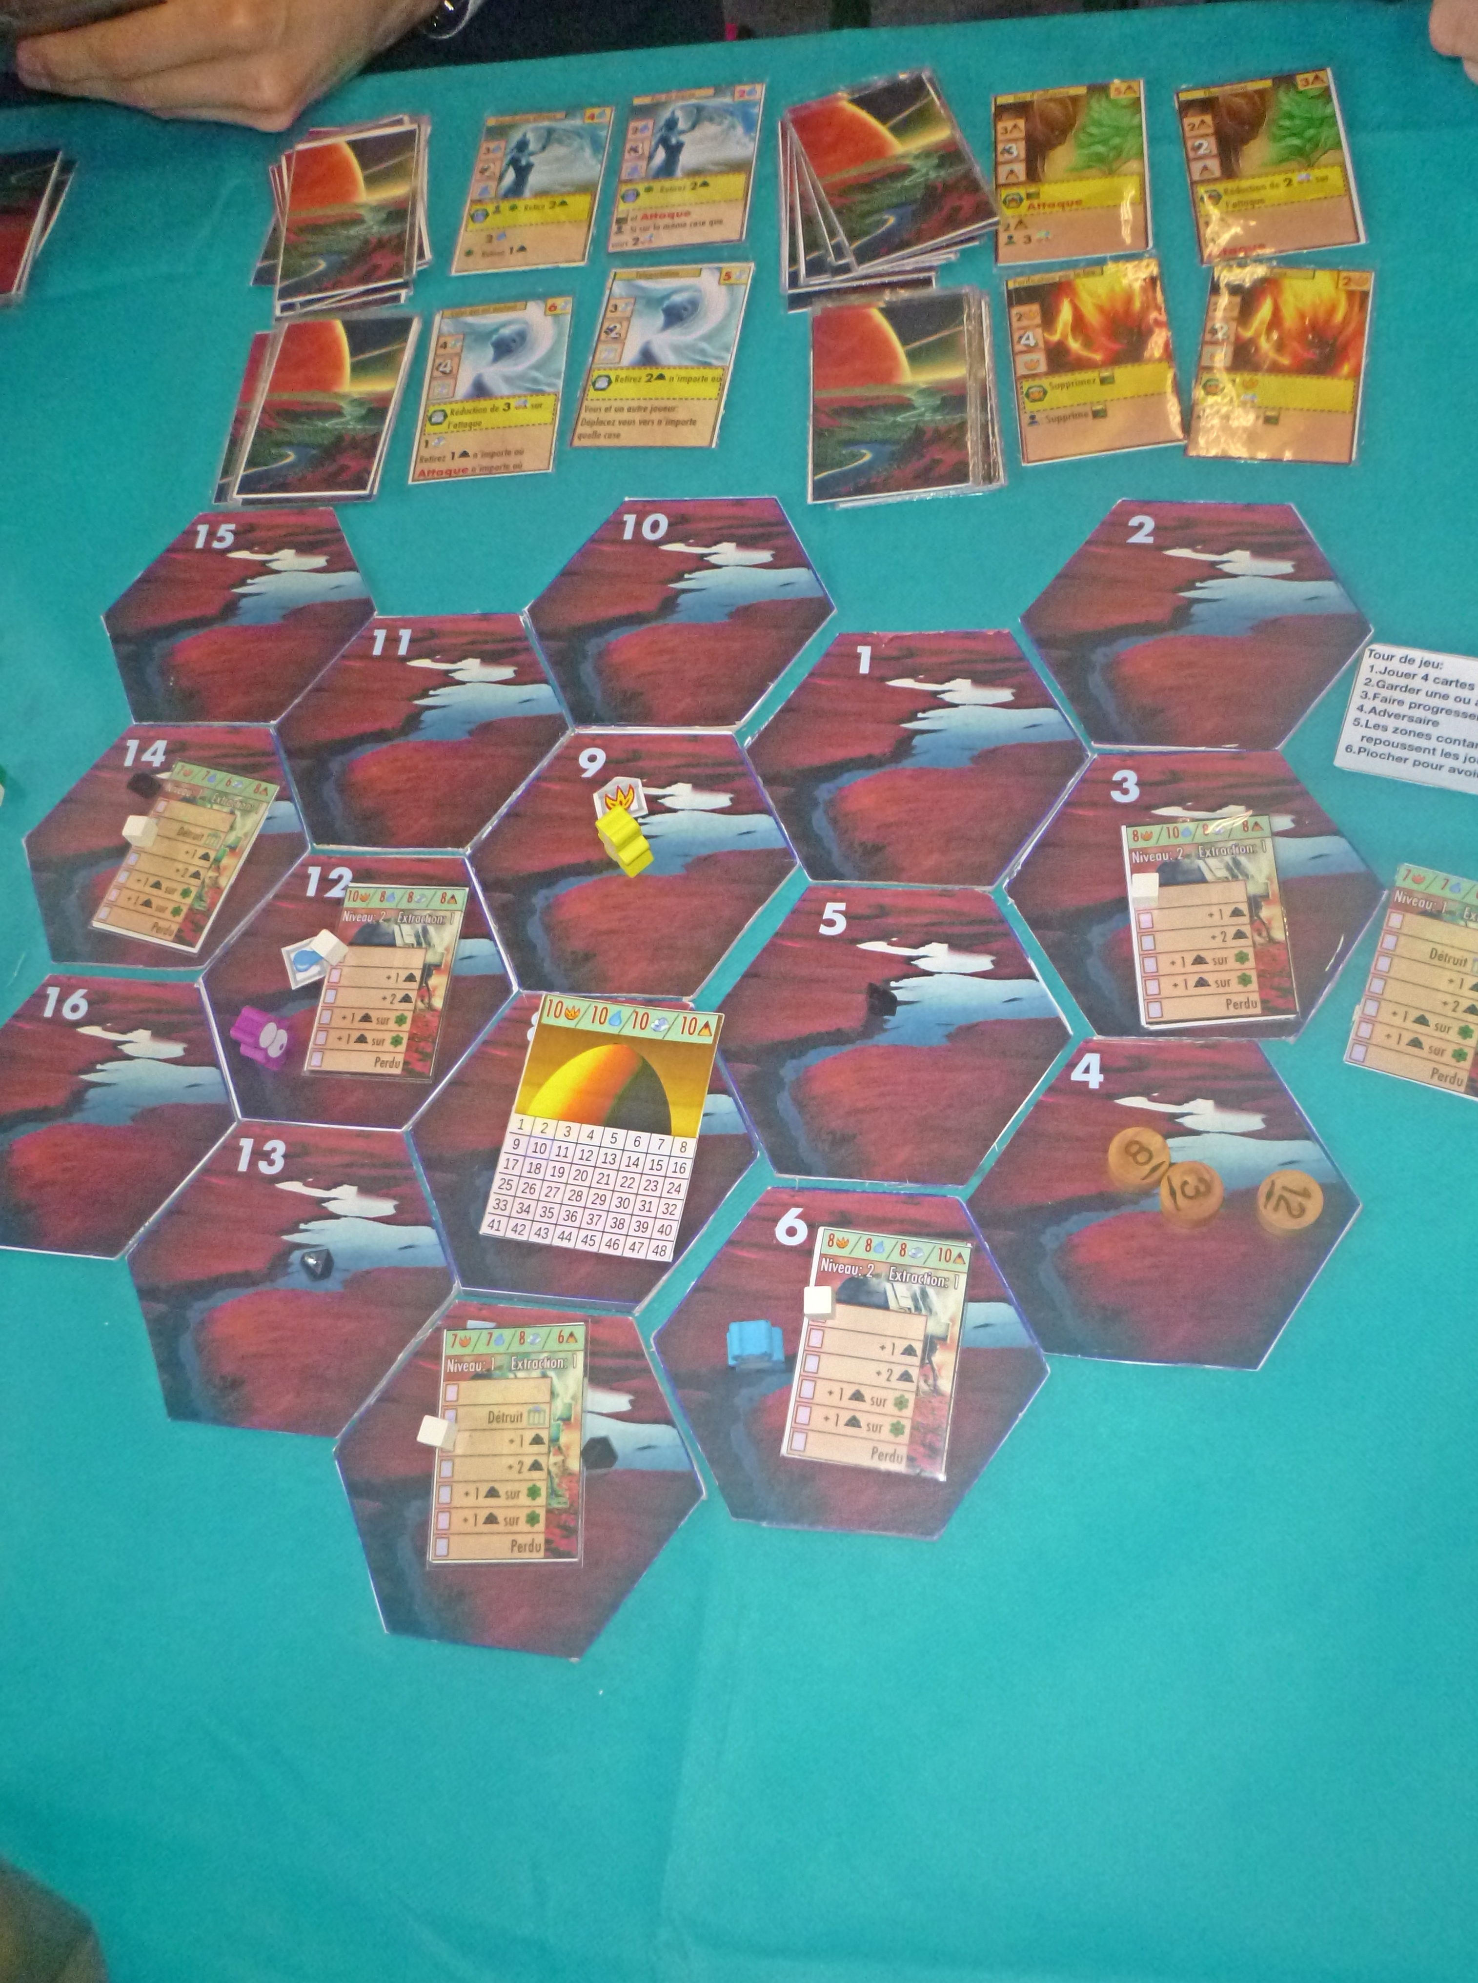
Photos
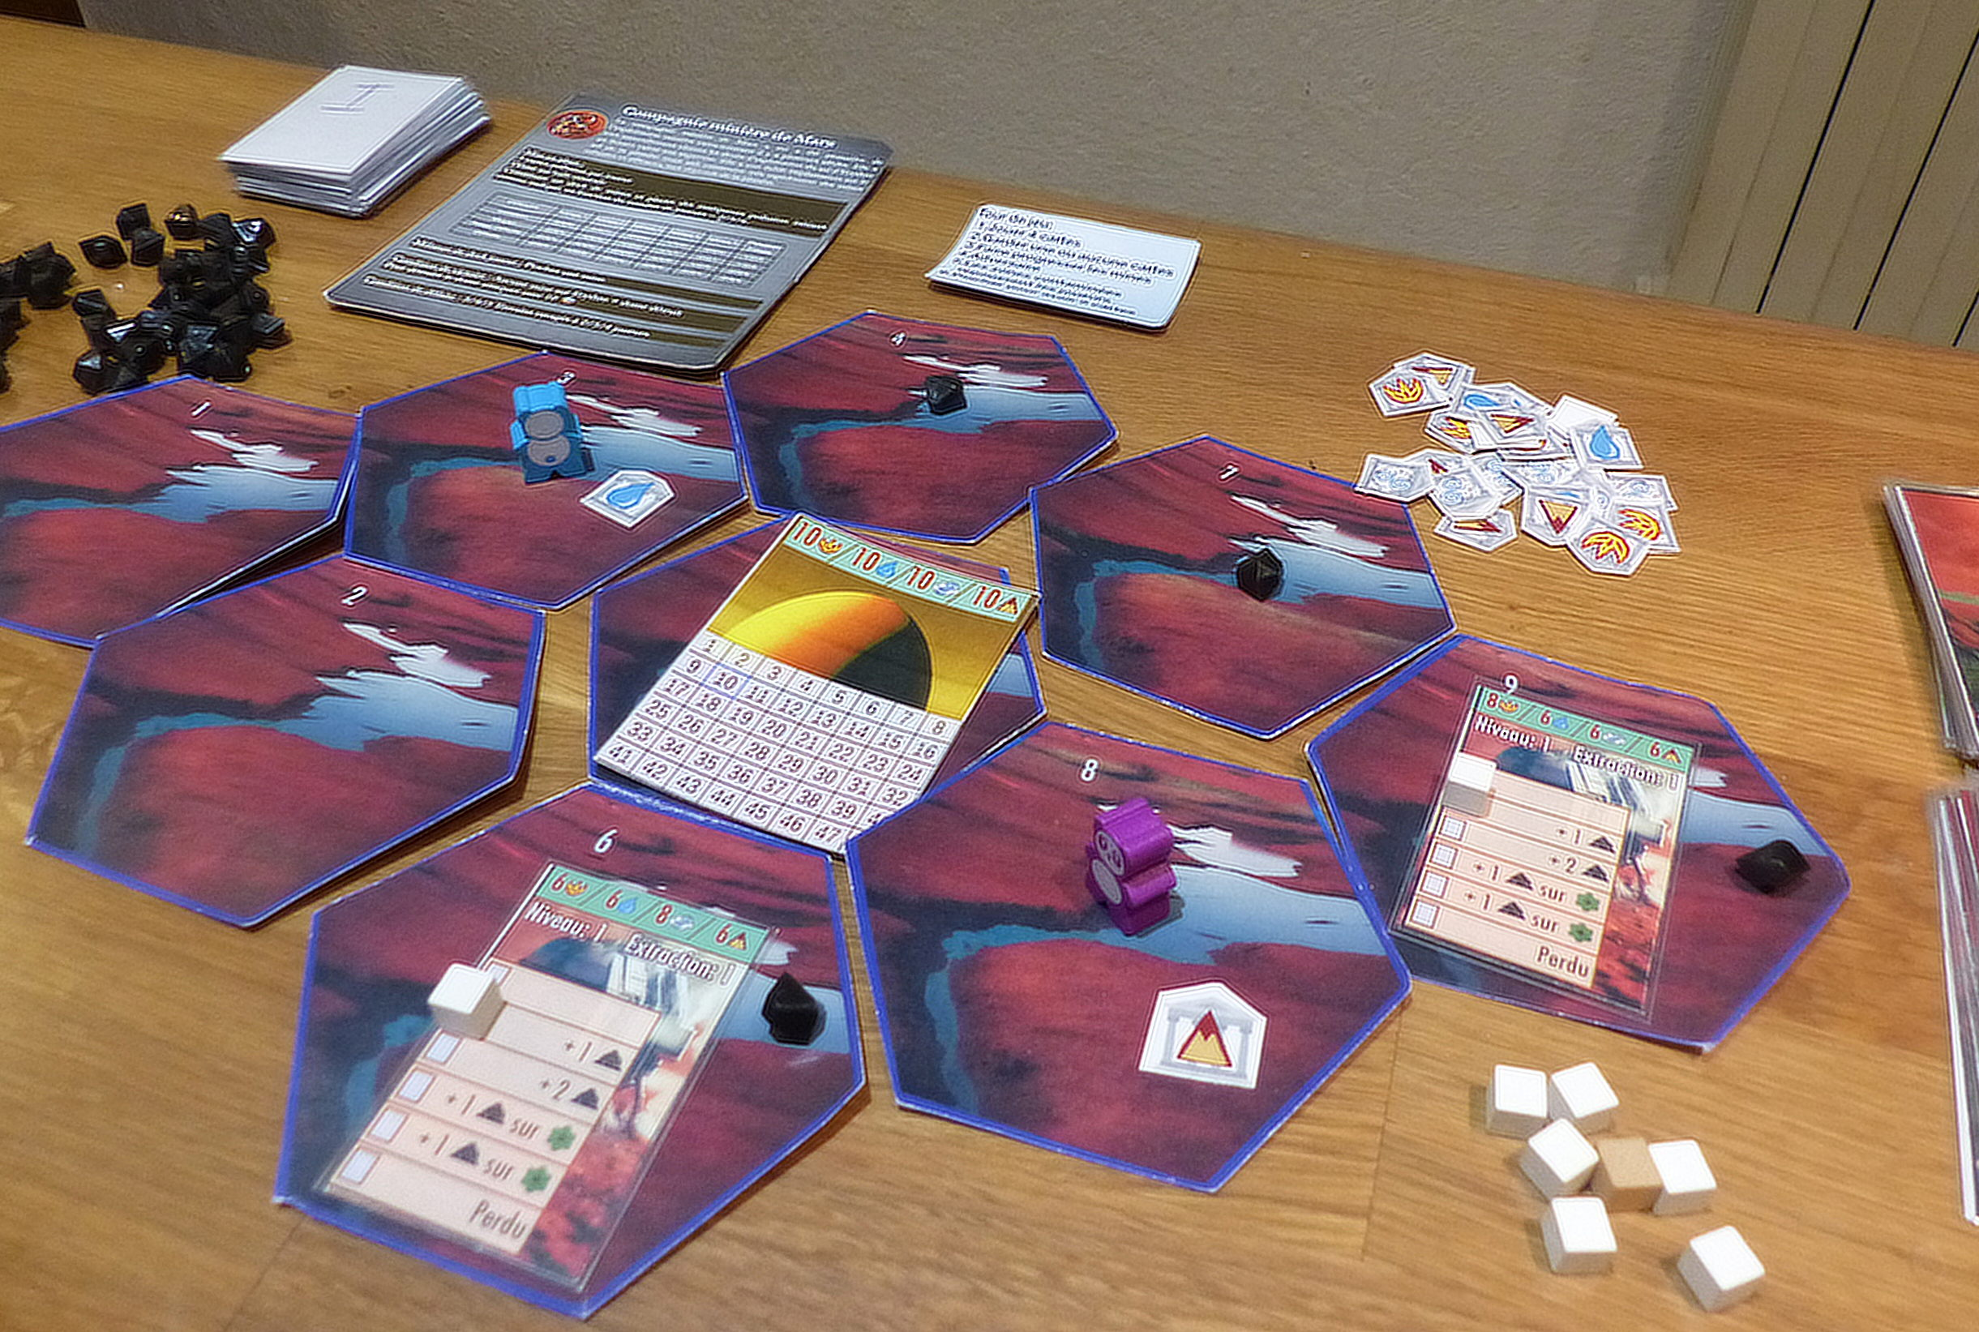End of the first round
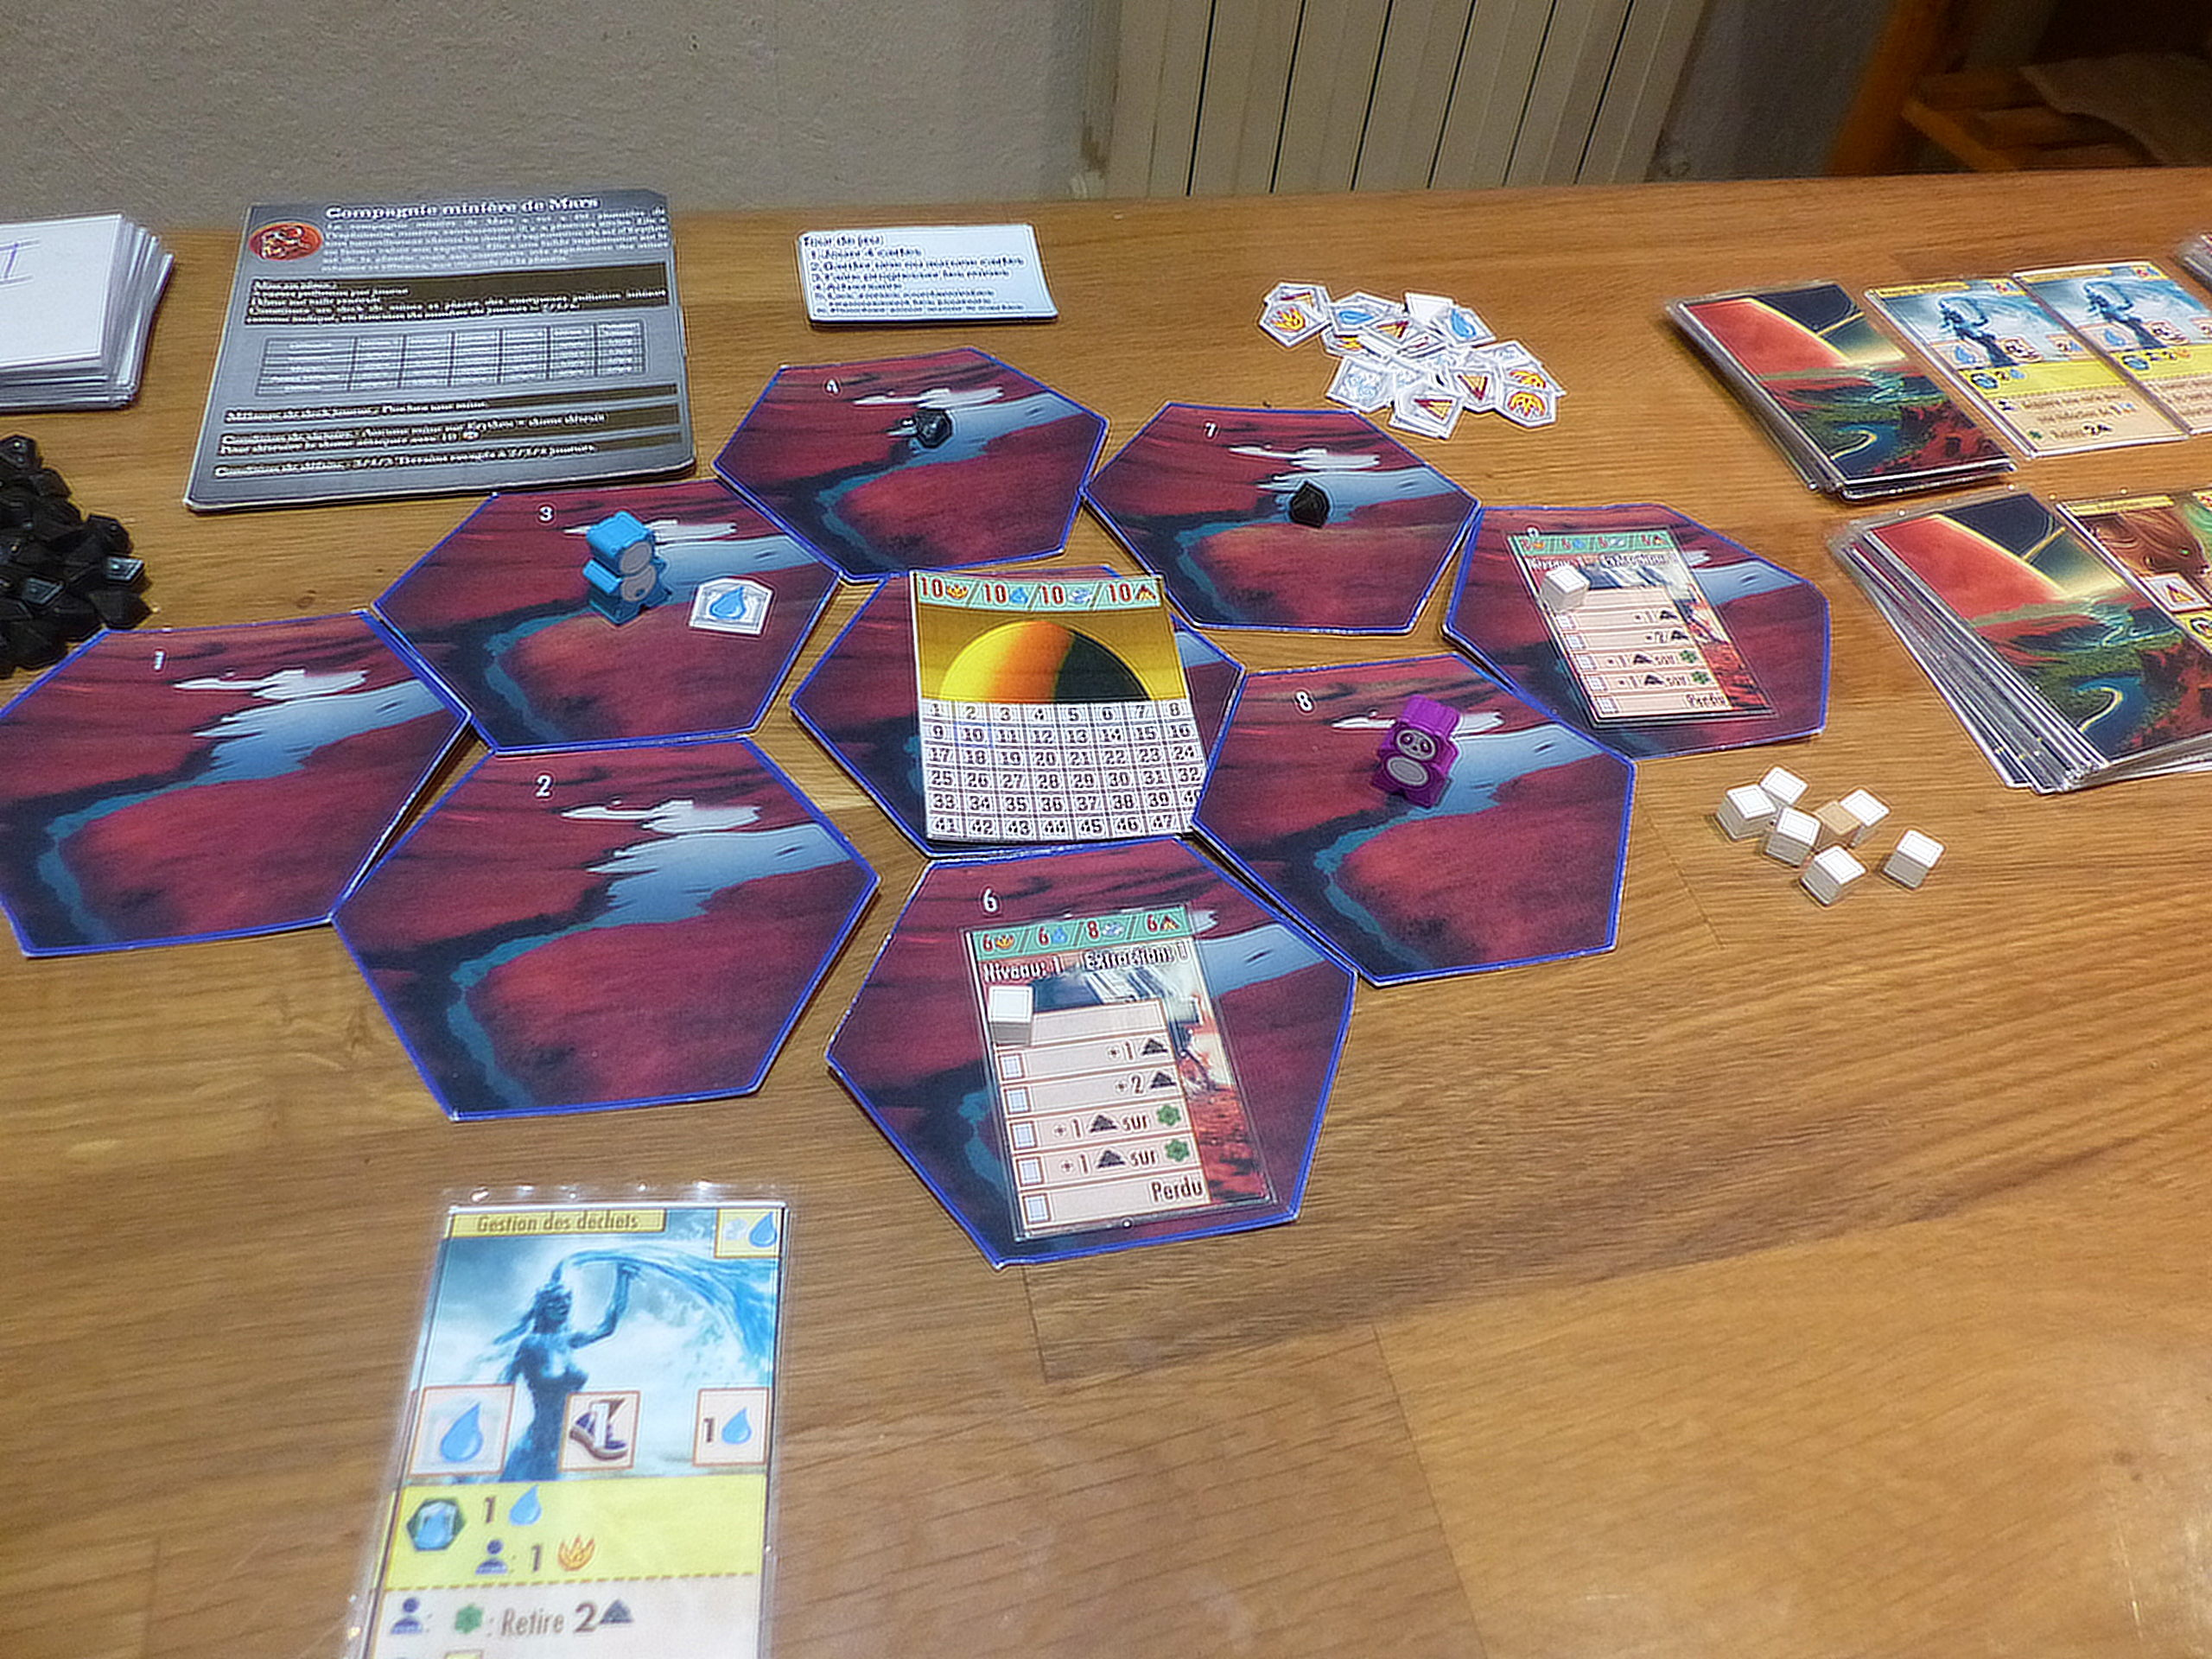Beginning of the first round
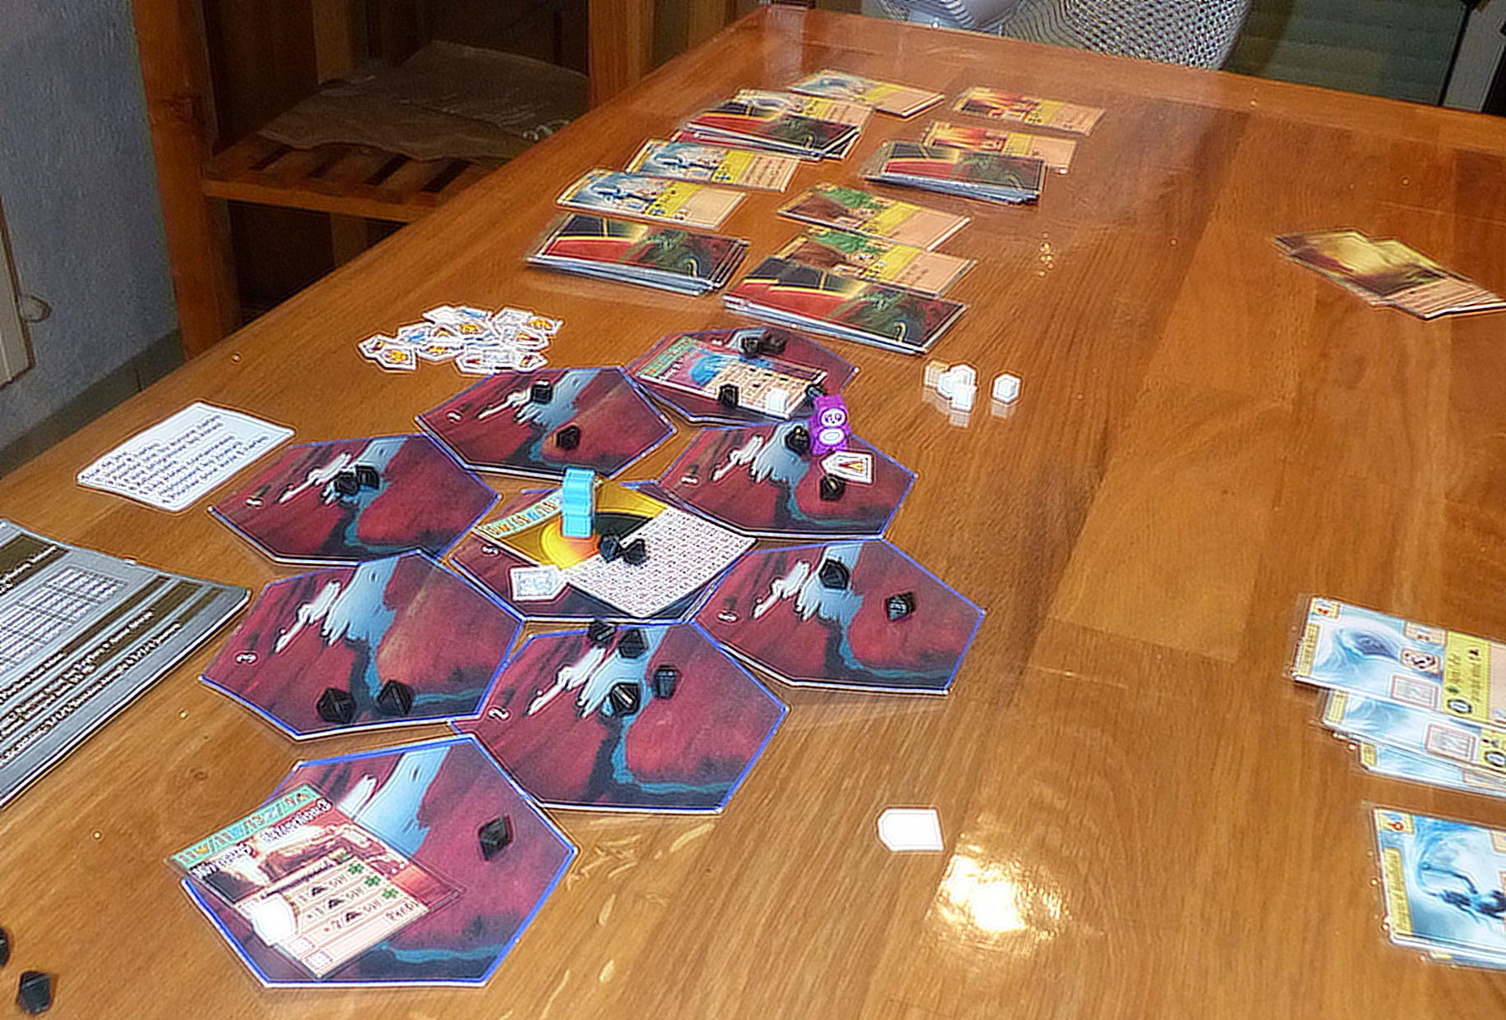Endgame (loss)
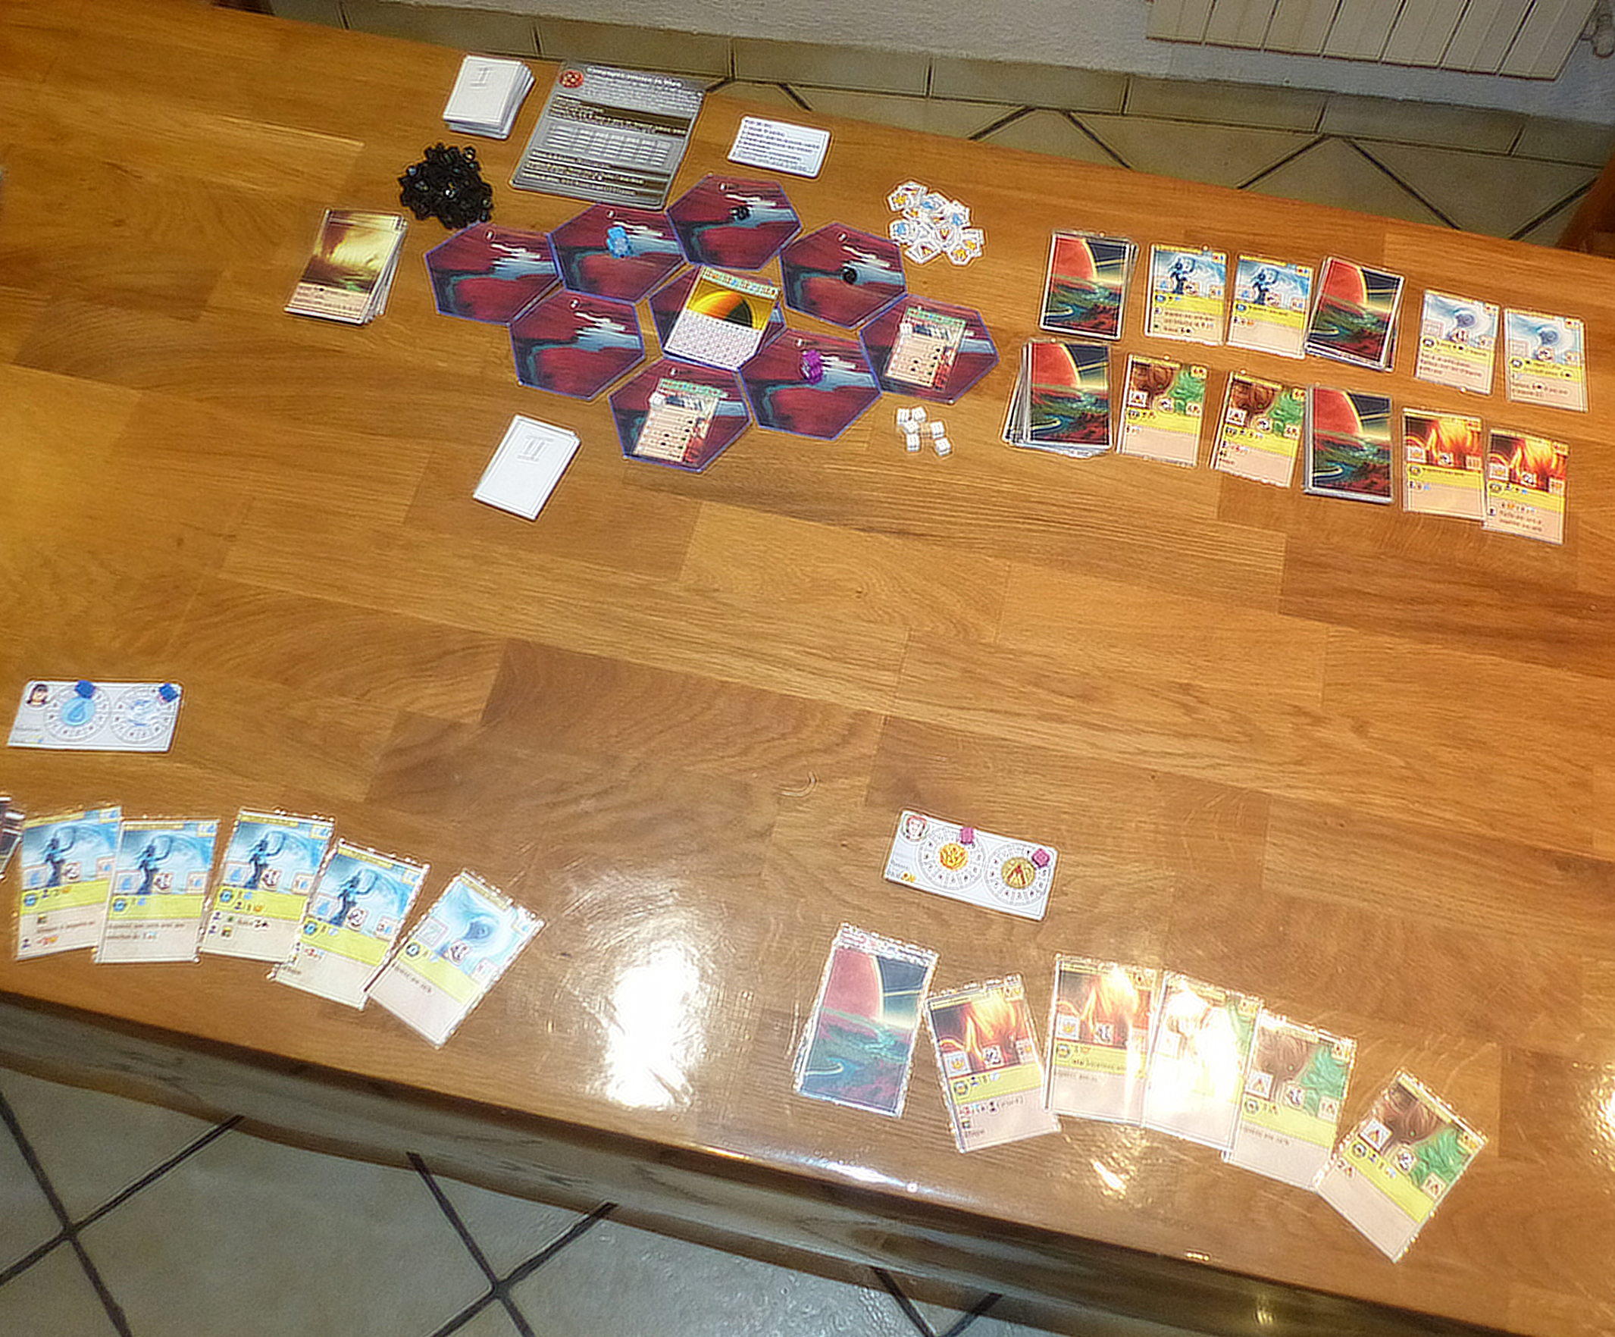Setup

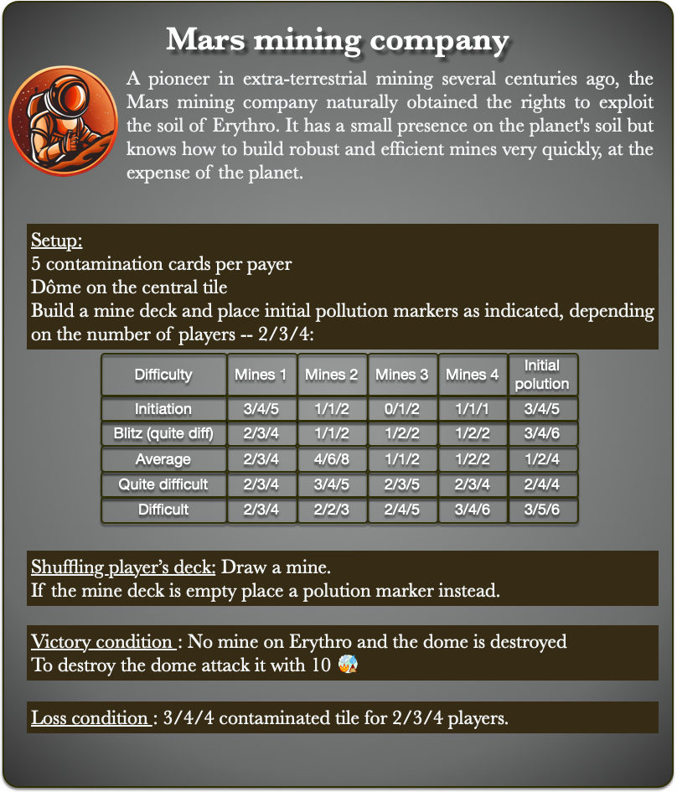
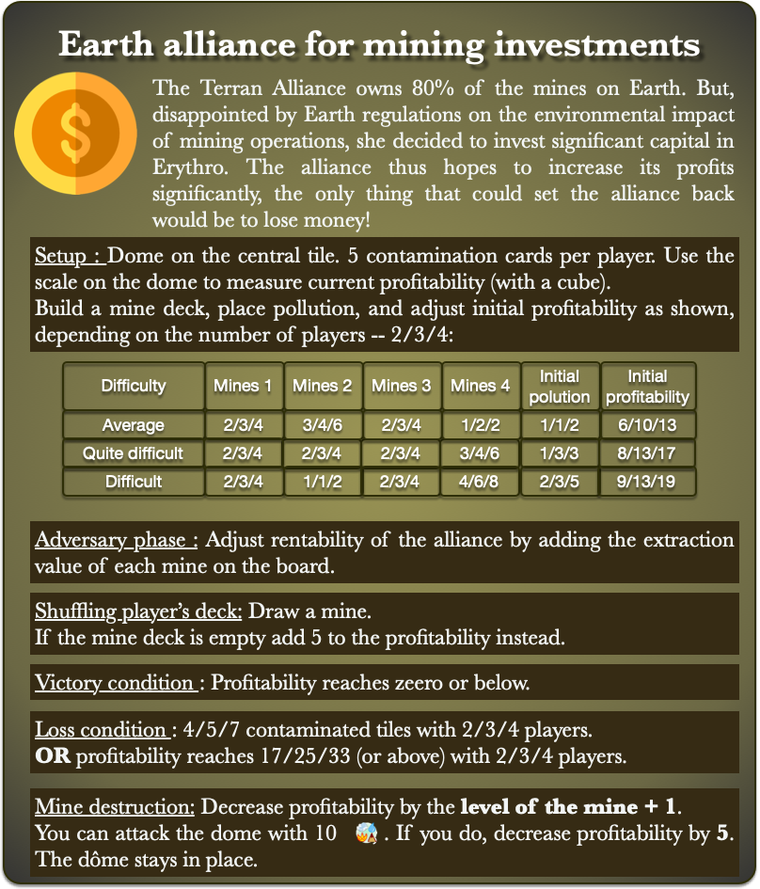
Adversaries


