**Project_3_Group_4: https://github.com/lhenry97/Project_3_Group_4.git**

Project Proposal: Visualizing Global Carbon Emissions Using Our World In Data: CO₂ and Greenhouse Gas Emissions

**Goal of the Project:**

The aim of our project is to uncover patterns with carbon and gas emissions by country. We'll examine relationships between country, population, temperature over the course of a decade, and other related relationships derived from the data.

**Dataset Link:**

Website: https://ourworldindata.org/co2-and-greenhouse-gas-emissions

Data: <https://github.com/owid/co2-data?tab=readme-ov-file>

**Screenshots:**

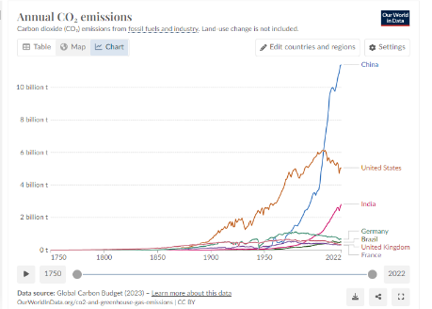

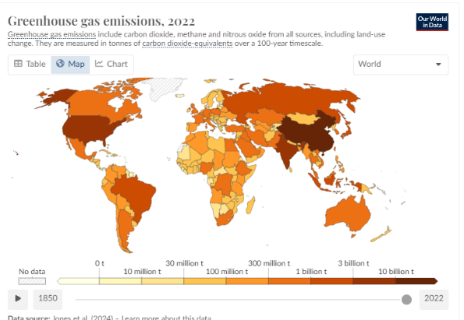

**Sketch:**

