Call coming into the ICM can be handled/examine and then decision can be made from the the incoming call/request. Example: a response can be give back to requestor, header/body data can be evaluated, In my sample code, the url is examine to set variable data that is used used to redirect to different views.

http://<host>.<domain>:<port>/sap/bc/bsp/sap/crm_ic/default.htm

**APPLICATION FLOW:**

**CISCO CAD**

* Call SAP ICW URL and pass dynamic value pair data
* HTTP GET

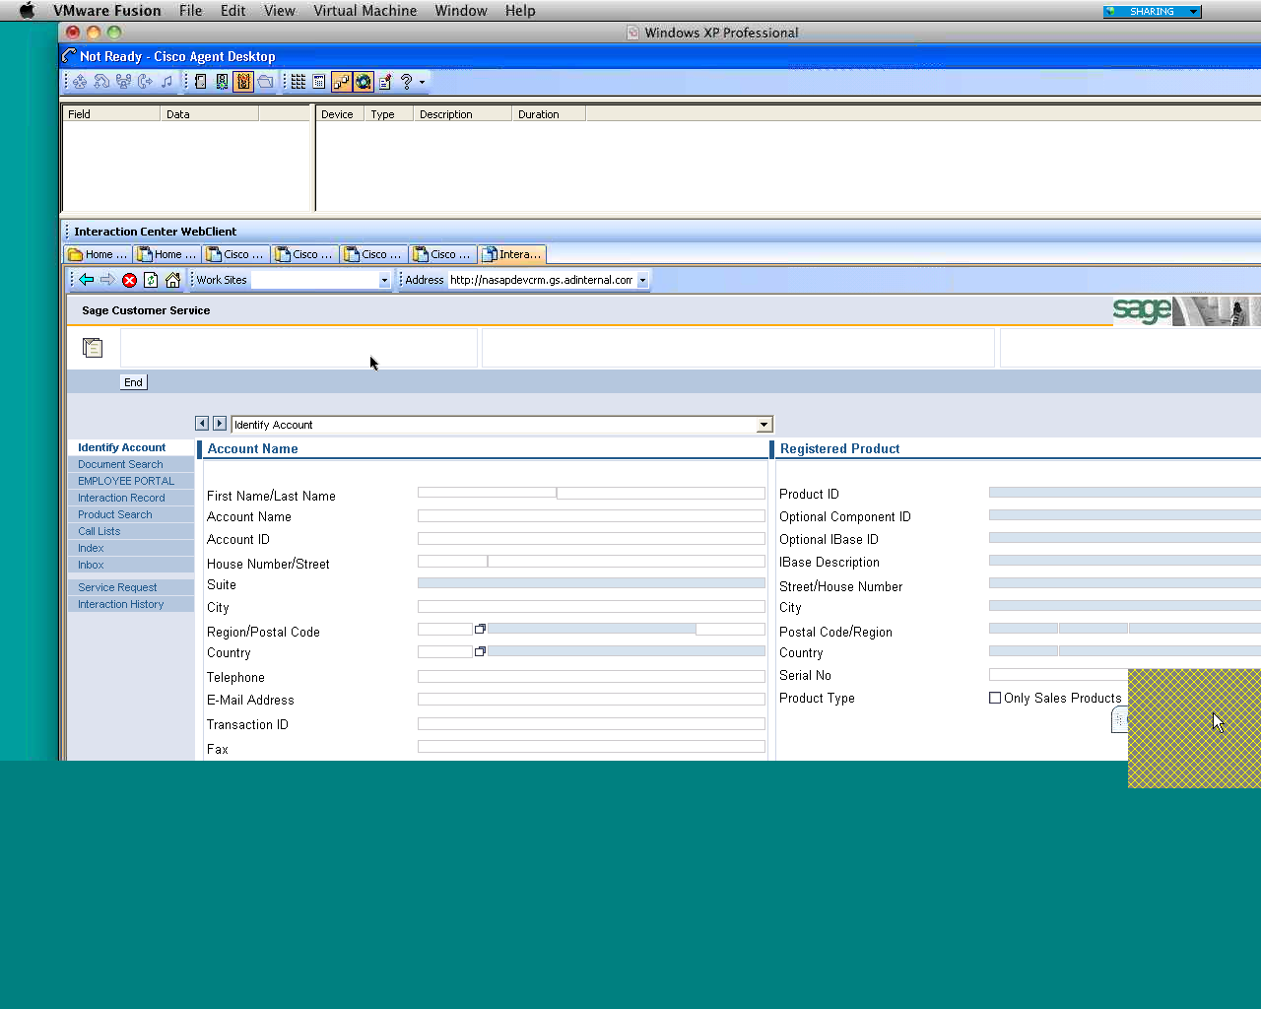

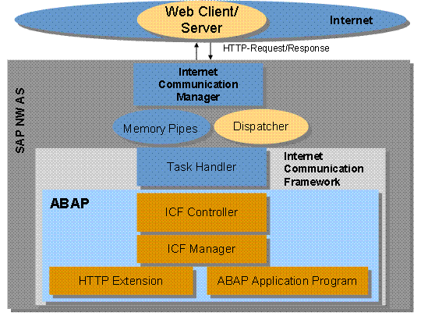

**HTTP intercept**

* Intercept HTTP Get variable

EXAMPLE OF PLACEMENT OF CREATED HTTP INTERCEPT IN SCICF PATH

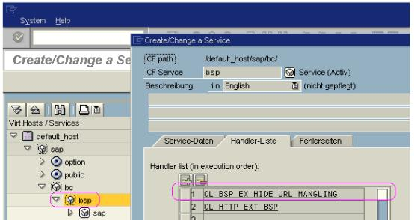

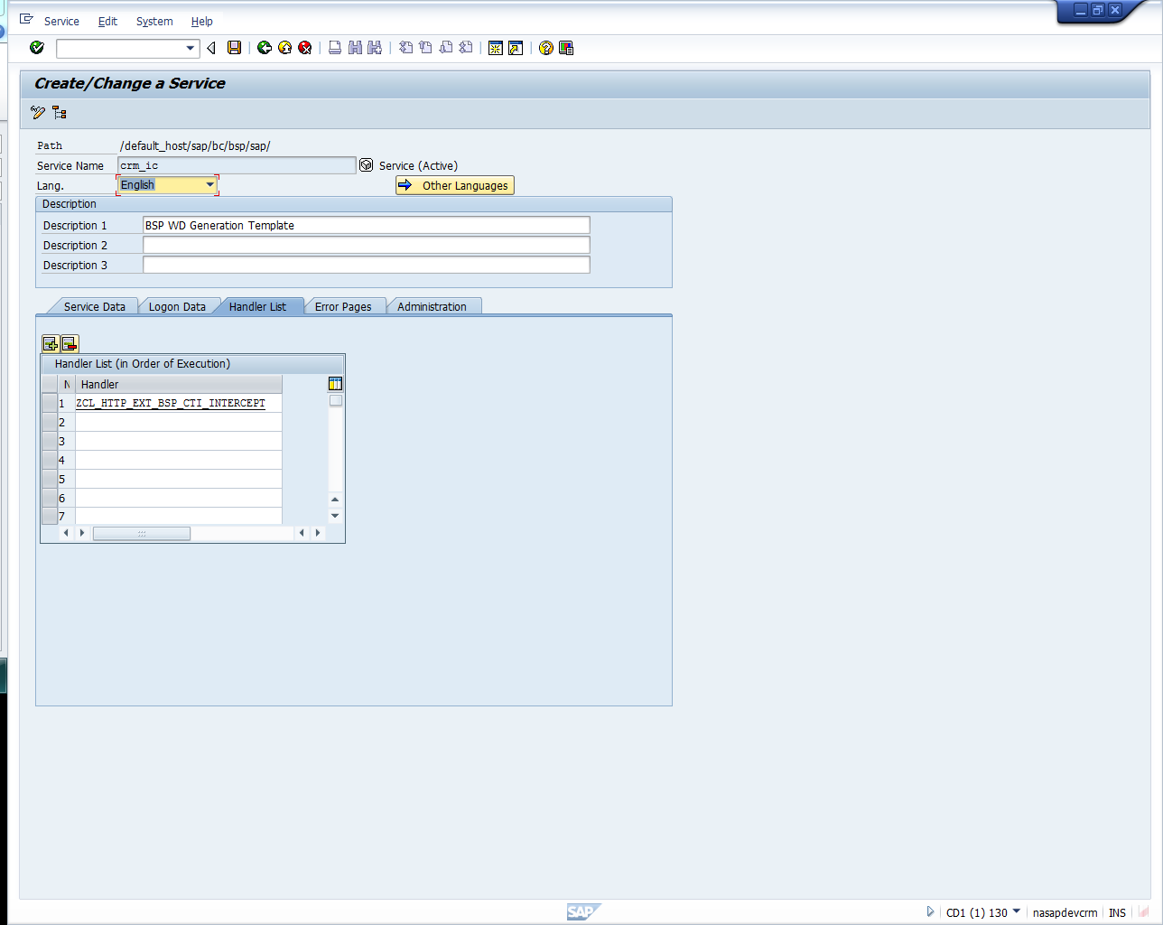

MY CODE SNIPPET FOR MY TEST SCENERIO

-This method can remain generic for debugging incoming call

-Object ‘server’ can be used to get information about incoming request for debugging or observing behavior of incoming request/calls

-If the method handler is not hit, then the call to the icm might not be coming to this subdirectory and the handler class may need to be move higher or lower in the service tree

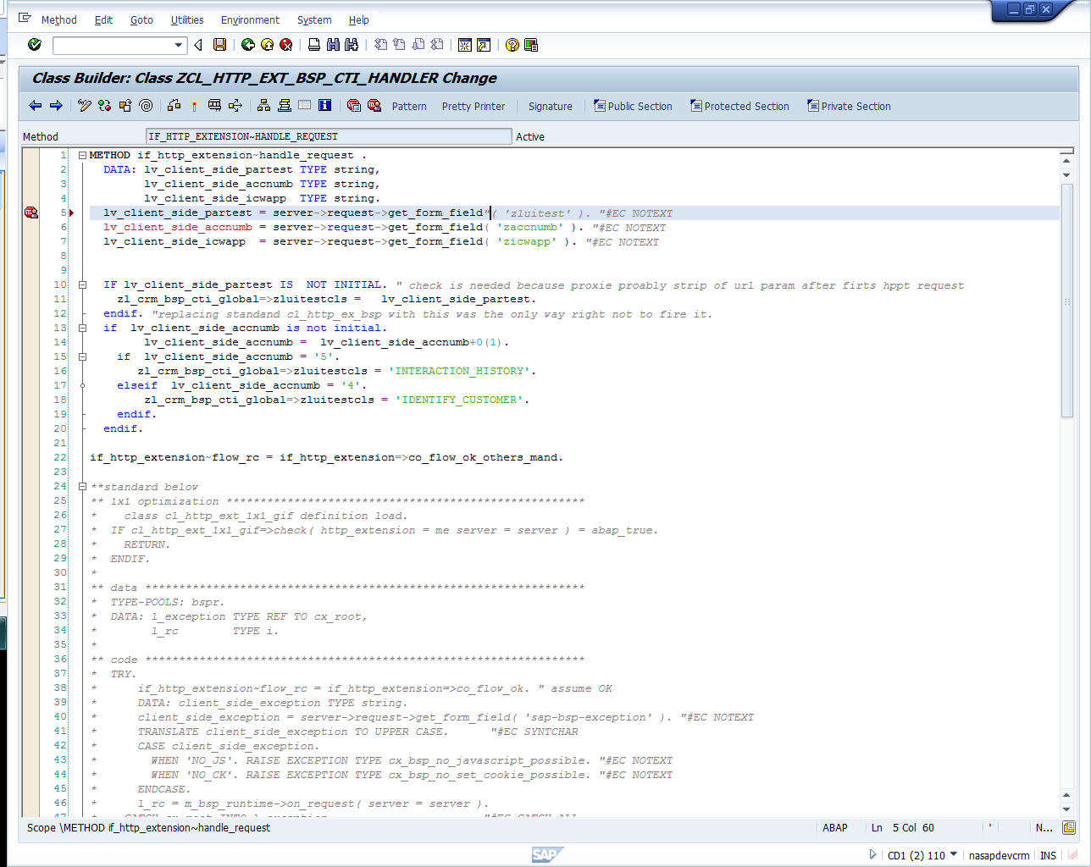

*CODE SAMPLE OF WAY TO GET OTHER INFORMATION FROM THE INCOMMING REQUESTINFORMATION FROM REQUEST

*Use to get session information : Class method to observe sessions in call stack: cl_bcb_worker_session->get_bcb_session

<!--code--> METHOD if_http_extension~handle_request.

<!--code-->

<!--code--> **\* Look for cookie as a signature that frame is already in position**

<!--code--> DATA: cookie TYPE string.

<!--code--> server->request->get_cookie( EXPORTING name = 'BspExampleHideUrlMangling'

<!--code--> IMPORTING value = cookie ).

<!--code--> IF cookie IS NOT INITIAL.

<!--code--> if_http_extension~flow_rc = if_http_extension=>co_flow_ok_others_mand.

<!--code--> RETURN.

<!--code--> ENDIF.

<!--code-->

<!--code--> **\* Get current URL, so that it can be written into frame to be loaded again**

<!--code--> DATA: url TYPE string.

<!--code--> url = server->request->get_header_field( if_http_header_fields_sap=>request_uri ).

<!--code-->

<!--code--> **\* Modify URL slightly, so that browser sees a new URL and actually loads it**

<!--code--> IF url NA '?'. CONCATENATE url '?BspExampleHideUrlMangling=TRUE' INTO url.

<!--code--> ELSE. CONCATENATE url '&BspExampleHideUrlMangling=TRUE' INTO url.

<!--code--> ENDIF.

<!--code-->

<!--code--> **\* Build HTML string together**

<!--code--> DATA: html TYPE string.

<!--code--> CONCATENATE

<!--code--> `<html><frameset><frame src="` url `"></frameset></html>`

<!--code--> INTO html.

<!--code-->

<!--code--> **\* Set response**

<!--code--> server->response->set_cdata( data = html ).

<!--code--> server->response->set_status( code = 200

<!--code--> reason = 'OK' ).

<!--code--> server->response->set_cookie( name = 'BspExampleHideUrlMangling'

<!--code--> value = 'TRUE'

<!--code--> path = '/').

<!--code--> server->response->set_header_field( name = if_http_header_fields=>content_type

<!--code--> value = 'text/html' ).

<!--code-->

<!--code--> **\* This handler finished processing request and don't call other handler**

<!--code--> if_http_extension~flow_rc = if_http_extension=>co_flow_ok.

<!--code-->

<!--code--> ENDMETHOD.