Login: uatsupt1

Pw: Passw0rd

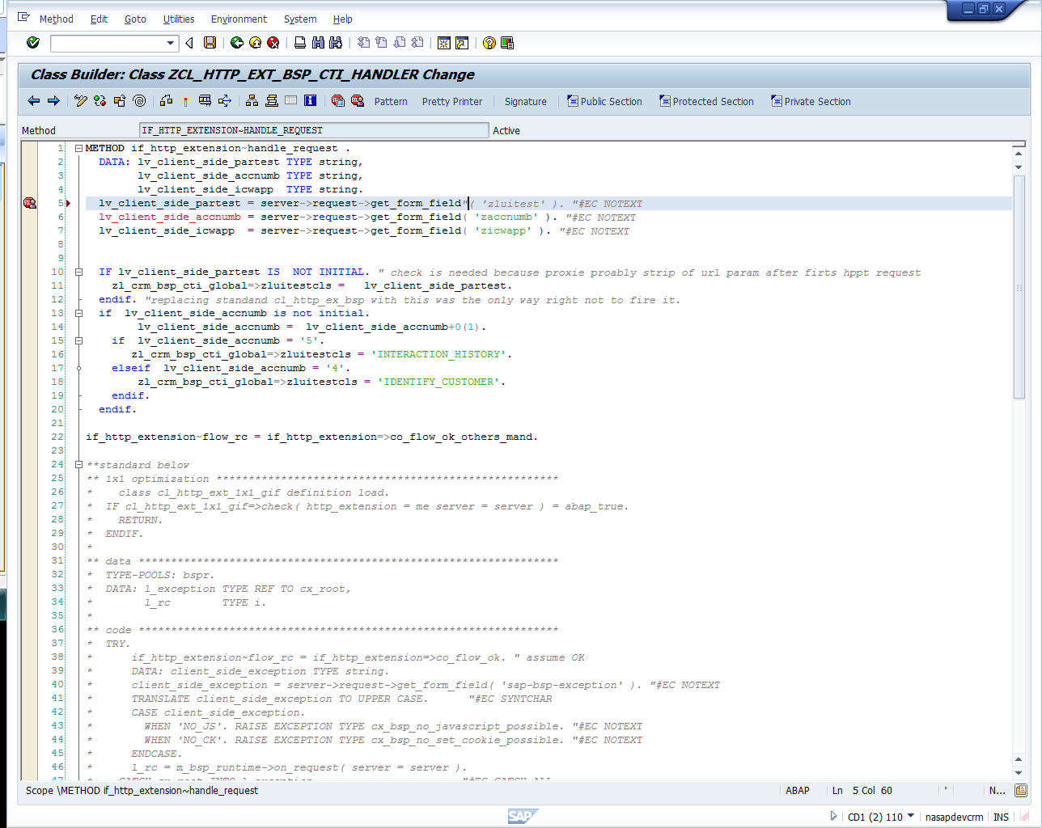

path

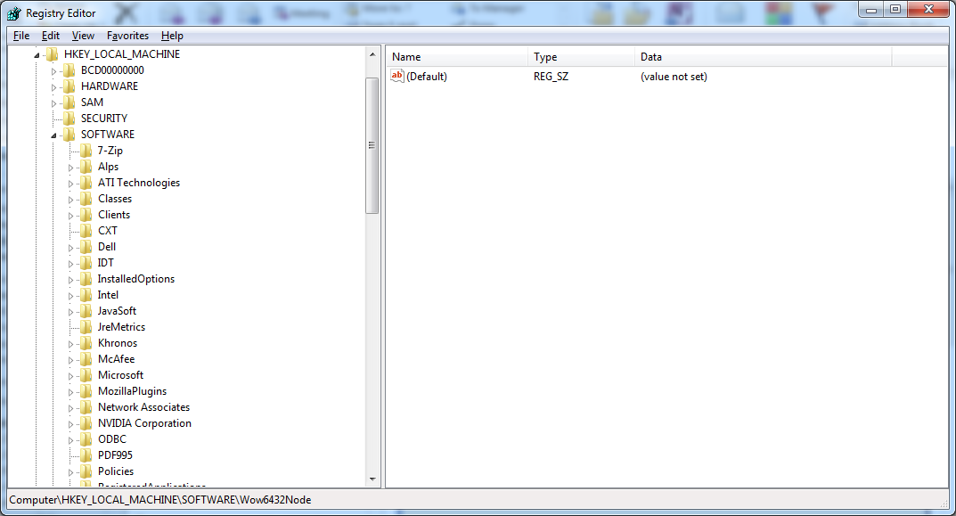

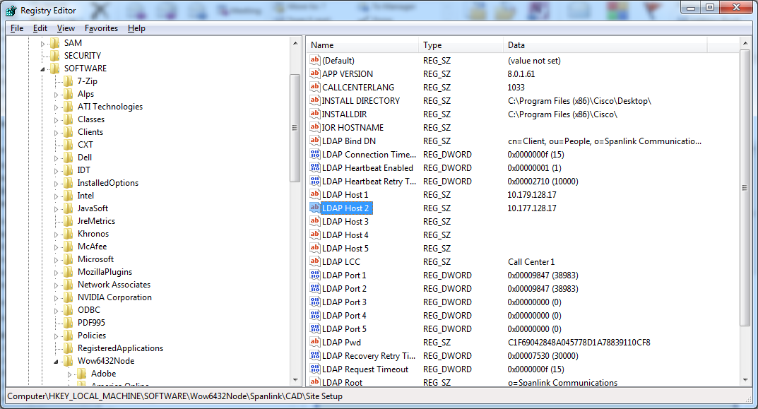

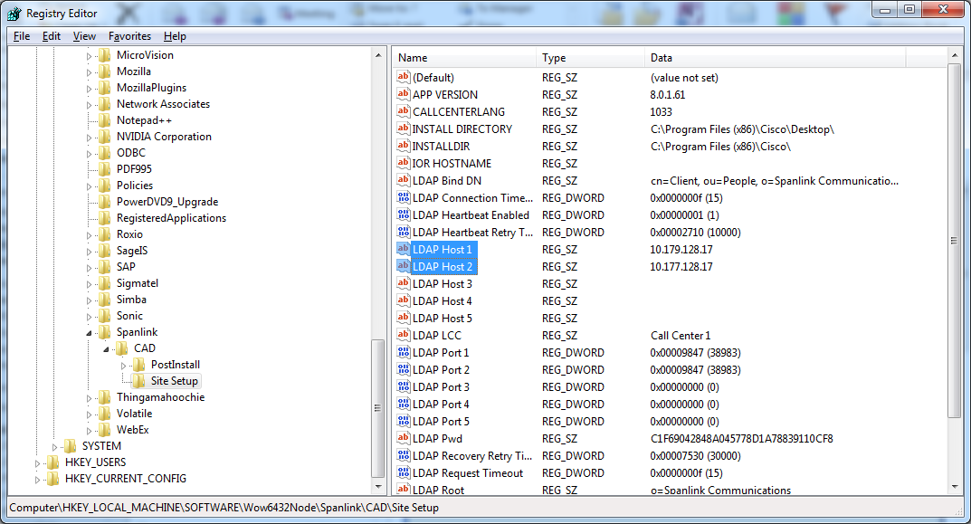

Change two value from 10.177.128.15 to 10.177.128.17

Changed to 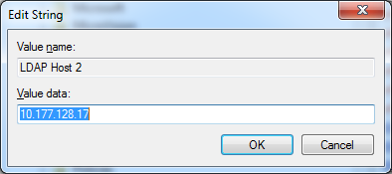

Login: uatsupt1

Pw: Passw0rd

data SOURCE type STRING.  
data GET_VALUE type STRING.  
  
data JS_PROCESSOR type ref to CL_JAVA_SCRIPT.  
  
JS_PROCESSOR = CL_JAVA_SCRIPT=>CREATE( ).  
  
concatenate  
  'var string = "Hello World,";   '  
  'function Set_String()          '  
  '  { string += " this";         '  
  '    string += " is";           '  
  '    string += " JavaScript!";} '  
  'Set_String();                  '  
  'string;                        '  
   into SOURCE separated by CL_ABAP_CHAR_UTILITIES=>CR_LF.  
  
JS_PROCESSOR->COMPILE(  
              exporting  
                SCRIPT_NAME = 'HELLO_WORLD.JS'  
                SCRIPT      = SOURCE ).  
  
JS_PROCESSOR->SET_BREAKPOINT(  
              exporting  
                SCRIPT_NAME = 'HELLO_WORLD.JS'  
                LINE_NUMBER = 1 ).  
  
JS_PROCESSOR->SET_BREAKPOINT(  
              exporting  
                SCRIPT_NAME = 'HELLO_WORLD.JS'  
                LINE_NUMBER = 4 ).  
  
  
JS_PROCESSOR->EXECUTE(  
              exporting SCRIPT_NAME = 'HELLO_WORLD.JS' ).  
  
JS_PROCESSOR->CONTINUE( ).  
GET_VALUE = JS_PROCESSOR->GET( NAME = 'string' ).  
write: / JS_PROCESSOR->BREAKPOINT_LINE_NUMBER, GET_VALUE.  
  
JS_PROCESSOR->CONTINUE( ).  
GET_VALUE = JS_PROCESSOR->GET( NAME = 'string' ).  
write: / JS_PROCESSOR->BREAKPOINT_LINE_NUMBER, GET_VALUE.