Feature selection with filter methods for an IDS flow dataset
Project "Arquitectura IDS impulsada por IA". Author: Laura Camila Herrera Murillo. Date: 2026-10-14.
All numbers in this report are read from the result files under results/; the scripts that produce them are listed in section 9.

1. Summary
- Three filter methods were applied to two flow datasets (A, captured with a firewall; B, without): Low Variance, Pearson correlation and Chi-square. Each filter was fitted on training rows only and each resulting feature subset was evaluated with the same RandomForest.
- No filter improves the model. What the filters achieve is a smaller input at no measurable cost: the final lists have 20 features for A and 30 for B (of 77) and score F1-macro 0.9678 and 0.9701 on test, against 0.9713 and 0.9669 with all features. The differences are smaller than the fold-to-fold noise measured in cross-validation (standard error about 0.0072).
- The combined pipeline (Low Variance, then Pearson, then Chi-square) reaches the baseline with fewer features than Chi-square alone (20 against 40 in A, 30 against 40 in B), because Chi-square alone fills its top ranks with redundant features.
- The scores must not be read as attack detection ability. The features identify which of the two data sources a row comes from almost perfectly, and labels that name the same attack in the two sources are never confused with each other. Section 8 explains this and the other limitations.

2. Data and preparation
Each dataset joins rows from an external dataset (IDS2025) with flows captured in a virtual lab, extracted with cicflowmeter: 79 features and the target newLabel with 12 labels. A and B are processed separately with the same code.
Step | A | B
Raw rows | 370,545 | 345,192
Exact duplicates removed (after dropping the port columns) | 35,062 | 36,079
Clean rows | 335,314 | 308,940
Train rows (stratified, 20% test, seed 42) | 268,251 | 247,152
Test rows | 67,063 | 61,788

Cleaning removed the two port columns (shortcuts), rows with NaN or Inf, exact duplicates and rows with contradictory labels, leaving 77 features. Details and justifications are in cleaning_notes.md and decisions.md.

3. What each filter does
Filters score features with statistics computed from the data. They are not models and nothing is trained. All three were fitted on training rows only.
Low Variance. A feature that takes almost the same value in every row cannot separate classes. Raw variance depends on the unit of each feature, so the rule used is the share of rows taken by the most frequent value: a feature is dropped when one value covers at least 99.9% of the training rows. This removes 9 features in both datasets: the 5 constant columns and 4 flag counters with 1 to 4 non-zero rows. A looser threshold (99%) was rejected because it removes Fwd PSH Flags and SYN Flag Count, which are non-zero in 22.5% of the Brute Force rows: with this class imbalance a quasi-constant feature can be the signal of a small class. The variance after MinMax scaling was computed and discarded as a rule, because it penalizes features with extreme values rather than uninformative ones (decisions.md, decision 6).
Pearson correlation. Two features with an absolute correlation close to 1 carry the same information. For every group of features correlated above the threshold (0.90, 0.95 and 0.99 were tried) only one is kept: the one with the highest ANOVA F score against the label. Constant features have no defined correlation, so this filter cannot remove them.
Chi-square. Measures the association between a feature and the label in a table of counts. The features are continuous, so each one is first cut into 10 quantile bins with edges learned on train; without this step the score would depend on the unit of measure. Features are ranked by the statistic and the top k are kept (k = 10, 20, 30, 40). The scores were cross-checked against the classic contingency-table test of SciPy for every feature. A second ranking by Cramer's V (the same statistic corrected for sample size and number of bins) was evaluated as a comparison.
Combined pipeline. Low Variance at 99.9%, then Pearson on the survivors, then the top k survivors by Chi-square.

4. Evaluation protocol
- Model: RandomForestClassifier with 200 trees and class_weight="balanced", identical for every subset and not tuned.
- Metrics: F1-macro, PR-AUC macro, MCC and per-class recall. Accuracy is not reported as a main metric because the two largest classes hold about 70% of the rows.
- Settings are compared with stratified 5-fold cross-validation inside train; the filters are refitted in every fold.
- Selection rule, fixed before seeing results: within each family, the setting with the fewest features whose mean F1-macro is within one standard error of the best one.
- The test rows are used once, for the baseline and the selected setting of each family.

5. Comparison

5.1 Cross-validation inside train (all configurations)
Mean of 5 folds; F1-macro is shown with its standard error. combined_pX_kY means Pearson threshold X and top Y by Chi-square.
Configuration | A feat. | A F1-macro | A PR-AUC | A MCC | B feat. | B F1-macro | B PR-AUC | B MCC
baseline | 77 | 0.9618 ± 0.0072 (selected) | 0.9789 | 0.9938 | 77 | 0.9675 ± 0.0081 (selected) | 0.9830 | 0.9928
variance_qc_0.999 | 68 | 0.9621 ± 0.0074 (selected) | 0.9794 | 0.9939 | 68 | 0.9677 ± 0.0081 (selected) | 0.9824 | 0.9930
pearson_0.90 | 45 | 0.9630 ± 0.0075 (selected) | 0.9792 | 0.9936 | 46 | 0.9574 ± 0.0076 (selected) | 0.9753 | 0.9932
pearson_0.95 | 52 | 0.9613 ± 0.0077 | 0.9759 | 0.9942 | 51 | 0.9612 ± 0.0081 | 0.9827 | 0.9934
pearson_0.99 | 61 | 0.9633 ± 0.0073 | 0.9789 | 0.9940 | 61 | 0.9611 ± 0.0076 | 0.9805 | 0.9929
chi2_top_10 | 10 | 0.8627 ± 0.0091 | 0.8903 | 0.9618 | 10 | 0.8707 ± 0.0048 | 0.8823 | 0.9633
cramers_v_top_10 | 10 | 0.4396 ± 0.0056 | 0.5127 | 0.2685 | 10 | 0.4198 ± 0.0104 | 0.4976 | 0.2802
chi2_top_20 | 20 | 0.9250 ± 0.0079 | 0.9574 | 0.9849 | 20 | 0.9254 ± 0.0056 | 0.9555 | 0.9831
cramers_v_top_20 | 20 | 0.9046 ± 0.0050 | 0.9178 | 0.9731 | 20 | 0.9022 ± 0.0037 | 0.9139 | 0.9726
chi2_top_30 | 30 | 0.9253 ± 0.0081 | 0.9577 | 0.9862 | 30 | 0.9242 ± 0.0057 | 0.9555 | 0.9845
cramers_v_top_30 | 30 | 0.9475 ± 0.0078 | 0.9759 | 0.9856 | 30 | 0.9606 ± 0.0048 (selected) | 0.9718 | 0.9896
chi2_top_40 | 40 | 0.9594 ± 0.0078 (selected) | 0.9710 | 0.9940 | 40 | 0.9576 ± 0.0080 (selected) | 0.9717 | 0.9928
cramers_v_top_40 | 40 | 0.9682 ± 0.0075 (selected) | 0.9800 | 0.9943 | 40 | 0.9618 ± 0.0085 | 0.9803 | 0.9928
combined_p0.90_k10 | 10 | 0.9266 ± 0.0067 | 0.9513 | 0.9839 | 10 | 0.9198 ± 0.0058 | 0.9514 | 0.9828
combined_p0.90_k20 | 20 | 0.9613 ± 0.0067 (selected) | 0.9687 | 0.9937 | 20 | 0.9548 ± 0.0077 | 0.9673 | 0.9932
combined_p0.90_k30 | 30 | 0.9662 ± 0.0077 | 0.9820 | 0.9936 | 30 | 0.9676 ± 0.0080 (selected) | 0.9789 | 0.9933
combined_p0.95_k10 | 10 | 0.9218 ± 0.0073 | 0.9539 | 0.9846 | 10 | 0.9225 ± 0.0050 | 0.9544 | 0.9814
combined_p0.95_k20 | 20 | 0.9244 ± 0.0073 | 0.9580 | 0.9859 | 20 | 0.9533 ± 0.0060 | 0.9702 | 0.9910
combined_p0.95_k30 | 30 | 0.9586 ± 0.0076 | 0.9705 | 0.9943 | 30 | 0.9672 ± 0.0083 | 0.9812 | 0.9932
combined_p0.99_k10 | 10 | 0.9072 ± 0.0078 | 0.9570 | 0.9807 | 10 | 0.8974 ± 0.0061 | 0.9354 | 0.9753
combined_p0.99_k20 | 20 | 0.9275 ± 0.0075 | 0.9592 | 0.9860 | 20 | 0.9232 ± 0.0038 | 0.9554 | 0.9832
combined_p0.99_k30 | 30 | 0.9614 ± 0.0069 | 0.9687 | 0.9942 | 30 | 0.9580 ± 0.0082 | 0.9734 | 0.9929

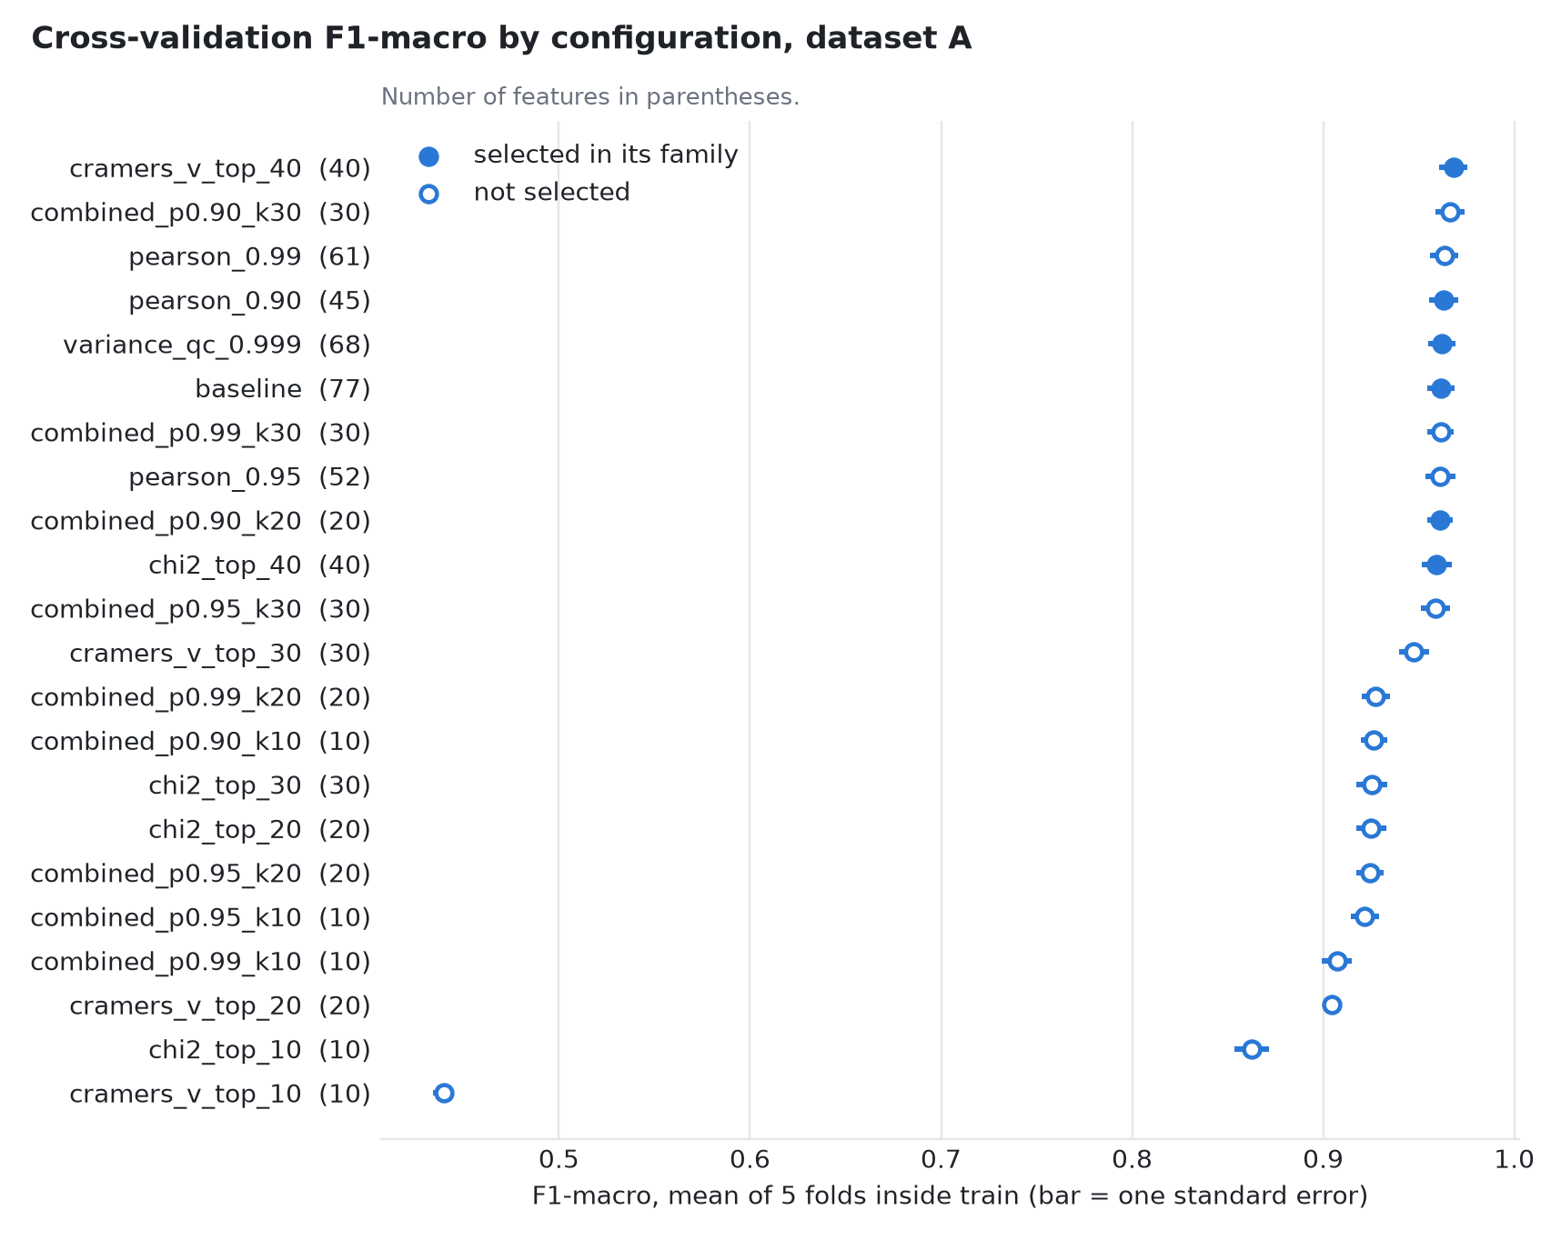
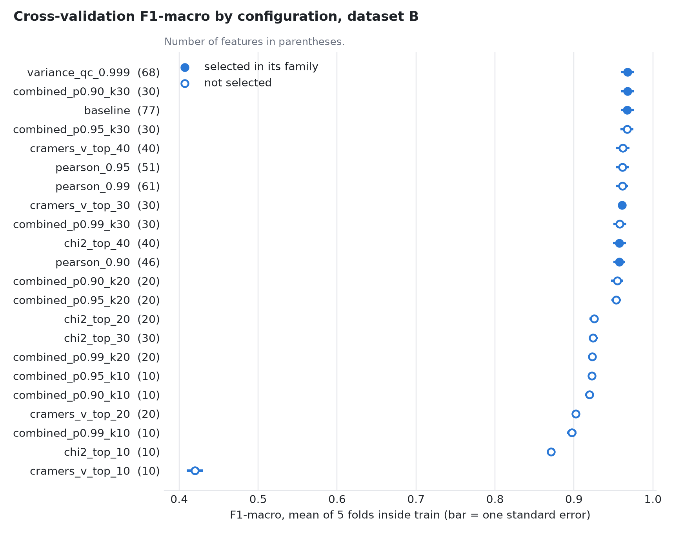

5.2 Test (baseline and the selected setting of each family)
Dataset | Configuration | Features | F1-macro | PR-AUC macro | MCC | Train time (s)
A | baseline | 77 | 0.9713 | 0.9688 | 0.9939 | 19.0
A | variance_qc_0.999 | 68 | 0.9721 | 0.9685 | 0.9941 | 21.6
A | pearson_0.90 | 45 | 0.9727 | 0.9685 | 0.9938 | 14.3
A | chi2_top_40 | 40 | 0.9659 | 0.9575 | 0.9940 | 16.0
A | cramers_v_top_40 | 40 | 0.9715 | 0.9691 | 0.9944 | 15.0
A | combined_p0.90_k20 | 20 | 0.9678 | 0.9650 | 0.9939 | 13.7
B | baseline | 77 | 0.9669 | 0.9682 | 0.9927 | 19.9
B | variance_qc_0.999 | 68 | 0.9683 | 0.9656 | 0.9928 | 19.8
B | pearson_0.90 | 46 | 0.9692 | 0.9676 | 0.9932 | 15.5
B | cramers_v_top_30 | 30 | 0.9540 | 0.9586 | 0.9892 | 9.5
B | chi2_top_40 | 40 | 0.9621 | 0.9674 | 0.9927 | 19.9
B | combined_p0.90_k30 | 30 | 0.9701 | 0.9661 | 0.9932 | 15.7

5.3 Recall per class on test, baseline against the final list
Label | A test rows | A baseline | A final | B test rows | B baseline | B final
Botnet ARES | 275 | 0.971 | 0.982 | 275 | 0.971 | 0.989
Brute Force | 1378 | 1.000 | 1.000 | 1378 | 0.999 | 1.000
Dos/DDos | 4273 | 0.997 | 0.998 | 4273 | 0.998 | 0.998
Infiltration | 6 | 0.667 | 0.667 | 6 | 0.667 | 0.667
PortScan | 111 | 0.982 | 0.982 | 111 | 0.973 | 0.982
Web Attack | 406 | 0.993 | 0.993 | 406 | 0.993 | 0.993
benign | 20834 | 0.988 | 0.990 | 20560 | 0.988 | 0.989
bruteforce | 13344 | 1.000 | 1.000 | 8422 | 1.000 | 1.000
dos_httpflood | 25403 | 0.999 | 0.998 | 24706 | 0.999 | 0.999
dos_slowhttptest | 165 | 1.000 | 1.000 | 164 | 1.000 | 1.000
recon | 857 | 0.995 | 0.988 | 1476 | 0.997 | 0.997
sqli | 11 | 1.000 | 1.000 | 11 | 1.000 | 1.000

Reading of the results:
- Low Variance and Pearson remove 9 to 32 features with no consistent change: the largest gap to the baseline in cross-validation is 0.010 in F1-macro (Pearson 0.90 in B, standard error 0.008) and it does not appear on test. The baseline was not being hurt by redundant features: a tree ensemble tolerates them.
- Chi-square alone needs 40 features to reach the baseline; with 10 or 20 it is clearly worse.
- The ranking by Cramer's V is not a better alternative: with 10 features its F1-macro falls to 0.44 (A), 0.42 (B) and it detects no sqli row.
- The largest single error of the baseline is 200 benign rows predicted as Dos/DDos in A and 203 benign rows predicted as Dos/DDos in B.

6. Why the combined pipeline beats Chi-square alone
Chi-square scores each feature on its own. Two features that are copies of each other get the same high score and both enter the top k, although the second one adds nothing. Evidence, for the same number of features:
 | A (k = 20) | B (k = 30)
F1-macro in cross-validation, Chi-square top k | 0.9250 | 0.9242
F1-macro in cross-validation, combined top k | 0.9613 | 0.9676
Feature pairs with absolute correlation above 0.90 inside Chi-square top k | 21 | 34
Same, inside the combined list | 0 | 0
Features present in both the Chi-square top k and the combined list | 6 | 13

The top of the Chi-square ranking is occupied by groups such as Total Length of Fwd Packets and Subflow Fwd Bytes, or Fwd Packet Length Mean and Avg Fwd Segment Size, which are the same quantity under two names. The combined pipeline lets Pearson keep one feature per group first, so each of the k places goes to different information.

7. Final feature lists
Chosen by the selection rule: combined_p0.90_k20 for A and combined_p0.90_k30 for B. The rule was not adjusted after seeing the results (decisions.md, decision 8), which is why the two lists have different lengths. The lists were fitted on the full training set of each dataset and are saved as results/final_features_A.csv and results/final_features_B.csv.

Dataset A (20 features)
Rank | Feature | Chi-square | Cramer's V | In the other list
1 | Total Length of Fwd Packets | 684,568 | 0.565 | yes
2 | Fwd Packet Length Mean | 643,034 | 0.632 | yes
3 | Max Packet Length | 635,350 | 0.628 | yes
4 | Fwd IAT Mean | 552,886 | 0.479 | yes
5 | Fwd IAT Total | 498,573 | 0.454 | no
6 | Flow Packetss | 495,073 | 0.453 | yes
7 | Fwd Header Length | 484,335 | 0.549 | yes
8 | Total Fwd Packets | 483,129 | 0.548 | yes
9 | Flow Bytess | 469,214 | 0.441 | yes
10 | Packet Length Mean | 468,722 | 0.591 | no
11 | Idle Max | 267,288 | 0.499 | no
12 | Idle Mean | 266,483 | 0.498 | yes
13 | Idle Std | 240,515 | 0.473 | yes
14 | Active Max | 232,852 | 0.466 | no
15 | Active Min | 206,749 | 0.439 | yes
16 | Flow IAT Min | 198,537 | 0.430 | yes
17 | Init_Win_bytes_backward | 198,103 | 0.608 | yes
18 | Fwd IAT Min | 181,074 | 0.411 | yes
19 | Init_Win_bytes_forward | 175,271 | 0.572 | yes
20 | Min Packet Length | 158,262 | 0.768 | yes

Dataset B (30 features)
Rank | Feature | Chi-square | Cramer's V | In the other list
1 | Total Length of Fwd Packets | 602,592 | 0.552 | yes
2 | Average Packet Size | 568,494 | 0.619 | no
3 | Fwd Packet Length Mean | 494,064 | 0.632 | yes
4 | Idle Mean | 488,277 | 0.497 | yes
5 | Max Packet Length | 478,543 | 0.622 | yes
6 | Flow Packetss | 452,778 | 0.451 | yes
7 | Flow IAT Mean | 451,824 | 0.451 | no
8 | Flow Duration | 445,525 | 0.448 | no
9 | Fwd IAT Mean | 429,245 | 0.439 | yes
10 | Flow Bytess | 411,823 | 0.430 | yes
11 | Idle Std | 364,752 | 0.430 | yes
12 | Fwd Header Length | 336,172 | 0.522 | yes
13 | Total Fwd Packets | 288,740 | 0.540 | yes
14 | Active Min | 261,817 | 0.515 | yes
15 | Active Mean | 243,260 | 0.496 | no
16 | Init_Win_bytes_backward | 181,329 | 0.606 | yes
17 | Flow IAT Min | 174,425 | 0.376 | yes
18 | Init_Win_bytes_forward | 174,182 | 0.594 | yes
19 | Min Packet Length | 143,281 | 0.761 | yes
20 | Fwd Packet Length Min | 143,193 | 0.761 | no
21 | Bwd IAT Total | 142,165 | 0.758 | no
22 | Bwd IAT Mean | 141,991 | 0.758 | no
23 | Subflow Bwd Bytes | 124,241 | 0.709 | no
24 | Bwd IAT Min | 118,020 | 0.691 | no
25 | Bwd Packet Length Mean | 106,954 | 0.658 | no
26 | Fwd IAT Min | 91,347 | 0.304 | yes
27 | Bwd Packetss | 83,502 | 0.581 | no
28 | Down Up Ratio | 66,174 | 0.517 | no
29 | Protocol | 61 | 0.016 | no
30 | Bwd Packet Length Min | 0 | 0.000 | no

A against B
- Shared (16): Active Min, Flow Bytess, Flow IAT Min, Flow Packetss, Fwd Header Length, Fwd IAT Mean, Fwd IAT Min, Fwd Packet Length Mean, Idle Mean, Idle Std, Init_Win_bytes_backward, Init_Win_bytes_forward, Max Packet Length, Min Packet Length, Total Fwd Packets, Total Length of Fwd Packets
- Only in A (4): Active Max, Fwd IAT Total, Idle Max, Packet Length Mean
- Only in B (14): Active Mean, Average Packet Size, Bwd IAT Mean, Bwd IAT Min, Bwd IAT Total, Bwd Packet Length Mean, Bwd Packet Length Min, Bwd Packetss, Down Up Ratio, Flow Duration, Flow IAT Mean, Fwd Packet Length Min, Protocol, Subflow Bwd Bytes
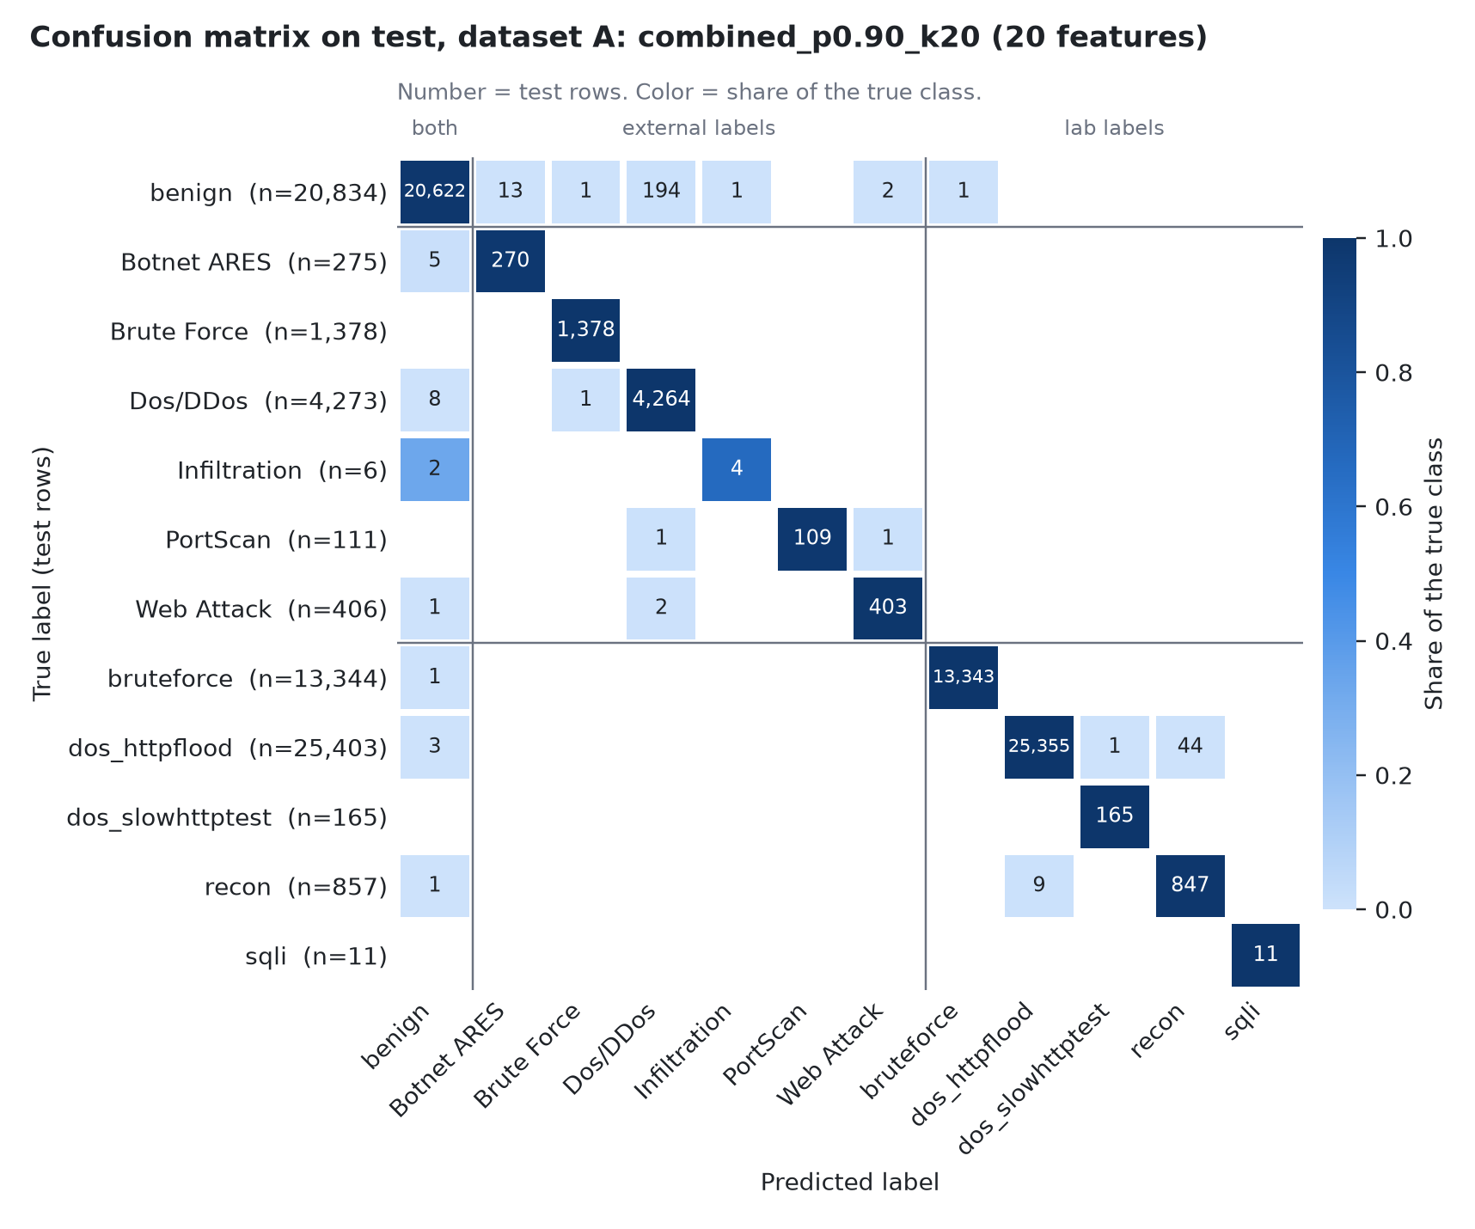
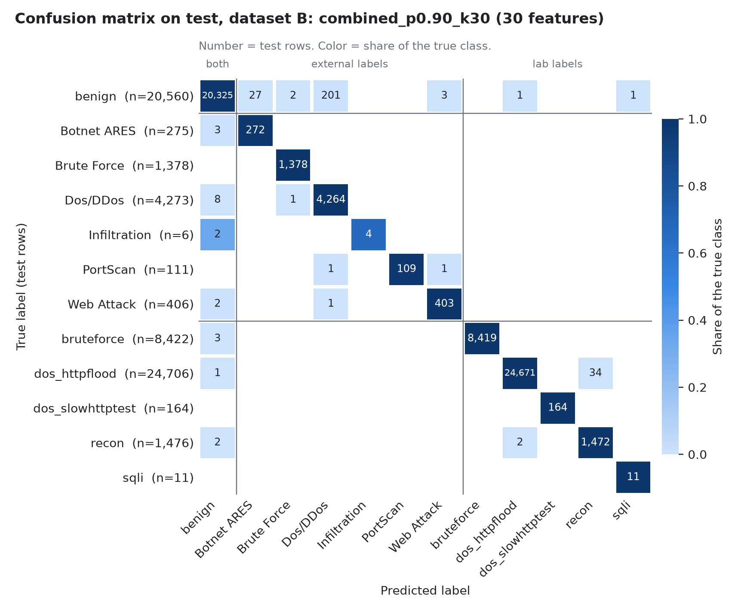
In the confusion matrices the labels are ordered by data source. Every misclassification falls inside one source block or involves benign, the only label present in both sources.

8. Limitations

8.1 The features identify the data source
External rows and lab rows come from different environments and different flow extractors, and the label vocabularies differ (Brute Force and bruteforce, PortScan and recon, Web Attack and sqli). Two checks were made:
- Confusions between equivalent labels: 0 in total, across the 12 configurations scored on test, in either direction. If the features described the attack itself, flows of the same attack type from the two sources would be confused at least occasionally.
- Source probe: a RandomForest with the same settings was trained to answer only "external or lab?" using benign rows alone, the one label present in both sources. With the final lists it misclassifies 0 of 20,834 test rows in A and 2 of 20,560 in B.
Part of the reason is visible in the features: 27 of the 77 features are zero in every lab row (see 8.3), so any non-zero value marks an external row. The final list of A contains 1 of them (Init_Win_bytes_backward) and the final list of B contains 9 (Init_Win_bytes_backward, Bwd IAT Total, Bwd IAT Mean, Subflow Bwd Bytes, Bwd IAT Min, Bwd Packet Length Mean, Bwd Packetss, Down Up Ratio, Bwd Packet Length Min).
Consequence: the model separates the sources and then the classes inside each source. The high scores do not show that the selected features characterize an attack type, and they say nothing about traffic from another network. The experiment that would test it, training on one source and evaluating on the equivalent labels of the other, was not done.

8.2 Infiltration
Infiltration has 29 rows in total: 23 in train and 6 in test. On test the model detects 4 of 6 in A and 4 of 6 in B, in every configuration; one row is 17 points of recall. In cross-validation, over the 23 training rows, recall ranges from 0.57 to 0.70 in A and from 0.52 to 0.70 in B depending on the configuration. No conclusion about which features help this class can be drawn from so few rows, and it is the class that limits F1-macro. sqli has 11 test rows after deduplication, so its recall is also indicative only.

8.3 One-direction flows
In 100% of the lab rows the backward packet count is 0 and the flow source is the server. The client side of every lab conversation is missing: no attacker requests and no SQL payloads are represented. Another extractor (NTLFlowLyzer) produces bidirectional flows from the same capture, which points to a failure of the extraction and not of the capture. That comparison was verified on a single PCAP (fw_benign_20260828_01), not on the 12 lab captures; for the other 11 it is assumed, not checked. All backward features are constant for lab rows, and the lab classes are being separated only by what the server sent.

8.4 Duplicates
With the port columns present the raw files have 94 (A) and 100 (B) exact duplicate rows. Once the ports are dropped, 35,062 (A) and 36,079 (B) rows are identical to another row and were removed, keeping one copy. The effect is concentrated: PortScan goes from 25,409 rows to 554 and sqli from 179 to 58 (A) and 57 (B). The metrics therefore describe performance per distinct flow pattern, not per captured flow, and class frequencies no longer reflect the captured traffic (decisions.md, decision 4). Rows that are almost identical were not removed and can fall on both sides of the train/test split, which may make test scores optimistic.

8.5 Other limits
- Chi-square and sparse features. With quantile bins, a feature where one value covers about 90% of the rows or more collapses into a single bin and gets a score of 0 whatever information it carries. This happens to 17 non-constant features in A and 16 in B, mostly flag counters. In B only 39 features survive Pearson, so the top 30 takes most of them and includes one feature with a score of 0 (Bwd Packet Length Min).
- One model. The comparison uses a RandomForest. Models that are sensitive to redundant features may benefit more from the filters.
- Five folds. The standard error used by the selection rule is itself a rough estimate.
- A and B share their external rows, so results on the two datasets are not independent replications.

9. Reproducibility
Run in order with .venv/bin/python:
Script | Stage
src/00_setup.py | Load and check the raw files
src/01_audit.py | Quality audit
src/02_clean.py, src/02b_duplicates_check.py | Cleaning and duplicate check
src/03_split.py, src/03b_handoff.py | Train/test split and data package
src/04_filters.py | The three filters on the full training set
src/05_evaluate.py, src/05b_plots.py | Evaluation and figures
src/06_deliverables.py, src/06b_report.py | Final lists and this report
src/06c_report_pdf.py, src/06d_report_docx.py | Export of this report to PDF and Word

Parameters are in src/config.py. Seeds are fixed. Stages 1 to 4 and 6 were run twice and produced identical files; stage 5 (about one hour) was run once.

Appendix. Confusion matrices of the other configurations scored on test
The matrices of the final lists are in section 7. The ones below belong to the baseline and to the setting selected in each of the other families.
