A concise abstract title here
Author One¹, Author Two², Author Three³
¹Name of the Institution, Address
²Name of the Institution, Address
³Name of the Institution, Address
Corresponding author email: responsible.author@email.com; https://orcid.org/0000-0002-1825-0097

Main Text
Please provide an abstract of no more than 600 words, one figure or one table (included here), and a brief list of references. We kindly request that you refrain from using section headers (remove the Main Text header). While it's encouraged to include a summary figure, it's not obligatory.
Example of a simple equation:

For units, please follow the recommendations of Koefoed (1967). References should be included in the references section arranged alphabetically and then chronologically if necessary. Use Elsevier - Harvard’s style including full titles for formatting the references. You can utilize https://zbib.org/ to automatically format your references by providing the doi or the title of the source.
Abstracts will be reviewed by the Scientific Committee, who will decide about the direct acceptance of the abstract and provide advice for modifications or rejection in case they consider that an abstract does not have sufficient quality or does not fit within the broad topics of the meeting.
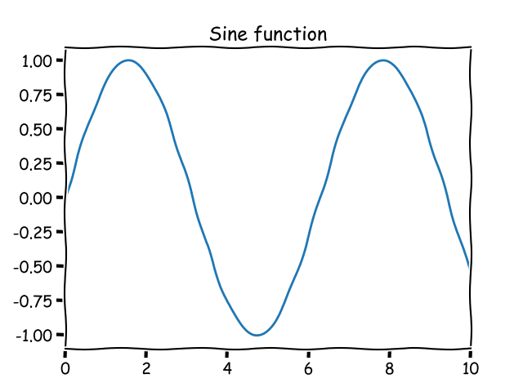
Figure. A sine wave

References
Girardeau, J., Ibarguchi, J.I.G., Jamaa, N.B., 1989. Evidence for a Heterogeneous Upper Mantle in the Cabo Ortegal Complex, Spain. Science 245, 1231–1233. https://doi.org/10.1126/science.245.4923.1231
Koefoed, O., 1967. UNITS IN GEOPHYSICAL PROSPECTING*. Geophys Prospect 15, 1–6. https://doi.org/10.1111/j.1365-2478.1967.tb01768.x

Preferred communication option:
☐ Oral
☐ Poster
Important: Please note that submitting this form indicates your preference for an oral or poster presentation but the final decision regarding the presentation format rests with the congress organizers. While we will consider your preferences, the final decisions will be based on various factors, including the overall program schedule and available slots.

Preferred thematic session (you may choose more than one):
☐ Geochemical and Petrological Perspectives: Latest advancements in geochemical and petrological studies of mantle and related high-P (granulites, eclogites) crustal rocks. Major and trace element rock composition, isotopic signatures, physic-chemical evolution, etc. This includes field-based and experimental approaches.
☐ Mantle-Crust Interaction and Melt Generation: This session will focus on the processes of mantle-crust interaction and melt generation, including melting processes, melt transport and their impact on crustal evolution, crustal recycling, and the significance of (ultra)mafic lithologies in orogenic peridotites.
☐ Seismic and Geophysical Studies: Present and discuss the results of seismic and geophysical studies related to mantle and high-P crustal rocks. Explore how these studies contribute to our understanding of mantle structure, composition, and dynamics. Including modelling seismic or other physical rock properties.
☐ Thermodynamic and Numerical Modelling Approaches: Showcase modelling efforts aimed at simulating conditions relevant to the mantle and related high-P rocks (granulites, eclogites). For example, discussing the significance of mineral reactions, phase equilibria, and mineral relations or simulating P-T paths in subduction settings. Approaches comparing models and field-based cases are encouraged.
☐ Deformation in the Mantle and High-P Crustal rocks: Showcase microstructural and textural (CPO) studies of mantle and high-P crustal rocks, rheological properties, and experimental rock deformation.
☐ Tectonic Settings and Geological Context: Discuss the tectonic settings where specific mantle and related rocks are found and originate.
☐ Mantle carbon and volatile cycles: Role of the mantle in the carbon and volatile cycles and low-temperature hydrothermal alteration.
☐ Economic Geology: Discuss any applied implications of mantle and related rocks such as their role in resource exploration, mining, or other industrial applications. Sulphides, PGE.
☐ Interdisciplinary Perspectives and Future Directions: Cross-disciplinary interactions, development of new techniques or tools, and future research directions.
Important: Please note that the organisation reserves the right to modify or combine thematic sessions based on the number of participants and scheduling constraints. While we aim to accommodate participants’ preferences, adjustments may be necessary to ensure a balanced and efficient programme.

Will you be attending an excursion?
☐ Pre-conference excursion. Cabo Ortegal complex
☐ Post-conference excursion.

