## A concise abstract title here

**Author One1, Author Two2, Author Three3**

1Name of the Institution, Address, <https://orcid.org/0000-0002-1825-0097>  
2Name of the Institution, Address, ORCID identifier  
3Name of the Institution, Address, ORCID identifier

*Contact Email:* [*responsible.author@email.com*](mailto:responsible.author@email.com)

### Main Text

Please provide an abstract of no more than 600 words, one figure or one table (included here), and a brief list of references. We kindly request that you refrain from using section headers (remove the Main Text header). While it's encouraged to include a summary figure, it's not obligatory.

Example of a simple equation:

$$\sin^{2}\left(a\right)+\cos^{2}\left(a\right)=1 \text{(1)}$$

For units, please follow the recommendations of Koefoed (1967). References should be included in the references section arranged first alphabetically and then chronologically if necessary. Use the Elsevier - Harvard’s style including full titles for formatting the references. You can utilize <https://zbib.org/> to automatically format your references by providing the doi or the title of the source.

Abstracts will be reviewed by the Scientific Committee, who will decide about the direct acceptation of the abstract, provide advice for modifications or reject in case that they consider that an abstract has not have sufficient quality or do not fit within the broad topics of the meeting.

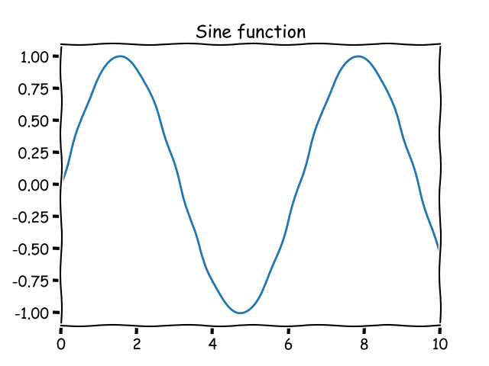

*Figure. A sine wave*

### References

Girardeau, J., Ibarguchi, J.I.G., Jamaa, N.B., 1989. Evidence for a Heterogeneous Upper Mantle in the Cabo Ortegal Complex, Spain. Science 245, 1231–1233. <https://doi.org/10.1126/science.245.4923.1231>

Koefoed, O., 1967. UNITS IN GEOPHYSICAL PROSPECTING*. Geophys Prospect 15, 1–6. <https://doi.org/10.1111/j.1365-2478.1967.tb01768.x>