Who you are?

What you do?

How to connect with you?

1. Define your profile: who you are as a snapshot of you as a professional and a person

* Current profession/position
* Qualifications
* Contact details
* Research profile : what makes you unique?

1. What are your skills

* List of publication
* Awards/grants
* Conference talks
* Something they may not know about you… (try to keep it separate from the primary informations)

1. What are you looking for

* Jobs?
* Collaborations?
* Invitations?
* Engagement?

A good test: turn on the incognito mode, search your name, your website should be at the top. Try other searches “dark matter durham”, and see if your website shows up at the top or not

Put in your facebook/twitter/linkedin (journalists look A LOT at Linkedin)

To show your programming skills and opensource attitude: share and show your GitHub or whatever repositories you hold.

Advertise that you are a science communicator (youtube/tiktok/Spotify/medias/…)

* Keep it simple.
  + Colours: make sure it is simple and use complementary colours
  + Not more than two or three different fonts
  + Use visuals only when they are relevant (little logos, png)
  + Organise your website visually, not in a messy way
* Make it easy to find information: remember, people spend about 30 sec on your website…

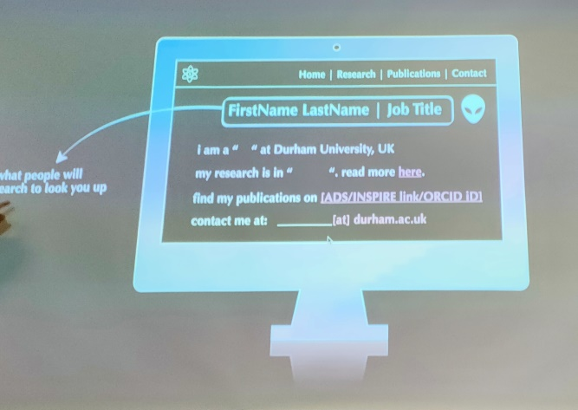

* Keep your users in mind:
  + Avoid high-resolution pictures (long to load)
  + F-shape of the website (the eyes spend time on the left and sometime adventure to the right
* Use google analytics (insert a link somewhere…)
* Website builders: **canva**, wix, squarespace, weebly, wordpress
* Html5up.net / Bootstrap 5 …
* Import fonts from google font using @import in google fonts
* Hostname: GoDaddy (buy domain), namecheap (free domain names for students)
* Free options: GitHub (hosts website on a repository, and link it using GitHub Pages)
* Use ADS to divide your publication list into categories, and use these links to reference it on your website (blocks for different categories with little description, image and title)