HO CHI MINH CITY UNIVERSITY OF TECHNOLOGY
DEPARTMENT OF TELECOMMUNICATIONS ENGINEERING
--------------------------


DIGITAL COMMUNICATIONS
HOMEWORK 01

Students : Lê Hoàng Giang-1551032

HCM City 2019

Problem 1
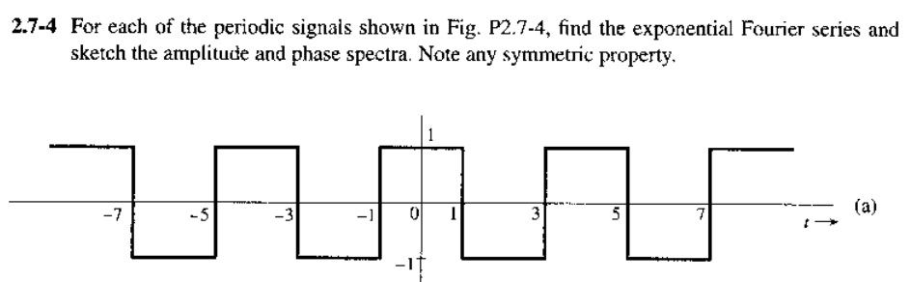
Fig. P2.7-4
We have t = 2, T = 4
We have 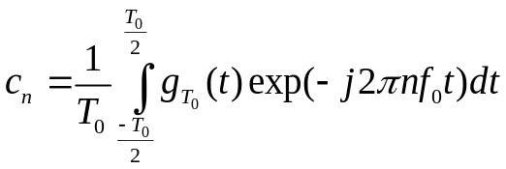
In this case 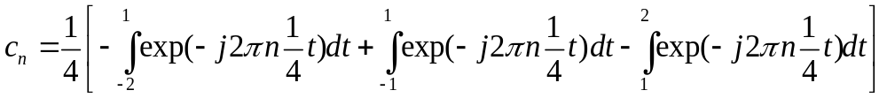
- 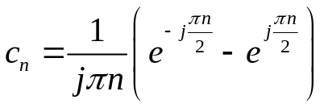
And 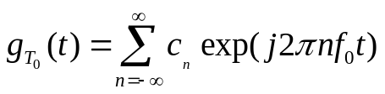
- 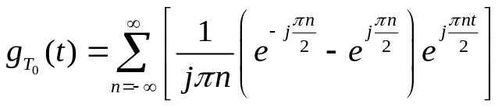
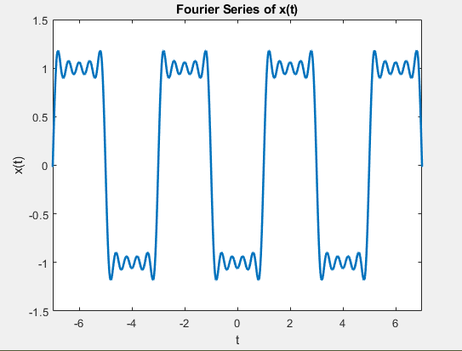
Problem 2
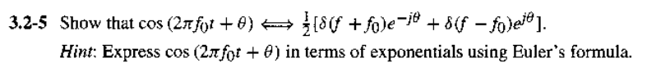
Fourier of 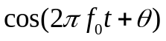 = 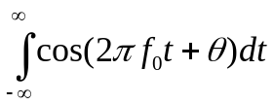
= 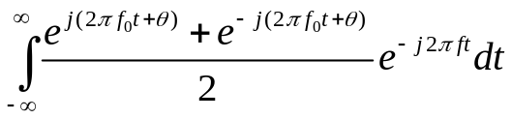
= 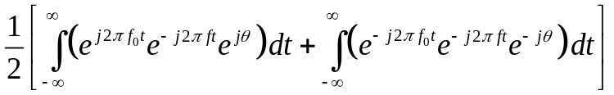
=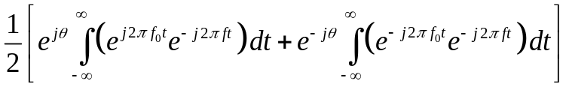
=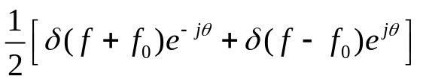

Problem 3
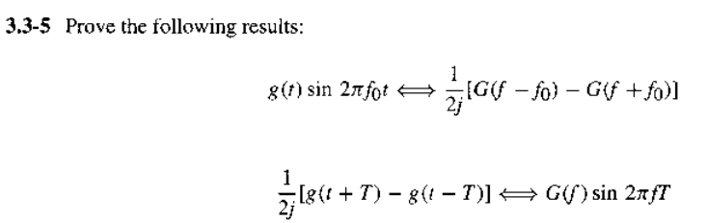
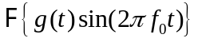= 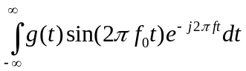
= 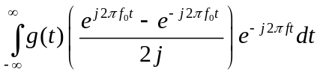
=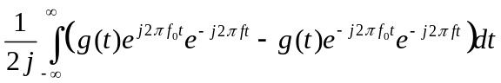
=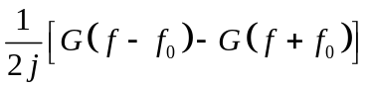
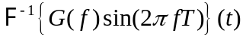 =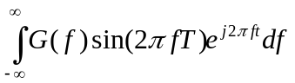
= 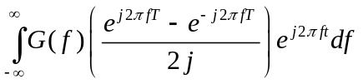
= 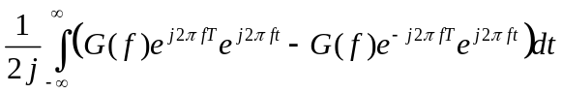
= 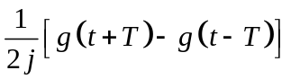

Problem 4
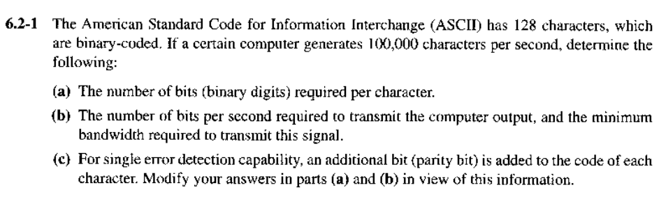
a/ Number of bits required per character is 7bits/character
b/ Number of bits on PCM words is 7 and sampling rate is 100000
- Bit rate : 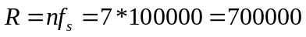bits/s
Bandwidth of PCM waveform is bounded by formula: 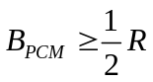
- Minimum bandwidth 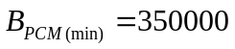Hz
c/ If add 1 bits parity into each character
- Number of bits required per character is 8bits/character
- Bit rate : 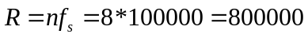bits/s
- Minimum bandwidth 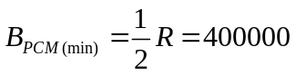Hz
Problem 5

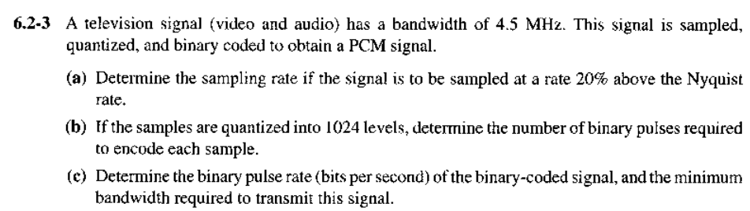
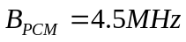
a/ We have 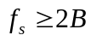
- Nyquist rate = 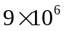Hz
- 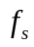 = 120% x Nyquist rate = 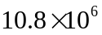samples/s
b/ 1024 levels
- Need 10 bits for each samples
c/ Bit rate: 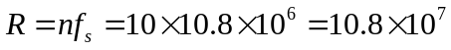bits/second
- Minimum bandwidth 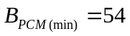MHz

Problem 6
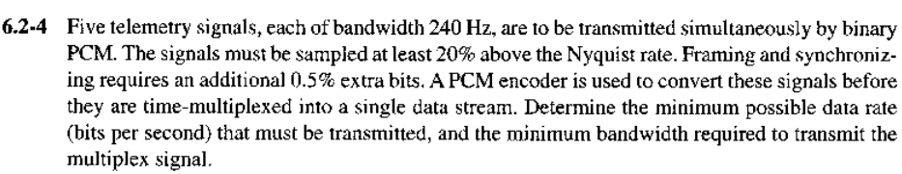
Telemetry signals have 8 bits per word format.
- Nyquist rate of each signal = 240*2= 480Hz
- = 120% x Nyquist rate = 576 samples/s for each signal
- Each signal has 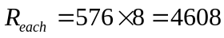bits/s
- There are 5 signals: R =  = 23.04kbps
Framing and synchronizing requires an additional 0.5% extra bits
- 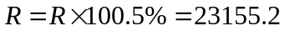bps
- Minimum bandwidth 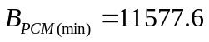MHz

Problem 7
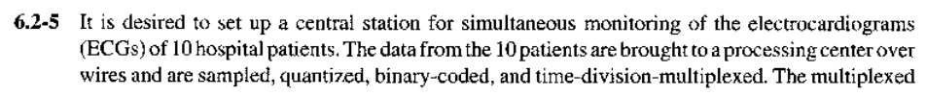
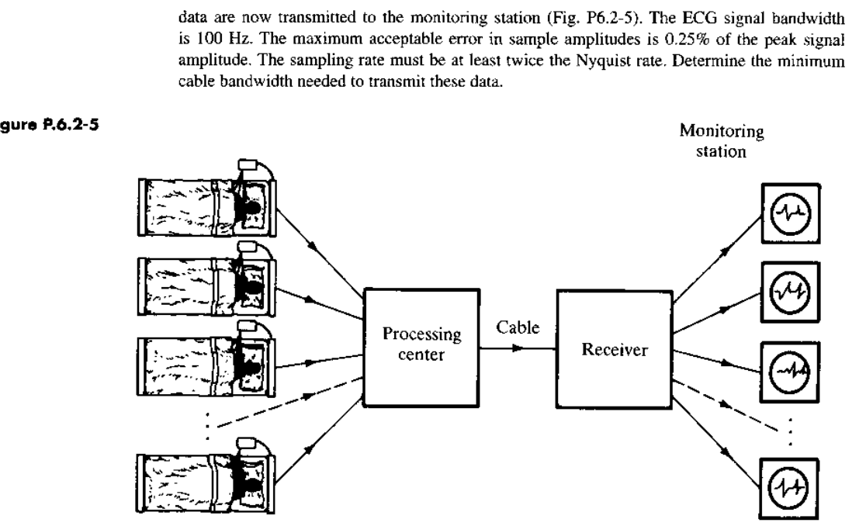

Signal bandwidth for each, 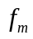=100Hz.
- Nyquist rate of each signal, 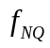 = 2 = 2*100 = 200Hz
- =2=2*200 = 400Hz
Maximum error in sample amplitudes is 0.25% of peak signal amplitude
- 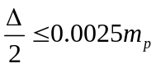
- 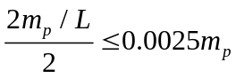
- 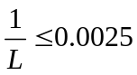
- 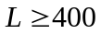
However, L should be a power of 2. So, L = 512 = 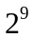
- Number of bit required is n = 9 bits
- Minimum bit rate required for one patient, bps

