26/07/2026 10:20 PM

Uhmm hi Hanna I hope you’re doing alright I know that these past days ag sasaruno apa ta because of me you’re always telling that I have an another girl or else I am sorry because that's not true eh I already said an awan there's no other girl I know my words are not enough to say or to prove that to you I know it's not enough yeah they're true actions is better than words.

But you know what I did that na eh but sadly you’re not seeing it or noticing my efforts just I know giving my account I know that it's not enough to show or to prove or to show an assurance but trust me I am doing my best to prove that I am not the old lhian yes I know there's a lot things I've changed you know what we're also a human or a people we're changing there's no perfect here but trust me PLEASE how many times do I have to tell you that you’re the only one I loved yes I know you have a big trauma for your ex and also to me because of what I did to you lately but it's past I know that is so painful but trust me I’m not that kind of lhian anymore.

You know what I know you’re feeling that three’s another girl because of my actions you know what why my actions is changed because it hurts you keep telling that "ADDA BABAI KNOW" because of my actions but you know what you’re wrong the truth is I am just tired because of what you’re doing or saying to me it hurts because I know to myself that you’re wrong I know to myself that there's no other girl but you keep telling that nga adda I’m just tired because I am tired reaching you out I am tired explaining that there's no other girl but awan mabalin kasta pinag kitam kanyakon ehh because of what I did lately to you I AM SORRY HANNAI AM REALLY SORRY, I know sorry is not enough on what I did to you.

But I am still hoping for your forgiveness I am really sorry you know me no matter what happens I will not quit or I will not surrender I am just saying my side or explaining my side, you know that surrendering is not on my vocabulary sorry but I will not tell so much words I am just only saying my side the rest is I’ve been said last night that’s all sorry and ILOVEYOUSOMUCH my love.

PUUUUUUUU
NAAAAA
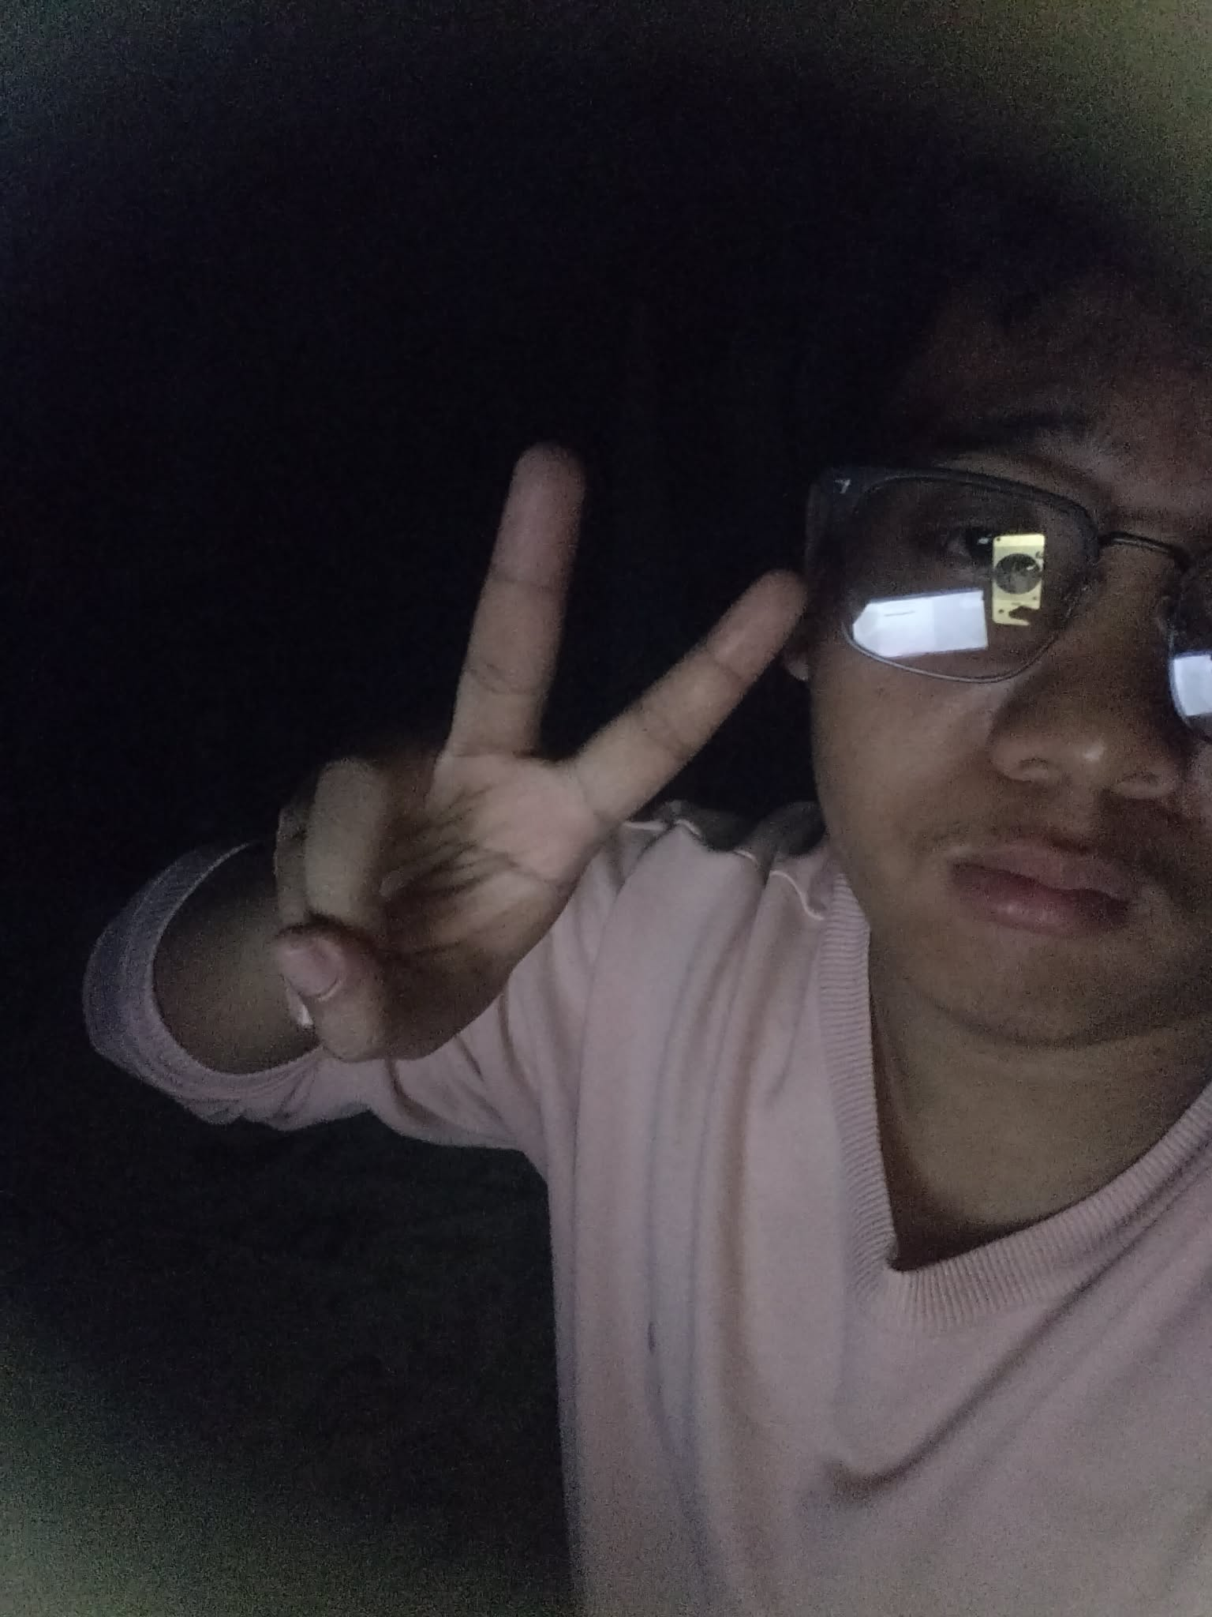
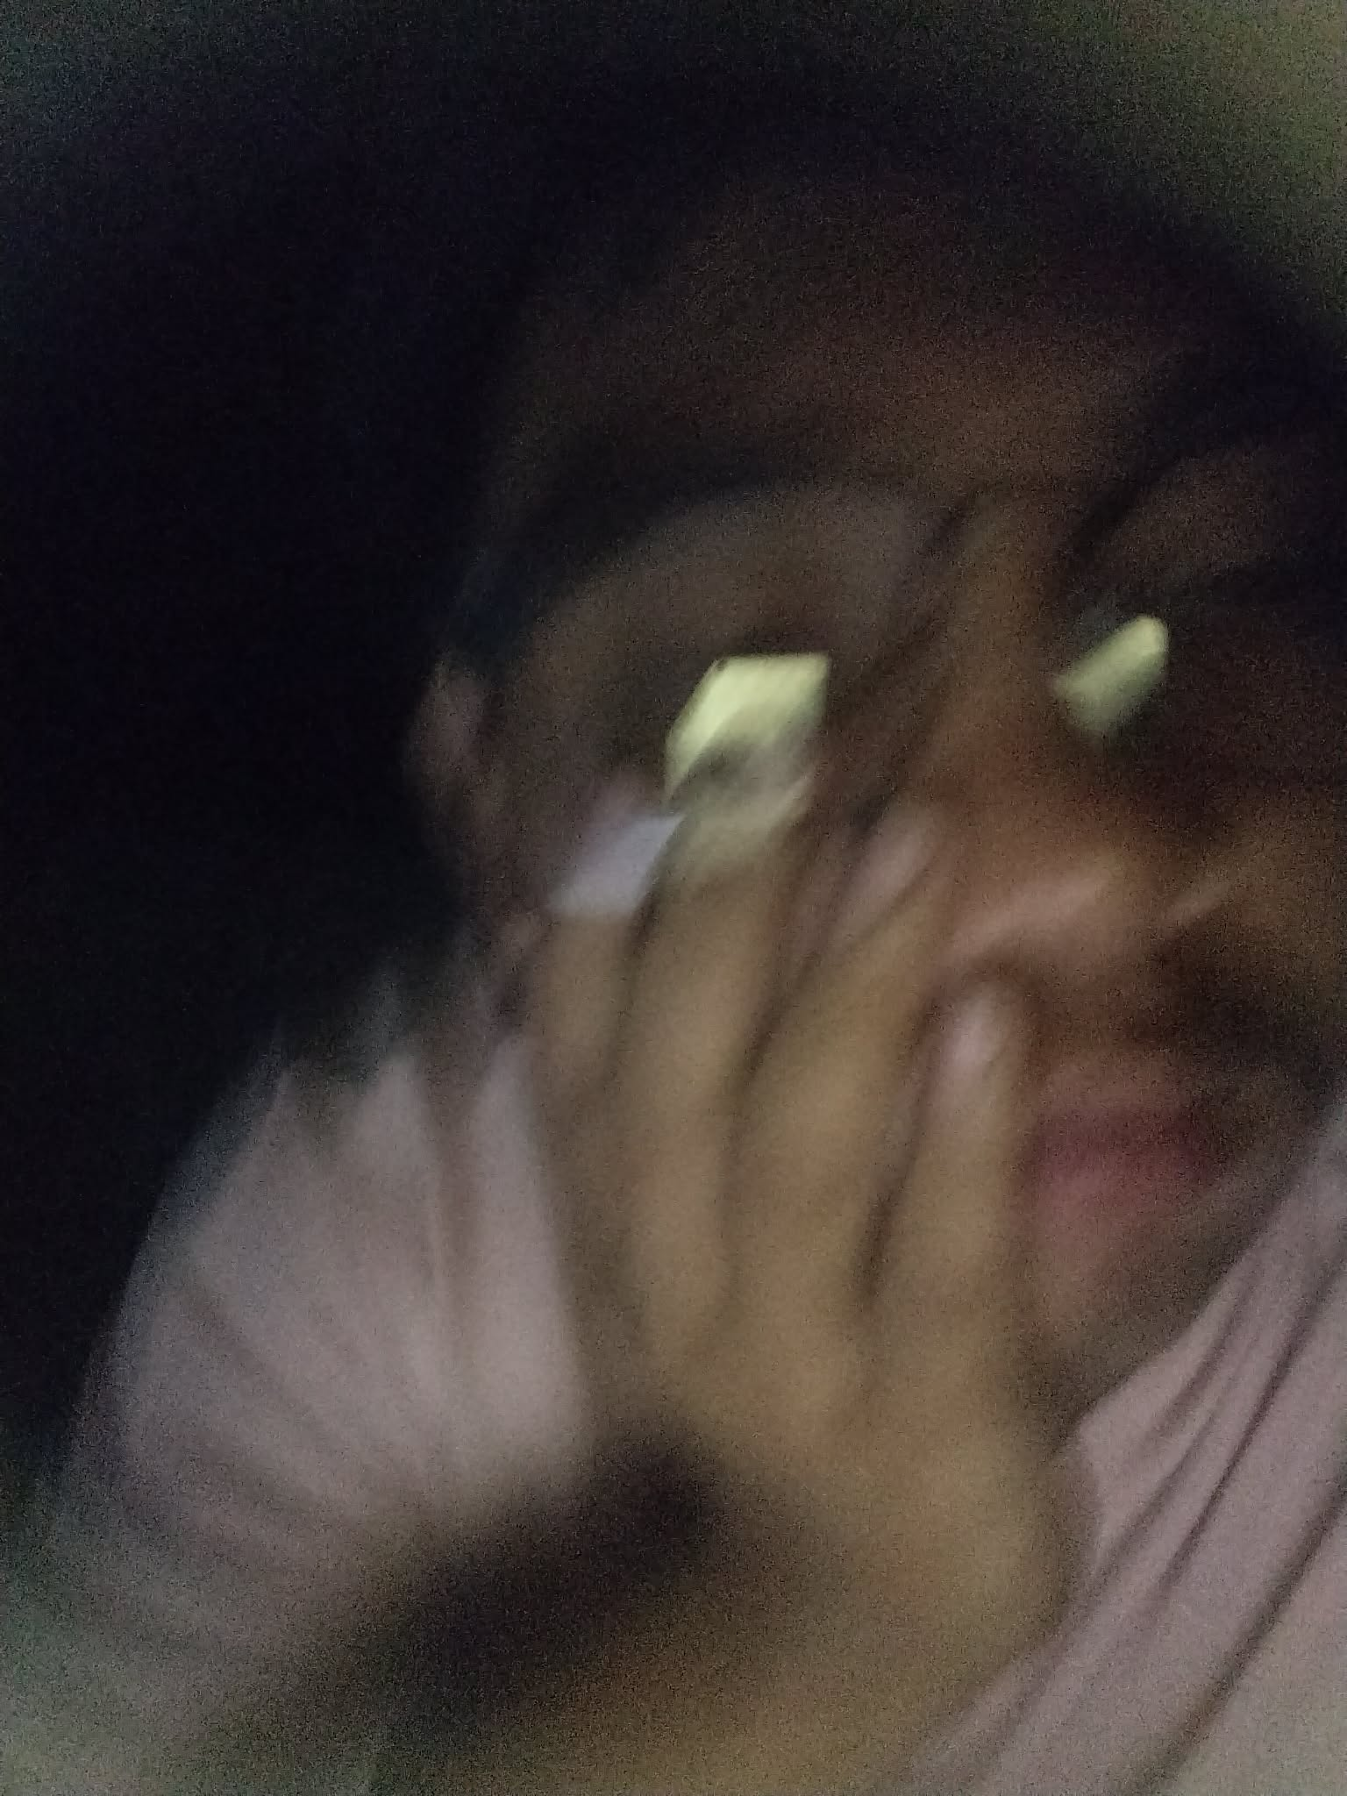
SORRYYYYYYYYYY
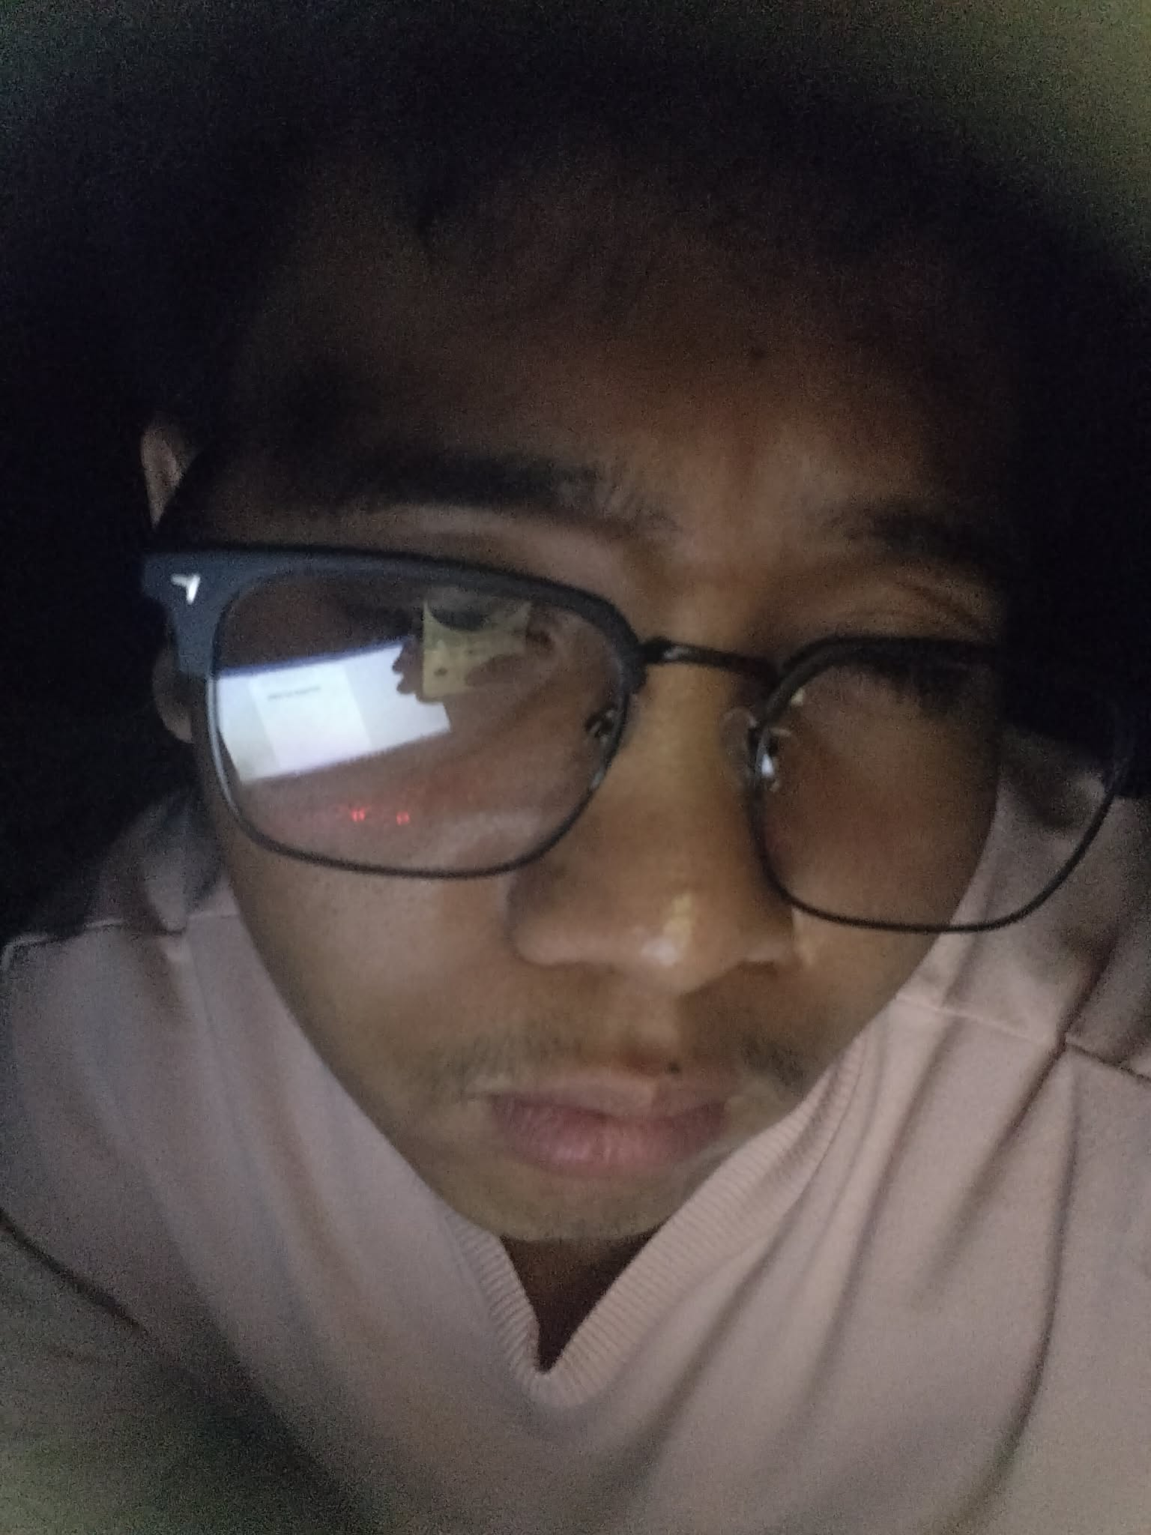
SORRY NA BABYYYY

SORRY NA BABYYYY

