Project Proposal Report IC367
AGV motion control system
Group: 14N04

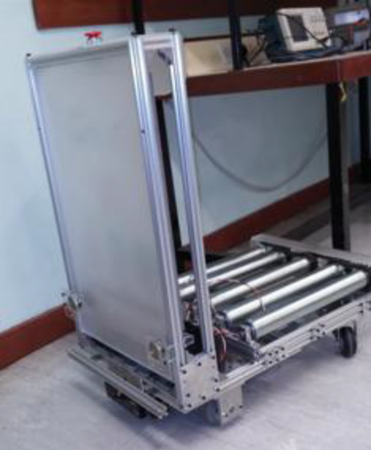

Group Members
Lang Yujian (10833700D)
Guo Zichang (11832891D)
Gu Tianyu (11837801D)
Liu Haikun (11804068D)

Table of Contents:

- Introduction

- Specification

- Key features

- Market Research & Cost Analysis

- Gantt Chart

- Key Components and Tools

- Block Diagram

- Project Roles

Introduction:
An automated guided vehicle or automatic guided vehicle (AGV) is a mobile robot that follows markers or wires in the floor, or uses vision, magnets, or lasers for navigation. They are most often used in industrial applications to move materials around a manufacturing facility or a warehouse. Application of the automatic guided vehicle has broadened during the late 20th century.
This project aims at:
- Develop the motion function for the AGV main controller
- Design and fabricate the motor drivers and sensors interfacing circuit
- Implement the speed control and AGV steering algorithm
This project requires us to apply the skills we learnt in the past few semesters, such as circuit design, PCB fabrication, etc.

Specification:
Efficient, cost effective movement of materials is an important and common element in improving operations in many manufacturing plants and warehouses. Because automatic guided vehicles (AGVs) can delivery efficient, cost effective movement of materials, AGVs can be applied to various industries in standard or customized designs to best suit an industry’s requirements. Industry’s currently utilizing AGVs include (but are not limited to):
AGV installations are found in Stamping Plants, Power Train (Engine and Transmission) Plants, and Assembly Plants delivering raw materials, transporting work-in process, and moving finished goods. AGVs are also used to supply specialized tooling which must be changed.
Automated Guided Vehicles can be used in a wide variety of applications to transport many different types of material including pallets, rolls, racks, carts, and containers:
Raw materials handling
Work-in-process movement
Pallet handling
Finished product handling
Trailer loading
Roll handling
Container handling
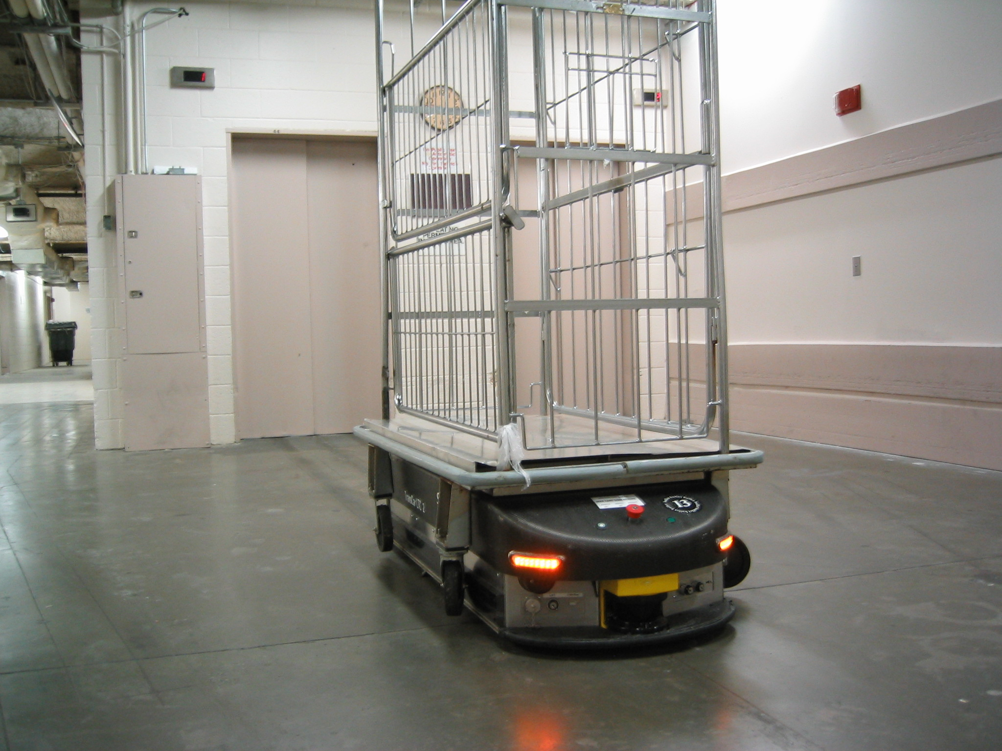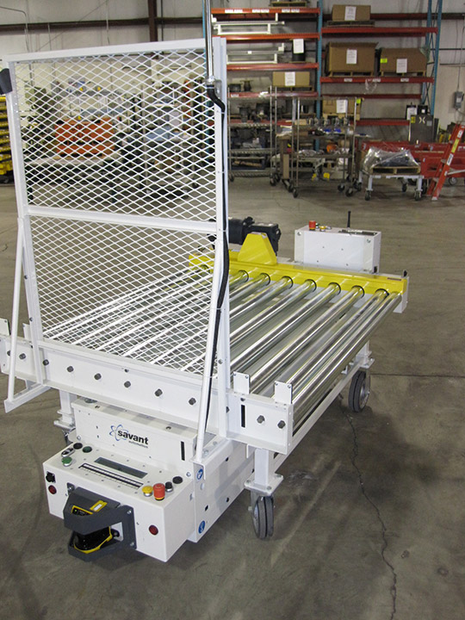

- Key features
- Automatic robust speed control
With the help of this function, whatever the weight is carried by the vehicle, the both wheels can be adjusted to a steady speed. For the lighter cargo, AGV will be accelerated quickly to certain speed, for example, 100 rpm and when the required speed is achieved, acceleration process will be ceased. For the cargo with heavier speed, the speed up process will be slower and longer. However, when the certain speed is fulfilled, AGV will provide only enough power to maintain this speed. This function can guarantee that the vehicle will maintain motions in steady speed.
- Remote control
To make the project practical, it is very necessary to make it remotely controllable. To make this function happen, a module will be added to the project. The interaction between the AGV and controller can be achieved through either Bluetooth or WIFI, which has not been decided yet. By adding this module, it can be controlled precisely even when the user is far away from AGV and finally accomplish the purpose of being automatic guided.
- LEDs direction indication
To make it more user friendly, just like the cars, LEDs are added to warn the passengers about its motion direction. When it moves forward, the front lights will be on. When it goes backwards, the back lights will be on. It does not only warn people of its motion direction, which will decrease the probability of accidents significantly, but also improve largely on the aesthetic aspect.

Market research & Cost analysis

Market research
The AGVS market has ranged from $40-100 million per year over the last 10 years. This generally represents 30-80 systems. The average system has about 4-5 vehicles. The largest material handling AGV systems have 50-100 vehicles. There are numerous small systems with 1-3 AGVs. For a functional AGV system, the average sale price ranges from 10,000 RMB to 35,000 RMB.
- Cost analysis
Components | Quantity | Unit Price | Total Prices
OMRON Encoder (E6B2) | 2 | 180 | 360
DC Motor (4GN-18K) | 3 | 220 | 660
Bluetooth Module | 1 | 30 | 30
Motor Drive | 2 | 100 | 200
IC (SDK-NUC140VE3CI) | 1 | 25 | 25
Other Components (resistors, capacitors…) |  |  | 50
Development Tools | 1 | 30 | 30
Total |  |  | 1355

Gantt chart & Project process
- Gantt chart
Time  Process | Week 1 |  |  |  | Week 2 |  |  |  | Week 3 |  |  |  | Week 4
Time  Process | 1 | 2 | 3 | 4 | 1 | 2 | 3 | 4 | 1 | 2 | 3 | 4 | 1 | 2 | 3 | 4
Research & Planning | √ | √
Circuit Design |  | √ | √ | √
PCB Layout Design |  |  | √ | √ | √ | √ | √ | √
PCB Drawing |  |  | √ | √ | √ | √ | √ | √
PCB Fabrication |  |  |  |  | √ | √ | √ | √
Programming |  |  | √ | √ | √ | √ | √ | √ | √ | √
Testing & Debugging |  |  |  |  |  |  | √ | √ | √ | √ | √ | √ | √ | √ | √ | √
Documentation | √ | √ | √ | √ | √ | √ | √ | √ | √ | √ | √ | √ | √ | √ | √ | √
Report |  |  |  |  |  |  |  |  |  |  |  |  | √ | √ | √ | √
Presentation |  |  |  |  |  |  |  |  |  |  |  |  |  |  | √ | √
Web Page |  |  |  |  |  |  |  |  |  |  |  |  | √ | √ | √ | √

- Project process
Week 1: focus on programming, circuit design
Week 2: focus on PADS drawing, PCB layout and fabrication of PCB
Week 3: focus on trouble shooting and program debugging
Week 4: report, presentation and the web page will be finished within this week

Key Components & Tools
- Key Components:
- NuTiny-SDK-NUC140
- Bluetooth module
- Motor Drive control board
- Power control

- Tools:
  - PADS Logic
  - PADS Layout
  - PCB Fabrication Machines
  - Oscilloscope
  - Multi-meter
  - Circuit Tester
  - Soldering Iron

Block Diagram
- Power Distribution
Right Motor Encoder
(5V)
Left Motor
(12V)
Left Motor Encoder
(5V)
Power distribution regulator
Battery
(12V)
Buttons

AGV microcontroller (5v)
Right Motor
(12V)
LED lights
(Direction Indication)
Bluetooth
(VCC)
Motor Control board (wheels)
(5V)
Motor Control board (Convey Shaft)
(5V)
Convey Motor
(12V)

- Signal Distribution

Right Motor Encoder
(5V)
Left Motor
(12V)
Left Motor Encoder
(5V)
Power distribution regulator
Battery
(12V)
Buttons

AGV microcontroller (5v)
Right Motor
(12V)
LED lights
(Direction Indication)
Bluetooth
(VCC)
Motor Control board (wheels)
(5V)
Motor Control board (Convey Shaft)
(5V)
Convey Motor
(12V)

Project Roles
Name | Position
Lang Yujian | Hardware engineer
Guo Zichang | Hardware engineer
Gu Tianty | Software engineer
Liu Haikun | Software engineer

