中南大学

Web应用开发技术
实验报告

姓 名： | 罗焕,张皓景
学 号： | 8209190111, 8209190115
班 级： | 软件工程1901
指导老师： | 宋 铁
完成时间： | 2021-2- 9
分 数：
批阅日期：
实验一 基于MVC用JSP/Servlet实现JPetStore

- 实验内容——基本任务。
- 商品展示业务模块，包括大类Category、小类Product和具体商品Item的展示和搜索功能。

运行界面截图：

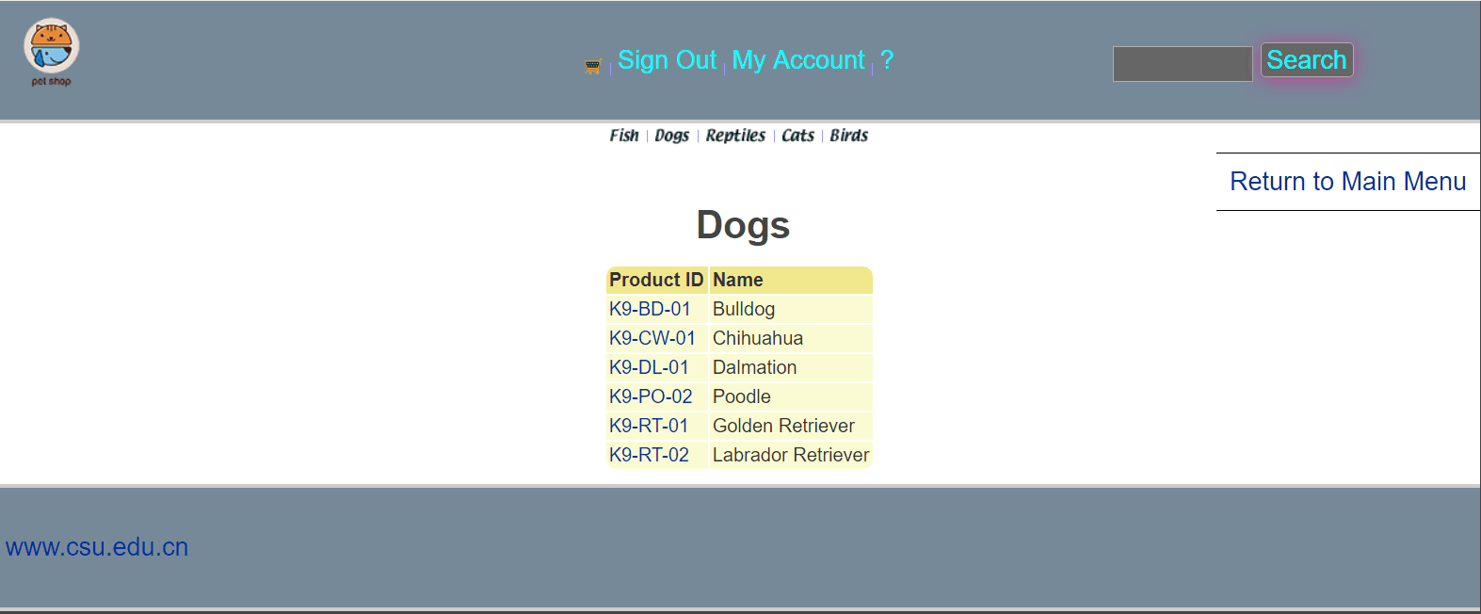

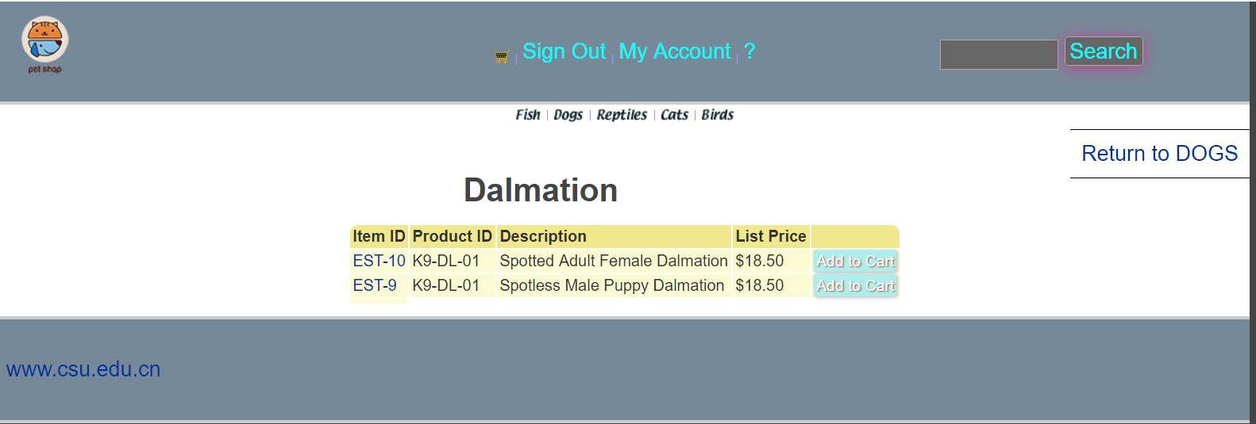

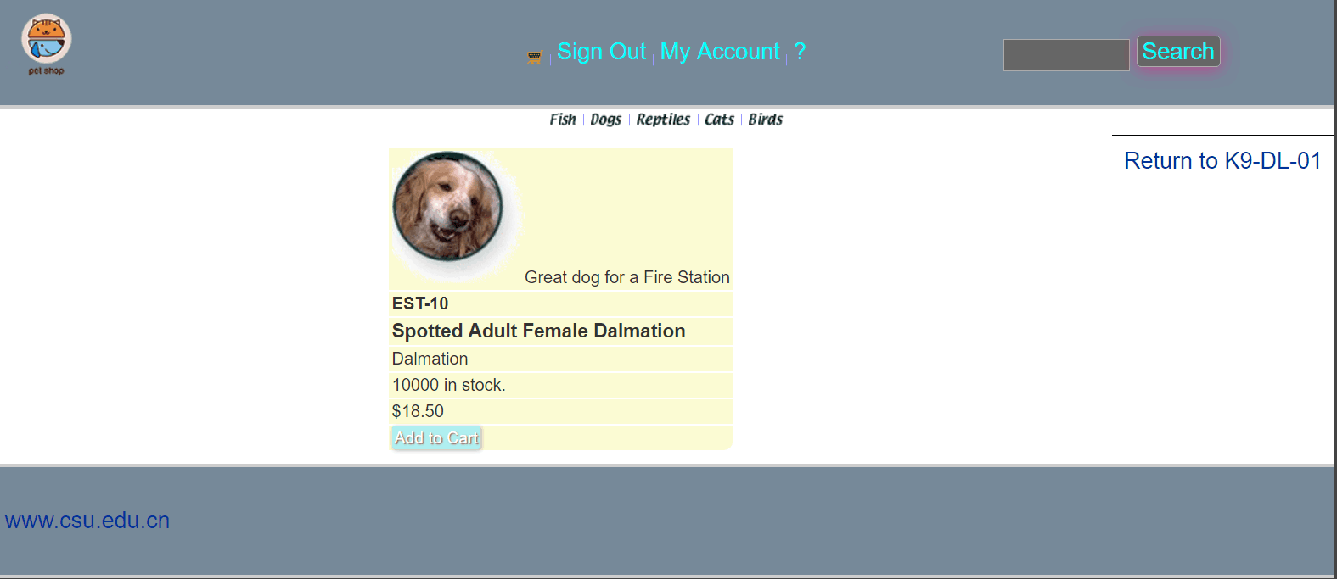

核心代码：

public class VeiwCatalogServlet extends HttpServlet {

private static final String VIEW_CATEGORY = "/WEB-INF/jsp/catalog/Category.jsp";

private String categoryId;

@Override

protected void doGet(HttpServletRequest req, HttpServletResponse resp) throws ServletException, IOException {

categoryId = req.getParameter("categoryId");

CatalogService catalogService = new CatalogService();

Category category = catalogService.getCategory(categoryId);

List<Product>productList = catalogService.getProductListByCategory(categoryId);

HttpSession session = req.getSession();

session.setAttribute("category" , category);

session.setAttribute("productList" ,productList);

req.getRequestDispatcher(VIEW_CATEGORY).forward(req,resp);

}

@Override

protected void doPost(HttpServletRequest req, HttpServletResponse resp) throws ServletException, IOException {

doGet(req, resp);

}

}

public class VeiwItemServlet extends HttpServlet {

private static final String VIEW_ITEM = "/WEB-INF/jsp/catalog/Item.jsp";

private String itemId;

@Override

protected void doPost(HttpServletRequest req, HttpServletResponse resp) throws ServletException, IOException {

doGet(req, resp);

}

@Override

protected void doGet(HttpServletRequest req, HttpServletResponse resp) throws ServletException, IOException {

itemId = req.getParameter("itemId");

CatalogService service = new CatalogService();

Item item = service.getItem(itemId);

HttpSession session = req.getSession();

session.setAttribute("item",item);

req.getRequestDispatcher(VIEW_ITEM).forward(req,resp);

}

}

public class VeiwProductServlet extends HttpServlet {

private String productId;

private static final String VIEW_PRODUCT = "/WEB-INF/jsp/catalog/Product.jsp";

@Override

protected void doPost(HttpServletRequest req, HttpServletResponse resp) throws ServletException, IOException {

doGet(req, resp);

}

@Override

protected void doGet(HttpServletRequest req, HttpServletResponse resp) throws ServletException, IOException {

productId = req.getParameter("productId");

CatalogService catalogService = new CatalogService();

Product product = catalogService.getProduct(productId);

List<Item>itemList = catalogService.getItemListByProduct(productId);

HttpSession session = req.getSession();

session.setAttribute("product" , product);

session.setAttribute("itemList" , itemList);

req.getRequestDispatcher(VIEW_PRODUCT).forward(req,resp);

}

}

- 用户管理业务模块，包括用户注册、登录、修改用户信息、查询用户相关订单等业务功能。

运行界面截图：

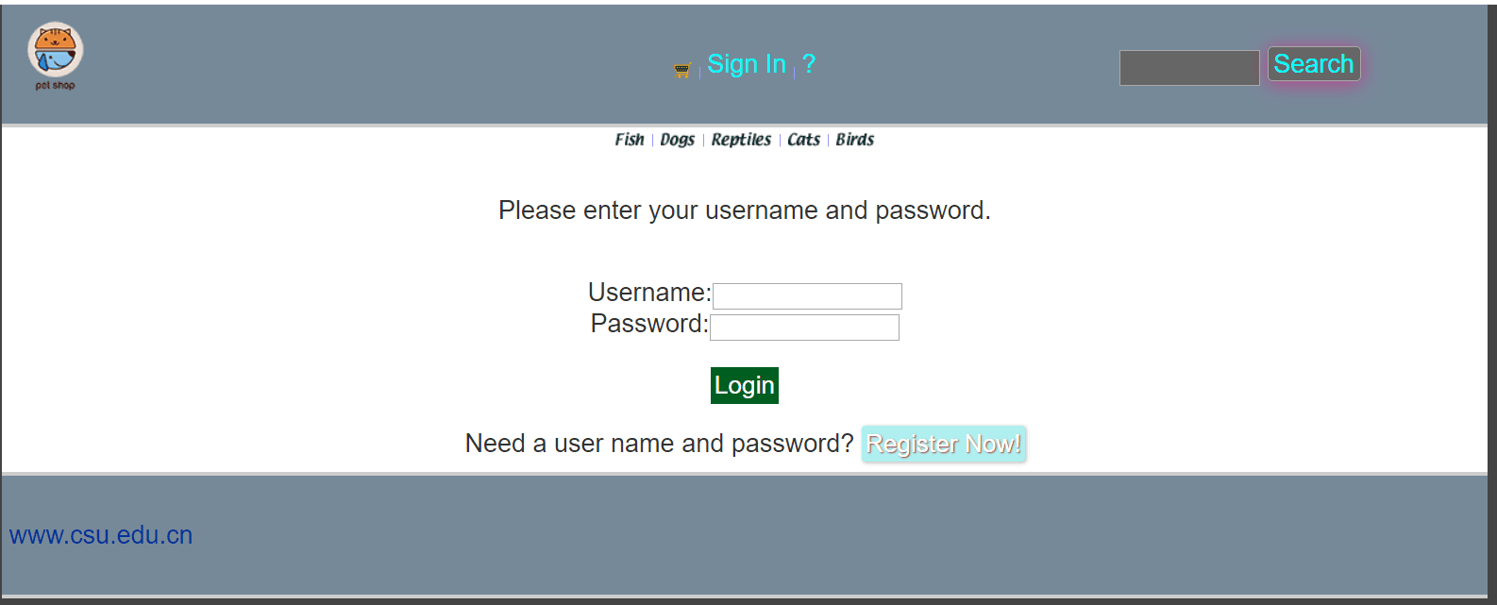

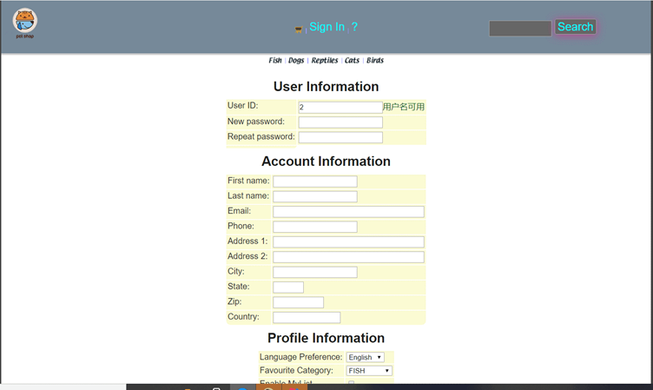

核心代码；

public class LoginInServlet extends HttpServlet {

private static final String EDIT_ACCOUNT = "/WEB-INF/jsp/account/EditAccountForm.jsp";

private static final String SIGNON = "/WEB-INF/jsp/account/SignonForm.jsp";

private static final String WARNING = "用户名或密码输入错误!";

private static final String MAIN = "/WEB-INF/jsp/catalog/main.jsp";

private AccountService accountService;

private Account account;

private Boolean accountLogin;

protected void doPost(HttpServletRequest request, HttpServletResponse response) throws ServletException, IOException {

doGet(request,response);

}

protected void doGet(HttpServletRequest request, HttpServletResponse response) throws ServletException, IOException {

String username = request.getParameter("username");

String password = request.getParameter("password");

HttpSession session = request.getSession();

accountService = new AccountService();

account = accountService.getAccount(username,password);

session.setAttribute("account",account);

session.setAttribute("username",username);

accountLogin = (Boolean)session.getAttribute("accountLogin");

//如果account为空,则用户名或密码输入错误

int num = (int)session.getAttribute("times");

if(account == null){

session.setAttribute("messageSignon",WARNING);

num++;

session.setAttribute("times",num);

request.getRequestDispatcher(SIGNON).forward(request,response);

}

else if( num >= 3 && !(session.getAttribute("imagetext").equals(request.getParameter("imagetext")))){

session.setAttribute("inputusername",request.getParameter("username"));

session.setAttribute("inputpassword",request.getParameter("password"));

session.setAttribute("messageSignon","验证码输入错误");

request.getRequestDispatcher(SIGNON).forward(request,response);

}

else{

accountLogin = true;

session.setAttribute("accountLogin",accountLogin);

session.setAttribute("messageSignon",null);

request.getRequestDispatcher(MAIN).forward(request,response);

}

}

}

public class RegisterNewAccountServlet extends HttpServlet {

private static final String SIGNON = "/WEB-INF/jsp/account/SignonForm.jsp";

private static final String NEWACCOUNTFORM = "/WEB-INF/jsp/account/NewAccountForm.jsp";

private static final String ERROR = "两次密码输入不一致";

private AccountService accountService;

private Account account;

protected void doPost(HttpServletRequest request, HttpServletResponse response) throws ServletException, IOException {

doGet(request,response);

}

protected void doGet(HttpServletRequest request, HttpServletResponse response) throws ServletException, IOException {

accountService = new AccountService();

account = new Account();

getMessageIntoAccount(request,response,account);

if(account != null)

accountService.insertAccount(account);

request.getRequestDispatcher(SIGNON).forward(request,response);

}

private void getMessageIntoAccount(HttpServletRequest request,HttpServletResponse response,Account account)throws ServletException, IOException{

HttpSession session = request.getSession();

account.setUsername(request.getParameter("username"));

String password = request.getParameter("password");

String repeatedPassword = request.getParameter("repeatedPassword");

if(password.equals(repeatedPassword)){

account.setPassword(password);

}else{

session.setAttribute("message",ERROR);

account = null;

request.getRequestDispatcher(NEWACCOUNTFORM).forward(request,response);

}

String firstName = request.getParameter("firstName");

account.setFirstName(firstName);

String lastName = request.getParameter("lastName");

account.setLastName(lastName);

String email = request.getParameter("email");

account.setEmail(email);

String phone = request.getParameter("phone");

account.setPhone(phone);

String address1 = request.getParameter("address1");

account.setAddress1(address1);

String address2 = request.getParameter("address2");

account.setAddress2(address2);

String city = request.getParameter("city");

account.setCity(city);

String state = request.getParameter("state");

account.setState(state);

String zip = request.getParameter("zip");

account.setZip(zip);

String country = request.getParameter("country");

account.setCountry(country);

String languagePreference = request.getParameter("languagePreference");

account.setLanguagePreference(languagePreference);

String favouriteCategoryId = request.getParameter("favouriteCategoryId");

account.setFavouriteCategoryId(favouriteCategoryId);

Boolean listOption = Boolean.parseBoolean(request.getParameter("listOption"));

account.setListOption(listOption);

Boolean bannerOption = Boolean.parseBoolean(request.getParameter("bannerOption"));

account.setBannerOption(bannerOption);

}

}

public class EditAccountServlet extends HttpServlet {

private static final String SIGNON = "/WEB-INF/jsp/account/SignonForm.jsp";

private static final String NEWACCOUNTFORM = "/WEB-INF/jsp/account/NewAccountForm.jsp";

private static final String EDIT_ACCOUNT = "/WEB-INF/jsp/account/EditAccountForm.jsp";

private static final String ERROR = "两次密码输入不一致";

private static final String MAIN = "/WEB-INF/jsp/catalog/main.jsp";

protected void doPost(HttpServletRequest request, HttpServletResponse response) throws ServletException, IOException {

doGet(request,response);

}

protected void doGet(HttpServletRequest request, HttpServletResponse response) throws ServletException, IOException {

HttpSession session = request.getSession();

AccountService accountService = new AccountService();

Account account = (Account)session.getAttribute("account");

String password1 = request.getParameter("password1");

String repeatedPassword1 = request.getParameter("repeatedPassword1");

if(!password1.equals(repeatedPassword1)){

session.setAttribute("message",ERROR);

request.getRequestDispatcher(EDIT_ACCOUNT).forward(request,response);

}else{

account.setPassword(password1);

getMessageIntoAccount(request,account);

accountService.updateAccount(account);

request.getRequestDispatcher(MAIN).forward(request,response);

}

}

private void getMessageIntoAccount(HttpServletRequest request ,Account account)throws ServletException, IOException{

String firstName = request.getParameter("firstName");

account.setFirstName(firstName);

String lastName = request.getParameter("lastName");

account.setLastName(lastName);

String email = request.getParameter("email");

account.setEmail(email);

String phone = request.getParameter("phone");

account.setPhone(phone);

String address1 = request.getParameter("address1");

account.setAddress1(address1);

String address2 = request.getParameter("address2");

account.setAddress2(address2);

String city = request.getParameter("city");

account.setCity(city);

String state = request.getParameter("state");

account.setState(state);

String zip = request.getParameter("zip");

account.setZip(zip);

String country = request.getParameter("country");

account.setCountry(country);

String languagePreference = request.getParameter("languagePreference");

account.setLanguagePreference(languagePreference);

String favouriteCategoryId = request.getParameter("favouriteCategoryId");

account.setFavouriteCategoryId(favouriteCategoryId);

Boolean listOption = Boolean.parseBoolean(request.getParameter("listOption"));

account.setListOption(listOption);

Boolean bannerOption = Boolean.parseBoolean(request.getParameter("bannerOption"));

account.setBannerOption(bannerOption);

}

}

- 订单管理模块，包括购物车管理、新增订单、地址信息等业务功能。

运行界面截图：

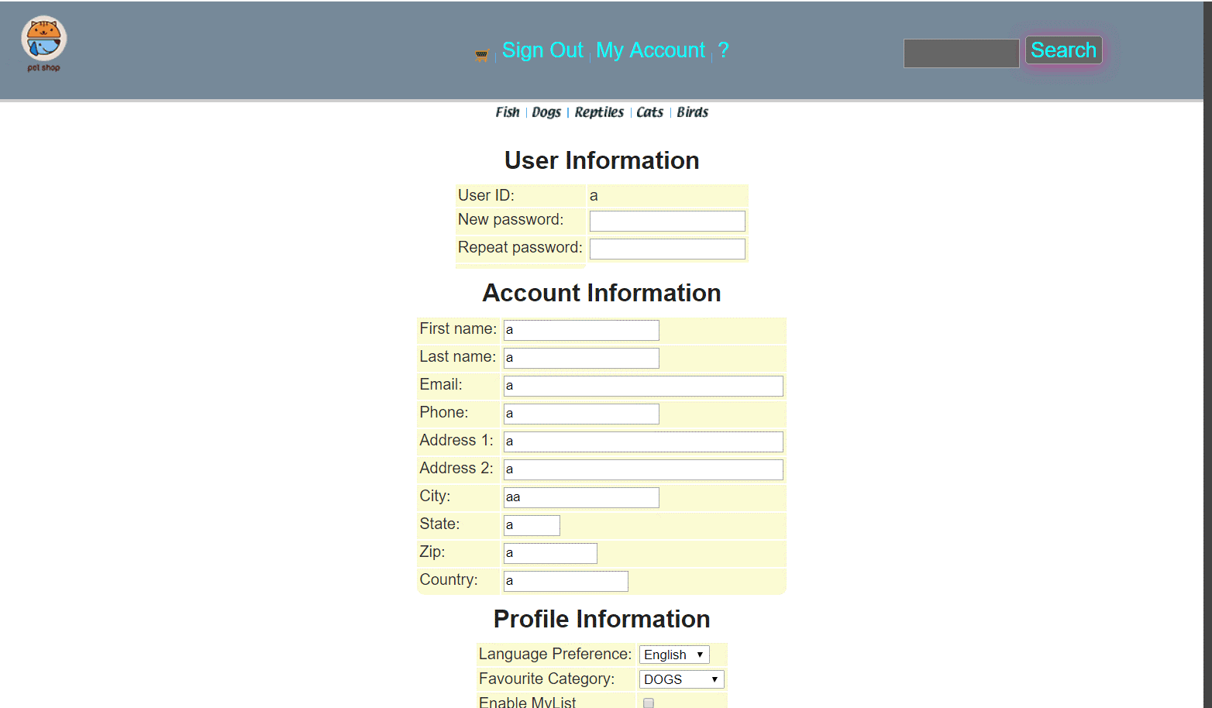

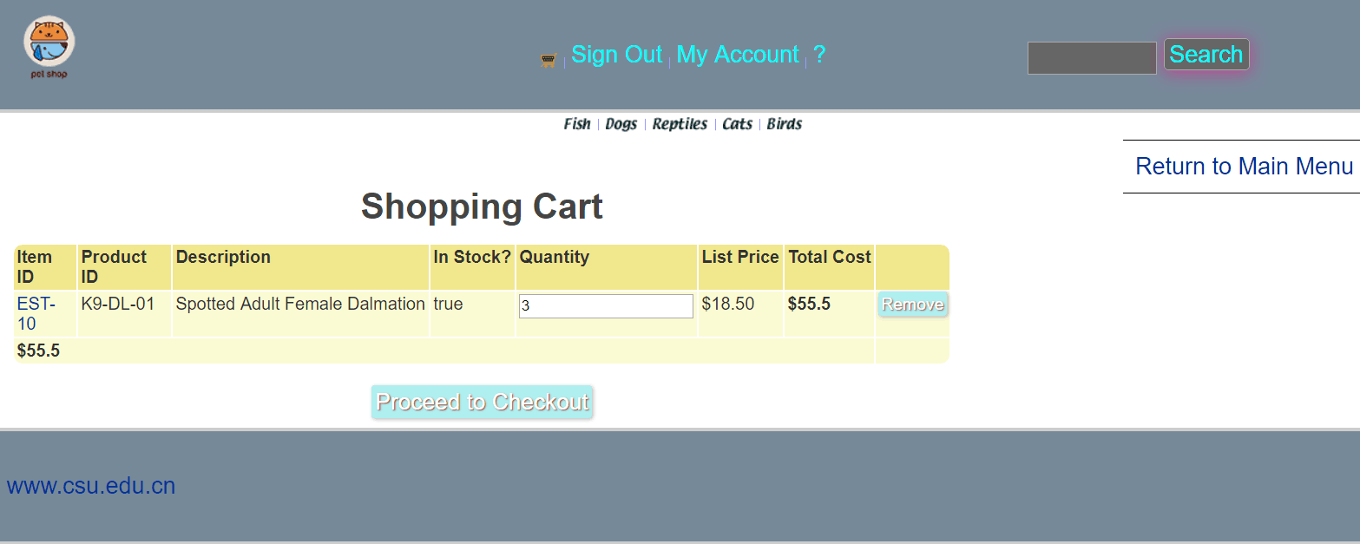

核心代码：

public class AddItemToCartServlet extends HttpServlet {

//处理完请求跳转界面

private static final String VIEW_CART = "/WEB-INF/jsp/cart/Cart.jsp";

//定义处理该请求需要的数据

private String workingItemId;

private Cart cart;

//定义处理该请求需要的业务逻辑层

private CatalogService catalogService;

private CartService cartService;

public AddItemToCartServlet(){

catalogService = new CatalogService();

cartService = new CartService();

}

@Override

protected void doPost(HttpServletRequest req, HttpServletResponse resp) throws ServletException, IOException {

doGet(req, resp);

}

@Override

protected void doGet(HttpServletRequest req, HttpServletResponse resp) throws ServletException, IOException {

workingItemId = req.getParameter("workingItemId");

HttpSession session = req.getSession();

Account account = (Account)session.getAttribute("account");

Boolean accountLogin = (Boolean) session.getAttribute("accountLogin");

if(!accountLogin){

req.getRequestDispatcher("viewLoginForm").forward(req,resp);

}

cart = (Cart) session.getAttribute("cart");

if(cart == null){

cart = new Cart();

}

if (cart.containsItemId(workingItemId)) {

cart.incrementQuantityByItemId(workingItemId);

CartItem cartItem = cart.getCartItemById(workingItemId);

cartService.updateCartByItemId(cartItem,account.getUsername());

} else {

boolean isInStock = catalogService.isItemInStock(workingItemId);

Item item = catalogService.getItem(workingItemId);

cart.addItem(item, isInStock);

CartItem cartItem = cart.getCartItemById(workingItemId);

cartService.insertCart(cartItem,account.getUsername());

}

session.setAttribute("cart",cart);

req.getRequestDispatcher("viewCart").forward(req,resp);

}

}

public class ShippingFormServlet extends HttpServlet {

protected void doPost(HttpServletRequest request, HttpServletResponse response) throws ServletException, IOException {

doGet(request,response);

}

protected void doGet(HttpServletRequest request, HttpServletResponse response) throws ServletException, IOException {

HttpSession session = request.getSession();

Order order = (Order)session.getAttribute("order");

if(order == null){

order = new Order();

}

order.setBillToFirstName(request.getParameter("billToFirstName"));

order.setBillToLastName(request.getParameter("billToLastName"));

order.setBillAddress1(request.getParameter("billAddress1"));

order.setBillAddress2(request.getParameter("billAddress2"));

order.setBillCity(request.getParameter("billCity"));

order.setBillState(request.getParameter("billState"));

order.setBillZip(request.getParameter("billZip"));

order.setBillCountry(request.getParameter("billCountry"));

session.setAttribute("billToFirstName",request.getParameter("billToFirstName"));

session.setAttribute("billToLastName",request.getParameter("billToLastName"));

session.setAttribute("billAddress1",request.getParameter("billAddress1"));

session.setAttribute("billAddress2",request.getParameter("billAddress2"));

session.setAttribute("billCity",request.getParameter("billCity"));

session.setAttribute("billState",request.getParameter("billState"));

session.setAttribute("billZip",request.getParameter("billZip"));

session.setAttribute("billCountry",request.getParameter("billCountry"));

//默认相同

order.setShipToFirstName(request.getParameter("billToFirstName"));

order.setShipToLastName(request.getParameter("billToLastName"));

order.setShipAddress1(request.getParameter("billAddress1"));

order.setShipAddress2(request.getParameter("billAddress2"));

order.setShipCity(request.getParameter("billCity"));

order.setShipState(request.getParameter("billState"));

order.setShipZip(request.getParameter("billZip"));

order.setShipCountry(request.getParameter("billCountry"));

session.setAttribute("order",order);

}

}

- 实验内容——扩展任务。
- 添加验证码功能：在用户注册和用户登录模块中添加验证码功能。

运行界面截图：

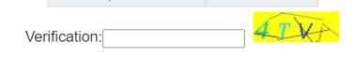

核心代码：

Verification:<input type="text" name="verification" width="20%">
<a href="javascript:getVerifiCode()">
<img name="yzm_img" style="cursor:pointer;width: 100px;height: 36px;margin: 5px 0 0 5px;
border-radius: 3px;" title="enter to refresh verificationCode" src="getVerifiCode"/>
</a><br/><br/>
<script type="text/javascript">
function getVerifiCode() {
yzm_img.src="getVerifiCode?a="+new Date().getTime();
}
</script>

ImageVerificationCode ivc = new ImageVerificationCode();
BufferedImage image = ivc.getImage();
request.getSession().setAttribute("text", ivc.getText()); //将验证码的文本存在session中
ivc.output(image, response.getOutputStream());//将验证码图片响应给客户端

基本原理：

通过调用的验证码类，生成验证码，返回给服务器，登陆时将返回的验证码和输入的验证码比较，相同，则通过。

实现方案：

写ImageVerificationCode类，生成的值放在session中，再把图片显示出来。

- 购物车功能：原项目中购物车为内存购物车，即将用户相关的购物车存储在session中；在数据库中添加购物车表，将购物车数据持久化，以便用户下次登录时可查看或修改自己的购物车数据。

运行界面截图：

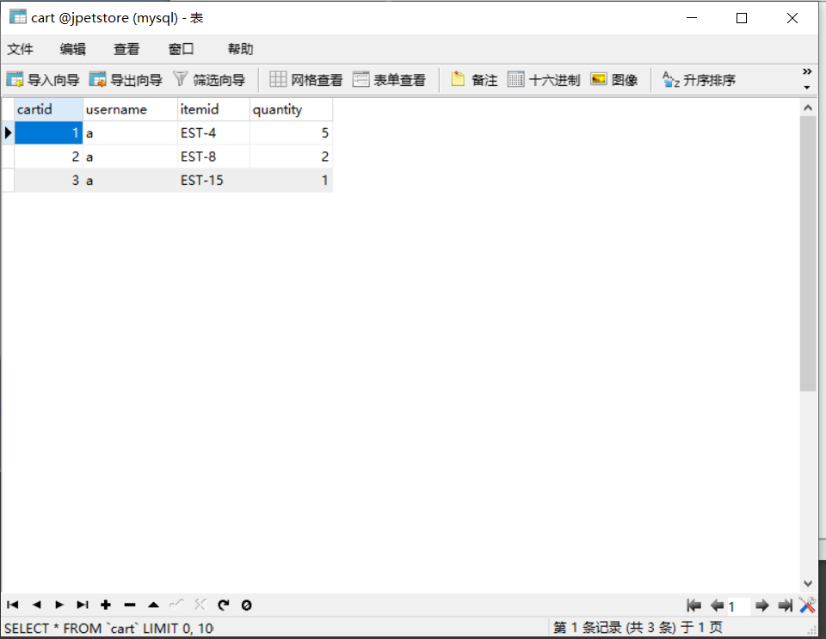

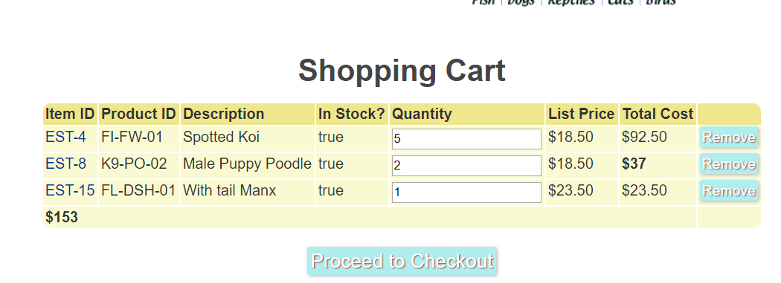

核心代码：

public class AddItemToCartServlet extends HttpServlet {

//处理完请求跳转界面

private static final String VIEW_CART = "/WEB-INF/jsp/cart/Cart.jsp";

//定义处理该请求需要的数据

private String workingItemId;

private Cart cart;

//定义处理该请求需要的业务逻辑层

private CatalogService catalogService;

private CartService cartService;

public AddItemToCartServlet(){

catalogService = new CatalogService();

cartService = new CartService();

}

@Override

protected void doPost(HttpServletRequest req, HttpServletResponse resp) throws ServletException, IOException {

doGet(req, resp);

}

@Override

protected void doGet(HttpServletRequest req, HttpServletResponse resp) throws ServletException, IOException {

workingItemId = req.getParameter("workingItemId");

HttpSession session = req.getSession();

Account account = (Account)session.getAttribute("account");

Boolean accountLogin = (Boolean) session.getAttribute("accountLogin");

if(!accountLogin){

req.getRequestDispatcher("viewLoginForm").forward(req,resp);

}

cart = (Cart) session.getAttribute("cart");

if(cart == null){

cart = new Cart();

}

if (cart.containsItemId(workingItemId)) {

cart.incrementQuantityByItemId(workingItemId);

CartItem cartItem = cart.getCartItemById(workingItemId);

cartService.updateCartByItemId(cartItem,account.getUsername());

} else {

boolean isInStock = catalogService.isItemInStock(workingItemId);

Item item = catalogService.getItem(workingItemId);

cart.addItem(item, isInStock);

CartItem cartItem = cart.getCartItemById(workingItemId);

cartService.insertCart(cartItem,account.getUsername());

}

session.setAttribute("cart",cart);

req.getRequestDispatcher("viewCart").forward(req,resp);

}

}

public class AutoCompleteServlet extends HttpServlet {

protected void doPost(HttpServletRequest request, HttpServletResponse response) throws ServletException, IOException {

String keyword = request.getParameter("keyword");

CatalogService service = new CatalogService();

List<Product> productList = service.searchProductList(keyword);

response.setContentType("text/json");

PrintWriter out = response.getWriter();

String str = JSON.toJSONString(productList);

out.print(str);

out.flush();

out.close();

}

}

- 日志功能：数据库中添加日志信息表，给项目添加日志功能，用户登录后记录用户行为，比如浏览了哪些商品、将商品添加进购物车、生成订单等。

运行界面截图：

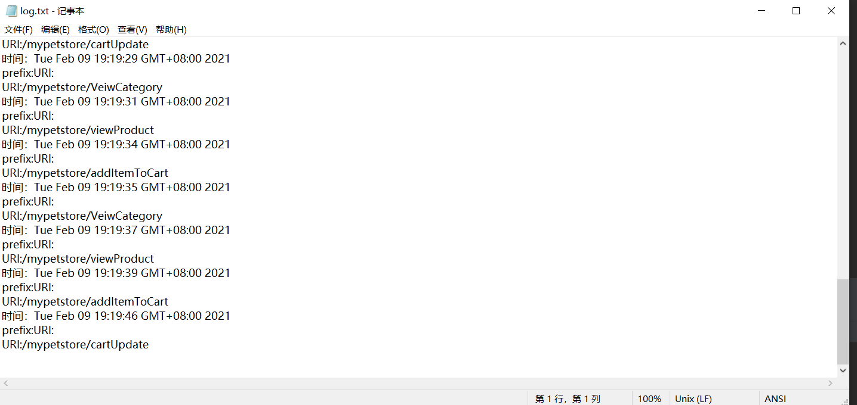

核心代码：
public class LoggingFilter implements Filter{
//声明两个变量 PrintWriter用来编写文本文件 prefix作为每个日志条目的前缀
private PrintWriter logger;
private String prefix;

@Override
public void destroy() {
// TODO Auto-generated method stub
//执行init会创建一个日志文件，如果应用程序目录下已经有同名文件存在，该文件将会被新文件覆盖
System.out.println("destroying filter");
if(logger != null){
logger.close();
}
}

@Override
public void doFilter(ServletRequest request, ServletResponse response,
FilterChain filterChain) throws IOException, ServletException {
// TODO Auto-generated method stub
System.out.println("LoggingFilter.doFilter");
/*doFilter方法通过将ServletRequest向下装换成HttpServletRequest,并调用其getRequestURI方法，记录下所有请求的日志。
* 然后将getRequestURI的结果填入PrintWriter的println方法中
*/
HttpServletRequest httpServletRequest = (HttpServletRequest) request;
logger.println("时间："+new Date()+" \n"+"prefix:"+prefix+"\nURI:"+httpServletRequest.getRequestURI());
/*
* 每个日志都有一个时间戳和前缀，以便识别。
* 之后doFilter方法接着刷新PrintWriter,并调用FilterChain.doFilter来调用资源。
*/
logger.flush();
filterChain.doFilter(request, response);
}

@Override
public void init(FilterConfig filterConfig) throws ServletException {
/*
* init方法在传入的FilterConfig中调用getInitParameter方法，获取prefix和logFileName的初始值。
* prefix参数值赋给类级变量prefix,并与用logFileName创建一个PrintWriter
*/
prefix = filterConfig.getInitParameter("prefix");
String logFileName = filterConfig.getInitParameter("logFileName");
/*
* 为了在应用程序目录中创建一个日志文件，需要有一个它的绝对路径。
* 利用getRealPath获取，也就是将应用程序的logFileName初始参数合并
*/
String appPath = filterConfig.getServletContext().getRealPath("/");
System.out.println(appPath);
System.out.println("logFileName:"+logFileName);
try {
logger = new PrintWriter(new File(appPath,logFileName));
} catch (FileNotFoundException e) {
// TODO Auto-generated catch block
e.printStackTrace();
}
}
}
日志功能记录：
使用过的服务器，时间，服务器的位置，以及用户的各种行为，浏览过的商品。
- 小组成员分工及实验总结
- 小组分工：

商品展示业务模块，订单管理模块，持久化购物车为组长负责，张皓景负责添加验证码模块,用户管理业务模块和日志功能模块。
- 实验总结

遇到的问题：

Ⅰ、在实现订单管理模块时，遇到了一些逻辑层面上的问题，导致订单信息显示不全，和无法导入或者更新数据库的情况。
Ⅱ、在实现购物车模块的时候，由于逻辑层面上相对于源代码出现了比较大的改变，需要对源代码进行比较大的改动，从而导致了一系列的逻辑不同的小bug，比如如果商品数量为一，则有时无法从购物车中删除物品，又比如ctrl+r强制刷新界面的时候会出现购物车商品数量集体加一的小bug
Ⅲ、在实现验证码功能的时候，由于没有学习AJAX，因而不知道如何异步地刷新界面从而使得用户点击验证码的时候要重新刷新整个界面，导致用户名和密码丢失的现象，使得用户的体验不佳。

解决的方法：

Ⅰ、通过不断的断点调试和数据库查询模块的使用，最终一步一步地处理了这些逻辑层面上的小bug。

Ⅱ、购物车的持久化的bug的调整则花了比较多的精力和时间，主要是对数据库层面上的逻辑的改动比较麻烦，需要结合数据库的可视化查询模块不断的试验，并且要观察改动后时候更新，在尝试了好几个不同的逻辑方法之后，最终还是找到了一个相对完美的解决方法，最终还是解决了相应的问题

Ⅲ、通过百度的方式，学习了别人博客上利用JavaScript异步刷新界面和生成验证码的方法，从而做到了验证码的异步刷新，极大很好地提升了用户的体验

心得体会：

由于这个实验的基础部分通过看视频敲代码的方式完成的，在完成的过程中并没有遇到特别大的问题，遇到的一些小bug也能够很快的通过断点调试就能解决，但是在完成附加功能的时候，由于没有了视频的支持，在实现的过程中还是遇到了不小的问题，虽然大部分依然能够通过依葫芦画瓢的方式来得到解决，但逻辑层面上的细微差别还是让我这个web小白感受到了极大的痛苦，不过好在通过时间的不断磨砺，最终还是能够完成这个实验，三四天的007生活着实让我体验到了程序员的艰辛，不过完成项目的那一刻也特别的快乐，也挺满足的。

实验二 使用AJAX和jQuery改善用户体验
- 实验内容——基本任务。
- 账号管理模块。在新建账号和修改账号信息页面上用AJAX技术进行表单验证，如“判断用户名是否已存在”等功能。

运行界面截图：

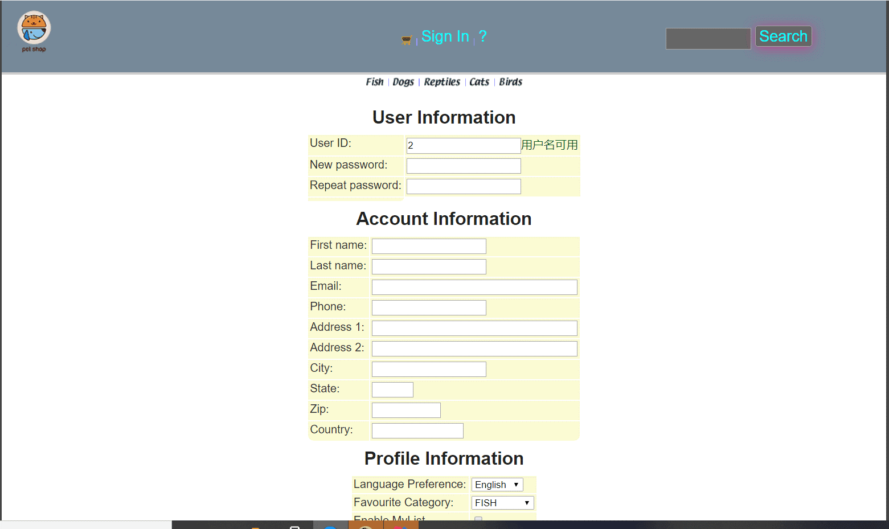

核心代码：

$(function () {
$(&apos;#username&apos;).on(&apos;blur&apos;,function () {
$.ajax({
type : "GET",
url : "UsernameIsExist?username="+$(&apos;#username&apos;).val(),
success : function (data) {
if(data.msg === "Exist"){
$(&apos;#isExistInfo&apos;).attr("class","errormsg").text("用户名已存在");
}else{
$(&apos;#isExistInfo&apos;).attr("class","okmsg").text("用户名可用");
}
}
});
});
});
- 查询商品模块。在主页面右上角的查询商品功能中添加自动补全功能。

运行界面截图：

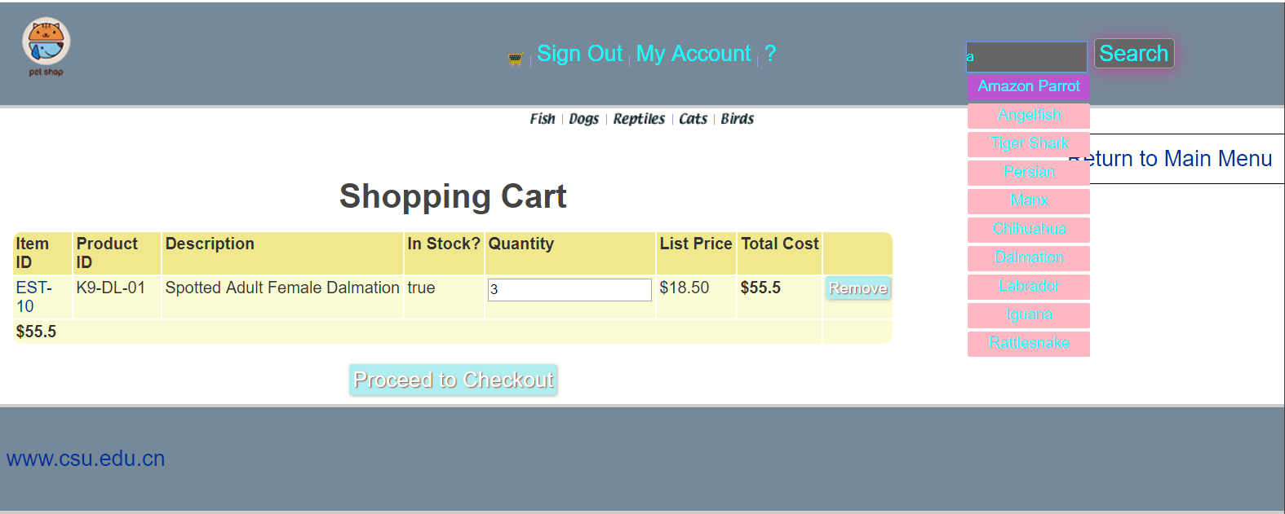 核心代码：

$(document).ready(function () {
$("#SearchInput").autocomplete({
source:function (request , response) {
$.ajax({
type : "post",
url : "autoComplete?keyword="+$("#SearchInput").val(),
success : function (jsonData) {
var data = eval(jsonData);
var context = "";
response($.map(data,function (item) {
var name = item.name;
context = context + "<div class=&apos;append_div&apos;><span class=&apos;append_span&apos;" +
" onclick=select(&apos;"+name+"&apos;)>"+name+"</span></div>";
}));
if(context != ""){
$(".showResults").html("");
$(".showResults").append(context);
$(".showResults").show();
}else{
$(".showResults").hide();
}
}
});
}
});
});
function select(name) {
console.log("Enter");
$("#SearchInput").val(name);
$(".showResults").hide();
}
- 购物车模块。在购物车模块中修改购买数量时，通过AJAX修改购物车信息。

运行界面截图：

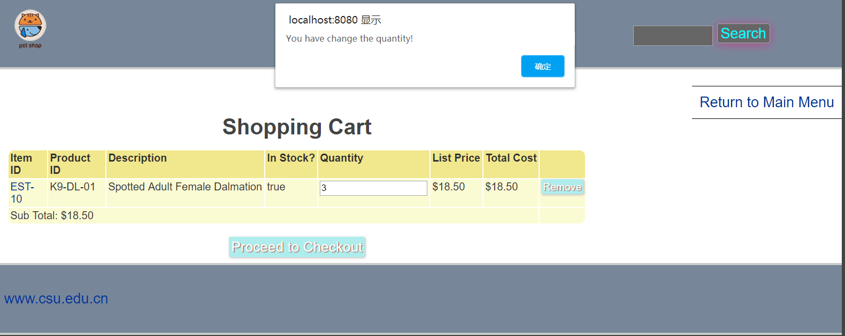

核心代码：

$(document).ready(function () {
$(".cartItemUpdate").each(function () {
var cartItemid = $(this).attr("id");
$("#" + cartItemid + " input").on(&apos;blur&apos;,function () {
var quantity = $(this).val();
$.ajax({
type : "GET",
url : "cartUpdate?cartItemid="+cartItemid+"&quantity="+quantity,
success : function () {
alert("You have change the quantity!");
var singlePrice = $("#" + cartItemid + " td.singlePrice").text();
var index = singlePrice.lastIndexOf("$");
singlePrice = singlePrice.substring(index+1,singlePrice.length);
var single = parseFloat(singlePrice);
var quantityInt = parseInt(quantity);
var listPrice = single * quantityInt;
console.log(listPrice);
var lastlistPrice = $("#" + cartItemid + " td.listTotalPrice").text();
index = lastlistPrice.lastIndexOf("$");
lastlistPrice = lastlistPrice.substring(index+1,lastlistPrice.length);
var lastlistPriceFloat = parseFloat(lastlistPrice);
console.log(lastlistPrice);
$("#" + cartItemid + " td.listTotalPrice").html("<b>$"+listPrice.toString()+"</b>");
var lastTotal = $(".subtotal").text();
index = lastTotal.lastIndexOf("$");
lastTotal = lastTotal.substring(index+1,lastTotal.length);
var lastTotalFloat = parseFloat(lastTotal);
console.log(lastTotalFloat);
lastTotalFloat = lastTotalFloat - lastlistPriceFloat + listPrice;
$(".subtotal").html("<b>$"+lastTotalFloat.toString()+"</b>");
}
});
});
});
});
- 实验内容——选做任务。
- 商品展示模块。在首页展示商品的图片上添加AJAX效果，即当鼠标移到某个商品图片上时，用悬浮窗展示该类型商品的信息。

运行界面截图：

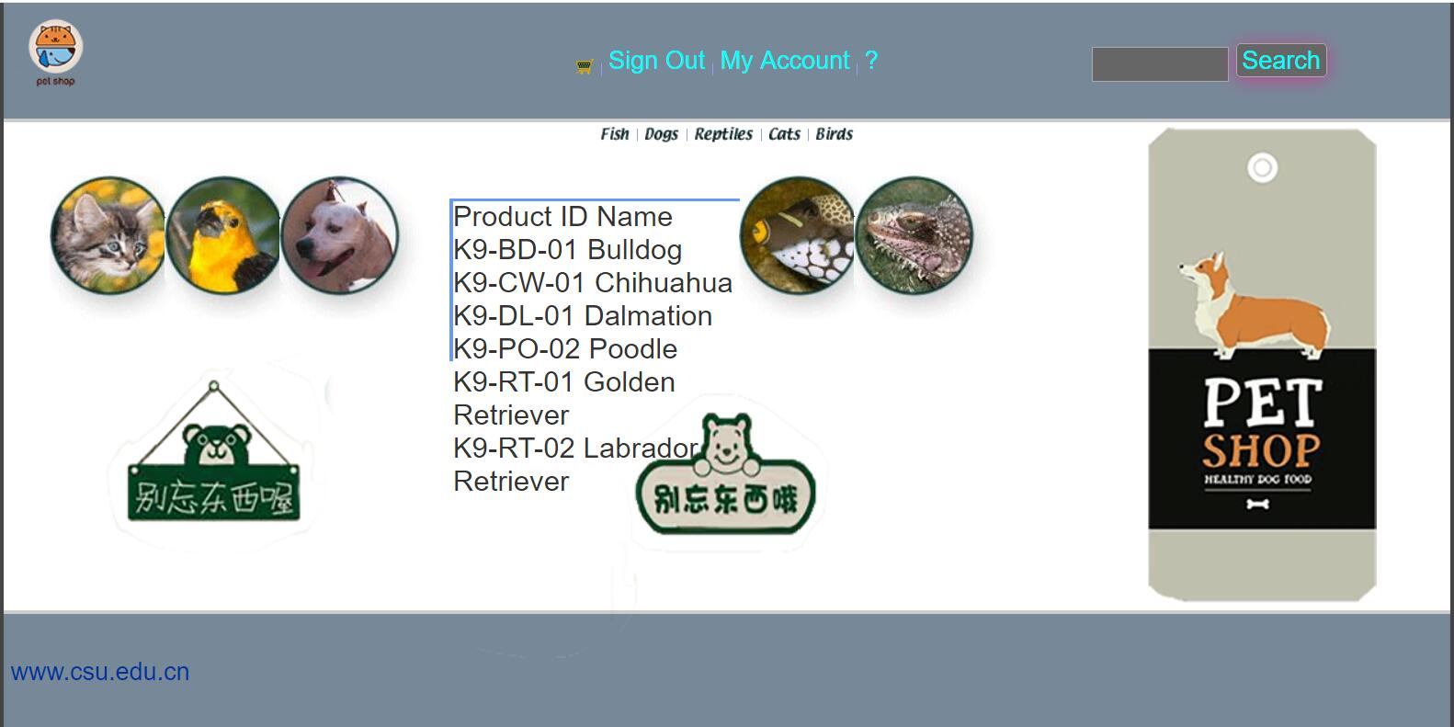

核心代码：

$(function () {
var $lis = $("ul>li");
for(var i=0;i<$lis.length;++i){
$lis.eq(i).css("backgroundImage","url(&apos;imgs/"+(i+1)+".jpg&apos;)");
}
$lis.mouseenter(function () {
$(this).stop().animate({"width":400}).siblings().stop().animate({"width":100});
}).mouseleave(function () {
$(this).stop().animate({"width":240}).siblings().stop().animate({"width":140});
});
});

基本原理：

利用JavaScript为界面添加动态效果，然后根据用户的鼠标所在的位置从数据库中提取信息，利用CSS展示到界面当中

实现方案：

利用JavaScript为界面添加动态效果，然后根据用户的鼠标所在的位置从数据库中提取信息，利用CSS展示到界面当中

是否使用框架：使用了JQuery
- 订单模块。通过选项卡或模版内容实现订单多个信息部分的录入，不需要页面跳转，在一个页面完成订单所有内容的录入。

运行界面截图：
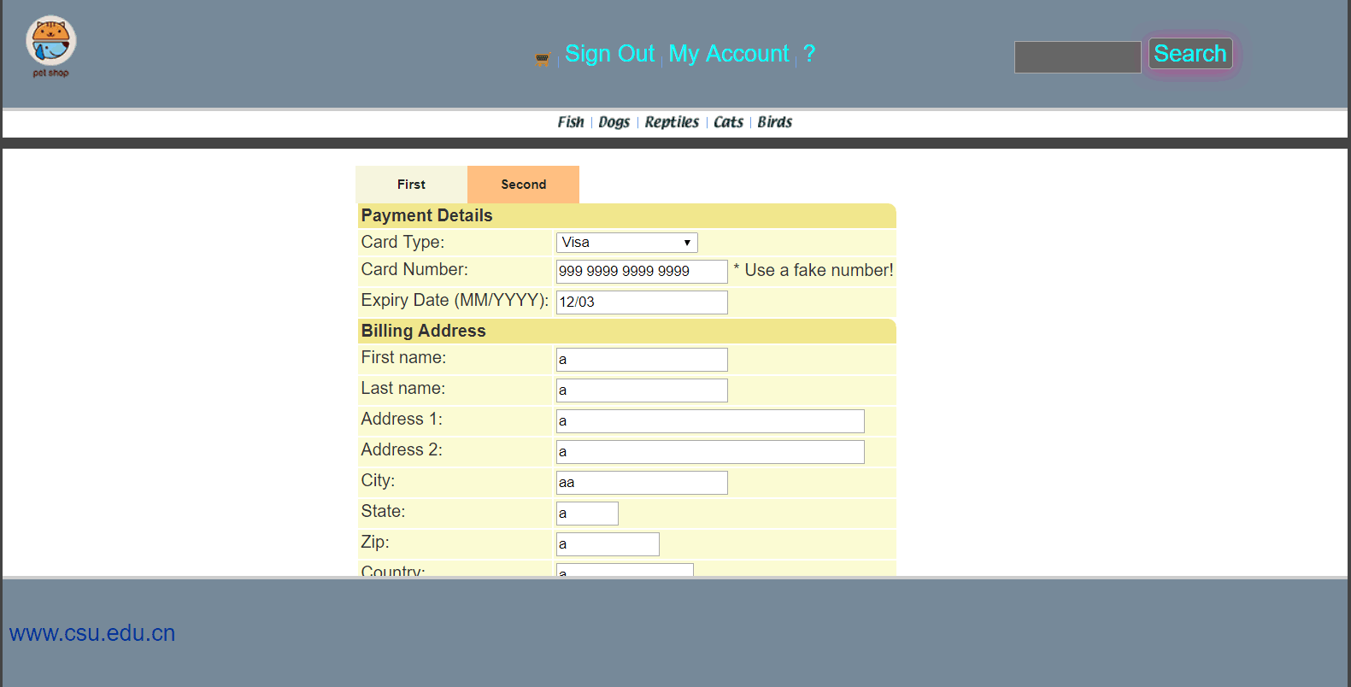

核心代码：

$(document).ready(function() {
var billToFirstName = $("#billToFirstName").val();
var billToLastName = $("#billToLastName").val();
var billAddress1 = $("#billAddress1").val();
var billAddress2 = $("#billAddress2").val();
var billCity = $("#billCity").val();
var billState = $("#billState").val();
var billZip = $("#billZip").val();
var billCountry = $("#billCountry").val();
$.ajax({
type : "GET",
url : "shippingForm?billToFirstName="+
billToFirstName+ "&billToLastName"+billToLastName+
"&billAddress1"+billAddress1+"&billAddress2"+billAddress2+"&billCity"+billCity+"&billState"
+billState+"&billZip"+billZip+"&billCountry"+billCountry,
success : function () {
$(&apos;.tab h3&apos;).mouseover(function(){$(this).attr("class","over");})
.click(function() {
$(&apos;.tab div&apos;).hide();
$(this).attr("class","active").next("div").show();
});
$(&apos;.tab h3&apos;).mouseleave(function () {
$(this).attr("class","origin_lab");
});
}
});
});

基本原理：

利用JavaScript和CSS的联合使用，做到选项卡的效果，利用CSS的hide和show方法来展示或者隐藏目标选项卡，利用z-index层级控制来做到页面分层。

实现方案：

利用JavaScript和CSS的联合使用，做到选项卡的效果，利用CSS的hide和show方法来展示或者隐藏目标选项卡，利用z-index层级控制来做到页面分层。

是否使用框架：使用了jQuery
- 其他效果：可自行选择其他UI模版，或选择其他功能点进行用户体验的优化。
基本原理、实现方案和是否使用框架等。

运行界面截图：

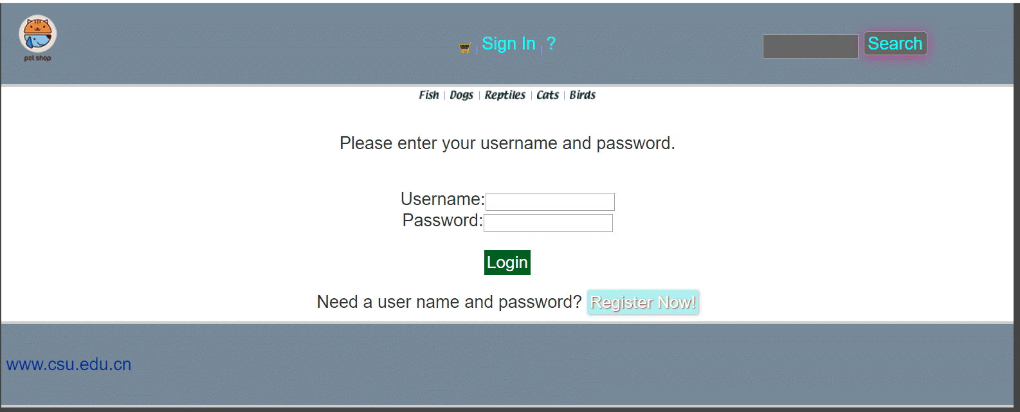

核心代码：
.append_div{
padding-left: 0;
padding-top: 0;
margin-top: 0;
list-style: none;
overflow: hidden;
text-align: right;
margin-bottom: 3px;
text-align: center;
transition: all .4s ease-out;
height: 25px;
width: 120px;
}
.append_span{
border-radius: 2px;
position: relative;
display: inline-block;
margin-left: 35px;
line-height: 1.5;
margin: 0;
margin-bottom: 5px;
background-color: lightpink;
transition: background 3s;
box-shadow: 2px 2px 10px -2px rgba(0,0,0,.35);
height: 25px;
width: 120px;
font-size: 15px;
}
.showResults{
position: absolute;
top: 71px;
left: 1061px;
}
.append_span:hover {
background: mediumorchid;
transition: background .45s;
}
.SearchButton {
font-family: &apos;Helvetica&apos;, &apos;Arial&apos;, sans-serif;
display: inline-block;
font-size: 1em;
padding: 0.1em 0.2em;
margin-top: 20px;
margin-bottom: 60px;
-webkit-appearance: none;
appearance: none;
background-color: #ff0081;
color: #fff;
border-radius: 4px;
border: none;
cursor: pointer;
position: relative;
transition: transform ease-in 0.1s, box-shadow ease-in 0.25s;
box-shadow: 0 2px 25px rgba(255, 0, 130, 0.5);
}
.SearchButton:focus {
outline: 0;
}
.SearchButton:before, .SearchButton:after {
position: absolute;
content: &apos;&apos;;
display: block;
width: 140%;
height: 100%;
left: -20%;
z-index: -1000;
transition: all ease-in-out 0.5s;
background-repeat: no-repeat;
}
.SearchButton:before {
display: none;
top: -75%;
background-image: radial-gradient(circle, #ff0081 20%, transparent 20%), radial-gradient(circle, transparent 20%, #ff0081 20%, transparent 30%), radial-gradient(circle, #ff0081 20%, transparent 20%), radial-gradient(circle, #ff0081 20%, transparent 20%), radial-gradient(circle, transparent 10%, #ff0081 15%, transparent 20%), radial-gradient(circle, #ff0081 20%, transparent 20%), radial-gradient(circle, #ff0081 20%, transparent 20%), radial-gradient(circle, #ff0081 20%, transparent 20%), radial-gradient(circle, #ff0081 20%, transparent 20%);
background-size: 10% 10%, 20% 20%, 15% 15%, 20% 20%, 18% 18%, 10% 10%, 15% 15%, 10% 10%, 18% 18%;
}
.SearchButton:after {
display: none;
bottom: -75%;
background-image: radial-gradient(circle, #ff0081 20%, transparent 20%), radial-gradient(circle, #ff0081 20%, transparent 20%), radial-gradient(circle, transparent 10%, #ff0081 15%, transparent 20%), radial-gradient(circle, #ff0081 20%, transparent 20%), radial-gradient(circle, #ff0081 20%, transparent 20%), radial-gradient(circle, #ff0081 20%, transparent 20%), radial-gradient(circle, #ff0081 20%, transparent 20%);
background-size: 15% 15%, 20% 20%, 18% 18%, 20% 20%, 15% 15%, 10% 10%, 20% 20%;
}
.SearchButton:active {
transform: scale(0.9);
background-color: #e60074;
box-shadow: 0 2px 25px rgba(255, 0, 130, 0.2);
}
.SearchButton.animate:before {
display: block;
animation: topBubbles ease-in-out 0.75s forwards;
}
.SearchButton.animate:after {
display: block;
animation: bottomBubbles ease-in-out 0.75s forwards;
}
@keyframes topBubbles {
0% {
background-position: 5% 90%, 10% 90%, 10% 90%, 15% 90%, 25% 90%, 25% 90%, 40% 90%, 55% 90%, 70% 90%;
}
50% {
background-position: 0% 80%, 0% 20%, 10% 40%, 20% 0%, 30% 30%, 22% 50%, 50% 50%, 65% 20%, 90% 30%;
}
100% {
background-position: 0% 70%, 0% 10%, 10% 30%, 20% -10%, 30% 20%, 22% 40%, 50% 40%, 65% 10%, 90% 20%;
background-size: 0% 0%, 0% 0%, 0% 0%, 0% 0%, 0% 0%, 0% 0%;
}
}
@keyframes bottomBubbles {
0% {
background-position: 10% -10%, 30% 10%, 55% -10%, 70% -10%, 85% -10%, 70% -10%, 70% 0%;
}
50% {
background-position: 0% 80%, 20% 80%, 45% 60%, 60% 100%, 75% 70%, 95% 60%, 105% 0%;
}
100% {
background-position: 0% 90%, 20% 90%, 45% 70%, 60% 110%, 75% 80%, 95% 70%, 110% 10%;
background-size: 0% 0%, 0% 0%, 0% 0%, 0% 0%, 0% 0%, 0% 0%;
}
}
基本原理、实现方案：利用CSS设计界面
是否使用框架：使用了jQuery
- 小组成员分工及实验总结
- 小组分工：

账号管理模块，查询商品自动补全模块，购物车模块和订单模块为组长负责，张皓景负责展示商品模块和商店界面的美化添加CSS动效等
- 实验总结

遇到的问题：

Ⅰ、在实现购物车自动补全模块时，由于使用的是jQueryui自带的autocomplete的方法，一开始由于路径的原因导致无法识别和使用该方法。
Ⅱ、在实现购物车模块的时候，由于逻辑层面上的一些问题，比如商品的数量改变，某一行的总价也需要随之改变从而导致逻辑层面上出现了比较大的纰漏，比如数据库中的数据无法更新，购物车展示模块中的物品总价没有发生变化等。
Ⅲ、在实现展示商品模块的时候，由于页面的动态效果的实现和商品信息的展示的匹配比较困难，订单的展示位置不知道如何处理等问题。

解决的方法：

Ⅰ、通过和之前路径的对比最终解决了路径问题，自动补全也能够正常显示，然后通过百度的方式选择了一种比较好看的CSS样式，然后通过调整最终还是达到了所预期的效果。

Ⅱ、购物车的异步更新的bug的解决则耗费了比较大的心血，最终还是通过自己一步步的尝试，利用JavaScript中的一些算法逻辑，解决了购物车中数据总价的更新和展示，然后用jQuery的Ajax方式实现了异步更新，对数据库中的内容也实现了异步更新。

Ⅲ、在展示商品信息的模块的位置问题，最终还是通过浏览器中内置的调试功能最终摆到了一个比较合适的位置，实现了基础功能，样式还过的去。

心得体会：
由于这个实验是在家中做的，直到还剩两三天的时间才开始匆匆忙地开始赶这个项目，一开始觉得这个项目还挺简单的，但后面越做越不对劲，逻辑方面的问题层出不穷，一步一步的调式，极大地磨砺了我的耐心，有的时候甚至一个下午都没办法找出一个bug，这种感觉着实挺恶心的，但是，这种提前体验007的生活，也让我之前非常枯燥无聊只知道打游戏的假期生活增添了一定的色彩，至少也算没有荒废自己的假期生活吧，从早上七点起来，到晚上十二点多睡觉，甚至连吃饭的时间都在找bug，不得不说这样的生活虽然很苦，但却是十分充实，而且还能够提升我的项目能力，总之，这次的实验，可以说是，获益匪浅吧。

