Interpretable Polarimetric Scattering Representation for PolSAR Ship Detection via Knowledge-Distillation-Guided Symbolic Regression

Haomiao Liu, Sinong Quan, and Zhihao Cai¹

Polarimetric synthetic aperture radar (PolSAR) provides complete target scattering information, but ship detection still depends on coarse box labels, handcrafted scattering features, or opaque deep detectors. This article develops a knowledge-distillation-guided symbolic-regression method that learns a closed-form polarimetric descriptor from soft pixel labels. A lightweight multilayer perceptron teacher converts threshold-derived hard labels into continuous ship-membership labels, and a bi-objective genetic-programming search fits these labels under an accuracy-complexity Pareto criterion. The selected six-node descriptor is Pmv = exp(-c/(Pm+Pv)). Since the exponential is strictly monotone, Pmv and the raw sum Pm+Pv have identical ranking performance (AUC 0.9772); the descriptor provides a bounded, closed-form output that is easier to calibrate and embed. In the three-channel input, Pmv raises the mAP@0.5 of YOLOv8n from 80.0% to 82.5% on PSDD, and all eight detectors improve in mAP@0.5, with a maximum gain of 2.5 percentage points. The comparison spans four YOLO variants and four MMDetection detectors; no broader architecture generality is claimed. A box-gated rule uses the descriptor for pixel-level extraction. On the third-party IPSD dataset, the descriptor reaches an AUC of 97.5% after a single scalar calibration, indicating cross-sensor consistency rather than zero-shot transfer. The method offers a lightweight and inspectable approach to descriptor learning for PolSAR ship detection.

Index Terms—Interpretable representation, knowledge distillation, polarimetric synthetic aperture radar (PolSAR), ship detection, soft labels, symbolic regression.

I. INTRODUCTION
W
ITH the continuous growth of marine resource exploitation and maritime traffic, ship detection has become a core technology of civilian remote sensing applications and maritime security tasks [1], [2]. Synthetic aperture radar (SAR), with its all-day, all-weather high-resolution imaging capability, has become one of the primary sensors for ocean remote sensing [3]. The scattering dimensionality that a conventional single-polarization SAR can provide is limited and can hardly support refined observation tasks. Polarimetric SAR (PolSAR) transmits and receives electromagnetic waves of different polarization states, acquires the complete scattering information of a target, and distinguishes targets by the differences in polarimetric properties and scattering mechanisms, which is well suited to ocean applications [4]. Optimized polarization modes such as generalized compact polarimetry have further improved the ship-sea contrast [5].
Existing PolSAR ship detection methods fall into three categories: statistical-distribution-based methods, scattering-characteristic-based methods, and deep-learning-based methods.
Statistical-distribution-based methods model sea clutter as a specific probability distribution and set the threshold adaptively by parameter estimation, which realizes constant-false-alarm-rate (CFAR) detection with a strict and controllable decision rule. di Bisceglie et al. established the approach with an extended-target CFAR detector for the extended targets that ships form in high-resolution SAR [6]; Gao and Shi suppressed nonhomogeneous sea clutter with a polarimetric notch-filter CFAR detector [7]; Larson et al. and Liu et al. developed spatial-polarimetric and multilook polarimetric whitening filters that exploit spatial and polarimetric information to suppress clutter and speckle [8], [9]; and Fan et al. described multilook polarimetric data with a K-Wishart distribution for fully automatic detection [10]. Such methods are reliable under uniform sea conditions but depend on a prior distribution; in heterogeneous near-shore scenes they suffer from model mismatch and threshold drift, and their performance degrades noticeably.
Scattering-characteristic-based methods exploit the difference in scattering mechanism between ships and sea clutter to build physically interpretable features that highlight the target, and they form the mainstream route today. DeGraaf first enhanced the ship-background power contrast by adaptive polarization synthesis [11]; Wang et al. used the reflection-symmetry difference between man-made targets and natural clutter to separate ships from the sea [12]; Marino designed a polarimetric notch filter that removes sea returns in the polarimetric domain to expose weakly scattering ships [13]; Cloude proposed rank-1 polarimetric processing, which approximates the target by a single scattering mechanism [14]; Li et al. developed roll-invariant features against the instability caused by ship attitude variation [15]; and Quan et al. compressed multidimensional scattering information into a few highly discriminative features [16]. The four-component decomposition of Yamaguchi et al. [17] and its ocean-oriented volume-scattering model [18] remain the most widely used physical models of target representation. These methods are physically meaningful and need no training data, but their feature forms and thresholds depend heavily on expert experience, their cross-band adaptability is limited, and their sensitivity to weakly scattering small ships is low; improvements such as PSO-based fine polarimetric decomposition [19] still remain within the handcrafted framework. Recent surveys and full-polarization detector studies note that the design of polarimetric scattering fingerprints is shifting from handcrafted design to data-driven mining [1], [20], which motivates this work.
Deep-learning-based methods learn implicit target features end to end and outperform traditional methods in complex scenes. Qin et al. introduced an end-to-end Transformer detector that alleviates missed detections of small targets in dense scenes [21]; Chen et al. designed the LRS2-DM framework on a diffusion model for small targets in low-resolution imagery [22]; Cai et al. coupled physical scattering mechanisms with a CNN detector [23]; Yin et al. enhanced a Transformer detector by scattering-point aggregation and contextual feature refinement [24]; and lightweight distillation-based detectors have been developed for SAR targets [25]. Knowledge distillation offers a compromise: a large network passes its decision knowledge to a small one as soft labels [26], an idea already used to lightweight remote-sensing and SAR detection [27]–[30]. Such methods are powerful, but their decision logic is stored implicitly in the weights and the physical mechanism is hard to trace, so they cannot provide the interpretability and traceability required in maritime surveillance. General model-compression principles are surveyed in [31]; speckle noise and target sparsity make their application to SAR detection non-trivial.
Three problems remain. Box annotations provide only coarse target extents and are converted into binary masks, so the continuous ship-sea transition is lost and boundary pixels receive unstable supervision. Handcrafted polarimetric features are physically meaningful, but their forms and thresholds depend on expert experience, which limits cross-band and cross-sensor transfer. Deep detectors perform well in complex scenes, but their decision logic is hidden in the network weights and their box outputs do not provide pixel-level evidence that can be inspected.
To address these problems, this article presents a knowledge-distillation-guided symbolic-regression method for learning an explicit polarimetric descriptor. A teacher-student formulation connects physical polarimetric features, soft pixel labels, and a closed-form descriptor; the descriptor serves as both a detector input and a pixel-level decision rule. The main contributions are as follows.
1) A soft-label generation mechanism based on knowledge distillation is developed. A lightweight MLP teacher maps three polarimetric components to a continuous ship-membership score, replacing threshold labels with a smooth regression target. At the low complexity used by the final descriptor, hard- and soft-label searches recover the same exponential form; soft labels become useful at higher complexity, where they keep the Pareto front smooth and avoid oscillatory expressions.
2) A symbolic-regression procedure is developed to obtain an explicit scattering descriptor. A bi-objective search over accuracy and complexity returns the six-node expression P_{mv} = exp(-c/(P_{m}+P_{v})). Analysis and experiments show that P_{mv} is a monotone, bounded rescaling of P_{m}+P_{v}: it has the same AUC as the raw sum (0.9772) but provides a closed-form, unit-interval output that is easier to calibrate and embed. As a single-channel input, it improves YOLOv8n mAP@0.5 from 73.7% (raw sum) to 76.5%, so the gain comes from input calibration rather than extra ranking information.
3) A dual-layer detection scheme is constructed. The descriptor is used as an input channel in YOLO detectors, and a box-gated rule converts its thresholded response into pixel-level masks. With [P_{mv}, P_{v}, P_{s}], YOLOv8n improves mAP@0.5 from 80.0% to 82.5%, and all four YOLO variants improve in mAP@0.5. The controlled comparison is the within-architecture replacement of P_{m} by P_{mv}.

II. METHODOLOGY
The proposed method has three stages, shown in Fig. 1. Stage I decomposes multi-source PolSAR imagery by the Yamaguchi four-component model, thresholds the result into pixel-level hard labels, and has an MLP teacher turn them into continuous soft labels. Stage II fits the soft labels by symbolic regression under a Pareto trade-off between accuracy and complexity and outputs an explicit descriptor. Stage III decides every pixel with the general layer and feeds the descriptor into a deep detector as one input channel.
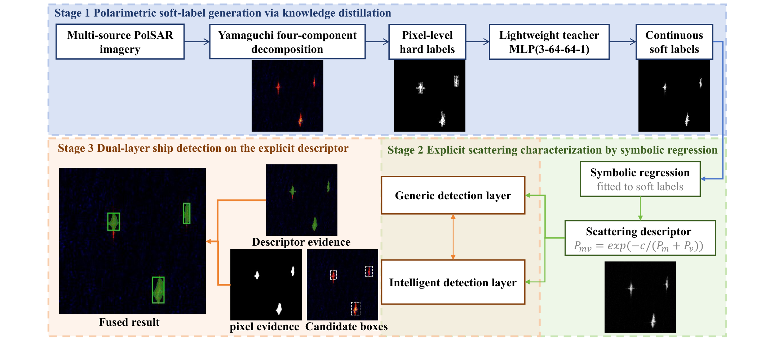
Fig. 1. Overall pipeline of the proposed method.

A. Polarimetric Soft-Label Generation via Knowledge Distillation
Fully polarimetric SAR acquires the complete backscattering response of each resolution cell, written as a 2 × 2 complex scattering matrix in the horizontal-vertical basis. Vectorizing it on the Pauli basis gives the scattering vector k, and a sliding-window multilook ensemble average of k suppresses speckle and yields a statistically stable 3 × 3 polarimetric coherency matrix:
k = 1/√2 [S_{HH} + S_{VV}, S_{HH} − S_{VV}, 2S_{HV}]^{T}  T = ⟨kk^{H}⟩ = [T₁₁ T₁₂ T₁₃; T₁₂* T₂₂ T₂₃; T₁₃* T₂₃* T₃₃] | (1)
where ${\left(\text{·}\right)}^{\text{H}}$ denotes the conjugate transpose and $\left\langle \text{·}\right\rangle$ the spatial sliding-window multilook ensemble average; the coherency matrix is the basis of the subsequent scattering decomposition.
Among the many decomposition methods, this paper adopts the Yamaguchi four-component decomposition [17], [18]: compared with the coherency-matrix elements its output is physically explicit and orientation-stable, and compared with features such as H/A/$α$ its components can be written directly as linear combinations of the detection features, which facilitates the mechanistic interpretation of the descriptor. Under a non-negative power constraint the coherency matrix is decomposed into surface, double-bounce, volume and helix scattering, the volume term using an adaptive model tailored to ocean scenes:
$$T\text{ = }P_{\text{s}}T_{\text{surface}}\text{ + }P_{\text{d}}T_{\text{double}}\text{ + }P_{\text{v}}T_{\text{volume}}\text{ + }P_{\text{h}}T_{\text{helix}}$$ | (2)
where $T_{\text{surface}}\text{, }T_{\text{double}}\text{, }T_{\text{volume}}$ and $T_{\text{helix}}$ are the basis coherency matrices of the four mechanisms. The physical meaning of each component is as follows: $P_{\text{s}}$ dominates the sea background return; $P_{\text{d}}$ is the main source of the strong backscattering from ship structures; $P_{\text{v}}$ characterizes the structural complexity of the target and its degree of depolarization; and $P_{\text{h}}$ is a direct indicator of reflection-symmetry breaking.
In ship pixels both double-bounce and helix scattering are far stronger than over the sea, corresponding to the main hull structure and the fine twisted structure, and the two fluctuate synchronously over ship and sea (Fig. 2). They are merged into the ship characteristic scattering component $P_{\text{m}}\text{ = }P_{\text{d}}\text{ + }P_{\text{h}}$ (which removes the redundancy between $P_{\text{d}}$ and $P_{\text{h}}$ and compresses the search space), reducing the features from four to three; the resulting polarimetric feature vector serves as the input of the symbolic regression:
x = 1/√2 [P_{m}, P_{v}, P_{s}]^{T} ∈ R³ | (3)
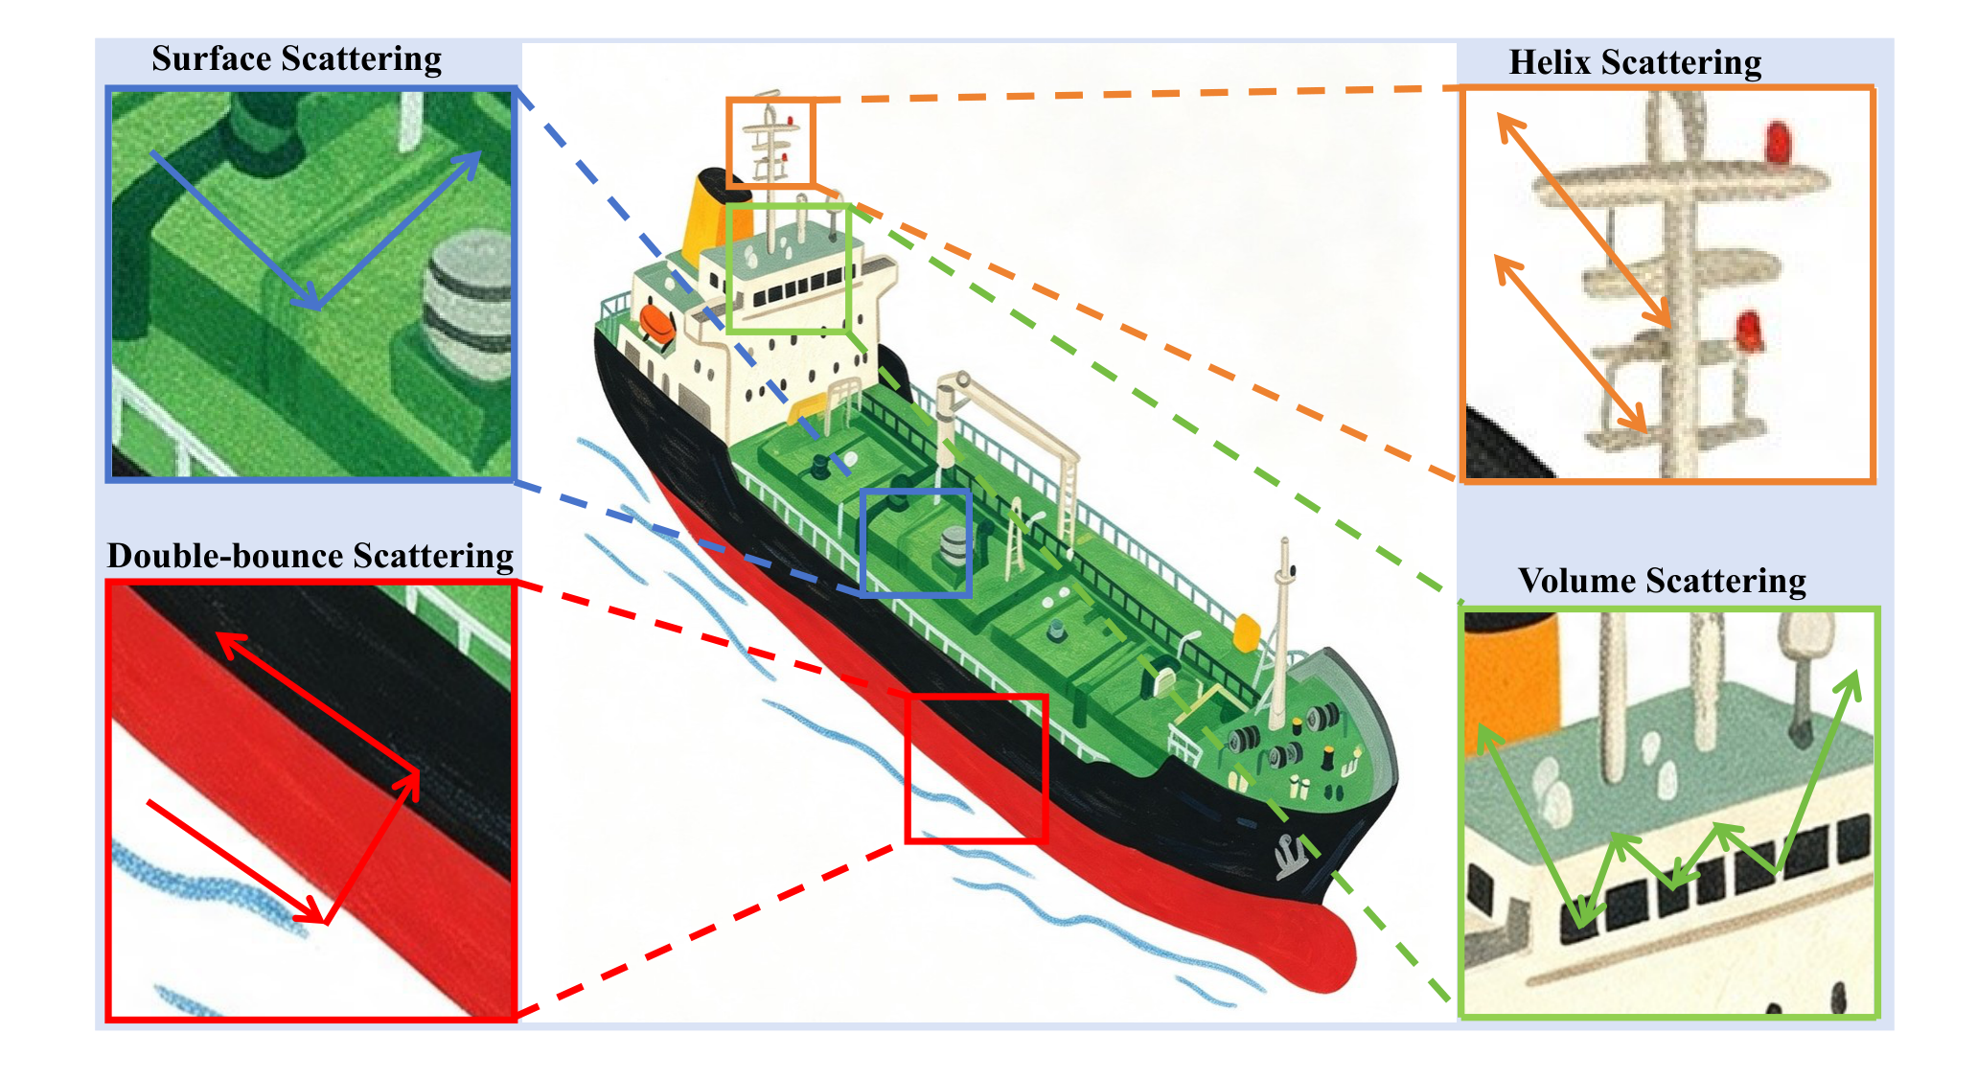
Fig. 2. Schematic diagram of the polarimetric scattering characteristics of a ship.
A rectangular annotation box gives only the rough extent of a target, and contains both hull and water. Since the hull scatters far more strongly than the sea, one fixed threshold on the rendered components separates the hull inside the box; compared with adaptive thresholding such as Otsu [32] this needs neither a per-scene histogram nor a parameter search, and the labels are reproducible by construction (Fig. 3).
To place the three components on a common intensity scale, each is clipped to the unit interval and scaled by 255 into an 8-bit rendering, whose luminance is taken with the published ITU-R BT.601 weights [33]:
$$L\text{ = 0.299}R\text{ + 0.587}G\text{ + 0.114}B$$ | (4)
where R, G and B are the 8-bit renderings of $P_{\text{m}}\text{, }P_{\text{v}}$ and $P_{\text{s}}$.
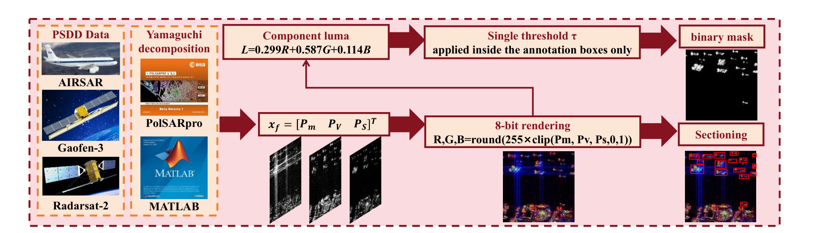
Fig. 3. Construction of the pixel-level dataset based on single-threshold segmentation.
A threshold of $τ$ = 40 on the luminance map gives the pixel-level hard labels:
$$y_{\text{i}}\text{ = }\left\{\begin{aligned}\text{1, }L_{\text{i}}\text{ ≥ }τ \\ \text{0, }L_{\text{i}}\text{ < }τ\end{aligned}\right.$$ | (5)
where $y_{\text{i}}$ is the hard label of pixel i (1 for ship, 0 for sea).
Supervising the symbolic regression directly with such hard labels raises two problems. First, the 0/1 labels jump at the ship-sea boundary, so the search oscillates along the transition band and tends to produce structurally redundant expressions. Second, a hard label gives no distance to the decision boundary, so a small feature change flips the label and the search has no stable improvement direction. A soft label provides a graded target in the transition band; we use it for optimization geometry, not because it carries more Shannon information than a hard label.
To solve these problems, we insert a soft-label step between the hard labels and the symbolic regression. A lightweight MLP teacher takes the three-dimensional scattering feature of each pixel and is trained against the hard label. Because ship and water features differ, the teacher learns a continuous decision boundary and outputs a ship-membership probability, which becomes the regression target of the symbolic search.
A multilayer perceptron is a stack of fully connected layers in which every unit forms a weighted sum of all outputs of the previous layer and passes it through a nonlinear activation, so it represents a smooth, globally defined nonlinear map from a low-dimensional feature to a score; its capacity is set by the layer widths rather than by any structural assumption, which keeps it small and strongly regularized. The teacher uses this lightweight fully connected form: the input is the independent three-dimensional feature of each pixel, so fully connected layers suffice, the parameter count stays small, and the decision boundary stays smooth, which is what makes a concise analytical expression findable afterwards.
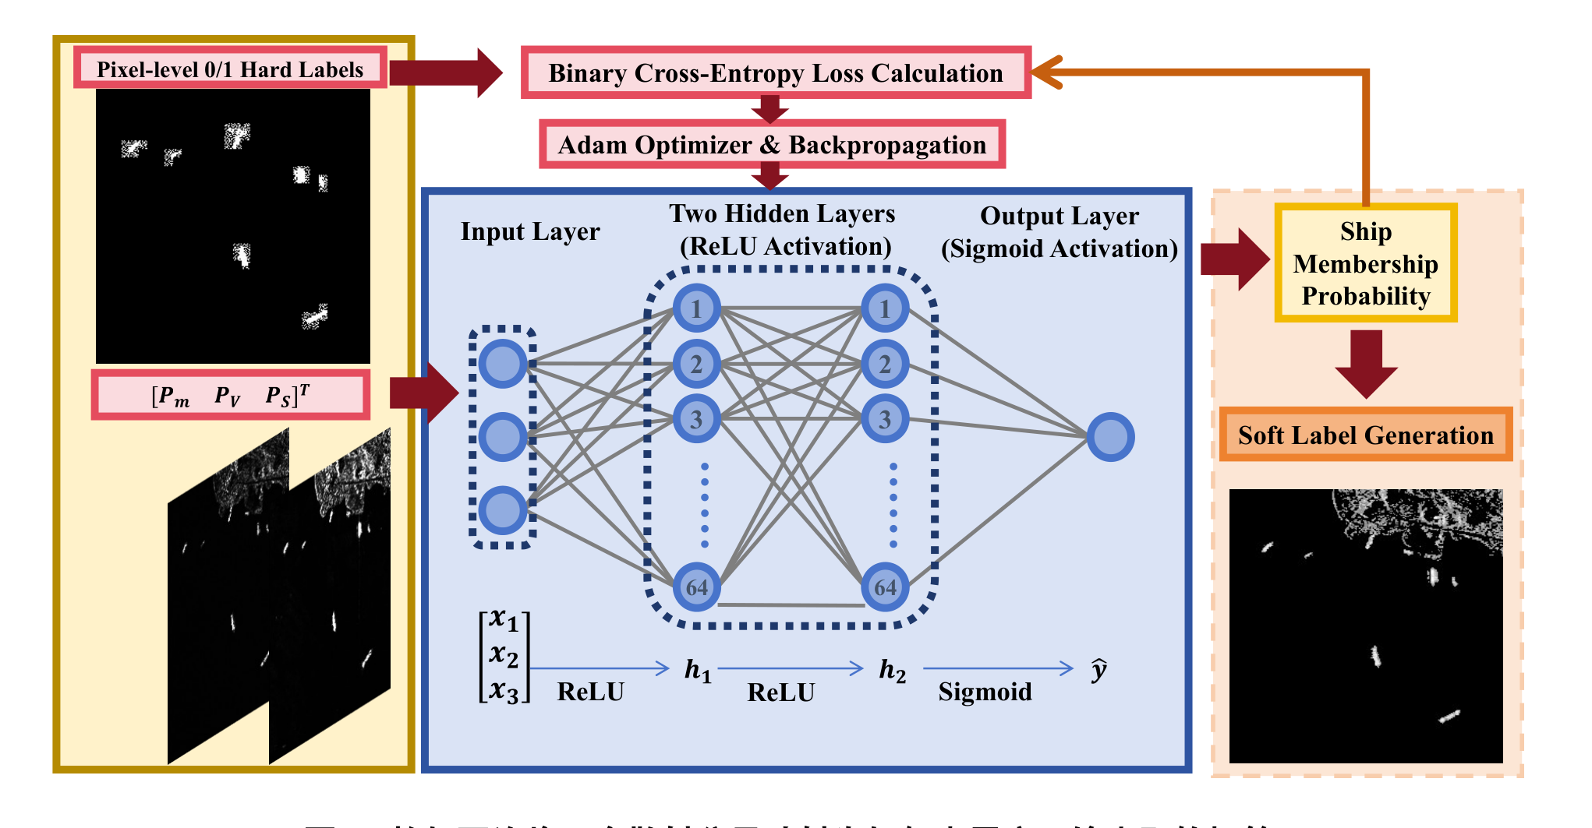
Fig. 4. Structure of the teacher MLP network.
The mapping is implemented by the three-layer feedforward network shown in Fig. 4: three input neurons receive the three scattering components, the two hidden layers contain 64 neurons each, and the output layer applies a Sigmoid activation to give the learned continuous ship membership. The forward propagation is as follows.
Given the input scattering feature vector x, every hidden layer applies a linear transformation followed by a ReLU activation:
$$h_{k}\text{ = ReLU}\left(W_{k}h_{\text{k−1}}\text{ + }b_{k}\right)$$ | (6)
where $W_{\text{1}}$ in ${\text{ℝ}}^{\text{64×3}}$ and $b_{\text{1}}$ in ${\text{ℝ}}^{\text{64}}$ are the parameters of the first hidden layer; the second takes the same form with a 64 × 64 weight matrix and a 64-dimensional bias. The one-sided suppression of ReLU agrees with the non-negative scattering power, so invalid combinations are zeroed and the features stay sparse.
The output layer aggregates the high-order features into a scalar and maps it through the Sigmoid function to the ship membership probability:
$$\hat{y}\text{ = }σ\left(z\right)\text{ = }\frac{\text{1}}{\text{1+exp}\left(\text{ − }z\right)}\text{, }z\text{ = }{w_{\text{3}}}^{\text{T}}h_{\text{2}}\text{ + }b_{\text{3}}$$ | (7)
where $σ$ is the Sigmoid function, and $w_{\text{3}}$ in ${\text{ℝ}}^{\text{64}}$ and $b_{\text{3}}$ are the output-layer parameters; the output $\hat{y}$ is the soft label of that pixel.
The rate of change of the Sigmoid function can be expressed by its own value:
$$σ^{\text{′}}\left(z\right)\text{ = }σ\left(z\right)\left(\text{1 − }σ\left(z\right)\right)\text{ = }\hat{y}\left(\text{1 − }\hat{y}\right)$$ | (8)
This derivative reaches its maximum of 0.25 at ŷ = 0.5 (the decision boundary) and decreases toward both ends: the probability surface changes fastest in the most ambiguous region. For reference, the entropy of the soft label is given by Eq. (9); it peaks at the boundary and tends to zero at the cores. We use it as a descriptive measure, not as a claim of additional Shannon information.
The network is trained with the binary cross-entropy loss, using Adam with a learning rate of 1 × 10⁻³, a batch size of 256 and 100 epochs, keeping the weights of the epoch with the best validation accuracy.
After training converges, the teacher outputs a continuous ship-membership probability for every pixel. These probabilities are the soft labels and serve as the regression target. The teacher is trained to reproduce the threshold labels while smoothing their boundary. The soft label is not intended to carry more Shannon information than the hard label; its role is to provide a continuous regression target.
$$\left.\begin{aligned}H\left(\hat{y}\right)\text{ =−}\hat{y} {\text{log}}_{\text{2}} \left(\hat{y}\right)\text{ − }\left(\text{1−}\hat{y}\right) {\text{log}}_{\text{2}} \left(\text{1−}\hat{y}\right) \\ \hat{y}\text{∈(0,1)}\end{aligned}\right.$$ | (9)
The soft label is useful because it defines a continuous target with a non-zero gradient in a band around the boundary, where the hard label is flat and ambiguous.
The second advantage is the smoothness of the objective: the gradient of a hard label is zero everywhere except at the label boundary, whereas the soft-label target varies continuously across the transition band, so the search receives a consistent improvement direction.

B. Explicit Scattering Characterization via Symbolic Regression
Symbolic regression searches directly for an explicit expression that fits the data [34], [35], instead of fitting the many weights of a fixed model: the unknowns are the expression itself, built from a few variables and operators, so the result is a closed-form formula that can be read, checked against physical reasoning, transferred between platforms and evaluated in a few arithmetic operations. Its toolchains are mature [36], [37], [38], [39], and in remote sensing they support parameter retrieval and imagery-based discovery [40], [41] and multimodal regression [42]; the functional form of a polarimetric descriptor, by contrast, is still chosen by hand. Neural-symbolic distillation [43], [44] shows that the implicit knowledge of a trained network can be restored into explicit laws by evolutionary search [45], [46], [47].
An explicit representation of a ship has to do two things at once: it must highlight the ship against the sea and suppress clutter, and it must stay simple enough to be read and reused. A handcrafted polarimetric feature satisfies the second requirement, but its functional form comes from expert experience rather than from the data and the task, whereas a learned representation satisfies the first but hides its rule in network weights. This section treats the descriptor itself as the unknown of an optimization problem instead of a hand-set formula.
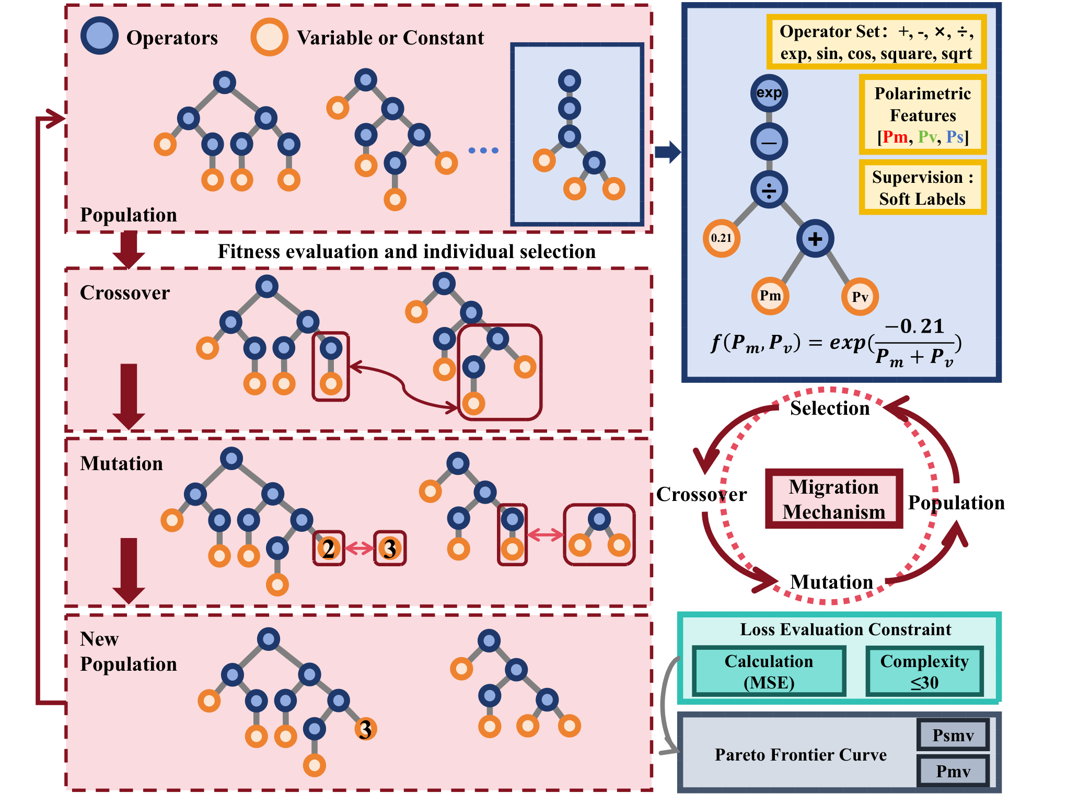
Fig. 5. Principle of the student symbolic regression: evolutionary search, the accuracy-complexity Pareto front, and the discovered expression tree.
The central formulation of the section is the bi-objective problem over the space F spanned by the operator set O and the variable set X: find an expression that minimizes the fitting error and the structural complexity simultaneously, which turns descriptor design from an expert choice into a well-posed search (Fig. 5). Expressions are generated from the variables and constants by composition of the operators in O, and each corresponds to a binary tree whose node count is its complexity. The operator set and the variable set are:
$$\left.\begin{aligned}O\text{=\{+, −, ×, ÷, exp, sqrt, square, sin, cos\}} \\ X\text{ = }\left\{P_{\text{s}}\text{, }P_{\text{m}}\text{, }P_{\text{v}}\text{, }c\right\}\end{aligned}\right.$$ | (10)
The operators follow scattering physics: ship membership varies smoothly with scattering power, so an exponential operator is included; the square and square-root operators convert between power and amplitude; the arithmetic operations provide the basic combinations; and the trigonometric functions only make local corrections at high complexity. The logarithm is prone to numerical trouble in the low-power sea region, so its nesting is restricted.
The first objective of symbolic regression is the fitting accuracy, measured by the mean squared error (MSE) between the expression output and the teacher soft label:
min_{f∈F} (MSE(f), C(f)) | (11)
A smaller MSE means a higher fitting accuracy. The second objective is the complexity C(f), defined as the total number of nodes of the binary tree:
$$C\left(f\right)\text{ = }N_{\text{operator}}\text{ + }N_{\text{leaf}}$$ | (12)
where $N_{\text{operator}}$ is the number of operator nodes and $N_{\text{leaf}}$ is the number of leaf nodes; fewer nodes mean a more concise expression, faster computation and lower deployment overhead. The final bi-objective problem is formalized as:
f* is a Pareto-optimal solution of Eq. (11) | (13)
The two objectives compete: a higher accuracy usually requires a longer expression, whereas a concise one cannot follow the soft-label surface fully. No unique optimum exists; instead, a set of mutually non-dominated compromises forms the Pareto front [48]. Eq. (11) is interpreted in this Pareto sense not as a scalar argmin. Short expressions suit edge devices of limited computing power, long ones ground processing that pursues accuracy.
The search is driven jointly by genetic programming [49] and NSGA-II selection [61]: NSGA-II selects individuals by dominance relations and crowding distance, and genetic programming generates new candidates by subtree crossover and node mutation. Two settings distinguish this work: the operator set follows scattering physics (Eq. (10)) and the fitting target is the soft label, not the hard label, which keeps the search inside a physically interpretable space and leaves a clear improvement direction near the boundary.
A refinement step follows: a one-dimensional local search on the real-valued constants of the elite individuals reduces the fitting error without changing the expression structure. It uses the Brent algorithm [50], which combines golden-section search with inverse parabolic interpolation and takes a convergence tolerance of $ε\text{ = 1×}{\text{10}}^{\text{−6}}$.
The final descriptor is taken at the complexity inflection point of the front: beyond it, further nodes bring almost no accuracy gain, so the simplest expression at the inflection point best balances accuracy and interpretability.
Its form is:
$$P_{\text{mv}}\text{ =exp}\left(\text{ − }\frac{c}{P_{\text{m}}\text{ + }P_{\text{v}}}\right)$$ | (14)
This descriptor is an explicit polarimetric feature of the same kind as SPAN and the reflection-symmetry descriptor [12] and can be used in their place; the difference is that its functional form comes from a data-driven search and needs no preset structure.
To put the descriptor on a physical footing, let $S\text{ = }P_{\text{m}}\text{ + }P_{\text{v}}$ and expand Eq. (14) in the small quantity $c\text{/}S$:
$$P_{\text{mv}}\text{ =1 − }\frac{c}{P_{\text{m}}\text{ + }P_{\text{v}}}\text{ + }\frac{c^{\text{2}}}{\text{2}{\left(P_{\text{m}}\text{ + }P_{\text{v}}\right)}^{\text{2}}}\text{ − }\frac{c^{\text{3}}}{\text{6}{\left(P_{\text{m}}\text{ + }P_{\text{v}}\right)}^{\text{3}}}\text{+o}\left(\frac{\text{1}}{{\left(P_{\text{m}}\text{ + }P_{\text{v}}\right)}^{\text{3}}}\right)\text{, }S\text{ = }P_{\text{m}}\text{ + }P_{\text{v}}$$ | (15)
Because the argument x = P_{m}+P_{v} is positive, the descriptor is bounded in (0,1): it tends to 0 as x tends to 0 and to 1 as x grows. For x much larger than c, the first-order expansion 1 - c/x is accurate and explains why the score grows with the scattering power; for x much smaller than c, the exponential is the correct form and the expansion does not apply. Monotonicity implies that any rank-based metric, including AUC, is independent of c.

C. Dual-Layer Detection Framework
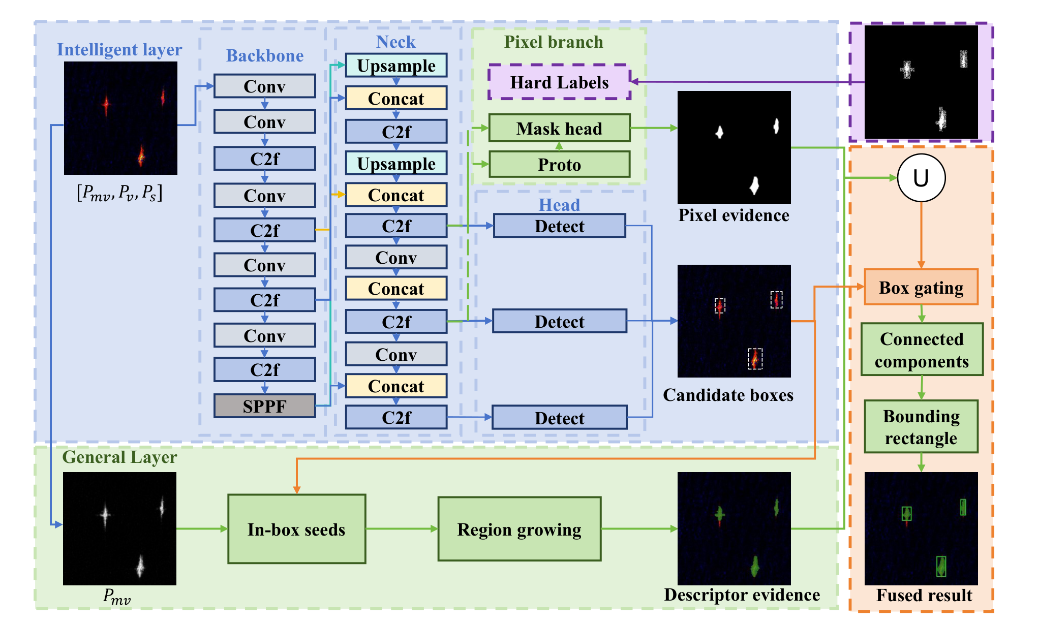
Fig. 6. Schematic diagram of the dual-layer detection framework.
The descriptor scores every pixel but carries no object-level semantics: a compact ship region and a cluster of clutter pixels can receive the same scores. A deep detector supplies that object-level view, yet every box it returns still contains water, wake and near-shore background. The two error types are complementary, so the layers are combined: the intelligent layer proposes candidate boxes first, and the general layer then extracts the ship pixels inside each box with the explicit descriptor, which tightens the boxes and makes each reported target traceable (Fig. 6).
Inside a candidate region the extraction is explicit. The general layer sets a threshold $T_{\text{d}}$ on the descriptor: a pixel is declared a ship if its score is not lower than the threshold and sea otherwise, where $y_{\text{i}}$ is the decision (1 for ship, 0 for sea). One exponential operation and one comparison are all the rule needs, with no training and no GPU:
$$y_{\text{i}}\text{ = }\left\{\begin{aligned}\text{1, }P_{\text{mv,i}}\text{ ≥ }T_{\text{d}} \\ \text{0, }P_{\text{mv,i}}\text{ < }T_{\text{d}}\end{aligned}\right.$$ | (16)
The threshold is not set empirically: an ROC curve is drawn on the training set and the point where the difference between the true-positive and false-positive rates is largest is taken as the working point, where TPR($τ$) and FPR($τ$) are the proportions of ship pixels correctly declared ships and of sea pixels incorrectly declared ships. Once fixed it stays unchanged on the test set:
$$T_{\text{d}}\text{ = }\underset{τ\text{ ∈ (0,1)}}{\text{arg max}} \left|\text{TPR}\left(τ\right)\text{ − FPR}\left(τ\right)\right|$$ | (17)
Eq. (17) thresholds the descriptor, whose readings are not directly interpretable. Let $S\text{ = }P_{\text{m}}\text{ + }P_{\text{v}}S$ be the sum of the ship characteristic scattering and the volume scattering power; by Eq. (14) the descriptor is monotonic in it, so the two thresholds are fully equivalent:
$$P_{\text{mv}}\text{ ≥ }T_{\text{d}}\text{ ⇔ }S\text{ ≥ }T_{\text{S}}\text{, }T_{\text{S}}\text{ =−}\frac{c}{\left(\text{ln}\left(T_{\text{d}}\right)\right)}$$ | (18)
The decision boundary is placed on a physical quantity, decoupled from the fitted constant: the constant differences among the five seeds change only the reading of the descriptor, not the decision of any pixel.
The general layer must output target-level boxes instead of a pixel cloud. The pixels declared as ships (i.e., all pixels with y_i = 1) are labeled by 8-connected components into blobs Ω_k; only blobs with an area of at least A_min are kept, each represented by its bounding box, where x^-_k and x^+_k (y^-_k and y^+_k) are the minimum and maximum of the blob along the horizontal (vertical) coordinate. Speckle leaves isolated spots of a few pixels whereas a real ship is a large connected region, so this step removes most false alarms with little loss of true targets and introduces no learnable parameter:
|Ω_k| ≥ A_min, B_k = ∪_i Ω_(k,i) | (19)
The intelligent layer supplies those proposals. It leaves the detector architecture, the loss and the training strategy untouched and changes only the input: instead of arranging the three scattering components into a three-channel image, this paper replaces $P_{\text{m}}$ with the descriptor:
$$X\text{ = }\left(P_{\text{m}}\text{, }P_{\text{v}}\text{, }P_{\text{s}}\right)\text{ → }X^{\text{′}}\text{ = }\left(P_{\text{mv}}\text{, }P_{\text{v}}\text{, }P_{\text{s}}\right)$$ | (20)
The substitution is limited in scope. The descriptor is bounded after the exponential mapping, so the network no longer adapts to the multi-order dynamic range of the raw powers, and it widens the ship-sea margin, performing one step of pre-discrimination; being parameter-free and architecture-agnostic, the channel can be embedded into any existing detector.
The two layers then act in sequence. Let $B_{\text{k}}$ be a box proposed by the intelligent layer; the general layer restricts its mask to that box and keeps the largest connected component, so the box is tightened to the ship it contains and any box whose mask falls below the minimum area is dropped:
${B_{\text{k}}}^{\text{′}}\text{ = bbox}\left(Ω_{\text{k}}\text{ ∩ }B_{\text{k}}\right)\text{, }\left|Ω_{\text{k}}\text{ ∩ }B_{\text{k}}\right|\text{ ≥ }A_{\text{min}}$ | (21)
Putting the two layers together, let $S\text{ = }P_{\text{m}}\text{ + }P_{\text{v}}$; the decision function of the general layer and the detection function of the intelligent layer are respectively:
$$\begin{aligned}g_{\text{G}}\left(x\right)\text{=1}\left[P_{\text{mv}}\left(S\left(x\right)\right)\text{≥}T_{\text{d}}\right]\text{,} \\ g_{\text{I}}\left(x\right)\text{=}F_{θ}\left(P_{\text{mv}}\left(S\left(x\right)\right)\text{, }P_{\text{m}}\left(x\right)\text{, }P_{\text{s}}\left(x\right)\right)\end{aligned}$$ | (22)
where $F_{θ}$ is the deep detector parameterized by $θ$. The deep layer decides where to look and the explicit layer decides what is a ship pixel, so the detection inherits both the robustness of the learned model and the precision and traceability of the closed-form operator. Either layer can be used alone, or use the intelligent layer to screen the scene and the general layer to refine every candidate.

III. EXPERIMENTAL RESULTS AND ANALYSIS

A. Experimental Setup
To validate the effectiveness of the proposed method, experiments are conducted on the PSDD dataset [51]. A dedicated benchmark study of this dataset [52] evaluated six polarization characteristics across ten CNN architectures, providing a solid baseline for performance comparison. This dataset contains fully polarimetric data from three platforms: C-band GF-3 satellite data (with a resolution of 3–8 m), L-band AIRSAR airborne system data (with a resolution of 5–12 m), and C-band Radarsat-2 satellite data (with a resolution of 3–10 m). The scenarios cover typical operating conditions including calm sea surfaces, moderate sea states, and inshore harbors, with 1,968 annotated ship targets of various types in the 23 scenes used here. After Yamaguchi decomposition and pixel-level mask construction, 270,423 pixel samples are obtained, with a positive-to-negative sample ratio of 1:2. A third-party IPSD dataset [23] is used only for the cross-sensor check in Section IV-C. The settings are listed in Table I.
TABLE I
Experimental Settings
Setting | Configuration
Dataset | PSDD [51], [52]; 23 scenes, 1,968 ships, 1,357 tiles, 2,577 boxes; 270,423 pixels, 1:2 positive/negative
Teacher MLP | 3-64-64-1, ReLU hidden, Sigmoid output, BCE loss, Adam, lr 1e-3, batch 256, 100 epochs
Symbolic regression | NSGA-II + genetic programming; 100 populations x 27 individuals; 300 generations; 30-node cap; nesting depth <= 5; Brent constant refinement; 7 runs, 5 converged
Detectors | YOLO: Ultralytics, 640x640, batch 8, AdamW, 300/200 epochs; MMDetection: RetinaNet/Faster R-CNN/SSD/PAA, SGD, batch 4, 12 epochs, official input scaling
Hardware | RTX 4060 Laptop 8 GB; i9-13980HX; 16 GB RAM; Python 3.9 and PyTorch
Metrics | Pixel: precision, recall, F1, IoU, AUC, TCR. Target: precision, recall, mAP@0.5, F1
For pixel-level tasks, performance is evaluated using accuracy, F1-score and AUC; for target-level tasks, precision, recall, mAP@0.5 and mAP@0.5:0.95. The comparison covers four YOLO variants (YOLOv8n, YOLOv11n, YOLOv12n and YOLO26 [53], [62]) and four MMDetection detectors (RetinaNet [55], SSD [56], PAA [57] and Faster R-CNN [58]). FCOS [54], Cascade R-CNN [59] and rotation-invariant or interpretable designs [20], [60] are outside this comparison. YOLO detectors use 640x640 input, batch 8, AdamW, and 300 epochs for three-channel inputs or 200 epochs for single-channel inputs; MMDetection detectors use SGD, batch 4 and 12 epochs, with the official input scaling (1333x800 for R50-FPN and 300x300 for SSD300). Experiments run on a workstation with an RTX 4060 Laptop GPU, an i9-13980HX CPU and 16 GB RAM, using Python 3.9 and PyTorch.

B. Performance Verification of Intermediate Products
The teacher MLP achieves an accuracy of 95.84%, an F1-score of 0.9413, and an AUC of 0.9881 on the test set. The training and validation losses converge smoothly after approximately 50 epochs, with no obvious overfitting. The t-SNE visualization results show that the soft labels of ship pixels are concentrated in the [0.8, 1.0] interval, while those of sea surface pixels cluster in the [0.0, 0.3] interval, and the boundary region exhibits a smooth gradient transition from 0.3 to 0.8.
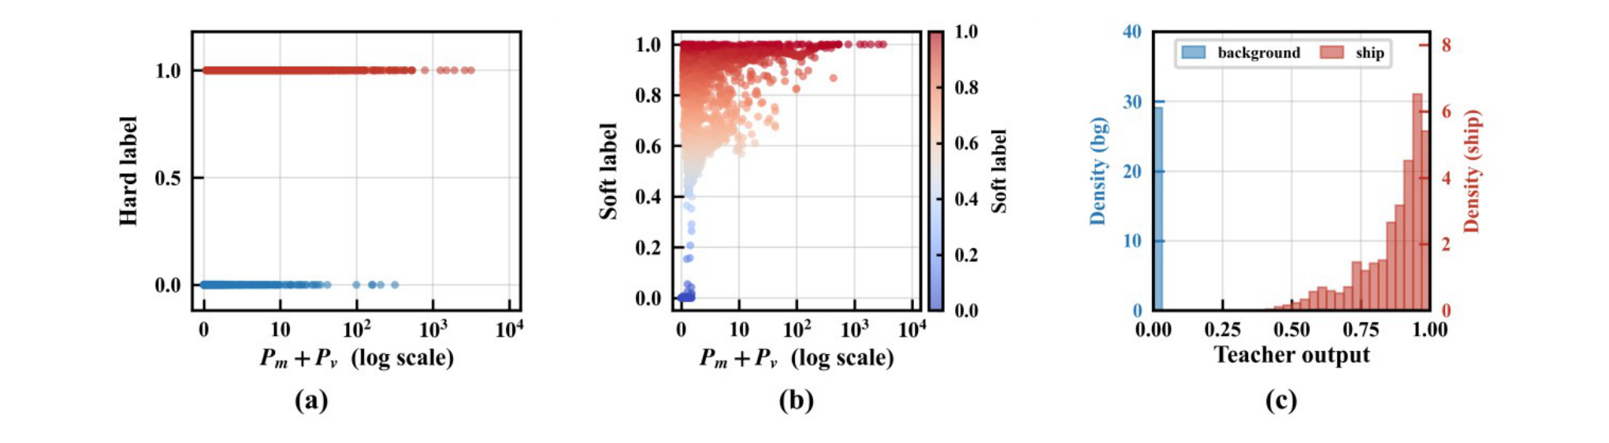
Fig. 7. Soft-label generation and teacher output: (a) hard labels, (b) soft labels, (c) teacher-output distribution.
The soft labels form a continuously transitioning probability surface that separates the ship core, the boundary band and the pure sea, providing high-quality supervision for the symbolic regression (Fig. 7). The search over the full operator set yields a typical L-shaped Pareto front (Fig. 8). At complexity 1–3, the expressions are constants or univariate functions, with MSE above 0.10; at complexity 4–6, the MSE drops from 0.0768 to 0.0228 (70.3%), and the optimal low-complexity expression lies in this interval, corresponding to an exponential function of P_{m}+P_{v} with complexity 6. From 7 to 15 the gain flattens and P_{s} enters to compensate the residual; above 16 the accuracy is nearly saturated. Table II summarizes the optimal expressions at each complexity.

TABLE II
Performance of Optimal Expressions at Different Complexities
Complexity | Loss (MSE) | Expression
1 | 0.1779 | 0.3329602
3 | 0.1087 | sqrt(sqrt(P_{v}))
4 | 0.0768 | exp(-0.10981266/Pm)
6 | 0.0228 | exp(-0.2043/(P_{m}+P_{v}))
15 | 0.0106 | nested (see supplement)
25 | 0.0071 | nested (see supplement)
29 | 0.0069 | Eq. (23)
The search settings were chosen to keep expressions readable: 100 populations of 27 individuals evolve for 300 generations with a 30-node cap, the nesting depth of the exponential, square-root, logarithm and division operators stays within five levels, and the division denominator is bounded below. Seven independent runs were performed; five converged to the same exponential structure and two to a different local optimum (AUC 0.9598, reported in the supplementary material). Table III lists the five converged runs. For these runs, the core constant c ranges from 0.204 to 0.214 with a mean of 0.21, and the test AUC is 0.9772 in all five. The constant changes only the operating point, not the pixel ranking.
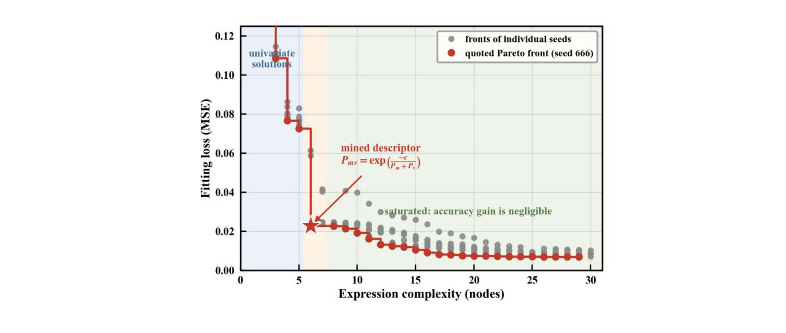
Fig. 8. Pareto front of the symbolic-regression search: MSE versus expression complexity; the red star marks the selected six-node descriptor.
TABLE III
Stability of Low-Complexity Expressions Under Different Random Seeds
Random Seed | Optimal Expression Structure | c | Loss
42 | $$exp⁡(−c/(P_{m}+P_{v}))$$ | 0.214 | 0.02465
123 | $$exp⁡(−c/(P_{m}+P_{v}))$$ | 0.210 | 0.02487
211 | $$exp⁡(−c/(P_{m}+P_{v}))$$ | 0.211 | 0.02363
666 | $$exp⁡(−c/(P_{m}+P_{v}))$$ | 0.204 | 0.02279
789 | $$exp⁡(−c/(P_{m}+P_{v}))$$ | 0.209 | 0.02463

Taking the mean constant c = 0.21 gives the low-complexity scattering descriptor of Eq. (14), which is adopted in the general detection layer.
A higher-complexity variant with 29 nodes couples Ps nonlinearly and improves the pixel-level fit (Table IV). Let A = exp((-0.72197366 - Ps) Pv) / (Pm2 + 1.0250757) and B = sin(sin(sin(cos(A8 + 0.48293668)))); its expression is Psmv = [B2/(0.61469054 x 0.49011374)]8, given by Eq. (23). Because the AUC gain over the six-node descriptor is small and the expression is less interpretable, this variant is reported only as a pixel-level reference and is not used in the detection experiments.
Psmv = [B2/(0.61469054 x 0.49011374)]8  B = sin(sin(sin(cos(A8 + 0.48293668))))  A = exp(Pv(-0.72197366 - Ps))/(Pm2 + 1.0250757) | (23)
The 29-node variant reaches 95.34% pixel accuracy and an AUC of 0.9867, versus 92.17% and 0.9772 for Pmv. The improvement comes at the cost of interpretability and is not carried into the detector-level evaluation.

C. Pixel-Level Threshold Detection Performance Comparison
In this section, the mined explicit features are compared with conventional handcrafted polarimetric features in the pixel-level threshold detection task to verify their discriminative capability under single-feature conditions. The visual comparison of different input features is shown in Fig. 9, and the quantitative results are summarized in Table IV.
TABLE IV
Pixel-Level Threshold Detection Performance Comparison (1:2 Balanced Sample)
Method | Accuracy (%) | F1 | AUC
P_{s} (surface) | 71.01 | 0.3080 | 0.3132
P_{m} (double + helix) | 84.60 | 0.7650 | 0.8223
P_{v} (volume) | 81.72 | 0.7480 | 0.8950
Teacher MLP | 95.84 | 0.9413 | 0.9881
P_{mv} (ours) | 92.17 | 0.8863 | 0.9772
Psmv (C29) | 95.34 | 0.9342 | 0.9867
P_{m}+P_{v} (raw sum) | 92.25 | 0.8877 | 0.9772

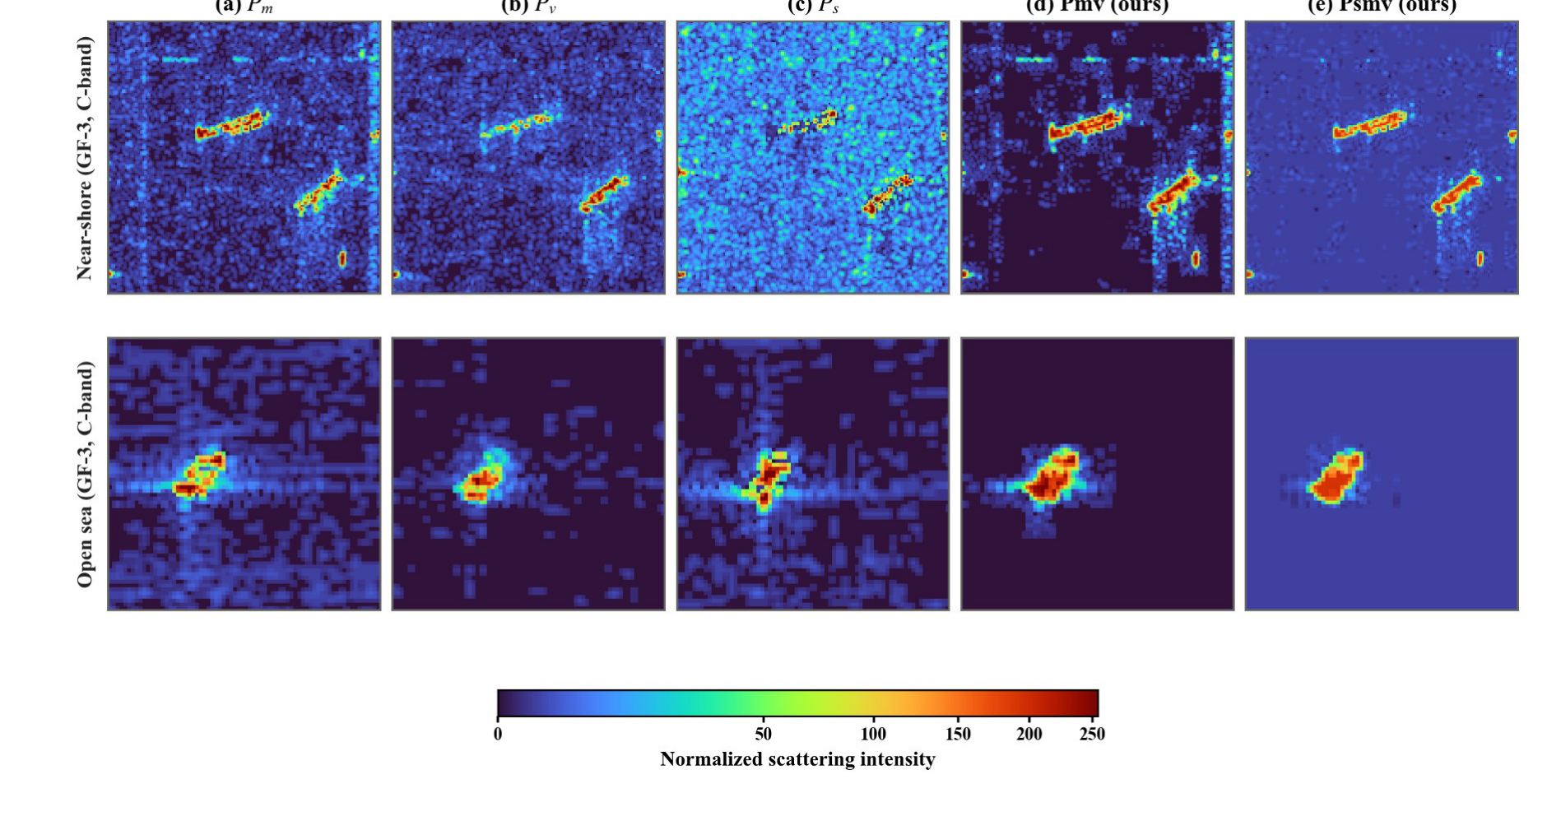
Fig. 9. Visual comparison of five representations: (a)-(c) the three decomposition components; (d), (e) the two descriptors (ours).
As the sea-dominated component, Ps is anti-correlated with ship membership: its raw AUC is 0.3132, equivalent to 0.6868 after sign inversion, which reflects that surface scattering dominates the sea, not the ship. Pm and Pv provide basic discrimination, with AUCs of 0.8223 and 0.8950. Pmv reaches 92.17% accuracy, 7.57 points above the best single component, and an AUC of 0.9772, 8.22 points above it; however, the raw sum Pm+Pv reaches 92.25% and the same AUC of 0.9772. The gain of Pmv is therefore not in ranking but in the bounded (0,1) output and its calibration for the detector. The 29-node variant reaches 95.34% and an AUC of 0.9867; it is reported as a high-complexity reference and is not used in detection.
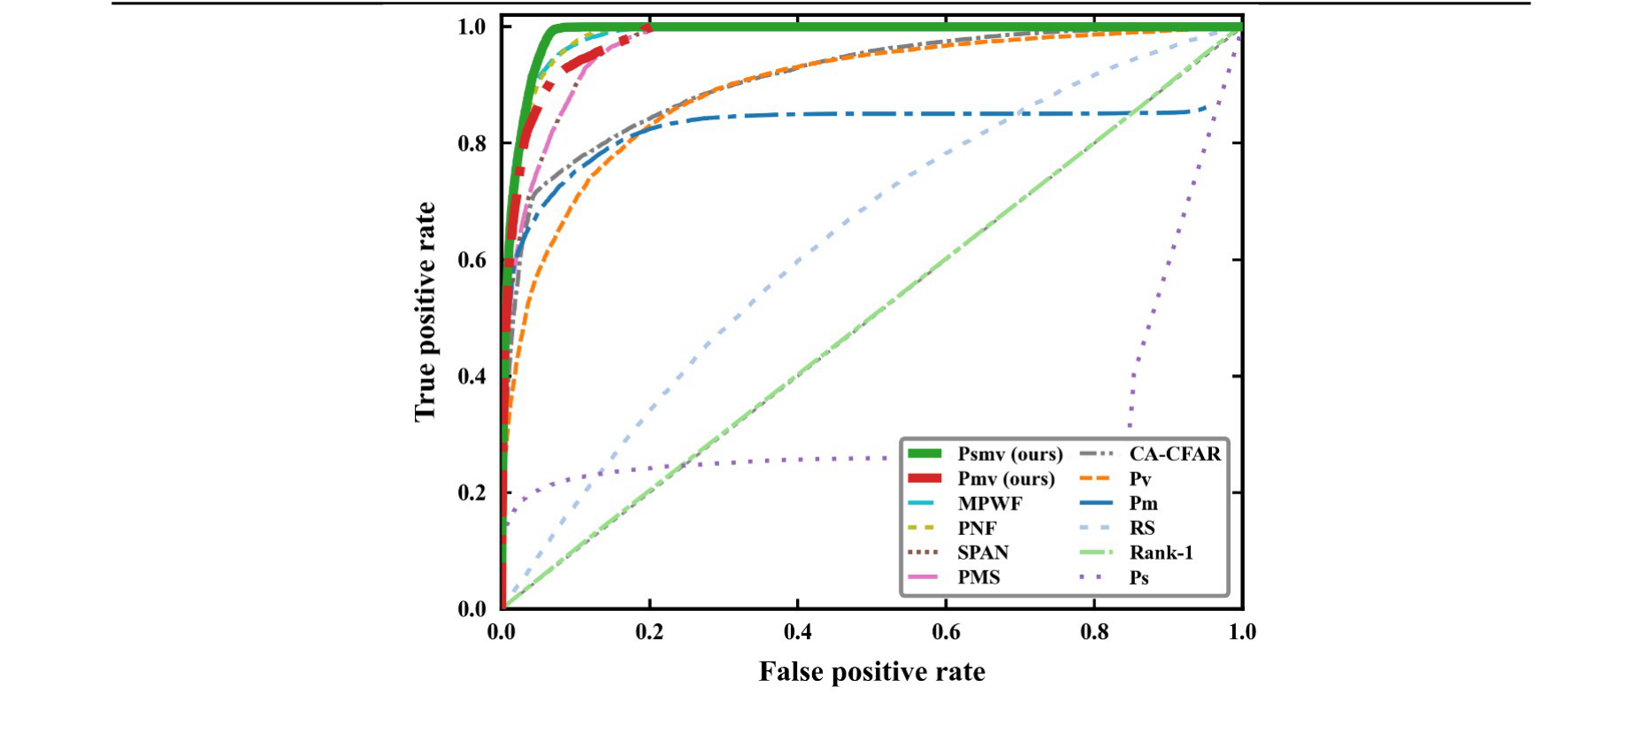
Fig. 10. ROC comparison of twelve representations on the 1:2 balanced test sample.
The results indicate that the descriptor preserves the ranking information of P_{m}+P_{v} while providing a bounded, closed-form output. It is more accurate than individual components and handcrafted features, but it does not add new ranking information.
Target-to-clutter ratio (TCR) gives a second view. On the 115-tile common set, Pmv has a median TCR of 26.0 dB, 6.9 dB above the best traditional single feature Pm (19.1 dB); Psmv has 17.1 dB, lower than Pmv but a more uniform response inside the hull. By sensor, Pmv reaches 28.6, 22.7 and 8.3 dB on GF-3, Radarsat-2 and AIRSAR; the low AIRSAR value is consistent with its L-band, low-look data.

TABLE V
Single-Channel Detection Performance of YOLOv8n at the Validation-Selected Operating Point
Input Feature | Precision (%) | Recall (%) | mAP@0.5 (%) | F1 (%)
P_{s} | 74.2 | 65.2 | 71.1 | 69.4
P_{m} | 72.0 | 66.9 | 73.2 | 69.4
P_{v} | 79.3 | 67.4 | 74.3 | 72.9
P_{mv} (ours) | 80.1 | 66.7 | 76.5 | 72.8
P_{m}+P_{v} (raw sum) | 74.8 | 66.1 | 73.7 | 70.2

D. Target-Level Detection and Architecture Generalization
This section evaluates the descriptor at three levels: single-feature input, component replacement, and architecture generalization.
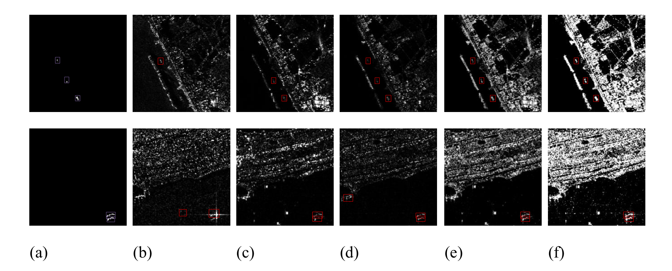
Fig. 11. Visual detection results of YOLOv8n with different input features: (a) ship binary mask; (b)-(f) single-channel P_{s}, P_{m}, P_{v}, P_{mv} (ours), and P_{smv} (ours).
In the single-channel experiment, each polarimetric feature is used as the sole input channel of YOLOv8n. The results are shown in Table V, with visual results in Fig. 11 and PR curves in Fig. 13(a).
The single-channel mAP@0.5 of P_{mv} is 0.765, higher than the raw sum (0.737) and the three traditional single features (0.711–0.743). Because P_{mv} and the raw sum have the same AUC, this gain is attributed to the bounded output scale, which reduces the dynamic range that the detector must learn. P_{smv} is not included in the detection comparison: its 29-node expression is less interpretable and its pixel-level gain is small.
TABLE VI
Three-Channel Detection Performance of YOLOv8n
Input Feature | Precision (%) | Recall (%) | mAP@0.5 (%) | F1 (%)
[P_{m}, P_{v}, P_{s}] | 79.1 | 73.5 | 80.0 | 76.2
[P_{mv}, P_{v}, P_{s}] | 80.1 | 76.8 | 82.5 | 78.4
[P_{m}, P_{mv}, P_{s}] | 81.0 | 69.9 | 78.0 | 75.0
[P_{m}, P_{v}, P_{mv}] | 79.6 | 73.8 | 79.1 | 76.6
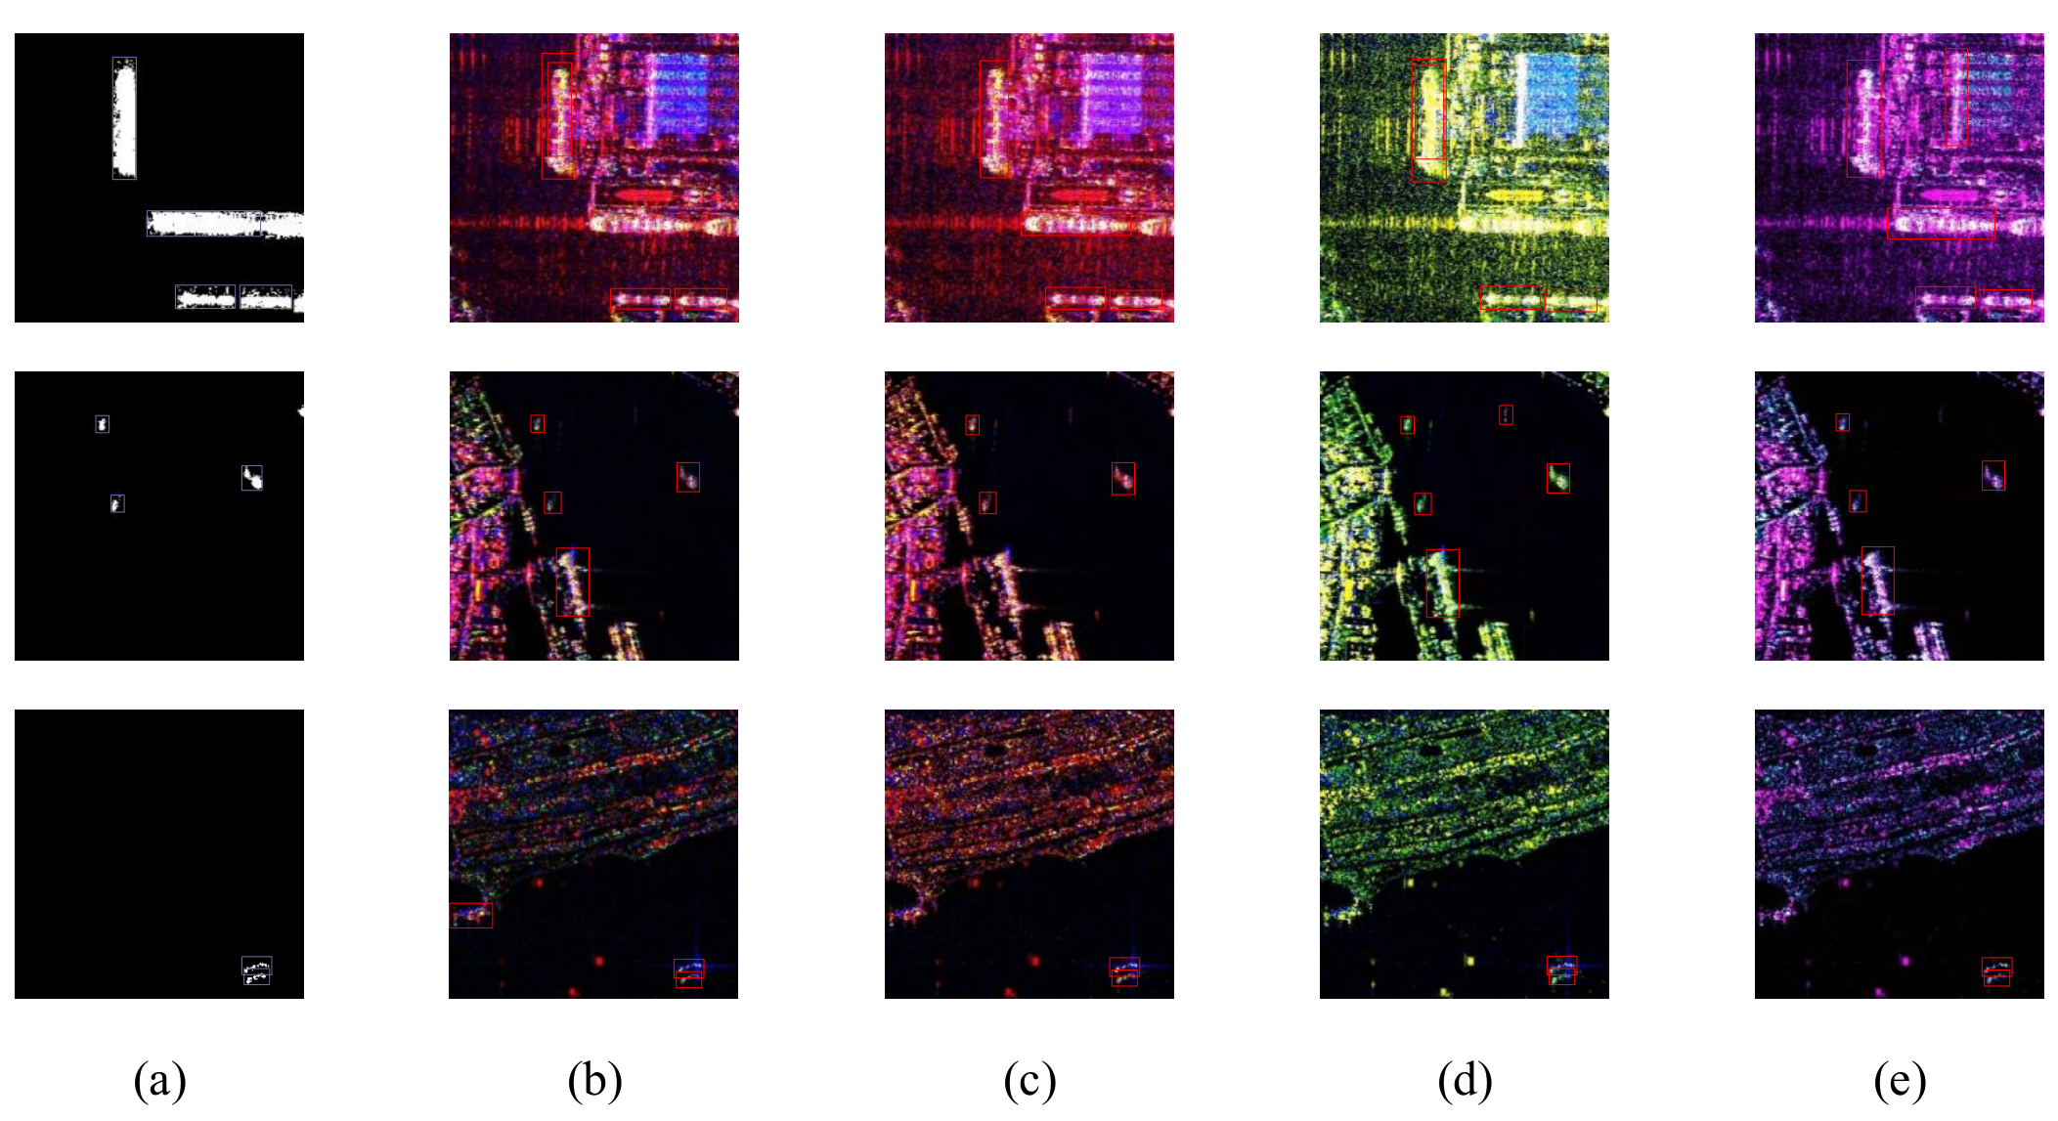
Fig. 12. Visual detection results of YOLOv8n with different three-channel combinations: (a) ship binary mask; (b)-(e) [P_{m},P_{v},P_{s}], [P_{mv},P_{v},P_{s}] (best), [P_{m},P_{mv},P_{s}], and [P_{m},P_{v},P_{mv}].
With the conventional combination [P_{m}, P_{v}, P_{s}] as the baseline, a new combination [P_{mv}, P_{v}, P_{s}] is built by substituting P_{m} with the descriptor. Precision rises from 79.1% to 80.1%, recall from 73.5% to 76.8%, and mAP@0.5 from 0.800 to 0.825 (Table VI). No other replacement improves both recall and mAP, so substituting P_{m} is the selected scheme (PR curves in Fig. 13(b)). Visual results are shown in Fig. 12.
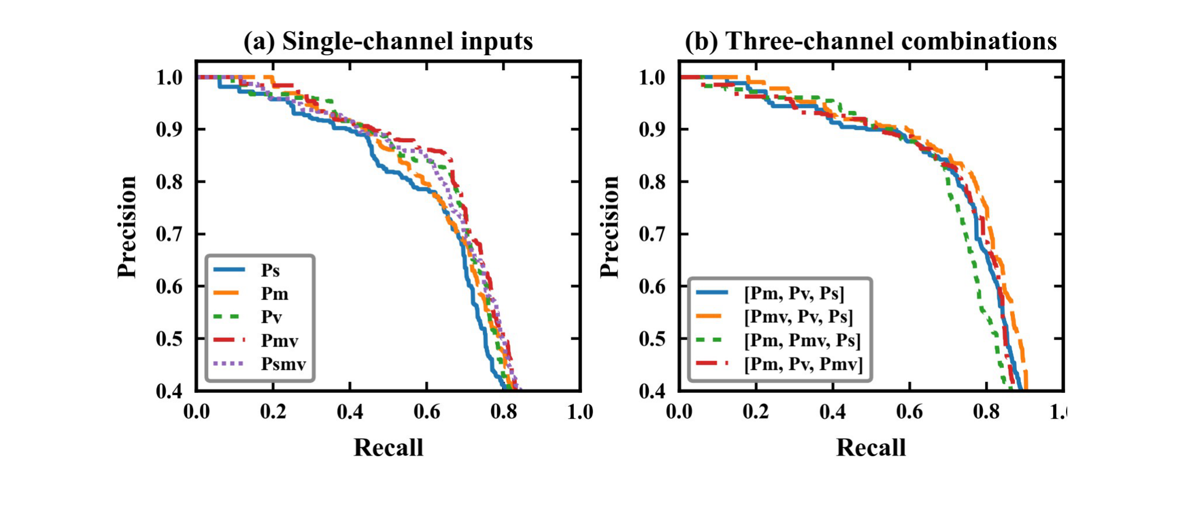
Fig. 13. PR curves of YOLOv8n: (a) single-channel inputs; (b) three-channel combinations.
The selected combination and the original [Pm, Pv, Ps] are compared across eight detectors (Table VII): four YOLO variants and four MMDetection detectors. All eight improve in mAP@0.5, with gains from +0.5 to +2.5 percentage points. YOLO rows use 640x640 input and 300 epochs; MMDetection rows use batch 4 and 12 epochs. The controlled evidence is the within-architecture replacement of Pm by Pmv. Precision and recall trade off in some rows: YOLOv11 precision rises from 78.7% to 82.4% and recall from 68.0% to 74.7%, while YOLO26 precision rises from 66.7% to 70.7% and recall falls from 66.5% to 65.7%; SSD recall rises from 16.6% to 27.4% while precision falls from 87.8% to 86.1%. The mAP gain is therefore not uniform across metrics.
TABLE VII
Performance Comparison of Eight Detectors
Detection Network | Baseline P/R (%) | Ours P/R (%) | Baseline mAP@0.5/F1 | Ours mAP@0.5/F1
YOLOv8 | 79.1/73.5 | 80.1/76.8 | 80.0/76.2 | 82.5/78.4
YOLOv11 | 78.7/68.0 | 82.4/74.7 | 78.7/72.9 | 80.9/78.4
YOLOv12 | 77.6/69.3 | 77.7/70.5 | 76.6/73.2 | 77.6/73.9
YOLO26 | 66.7/66.5 | 70.7/65.7 | 69.7/66.6 | 71.1/68.1
RetinaNet | 79.0/75.2 | 81.8/74.5 | 80.5/77.0 | 81.9/78.0
Faster R-CNN | 75.6/79.6 | 76.1/81.7 | 80.2/77.5 | 81.1/78.8
SSD | 87.8/16.6 | 86.1/27.4 | 63.4/28.0 | 64.4/41.5
PAA | 72.7/81.7 | 69.8/80.8 | 80.8/76.9 | 81.3/74.9
Note: YOLO rows use 640x640 input and 300 epochs; MMDetection rows use batch 4 and 12 epochs, with 1333x800 input for R50-FPN and 300x300 for SSD300. The controlled comparison is the within-row replacement of Pm by Pmv; absolute scores across architectures are not directly comparable.

E. Pixel-Level Extraction With Two-Layer Fusion
The intelligent layer carries a prototype-mask pixel branch trained with the hard labels inside candidate boxes. The branch outputs a pixel-level ship probability for each box. The general layer thresholds the explicit descriptor inside the same box, and the two pixel-level evidence maps are combined by a logical OR, followed by connected-component filtering and a minimum-area rule.
Table VIII reports the pixel-level results on the 122 test tiles that passed the mask-image consistency check. The two-layer fusion reaches 59.8% precision, 57.1% recall, 58.4% F1 and 41.3% IoU. The single-threshold in-box descriptor has the highest precision (61.5%) but lower F1, while the fusion gives the best F1 and IoU. The difference is small, and the main benefit of the two-layer design is that it outputs both candidate boxes and pixel-level contours while keeping the descriptor evidence inspectable. Fig. 14 visualizes the four stages.
TABLE VIII
Pixel-Level Extraction Performance of the Two-Layer Framework
Scheme | Prec. | Rec. | F1 | IoU
Global descriptor | 0.281 | 0.249 | 0.264 | 0.152
Boxes only | 0.224 | 0.793 | 0.349 | 0.212
Descriptor, single T | 0.615 | 0.543 | 0.577 | 0.405
Descriptor, double T | 0.574 | 0.584 | 0.579 | 0.407
Pixel branch | 0.609 | 0.550 | 0.578 | 0.407
Fusion (OR) | 0.598 | 0.571 | 0.584 | 0.413
Operating points: global descriptor T=168, single threshold T=32, double threshold 128/16, pixel branch 0.20, fusion 0.20/96; A_min=16 in all rows.
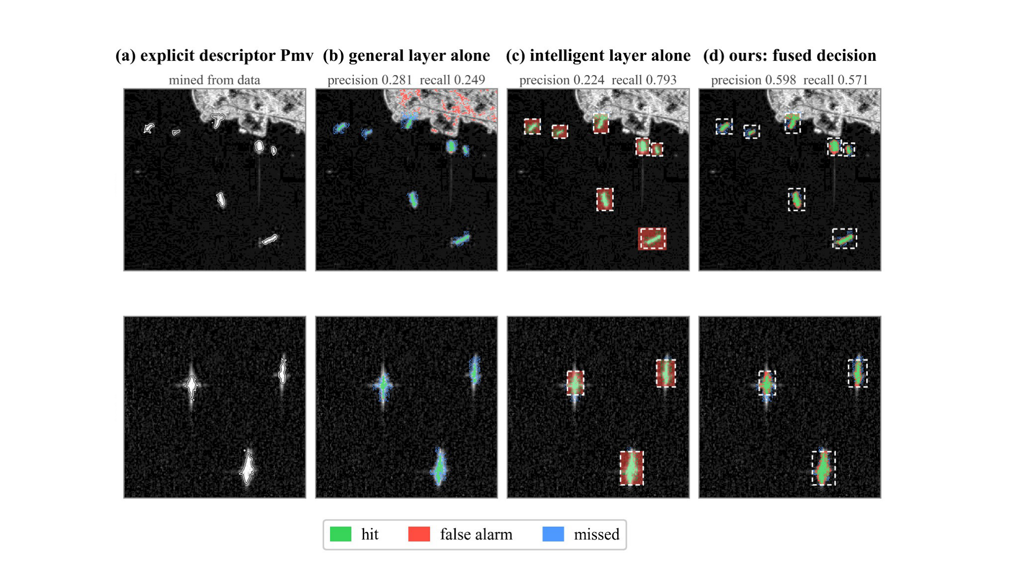
Fig. 14. Step-by-step comparison of the two-layer decision: (a) explicit-descriptor response without boxes; (b) general layer alone on the full image; (c) intelligent layer alone (all pixels in the box are targets); (d) fusion within the box. Green, red and blue denote hits, false alarms and misses; white dashed boxes are candidate boxes.

F. Ablation Study
In this section, three sets of ablation experiments are conducted to verify the necessity of each core component of the proposed method and quantify their respective contributions to the overall detection performance.
To verify the guidance of soft-label distillation, a control group (Direct-SR) is built by training the symbolic regression directly on the discrete hard labels, with no teacher. At the complexity of the low-complexity optimum, both supervisors lead to the same exponential form and the same single-channel AUC of 0.9772, which is expected because a fitted constant does not affect a rank-based metric. The variants differ at the high-complexity end: soft labels keep the front smooth and monotone and reach an AUC of 0.9867 (the 29-node variant of Table IV), whereas hard labels drift into oscillatory nestings that are no longer interpretable and reach only 0.9813. Soft labels mainly change the structure of the admissible solutions, not the accuracy of the compact operator (Fig. 15). Five of seven independent runs recovered the exponential form; the other two converged to a different local optimum (AUC 0.9598) and are reported in the supplementary material.
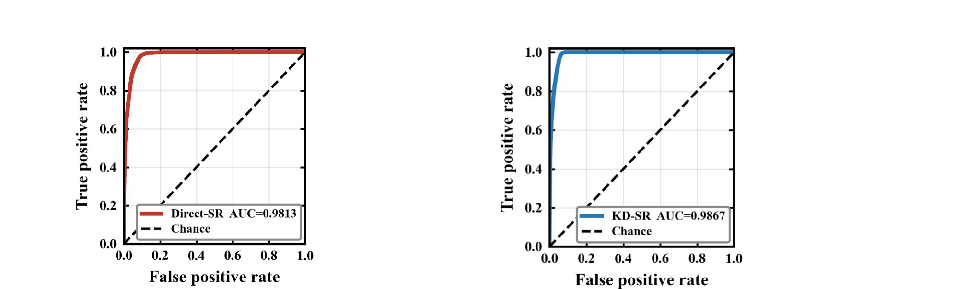
Fig. 15. ROC curves of the symbolic-regression ablation: (a) Direct-SR with hard-label supervision; (b) KD-SR with soft-label supervision.
Three operator-set ablations quantify the effect of the operator configuration (Fig. 16). The baseline set of linear and ratio operations cannot fit the sigmoidal mapping from scattering power to membership and must approximate it by heavy nesting, which produces redundant expressions that are difficult to interpret; nonlinear operators are therefore necessary. Adding exp improves the low-complexity accuracy markedly, showing that it is the core physical operator: it realizes the smooth mapping from scattering magnitude to membership directly. The power and trigonometric operators of the full set then correct local residuals through multivariate interaction at high complexity, avoiding redundant stacking of the same variable.
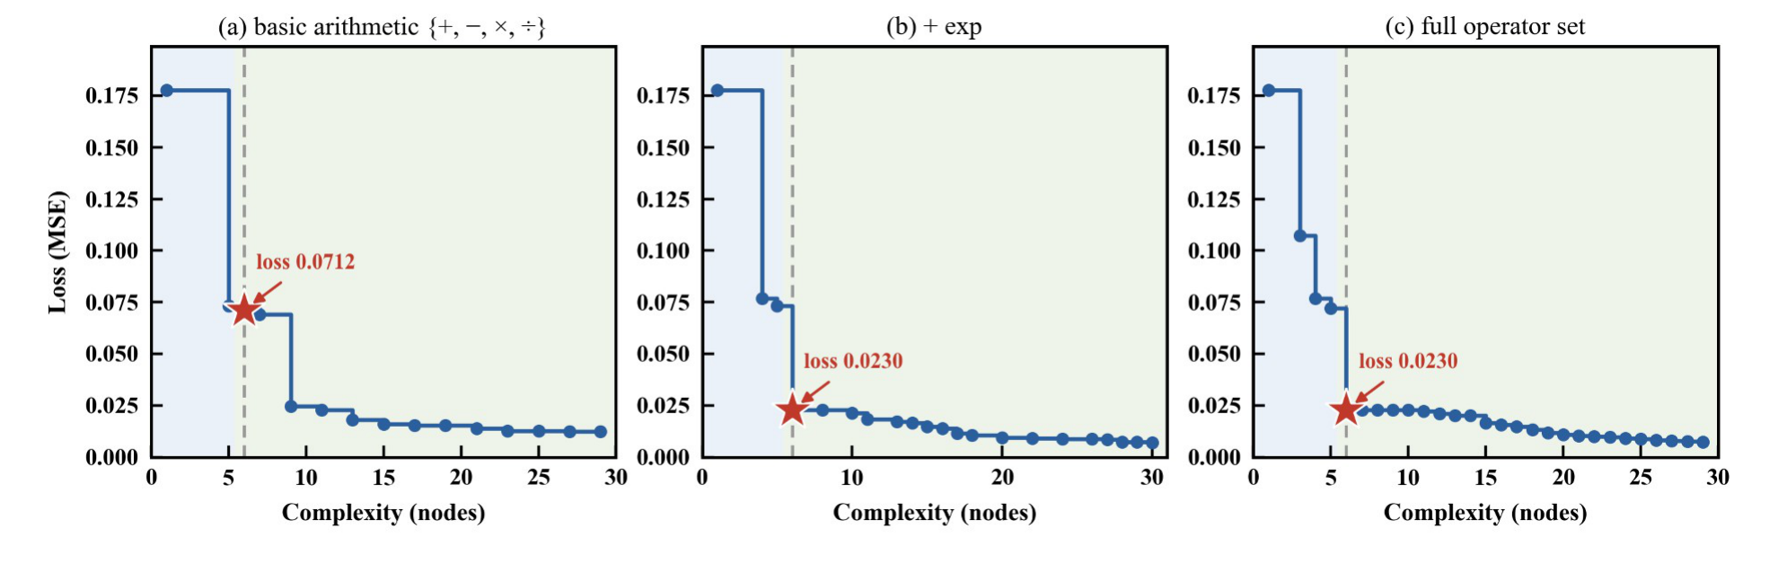
Fig. 16. Pareto frontiers under different operator sets: (a) basic arithmetic; (b) with exp; (c) full operator set.
Finally, to investigate the influence of input features, two subsets are evaluated: the dual-feature set {P_{m}, P_{v}} and the complete three-feature set {P_{s}, P_{m}, P_{v}}. With only P_{m} and P_{v}, symbolic regression still converges stably to the exponential form, confirming that the ship-characteristic and volume components are the key discriminative features. Adding P_{s} does not change the low-complexity expression but improves the high-complexity front (AUC 0.9715 to 0.9867), indicating that P_{s} is not needed for the compact descriptor but can refine high-complexity fits.
P_{s} does not appear in the optimal low-complexity expression, so the search discards it when only the compact descriptor is required. This is consistent with the fact that surface scattering is dominated by the sea background; the three-channel detector still uses P_{s} because it provides complementary background context.

IV. DISCUSSION

A. Physical Mechanism of the Scattering Descriptor
The low-complexity descriptor admits a simple physical and mathematical interpretation.
Physically, P_{m} and P_{v} capture ship-specific double-bounce/helix and volume scattering, both strong over vessels and weak over the sea. The search selects their sum instead of a ratio or product. A direct evaluation shows that the raw sum has the same AUC (0.9772); P_{mv} therefore changes the output scale, not the pixel ranking.
Mathematically, exp(-c/x) maps x = P_{m}+P_{v} to (0,1): it tends to 0 for x much smaller than c and to 1 for x much larger than c, and its slope is largest at intermediate powers. In the 8-bit rendering used by the detector, this mapping expands the low-power range and compresses the high-power range, which reduces the dynamic range and stabilizes the input scale. It does not change the ranking.
The 29-node variant adds a P_{s} nonlinearity and improves pixel accuracy to 95.34% and AUC to 0.9867, but it is less interpretable and is not used in detection. The two formulas represent an accuracy-interpretability trade-off not a monotone improvement.

B. Synergy Mechanism of Accuracy, Lightweight Design and Interpretability
Conventional knowledge distillation compresses networks while retaining black-box logic. The method here converts implicit MLP knowledge into closed-form expressions and balances detection accuracy, deployment cost and interpretability.
The descriptor itself requires one addition, one division, one exponential operation and one constant. This count excludes the Yamaguchi decomposition and the detector; its storage is negligible compared with the 4,481-parameter teacher MLP. The mapping is deterministic and easy to inspect, but the end-to-end cost is dominated by decomposition and detection.
For engineering integration, the descriptor is a plug-and-play input channel: replacing P_{m} requires no architectural change or extra tuning. The mAP gains are observed within each architecture; cross-architecture absolute comparisons are not controlled because the training budgets differ.

C. Generalization and Scalability
The multi-band, multi-source training set was constructed to extract scattering rules that hold across sensors not sensor-specific noise. Because the search fits the same physical quantity across sensors, the resulting formulas contain no sensor-specific terms and transfer across platforms, consistent with prior cross-sensor PolSAR research [20].
TABLE IX
Cross-Dataset AUC Comparison
Method | PSDD AUC | IPSD AUC | IPSD F1
Psmv (C29) | 98.7 | 96.9 | 92.0
P_{mv} (ours) | 97.7 | 97.5 | 90.3
SPAN | 96.8 | 95.0 | 87.9
PMS | 96.8 | 97.7 | 89.2
PNF | 98.4 | 91.5 | 76.7
MPWF | 98.4 | 64.1 | 62.6
P_{m} | 82.7 | 88.3 | 80.3
P_{v} | 89.4 | 64.7 | 57.2
P_{s} | 31.4 | 57.5 | 44.8
RS | 63.3 | 55.4 | 45.6
Rank-1 | 50.2 | 53.2 | 43.3
CA-CFAR | 91.2 | 76.0 | 65.1
On the third-party IPSD dataset, the six-node descriptor reaches an AUC of 97.5% after a single scalar calibration, and the 29-node variant reaches 96.9%; on PSDD the corresponding values are 97.7% and 98.7%. Because both datasets use the same threshold rule for pixel labels, the experiment tests cross-sensor consistency under a shared labeling rule; it does not test agreement with independent annotations. The calibration is one scalar applied to Pm+Pv; neither the expression nor its constant changes. Table IX summarizes the AUC values.
The teacher-student procedure is not specific to PolSAR and can be adapted to other remote-sensing tasks: for PolSAR classification, descriptors can be generated for different land-cover types from target decomposition; for hyperspectral imagery, explicit spectral-ground mapping rules can be mined; for infrared detection, interpretable background-suppression operators can be constructed.
Most interpretable remote-sensing methods still rely on network-derived features [60]. The descriptor in this work can be read and checked directly, and the study shows how polarimetric decomposition, knowledge distillation and symbolic regression can be combined.

D. Limitations
Several limitations apply. First, all pixel-level metrics are computed on a 1:2 balanced sample; the natural positive prevalence is about 0.86%, so the reported precision is higher than what deployment prevalence would produce. Second, the detection experiments follow the benchmark tile-level split, in which tiles from 20 of the 23 scenes appear in both training and test sets; overlapping tiles and shared scenes can inflate the absolute scores, and a scene-level split is needed for a deployment estimate. Third, the pixel labels are generated by a fixed BT.601 luminance threshold (τ = 40), and the IPSD labels use the same rule; the cross-dataset experiment tests consistency under a shared labeling rule, not agreement with independent annotations.
Fourth, the detector results are single-run, and the architecture comparison covers eight detectors: four YOLO variants and four MMDetection detectors. Only the within-architecture input replacement is controlled. Fifth, the low-complexity descriptor is rank-equivalent to Pm+Pv; its value is a bounded, closed-form output. Sixth, the 29-node variant is reported only at the pixel level and is not used for detection, and no PolSAR-specific detector was compared under the same protocol. These limitations restrict the quantitative scope; they do not affect the reproducibility of the descriptor or the main trend.

V. CONCLUSION
This article presented a knowledge-distillation-guided symbolic-regression method for learning an explicit polarimetric descriptor for PolSAR ship detection. A teacher MLP converts threshold labels into soft pixel labels, and a bi-objective search selects a six-node descriptor that is embedded into detectors as an input channel and used for box-gated pixel extraction.
The results support three findings. First, the six-node descriptor Pmv = exp(-c/(Pm+Pv)) is a monotone, bounded rescaling of Pm+Pv: it has the same AUC (0.9772) as the raw sum and provides a closed-form, unit-interval output. Its value lies in interpretability, traceability, and detector-input calibration, not additional ranking information. Second, in the three-channel input, Pmv raises the YOLOv8n mAP@0.5 from 80.0% to 82.5%, and all eight detectors improve in mAP@0.5; the controlled evidence is the within-architecture replacement of Pm by Pmv. Third, soft labels mainly affect the high-complexity solution structure: hard- and soft-label searches recover the same low-complexity form, while soft labels keep the Pareto front smooth at higher complexity.
The method is limited by balanced-sample evaluation, tile-level splits with shared scenes, a shared labeling rule for cross-dataset testing, single-run detection results, and the eight-detector scope. Scene-level splits, independent pixel annotations and multiple seeds are needed before deployment claims. Future work will extend the method to other PolSAR tasks and validate it with independent annotations and PolSAR-specific detectors.

DATA AVAILABILITY
The implementation of the method described in this paper is openly available at https://github.com/lhm-shuai/polsar-kd-sr. It covers the Yamaguchi decomposition and the labelling rule of Section II-A, the teacher of Section II-A, the symbolic regression search of Section II-B, and the pixel-level and detector-level evaluation. The PSDD dataset is third-party and is not redistributed; it should be obtained from the sources described in [51], [52].
REFERENCES
[1] C. Zhang et al., "An overview of polarized synthetic aperture radar ship detection: From traditional methods to artificial intelligence," IEEE Geosci. Remote Sens. Mag., vol. 13, no. 4, pp. 174–209, Dec. 2025.
[2] J. Wang, S. Quan, Z. Cai, S. Xing, Y. Li, and W. Meng, "Translation difference characterization for PolSAR ship extraction," IEEE Trans. Geosci. Remote Sens., vol. 64, Art. no. 5202415, 2026.
[3] Z. Sun et al., "Arbitrary-direction SAR ship detection method for multiscale imbalance," IEEE Trans. Geosci. Remote Sens., vol. 63, Art. no. 5208921, 2025.
[4] Y. Li, W. Zhu, C. Li, and C. Zeng, "SAR image near-shore ship target detection in complex background," Int. J. Remote Sens., vol. 44, no. 3, pp. 924–952, 2023.
[5] G. Song, Y. Deng, H. Zhang, X. Liu, and S. Chang, "Improving SAR ship detection accuracy by optimizing polarization modes: A study of generalized compact polarimetry (GCP) performance," Remote Sens., vol. 17, no. 11, Art. no. 1951, Jun. 2025.
[6] M. di Bisceglie and C. Galdi, "CFAR detection of extended objects in high-resolution SAR images," IEEE Trans. Geosci. Remote Sens., vol. 43, no. 4, pp. 833–843, Apr. 2005.
[7] G. Gao and G. Shi, "CFAR ship detection in nonhomogeneous sea clutter using polarimetric SAR data based on the notch filter," IEEE Trans. Geosci. Remote Sens., vol. 55, no. 8, pp. 4811–4824, Aug. 2017.
[8] V. Larson, L. Novak, and C. Stewart, "Joint spatial-polarimetric whitening filter to improve SAR target detection performance for spatially distributed targets," in Proc. SPIE, vol. 2230, Orlando, FL, USA, 1994, pp. 285–301.
[9] G. Liu, S. Huang, A. Torre, and F. Rubertone, "The multilook polarimetric whitening filter (MPWF) for intensity speckle reduction in polarimetric SAR images," IEEE Trans. Geosci. Remote Sens., vol. 36, no. 3, pp. 1016–1020, May 1998.
[10] W. Fan, F. Zhou, M. Tao, X. Bai, X. Shi, and H. Xu, "An automatic ship detection method for PolSAR data based on K-Wishart distribution," IEEE J. Sel. Topics Appl. Earth Observ. Remote Sens., vol. 10, no. 6, pp. 2725–2737, Jun. 2017.
[11] S. R. DeGraaf, "SAR image enhancement via adaptive polarization synthesis and polarimetric detection performance," in Proc. Polarimetric Technol. Workshop, vol. I.1, Redstone Arsenal, AL, USA, Aug. 1988, pp. 615–631.
[12] N. Wang, G. Shi, L. Liu, L. Zhao, and G. Kuang, "Polarimetric SAR target detection using the reflection symmetry," IEEE Geosci. Remote Sens. Lett., vol. 9, no. 6, pp. 1104–1108, Nov. 2012.
[13] A. Marino, "A notch filter for ship detection with polarimetric SAR data," IEEE J. Sel. Topics Appl. Earth Observ. Remote Sens., vol. 6, no. 3, pp. 1219–1232, Jun. 2013.
[14] S. R. Cloude, "Target detection using rank-1 polarimetric processing," IEEE Geosci. Remote Sens. Lett., vol. 18, no. 4, pp. 717–720, Apr. 2021.
[15] H. Li, S. Liu, and S. Chen, "PolSAR ship characterization and robust detection at different grazing angles with polarimetric roll-invariant features," IEEE Trans. Geosci. Remote Sens., vol. 62, Art. no. 5219712, 2024.
[16] S. Quan, T. Zhang, S. Xing, X. Wang, and Q. Yu, "Maritime ship detection with concise polarimetric characterization pattern," Int. J. Appl. Earth Observ. Geoinf., vol. 131, Art. no. 103954, Jul. 2024.
[17] Y. Yamaguchi, T. Moriyama, M. Ishido, and H. Yamada, "Four-component scattering model for polarimetric SAR image decomposition," IEEE Trans. Geosci. Remote Sens., vol. 43, no. 8, pp. 1699–1706, Aug. 2005.
[18] A. Sato, Y. Yamaguchi, G. Singh, and S.-E. Park, "Four-component scattering power decomposition with extended volume scattering model," IEEE Geosci. Remote Sens. Lett., vol. 9, no. 2, pp. 166–170, Mar. 2012.
[19] J. Wang, S. Quan, S. Xing, et al., "PSO-based fine polarimetric decomposition for ship scattering characterization," ISPRS J. Photogramm. Remote Sens., vol. 220, pp. 18–31, Feb. 2025.
[20] C. Zhang, G. Gao, L. Zhang, et al., "A novel full-polarization SAR image ship detector based on scattering mechanisms and wave polarization anisotropy," ISPRS J. Photogramm. Remote Sens., vol. 190, pp. 129–143, Oct. 2022.
[21] C. Qin, L. Zhang, X. Wang, G. Li, Y. He, and Y. Liu, "RDB-DINO: An improved end-to-end transformer with refined de-noising and boxes for small-scale ship detection in SAR images," IEEE Trans. Geosci. Remote Sens., vol. 63, Art. no. 5207617, 2025.
[22] Y. Chen, J. Yan, Y. Liu, and Z. Gao, "LRS2-DM: Small ship target detection in low-resolution remote sensing images based on diffusion models," IEEE Trans. Geosci. Remote Sens., vol. 63, Art. no. 5211215, 2025.
[23] Z. Cai, S. Quan, J. Wang, et al., "MaOutCNN: A physical mechanism coupled MambaOut-CNN detection network with maiden-released interference polarized ship detection dataset," ISPRS J. Photogramm. Remote Sens., vol. 236, pp. 500–527, 2026.
[24] Y. Yin, Z. Yang, H. Shi, F. Meng, and W. Li, "Ship detection transformer in SAR images based on key scattering points feature aggregation and context feature refinement," IEEE J. Sel. Topics Appl. Earth Observ. Remote Sens., vol. 18, pp. 17820–17836, 2025.
[25] Z. Zhou, S. Li, Y. Lv, et al., "LightKD-SAR: Lightweight architecture with knowledge distillation for high-performance SAR object detection," IEEE J. Sel. Topics Appl. Earth Observ. Remote Sens., vol. 19, pp. 4935–4949, 2026.
[26] G. Hinton, O. Vinyals, and J. Dean, "Distilling the knowledge in a neural network," arXiv:1503.02531, 2015. [Online]. Available: https://arxiv.org/abs/1503.02531
[27] W. Zhou, Y. Li, J. Huang, Y. Liu, and Q. Jiang, "MSTNet-KD: Multilevel transfer networks using knowledge distillation for the dense prediction of remote-sensing images," IEEE Trans. Geosci. Remote Sens., vol. 62, Art. no. 4504612, 2024.
[28] X. Yang, H. Zhang, S. Zhang, and N. Wang, "Prompt-driven knowledge distillation for remote sensing object detection," IEEE Trans. Image Process., vol. 35, pp. 3023–3037, 2026.
[29] S. Chen, R. Zhan, W. Wang, et al., "Learning slimming SAR ship object detector through network pruning and knowledge distillation," IEEE J. Sel. Topics Appl. Earth Observ. Remote Sens., vol. 14, pp. 1267–1282, 2021.
[30] Y. Himeur et al., "Applications of knowledge distillation in remote sensing: A survey," Inf. Fusion, vol. 115, Art. no. 102742, Mar. 2025.
[31] Y. Cheng, D. Wang, P. Zhou, and T. Zhang, "Model compression and acceleration for deep neural networks: The principles, progress, and challenges," IEEE Signal Process. Mag., vol. 35, no. 1, pp. 126–136, Jan. 2018.
[32] N. Otsu, "A threshold selection method from gray-level histograms," IEEE Trans. Syst., Man, Cybern., vol. SMC-9, no. 1, pp. 62–66, Jan. 1979.
[33] Recommendation ITU-R BT.601-7, "Studio encoding parameters of digital television for standard 4:3 and wide-screen 16:9 aspect ratios," Int. Telecommun. Union, Geneva, Switzerland, Mar. 2011.
[34] M. Schmidt and H. Lipson, "Distilling free-form natural laws from experimental data," Science, vol. 324, no. 5923, pp. 81–85, Apr. 2009.
[35] W. La Cava et al., "Contemporary symbolic regression methods and their relative performance," in Proc. Adv. Neural Inf. Process. Syst. (NeurIPS), Datasets Benchmarks Track, 2021. [Online]. Available: https://arxiv.org/abs/2107.14351
[36] M. Cranmer, "PySR: Fast and parallelized symbolic regression in Python/Julia," 2020, doi: 10.5281/zenodo.4041459.
[37] S.-H. Jang, "GoodRegressor: A general-purpose symbolic regression framework for physically interpretable materials modeling," arXiv:2510.18325, 2025. [Online]. Available: https://arxiv.org/abs/2510.18325
[38] M. Udrescu and T. Tegmark, "AI Feynman: A physics-inspired method for symbolic regression," Sci. Adv., vol. 6, no. 16, Art. no. eaay2631, Apr. 2020.
[39] S. Brunton, J. Proctor, and J. Kutz, "Discovering governing equations from data by sparse identification of nonlinear dynamical systems," Proc. Natl. Acad. Sci. USA, vol. 113, no. 15, pp. 3932–3937, Apr. 2016.
[40] Q. Li, C. Zhang, Z. Wei, et al., "Advancing symbolic regression for earth science with a focus on evapotranspiration modeling," npj Climate Atmos. Sci., vol. 7, no. 1, Art. no. 321, 2024.
[41] Z. Yu, M. Y. I. Idris, and P. Wang, "Physics-constrained symbolic regression from imagery," in Proc. 2nd AI Math Workshop, 42nd Int. Conf. Mach. Learn. (ICML), Vancouver, BC, Canada, Jul. 2025.
[42] Z. Yu, M. Y. I. Idris, P. Wang, Y. Xia, F. Ma, and R. Qureshi, "SatelliteFormula: Multi-modal symbolic regression from remote sensing imagery for physics discovery," arXiv:2506.06176, 2025. [Online]. Available: https://arxiv.org/abs/2506.06176
[43] M. Cranmer et al., "Discovering symbolic models from deep learning with inductive biases," in Proc. Adv. Neural Inf. Process. Syst. (NeurIPS), 2020, pp. 17429–17442.
[44] A. Shmuel, T. Lazebnik, and O. Glickman, "Follow the forest trail: Distillation by gradient boosting models to enhance symbolic regression performance," IEEE Access, vol. 14, pp. 19701–19712, 2026.
[45] S. Liu, Q. Li, X. Shen, J. Sun, and Z. Yang, "Automated discovery of symbolic laws governing skill acquisition from naturally occurring data," Nat. Comput. Sci., vol. 4, no. 5, pp. 334–345, May 2024.
[46] E. S. Z. Tan, A. Soubki, and M. Cranmer, "SymTorch: Symbolic distillation of neural networks," arXiv:2602.21307, 2026. [Online]. Available: https://arxiv.org/abs/2602.21307
[47] A. Shmuel, N. Koren, O. Glickman, and T. Lazebnik, "Interpretable knowledge distillation via symbolic regression for feedforward neural networks," Neural Comput. Appl., vol. 38, no. 7, Art. no. 243, Apr. 2026.
[48] K. S. Fong and M. Motani, "Pareto-optimal fronts for benchmarking symbolic regression algorithms," in Proc. 42nd Int. Conf. Mach. Learn. (ICML), Vancouver, BC, Canada, Jul. 2025, pp. 17392–17410.
[49] J. R. Koza, Genetic Programming: On the Programming of Computers by Means of Natural Selection. Cambridge, MA, USA: MIT Press, 1992.
[50] R. P. Brent, Algorithms for Minimization Without Derivatives. Englewood Cliffs, NJ, USA: Prentice-Hall, 1973.
[51] G. Gao, Q. Bai, C. Zhang, L. Zhang, and L. Yao, "Dualistic cascade convolutional neural network dedicated to fully PolSAR image ship detection," ISPRS J. Photogramm. Remote Sens., vol. 202, pp. 663–681, Aug. 2023.
[52] G. Gao, G. Yang, C. Zhang, Q. Bai, C. Li, L. Zhang, and D. Duan, "PSDD: A benchmark PolSAR dataset for CNN performance evaluation of ship detection," IEEE Aerosp. Electron. Syst. Mag., vol. 41, no. 4, pp. 36–54, Apr. 2026.
[53] G. Jocher, J. Qiu, M. Liu, et al., "Ultralytics YOLO26: Unified real-time end-to-end vision models," arXiv:2606.03748, Jun. 2026. [Online]. Available: https://arxiv.org/abs/2606.03748
[54] Z. Tian, C. Shen, H. Chen, and T. He, "FCOS: Fully convolutional one-stage object detection," in Proc. IEEE/CVF Int. Conf. Comput. Vis. (ICCV), Seoul, South Korea, 2019, pp. 9627–9636.
[55] T.-Y. Lin, P. Goyal, R. Girshick, K. He, and P. Dollár, "Focal loss for dense object detection," in Proc. IEEE Int. Conf. Comput. Vis. (ICCV), Venice, Italy, 2017, pp. 2980–2988.
[56] W. Liu et al., "SSD: Single shot multibox detector," in Proc. Eur. Conf. Comput. Vis. (ECCV), Amsterdam, The Netherlands, 2016, pp. 21–37.
[57] K. H. Kim, S. W. Hong, B. Roh, Y. Cheon, and M. Park, "Probabilistic anchor assignment for object detection," in Proc. Eur. Conf. Comput. Vis. (ECCV), Glasgow, UK, 2020, pp. 355–371.
[58] S. Ren, K. He, R. Girshick, and J. Sun, "Faster R-CNN: Towards real-time object detection with region proposal networks," IEEE Trans. Pattern Anal. Mach. Intell., vol. 39, no. 6, pp. 1137–1149, Jun. 2017.
[59] Z. Cai and N. Vasconcelos, "Cascade R-CNN: Delving into high quality object detection," in Proc. IEEE/CVF Conf. Comput. Vis. Pattern Recognit. (CVPR), Salt Lake City, UT, USA, 2018, pp. 6154–6162.
[60] J. Zhang et al., "Toward interpretable PolSAR image classification: Polarimetric scattering mechanism informed concept bottleneck and Kolmogorov–Arnold network," IEEE Trans. Geosci. Remote Sens., vol. 64, 2026, doi: 10.1109/TGRS.2026.3652576.
[61] K. Deb, A. Pratap, S. Agarwal, and T. Meyarivan, "A fast and elitist multiobjective genetic algorithm: NSGA-II," IEEE Trans. Evol. Comput., vol. 6, no. 2, pp. 182–197, Apr. 2002.
[62] G. Jocher, A. Chaurasia, and J. Qiu, "Ultralytics YOLOv8," 2023. [Online]. Available: https://github.com/ultralytics/ultralytics

This work was supported by the Hunan Provincial College Students' Innovation and Entrepreneurship Training Program under Grant No. S202690002228. (Corresponding author: Sinong Quan.) The authors are with the National University of Defense Technology, Changsha, China (e-mail: liuhaomiao@nudt.edu.cn; quansinong13@nudt.edu.cn; cai_zhihao23@nudt.edu.cn).

