# Send Bulk Emails User Guide

## Installation

1. Save the following files to a temporary folder on your computer, for example D:\tmp\VBA

* modSendBulkEmails.bas
* frmSendBulkEmails.frm
* frmSendBulkEmails.frx

1. Open Outlook
2. Press <Alt+F11> to bring up Microsoft Visual Basic for Applications

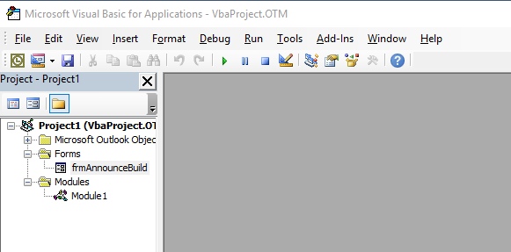

1. Right click on the Forms folder on the left and select ‘Import File …’

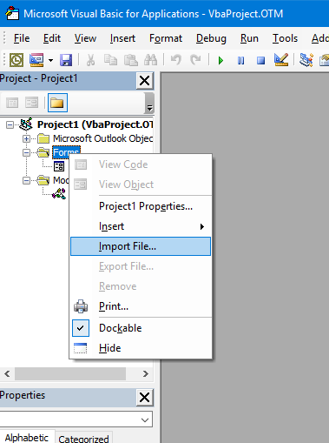

1. Browse to the folder in step #1, select the file ‘frmSendBulkEmails.frm’ and click ‘Open’

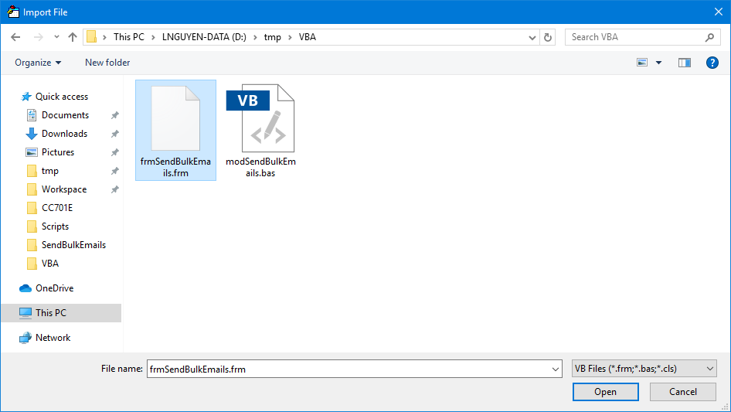

1. Right click on the Modules folder on the left and select ‘Import File …’

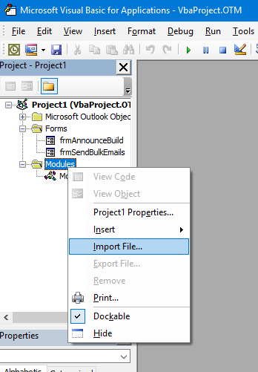

1. Browse to the folder in step #1, select the file ‘modSendBulkEmails.bas’ and click ‘Open’

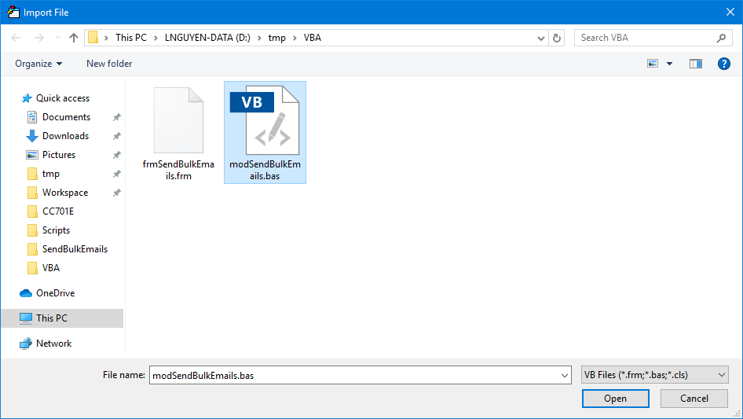

1. In the main Outlook window:
   1. Select the Home ribbon

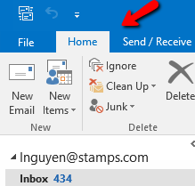

* 1. Right click on the empty area of the Home ribbon and select ‘Customize the Ribbon…’

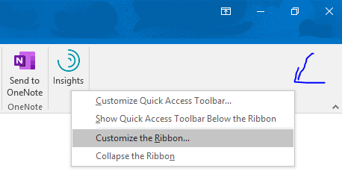

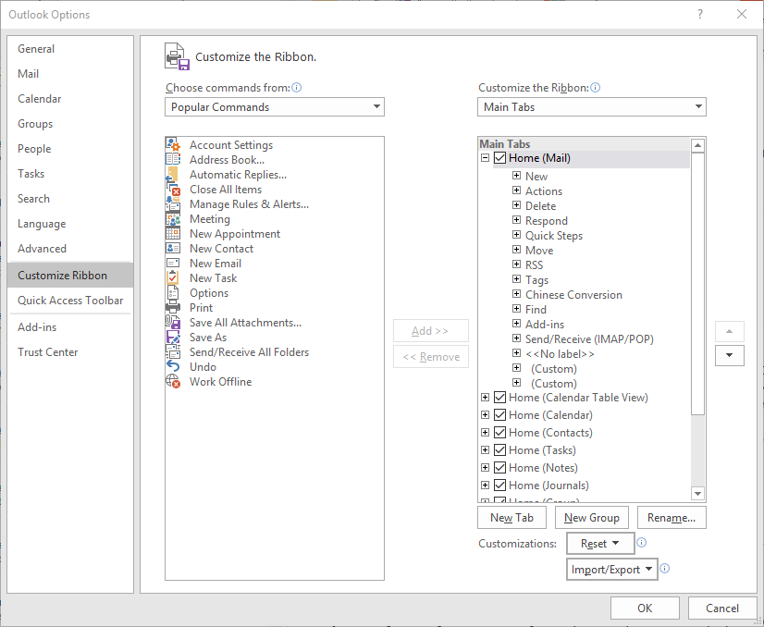

1. Click on the ‘Choose commands from:’ drop-down list, select ‘Macros’

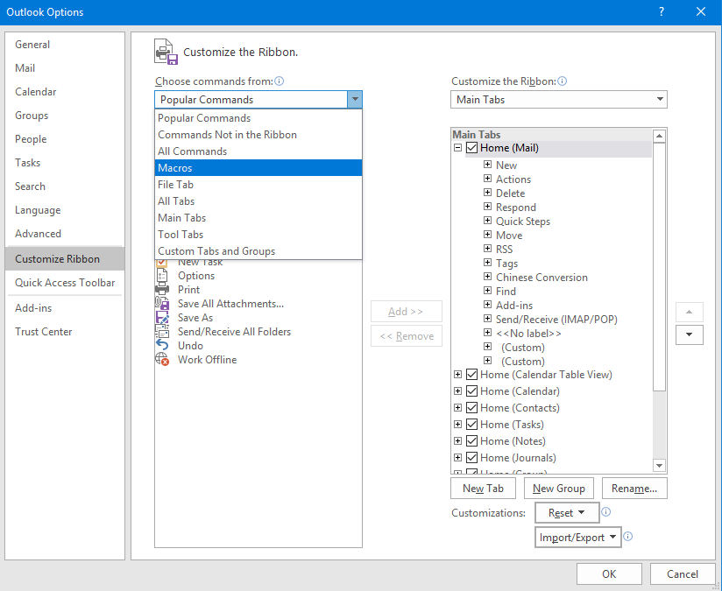

1. Right click on the ‘Home (Mail)’ check box on the right and select ‘Add New Group’

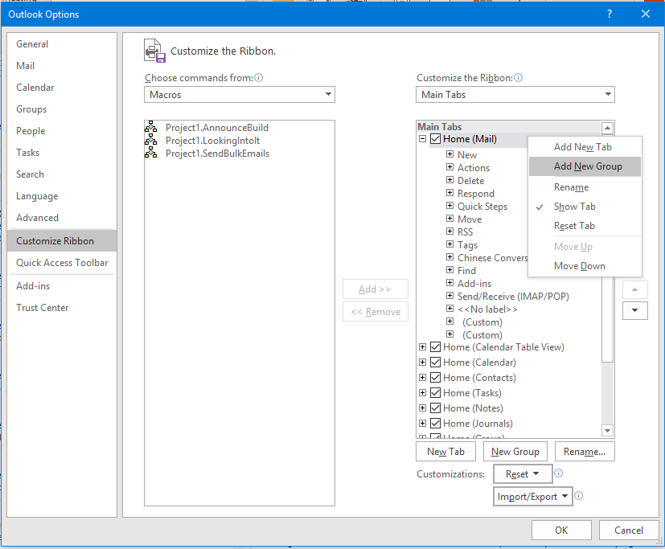

1. Select the ‘New Group (Custom)’ item at the bottom and click on ‘Rename’

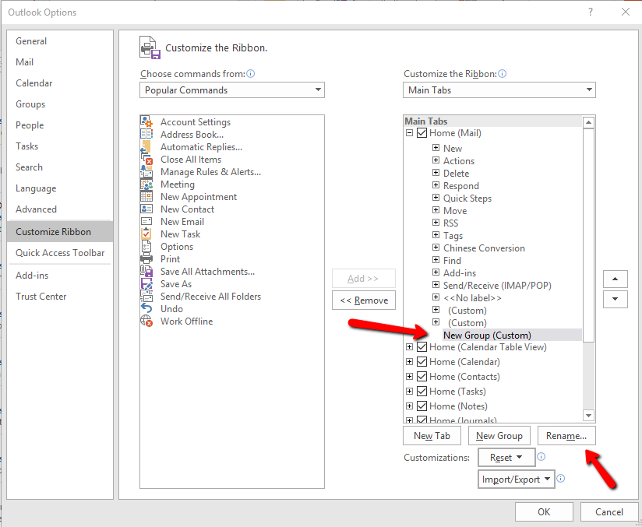

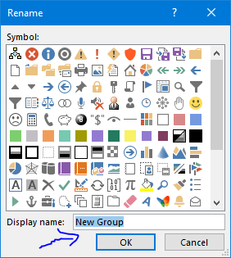

1. Delete the text ‘New Group’ from the ‘Display name:’ text box and click OK

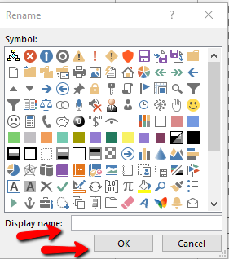

1. Select ‘Project1.SendBulkEmails’ on the left and select the ‘(Custom)’ on the right, then click ‘Add >>’

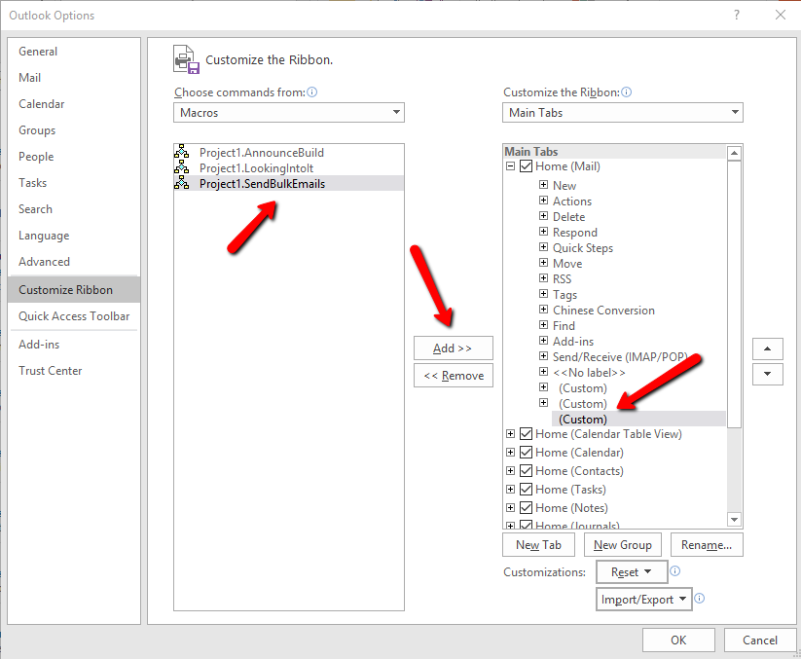

1. Right click on ‘Project1.SendBulkEmails’ and select ‘Rename’

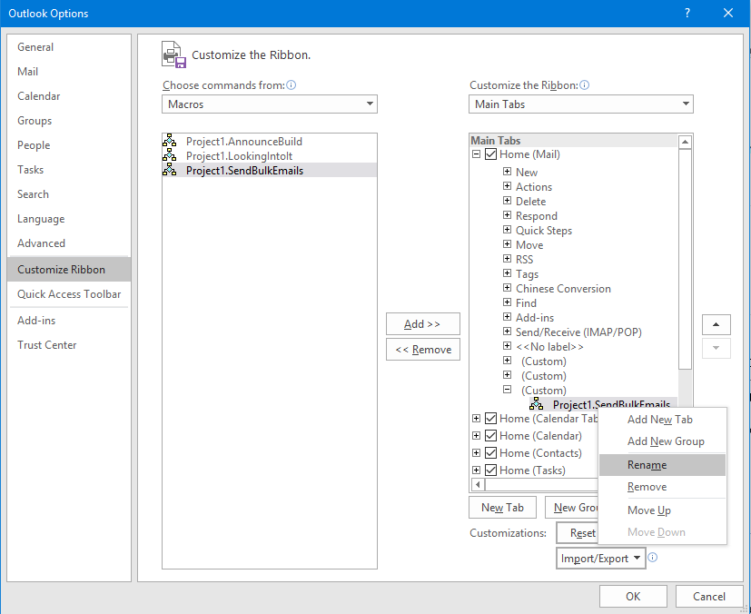

1. Select the ->> symbol, change the display name from ‘Project1.SendBulkEmails’ to ‘Send Bulk Emails’ and click OK

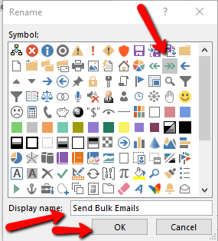

1. Click OK and voila, you now have a new button in the Home ribbon called ‘Send Bulk Emails’

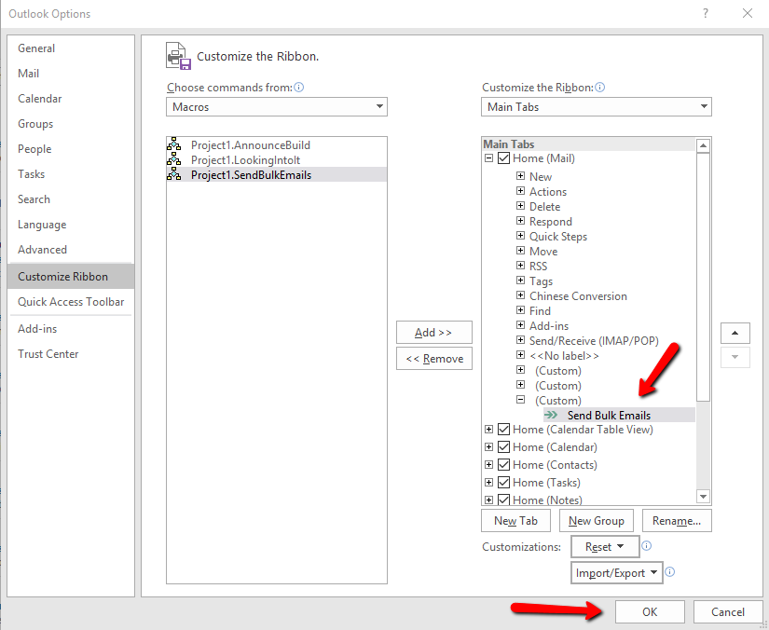

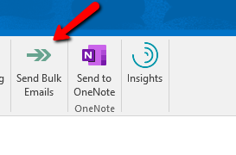

1. Trial Run
   1. Create a draft email. Note that you are in the ‘Message’ ribbon, not the ‘Home’ ribbon. There’s no ‘Send Bulk Emails’ button there.

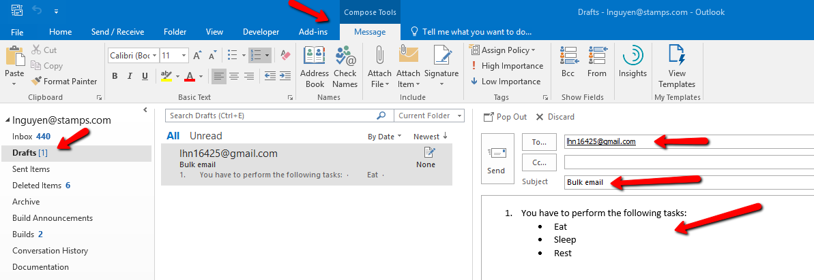

* 1. Click on the ‘Home’ ribbon and click on the ‘Send Bulk Emails’ button. You may need to click on this button twice because the Outlook app does not have the focus.

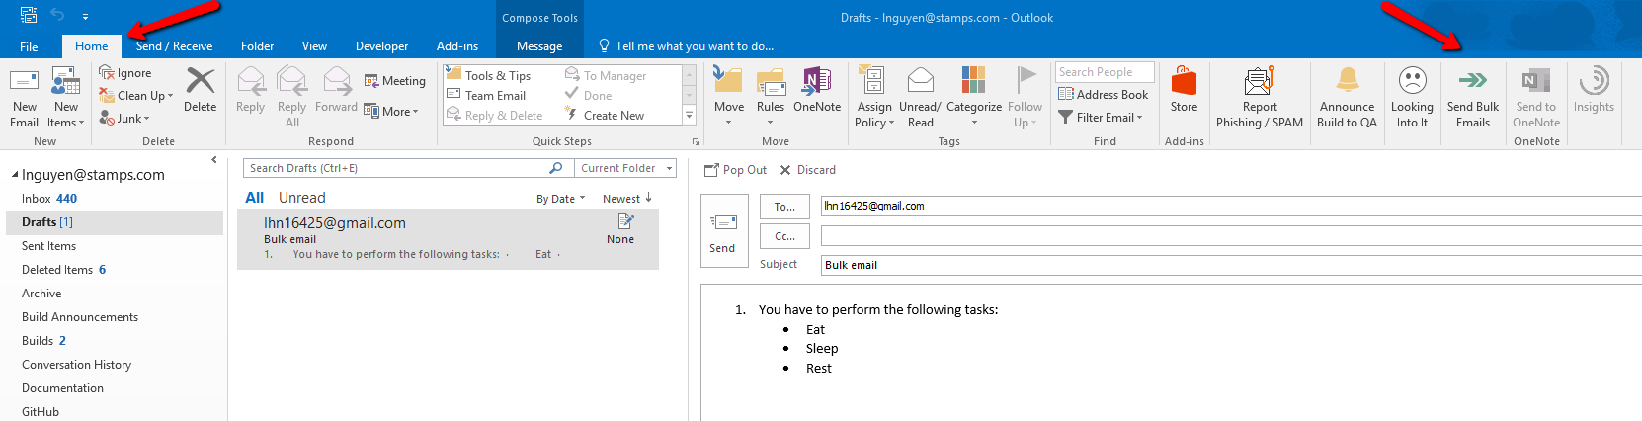

* 1. Type in a few email addresses, separated by semi-colon and click ‘Send Emails’. Verify the emails are sent. Examine the log and click ‘Close’ when you are done.

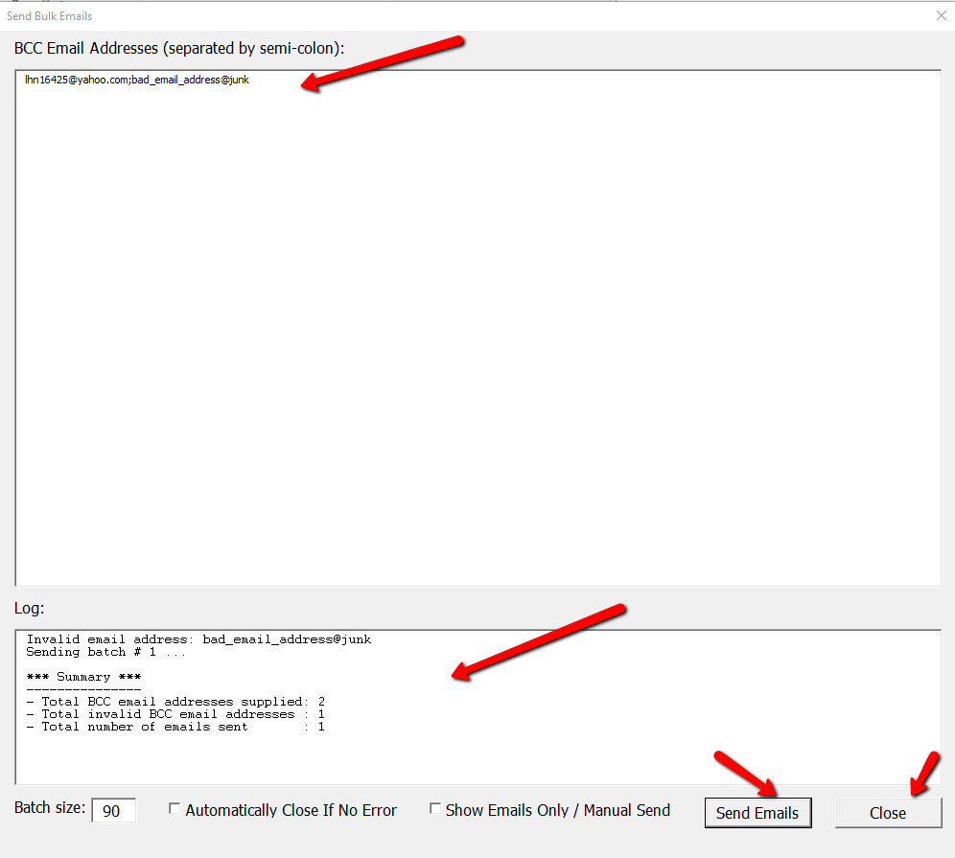

1. UI Detailed Description
   1. BCC Email Addresses

This is your mailing list. The emails need to be separated by semi-colon. This list will be broken up into batches of at most 90 emails each. An email based on your draft will be sent for each batch.

* 1. Log

This is where the tools shows the progress, error messages, and a summary at the end

* 1. Batch size

Valid values are 1 – 90. This is the number of BCC emails addresses in each email (a.k.a batch) to be sent.

* 1. Automatically Close If No Error

Close this form automatically if and when all emails are sent without any error, i.e. there’s no mal-formed email address in the mailing list. Check this box if you don’t care about the mal-formed email addresses or you don’t want to see the progress or the summary.

* 1. Show Emails Only / Manual Send

This is very useful for testing where instead of actually sending the emails, the tool just pops up the emails to be sent and you can either click send or dismiss each individual email.

Note that this is only useful if you are “sending” a handful of batches. If you are “sending” more than 5 batches, the tool will force you to uncheck this option because you will not like having too many emails popping up on your computer screen.

* 1. Send Emails

Trigger the sending of emails.

* 1. Close

Close down the form.

1. Notes
   1. For initial testing, I recommend initially setting the batch size to 1 and enter 3 email addresses. This means the tool will send 3 batches, each batch contains only 1 email. Also check the box ‘Show Emails Only / Manual Send’ so that no actual email is sent. After clicking ‘Send Emails’, verify that 3 emails will pop up.
   2. As you get more comfortable with the tool, you can play around with the size of the mailing list, the batch size, and the auto-close feature.