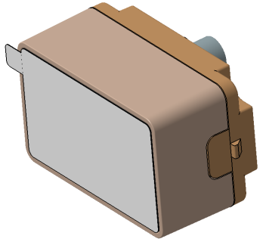

STK-HD-CAM-OV2311-SPEC
2 MP DMS CAM(摄像头)
基本描述/General Description
合肥晟泰克车载摄像头采用高动态车规图像传感器,配合主流串行传输芯片,使得该模组具有高可靠性能, 该模组具有广泛适用性，能适配不同的SOC 平台。
Vehicle camera module of Hefei Softec adopts high dynamic vehicle gauge image sensor, with mainstream serial transmission chip, making the module has high reliability performance, the module has a wide range of applicability, can be adapted to different SOC platforms.
特点/Features
● 车规高性能 /High Performance Automotive Grade;
● 支持识别人脸等多功能/ Support face recognition and other unctions

应用/Application
● 驾驶员监控 / Driver monitoring
● 眼球追踪 / eyeball tracking
● 面部识别 / facial recognition


硬件框图/Hardware block diagram
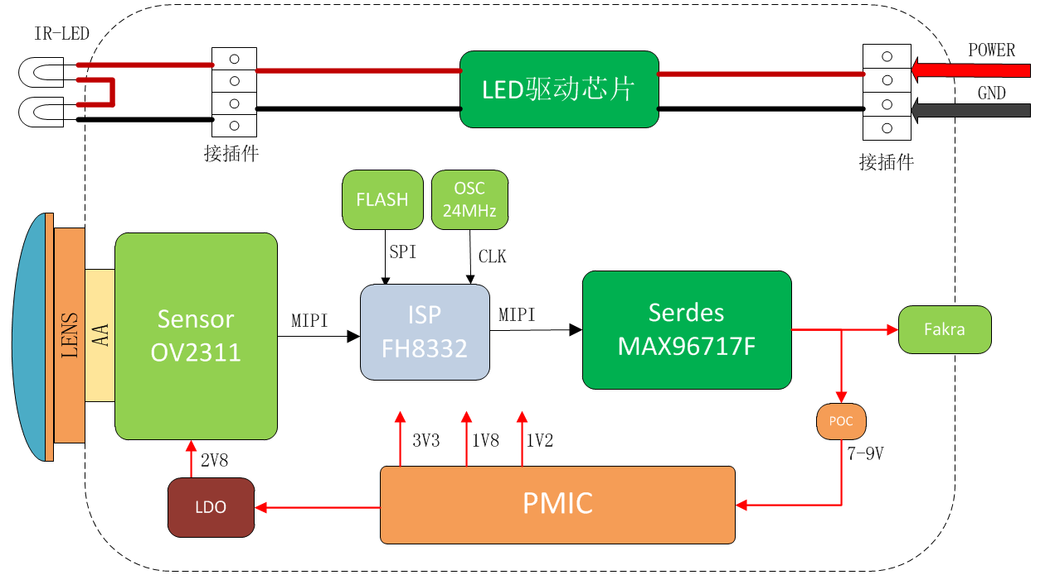

关键参数/ KEY PARAMETERS
序号 | Sensor参数 | OV OV02311
1 | Active Pixels(有效像素) | 2MP
2 | Image Size(图像尺寸) | 1/2.9-inch CMOS
3 | Shutter Type(曝光模式) | Rolling Shutter 卷帘快门
4 | Output Pixels(输出像素) | 1600*1300
5 | Pixel Size(像素尺寸) | 3um*3um
6 | ISP参数 | FH8322
7 | Frame Rate(帧率) | 30fps
8 | Output data(输出信号格式) | YUV422
9 | Lens参数 | CM207(宇瞳)
10 | Lens Type(镜头结构) | 1G2P+IR
11 | F/No. | 2.06±5%
12 | EFL | 5.21±5%
13 | F.O.V(Horizontal/Vertical) | H:50°±3°  V:41.1°±3°
14 | OP Distortion(OP畸变) | -3%
15 | Relative Illumination(相对照度) | 50.2%±5%@φ6.18
16 | Focusing Distance(调焦距离，物距) | 1000mm(按应用的物距)
17 | Depth of Field(景深范围) | 688mm-1830mm
18 | 整体模组 | 参数
19 | Dimensions(尺寸) | L: 44mm, W:28mm, H:37mm
20 | Weight(重量) | ＜50g
21 | Connector(连接器) | 电连-818032090
22 | Serializer(串行器) | MAXIM MAX96717F
23 | Power Supply(工作电压) | 7-9V
24 | Current(工作电流) | ＜100mA
25 | Camera Interface(摄像头接口) | LVDS
26 | Optical Axis Precision(光轴精度) | X:±5 Pixel,Y: ±5 Pixel;
27 | Startup Time(启动时间) | ≤500ms
28 | Operating temperature(工作温度) | -40℃~85℃
29 | Storage temperature(存储温度) | -40℃~95℃
30 | IP Grade(防护等级) | 模组本体IP52
31 | MTF(清晰度) | 中心视场：MTF50P≥0.55  0.7视场：MTF50P≥0.38
32 | Low Light(最低照度) | 0 Lux (IR pattern)
33 | SNR(信噪比) | 40 dB

附件Ⅰ：摄像头本体尺寸示意图(单位：mm)
